https://www.vogella.com/tutorials/JUnit/article.html

Table of content

UT example 1
UT with test data 1
UT with set of test data 2
Run the test cases 3
Naming convension 4
Important annotations 4
important methods 4
Ignoring/disable test 4
Ignoring/disable single test: 4
ignore set of test cases 4
object mocking (using mockito) 5
testing of static method (using powermock) 6
usage of @Rule 7
Calling static and private method (using powermock) 9
Verify method 11

UT example

UT with test data

code:

package com.pv.calc;
public class Calculate {

public int sum(int a, int b) {
return a + b;
}

public int substract(int a, int b) {
return a - b;
}
}

ut:

import static org.junit.Assert.assertEquals;
import org.junit.Test;
import org.junit.runner.RunWith;
import org.mockito.InjectMocks;
import org.mockito.junit.MockitoJUnitRunner;
import com.pv.calc.Calculate;
@RunWith(MockitoJUnitRunner.class)
public class CalculateTest {
@InjectMocks
Calculate calculate;

@Test
public void sum() {
assertEquals("asdfsdf", calculate.sum(12, 34), 46);
here, 12 and 34 are the test data
}

@Test
public void sum1() {
calculate.substract(12, 2);
calculate.sum(12, 34);
assertEquals("result", 12, 12);
}
}

UT with set of test data

CODE:

package com.pv.calc;
public class MyClass {
public int multiply(int i, int j) {
return i * j;
}
}

UT:

import static org.junit.Assert.assertEquals;
import java.util.Arrays;
import java.util.Collection;
import org.junit.Ignore;
import org.junit.Test;
import org.junit.runner.RunWith;
import org.junit.runners.Parameterized;
import org.junit.runners.Parameterized.Parameter;
import org.junit.runners.Parameterized.Parameters;
import com.pv.calc.MyClass;
@RunWith(Parameterized.class)
public class MyClassTest {
// fields used together with @Parameter must be public
@Parameter(0)
public int m1; //input 1
@Parameter(1)
public int m2; //input 2
@Parameter(2)
public int result;

// creates the test data
@Parameters
public static Collection<Object[]> data() {
Object[][] data = new Object[][] { { 1, 2, 2 }, { 5, 3, 15 }, { 121, 4, 484 } };
// input1, input2, result
return Arrays.asList(data);
}

@Test
public void testMultiplyException() {
MyClass tester = new MyClass();
assertEquals("Result", result, tester.multiply(m1, m2));
}
}

Run the test cases

using java
using eclipse

using eclipse:
right click on test class and run it

using java:
Result result = JunitCore.runClasses(MyClassTest.class);
Boolean boolean = result.wasSuccessful();

for multiple test classes:
1. create a test suit
import org.junit.runner.RunWith;
import org.junit.runners.Suite;
@RunWith(Suite.class)
@Suite.SuiteClasses({
JunitTest1.class,
JunitTest2.class
})
public class JunitTestSuite {
}

2. in main class
Result result = JUnitCore.runClasses(JunitTestSuite.class);

Naming convension
test class name: classnameTest (suffix with test)
test class method name: methodNameTest (suffix with test)

Important annotations
@Test
@Test(expected=Exception.class)
@Test(timeout = 100)
@After
@Before
@BeforeClass
@AfterClass

important methods

assertTrue("message", condition)
assertEquals("message", expected, actual)
assertNull("message", object)

assertFalse
assertNotNull
fail("message")

Ignoring/disable test

Ignoring/disable single test:

using @Ignore
ex.
@Ignore
@Test
public void test1(){ -- -- }

it count the test but it is disable

ignore set of test cases

it is possible using categories
you can include or exclude based on categories

public interface FastTests { /* category marker */
}

public interface SlowTests { /* category marker */
}

public class A {
@Test
public void a() {
fail();
}

@Category(SlowTests.class)
@Test
public void b() {
}
}

@Category({ SlowTests.class, FastTests.class })
public class B {
@Test
public void c() {
}
}

@RunWith(Categories.class)
@IncludeCategory(SlowTests.class)
@SuiteClasses({ A.class, B.class })
// Note that Categories is a kind of Suite
public class SlowTestSuite {
// Will run A.b and B.c, but not A.a
}

@RunWith(Categories.class)
@IncludeCategory(SlowTests.class)
@ExcludeCategory(FastTests.class)
@SuiteClasses({ A.class, B.class })
// Note that Categories is a kind of Suite
public class SlowTestSuite {
// Will run A.b, but not A.a or B.c
}

object mocking (using mockito)

Let have Calculate class to be test then
to test Calculate class in CalculateTest class
we have,

class CalculateTest{
@InjectMocks
Calculate calculate;

@Test
public void sum(){
int result = calculate.sum(12,3);
assertEquals("Result", result, 36);
}
}

Note:
in calculate.sum() method, if it calls some service.abc() then
in CalculateTest, we have
@Mock
Abc service;
in CalculateTest.sum(),
Mockito.when(service.sum()).thenReturn("requiredObject");
int result = calculate.sum(12,3);
assertEquals("Result", result, 36);

testing of static method (using powermock)

using powermock
powermock runs as an extension of any mock framework like easymock or mockito

@InjectMocks
OrderService service;

@public void test1(){
//calling static method of Notification class
PowerMockito.mockStatic(Notification.class);
when(Notification.sendEmail("asdf@gmail.com")).thenReturn("success");

//calling private method of OrderService
}

dependencies:

<dependency>
<groupId>org.powermock</groupId>
<artifactId>powermock-module-junit4</artifactId>
<version>2.0.0</version>
<scope>test</scope>
</dependency>

<dependency>
<groupId>org.powermock</groupId>
<artifactId>powermock-api-mockito2</artifactId>
<version>2.0.0</version>
<scope>test</scope>
</dependency>

usage of @Rule

- It is based on the concept of AOP
- Some code runs before and after of all the testcases within the test class
- These are basically intercepters in JUNIT

Creating custom rule:

public class MyRule implements TestRule {

@Override
public Statement apply( Statement base, Description description ) {
return new MyStatement( base );
}
}

public class MyStatement extends Statement {

private final Statement base;

public MyStatement( Statement base ) {
this.base = base;
}

@Override
public void evaluate() throws Throwable {
System.out.println( "before" );
try {
base.evaluate();
} finally {
System.out.println( "after" );
}
}
}

Test class:

public class MyTest {

@Rule
public MyRule myRule = new MyRule();

@Test
public void testRun() {
System.out.println( "during" );
}
}

o/p:

before
during
after

Predefined rules in Junit:

TemporaryFolder rule
it is use to create and delete files and folder when test runs starts and completed

@Rule
TemporaryFolder folder = new TemporaryFolder();

@Test
public void testUsingTempFolder() throws IOException {
File createdFile = folder.newFile("myfile.txt");
File createdFolder = folder.newFolder("subfolder");
// ...
}

Note:
TemporaryFolder#newFolder(String... folderNames) creates recursively deep temporary folders

Note:
@Rule
public TemporaryFolder folder = TemporaryFolder.builder().assureDeletion().build();

ExternalResource rule
Run some code before and after
Like server or socket connect or disconnect

ex.

Server myServer = new Server();
@Rule
public final ExternalResource resource = new ExternalResource() {
@Override
protected void before() throws Throwable {
myServer.connect();
}

@Override
protected void after() {
myServer.disconnect();
}
}

@Test
public void testFoo() {
new Client().run(myServer);
}

Calling static and private method (using powermock)

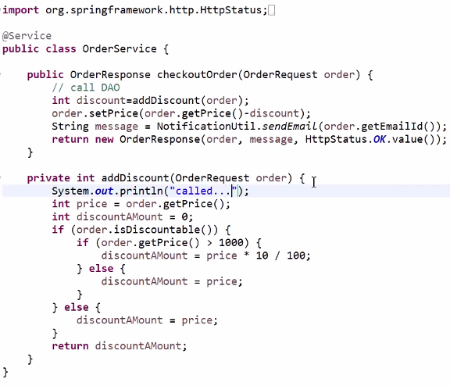

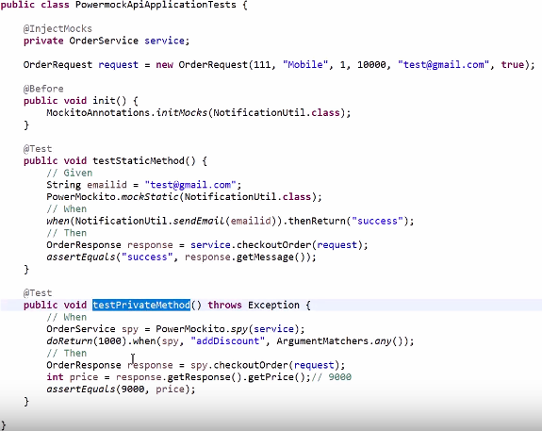

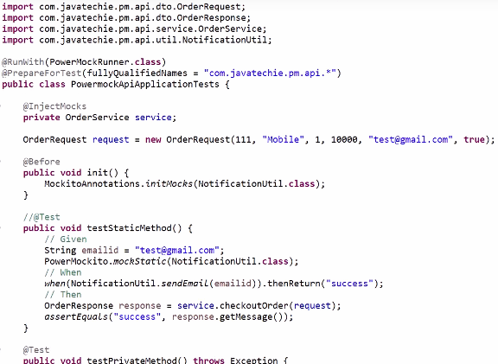

Note:
To call private method, you need to create a spy object

Verify method
It checks how many number of times, a mocking object's method is called
This is usually the last statement in a test

