QCI Central Finite Curve
Production Implementation Plan
Prepared: 24 April 2026 · Post-Demo with Subroto Sir (23 Apr 2026)
Status: Decision Document for Leadership

Executive Summary
The demo successfully validated the core concept: a RAG-powered platform that ingests QCI's institutional knowledge (Work Orders, Proposals) and generates new drafts grounded in prior work. The current system runs on Railway (PaaS) with a Next.js frontend, FastAPI backend, PostgreSQL + pgvector, Redis/Celery, RunPulse OCR, and Gemini Flash for generation and embeddings.

This document presents three implementation options — from lean to enterprise-grade — so leadership can choose based on budget appetite, risk tolerance, and timeline.

⚠ IMPORTANT

The demo processed ~24 documents. Production requires ingesting ~80 GB of institutional documents and supporting ~500 concurrent users. This is a fundamentally different scale requiring deliberate architecture decisions.

1. Current Architecture — Demo State
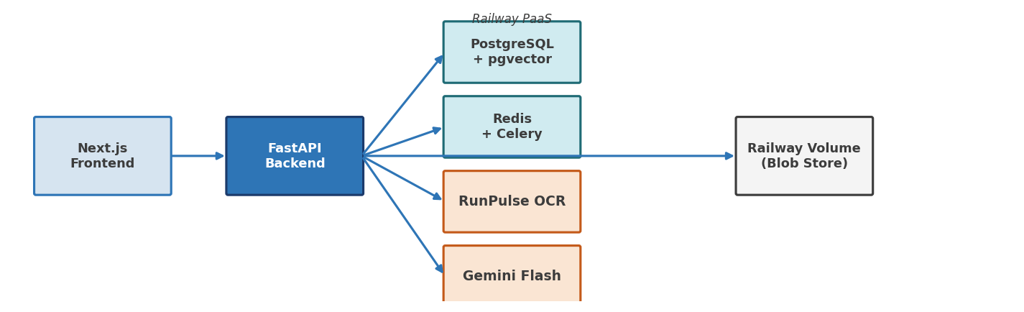
Figure 1: Demo system components running on Railway PaaS
Component | Demo Setup | Production Gap
Documents | 24 PDFs (~50 MB) | ~80 GB corpus (thousands of docs)
Users | 1–3 demo users | ~500 concurrent
Auth | Shared demo password + JWT | SSO / RBAC needed
OCR | RunPulse free/dev tier | Enterprise subscription required
Database | Railway-managed Postgres | Needs backup, HA, proper sizing
Storage | Railway volume mount | S3-compatible blob storage
LLM | Gemini Flash free tier | Paid tier or alternative needed

2. Key Decision Areas

2.1 OCR — Processing 80 GB of Documents
The current pipeline uses RunPulse (Pulse AI) for OCR and schema extraction. RunPulse does not publish fixed pricing — enterprise is custom/sales-driven.
Estimation basis: 80 GB ≈ 15,000–25,000 document pages (assuming average 3–5 MB per multi-page PDF).

OCR Option | One-Time Ingest Cost | Ongoing Cost | Quality | Effort to Switch
RunPulse Enterprise | ₹3–6L (custom quote: on the higher side ~10k pages are free) | ₹50K–1L/mo | High (tables, layout-aware) | None — already integrated
Google Document AI | ~₹3–5L for full corpus | Pay-per-page | High | Medium (API swap)
Docling (Open Source) | ₹0 + compute time | Compute only | Good (improving rapidly) | Low — already have prior experience
Azure AI Doc Intelligence | ~₹2–4L | Pay-per-page | High | Medium

✔ RECOMMENDATION Use Docling (open-source, with prior experience from the reimbursement project) for bulk historical ingestion to save ₹3–6L, and retain RunPulse only for ongoing new documents where structured schema extraction is critical. This hybrid approach minimises cost while maintaining quality. Can check with RunPulse Sales team to get a realistic quote for services.

2.2 Hosting & Infrastructure
The core question: can Railway handle 500 concurrent users, or do we need Azure/AWS?

Factor | Railway Pro/Enterprise | Azure App Service | AWS Fargate
500 concurrent users | Yes (horizontal replicas) | Yes (scale-out plans) | Yes (auto-scaling)
Ease of Setup | ★★★★★ — git push deploy | ★★★☆☆ — more config | ★★☆☆☆ — DevOps heavy
Maintenance Burden | Very low | Medium | High
Est. Monthly Cost | ₹8K–25K | ₹15K–40K | ₹12K–35K
India Region | No (US/EU only) | Yes — Central India | Yes — Mumbai
Compliance / Govt | Limited | Strong (govt certs) | Strong
Data Residency | US/EU servers | India possible | India possible

⚑ DATA RESIDENCY WARNING
Data residency is critical for a government body like QCI. Railway hosts in US/EU only. If QCI's IT security policy requires data to stay in India, Azure (Central India) or AWS (Mumbai) becomes mandatory regardless of convenience.

Azure vs AWS practical comparison for this project:
- Azure is the better fit if QCI already has Microsoft licensing (Office 365, etc.) — Azure Hybrid Benefit could cut costs 30–40%
- AWS offers more granular container control but requires more DevOps expertise
- Both provide equivalent compute for this use case; the difference is in operational complexity, not capability

2.3 Database & Deployment Architecture
Current: Railway-managed PostgreSQL (auto-provisioned, limited backup control).
Production target architecture:

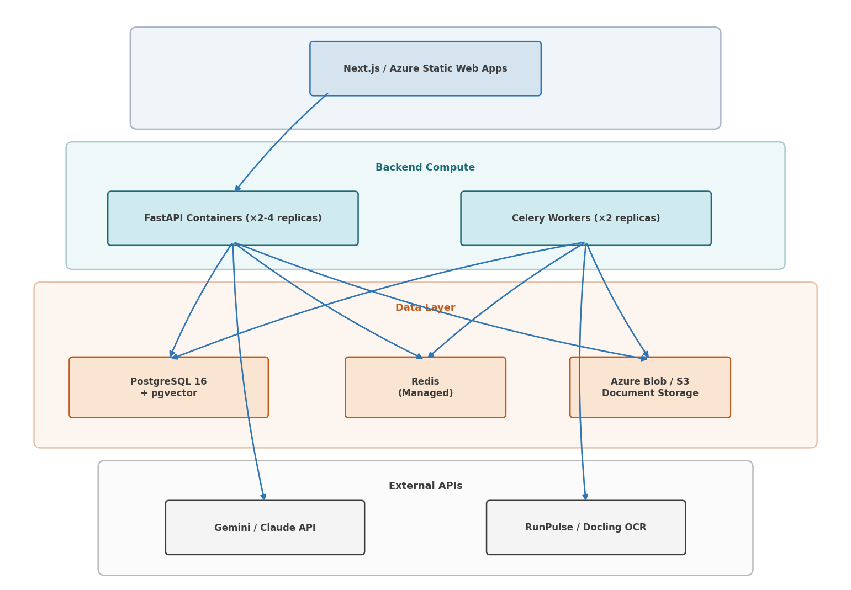
Figure 2: Production target architecture with subgraph groupings

Migration path:
- Export Railway Postgres → SQL dump
- Provision managed Postgres (Azure Flexible Server or AWS RDS) with pgvector extension
- Restore dump + run Alembic migrations
- Switch blob storage from Railway volume → Azure Blob / S3
- Update environment variables and redeploy

2.4 Security & VPN Pipeline
To access QCI's local document server safely, a site-to-site VPN with read-only access is established:

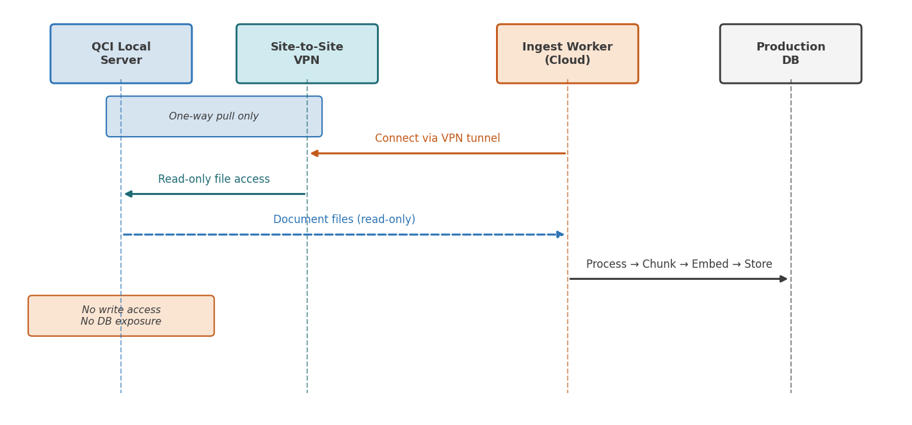
Figure 3: VPN security pipeline — read-only ingest, no write-back

Key security principles:
- Read-only mount — ingest worker can only pull files, never write back
- No direct DB exposure — QCI's repository server is never exposed to the internet
- VPN with mutual TLS — Azure VPN Gateway or WireGuard tunnel
- Audit logging — every file access logged with timestamp and operator
- QCI IT sign-off required before any VPN configuration

2.5 Model / API Choices for Document Generation
Provider | Model | Input $/MTok | Output $/MTok | Quality | Notes
Google (current) | Gemini Flash | $0.30–0.50 | $1.50–3.00 | Good | Free tier, already integrated
Google | Gemini Pro | $1.25 | $5.00 | Very Good | Better structure adherence
Anthropic | Claude Haiku 4.5 | $1.00 | $5.00 | Very Good | Excellent structured docs
Anthropic | Claude Sonnet 4.6 | $3.00 | $15.00 | Excellent | Best for complex proposals
OpenAI | GPT-4.1 mini | $0.40 | $1.60 | Good | Cheapest high-quality option
OpenAI | GPT-4.1 | $2.00 | $8.00 | Very Good | Strong structured output
Open Source | Llama/Mistral/Google Gemma Models | GPU cost only | GPU cost only | Variable | Requires GPU infra, finetuning expertise

Monthly generation cost estimate (200 documents/month, ~4K tokens in + 4K out each):

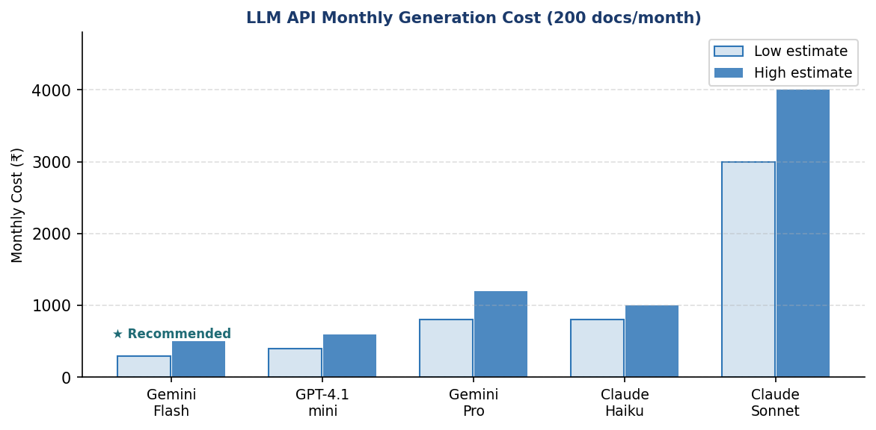
Figure 4: Estimated monthly LLM API generation costs by model

Embedding costs (one-time for 80 GB corpus + ongoing):
- Gemini embedding-001: ~₹2,000–4,000 for full corpus ingestion
- Ongoing: negligible (<₹500/month)

✔ RECOMMENDATION

Can keep Gemini Flash for generation (cheapest, already integrated, good quality). The generation costs are surprisingly low — even at scale, LLM API costs will be <₹5K/month. Can be fine-tuned easily with prompts and can always be switched for some other better option. Since quality of OCR is the main determinant for project success, there is a strong argument for using costs at the OCR stage than at Models for document generation. Self-hosting an LLM is not justified at this volume.

3. Implementation Options

Option A — Lean Production (Railway + Incremental Hardening)
"Ship fast, harden later"
Approach: Stay on Railway, upgrade to Enterprise plan, add proper auth and monitoring.

Aspect | Detail
Hosting | Railway Pro ($20/mo base + usage) – currently being used; need to switch to enterprise plan
Database | Railway Postgres (enable backups)
OCR | Docling (bulk) + RunPulse (new docs)
LLM | Gemini Flash (current)
Auth | Add proper JWT with user accounts (no SSO yet)
VPN | WireGuard tunnel to QCI server
Frontend | Vercel free tier or Railway

Budget:
Category | Best Case | Normal Case | Worst Case
Railway hosting | ₹5K/mo | ₹12K/mo | ₹25K/mo
RunPulse (ongoing) (on the highest sides) ~10k pages are free | ₹15K/mo | ₹40K/mo | ₹80K/mo
Gemini API | ₹500/mo | ₹2K/mo | ₹5K/mo
Claude Pro (dev) | ₹8.5K/mo | ₹8.5K/mo | ₹17K/mo
Domain + SSL | ₹500/mo | ₹500/mo | ₹500/mo
Monthly Total | ₹30K | ₹63K | ₹1.3L
One-time setup | ₹50K | ₹1L | ₹2L
Year 1 Total | ₹4.1L | ₹8.6L | ₹17.6L

Timeline: 4–6 weeks · Staffing: Prabhav + QCI IT (part-time)

Trade-offs:
- ✅ Fastest to production
- ✅ Lowest cost
- ✅ Buildable with Claude Pro coding access
- ⚠️ Data hosted in US (Railway) — no India data residency
- ⚠️ Limited enterprise compliance features
- ❌ May not pass QCI IT security audit

Option B — Hybrid: Azure India + Managed Services

★ Recommended Option
"Government-ready without over-engineering"
Approach: Move compute and DB to Azure Central India for data residency. Use managed services to minimise ops burden.

Aspect | Detail
Hosting | Azure App Service (B2 plan, 2 instances)
Database | Azure Database for PostgreSQL Flexible Server + pgvector
OCR | Docling (bulk ingest) + Azure Document Intelligence (ongoing)
LLM | Gemini Flash via API (or Azure OpenAI for compliance)
Auth | Azure AD B2C / QCI's existing SSO
VPN | Azure VPN Gateway → QCI local server
Storage | Azure Blob Storage
Frontend | Azure Static Web Apps or Vercel

Budget:
Category | Best Case | Normal Case | Worst Case
Azure Compute (App Service) | ₹8K/mo | ₹18K/mo | ₹35K/mo
Azure PostgreSQL | ₹5K/mo | ₹10K/mo | ₹20K/mo
Azure Blob Storage | ₹500/mo | ₹1.5K/mo | ₹3K/mo
Azure VPN Gateway | ₹3K/mo | ₹3K/mo | ₹5K/mo
OCR (Azure Doc Intel) | ₹2K/mo | ₹5K/mo | ₹15K/mo
LLM API (Gemini/OpenAI) | ₹500/mo | ₹3K/mo | ₹8K/mo
Claude Pro (dev) | ₹8.5K/mo | ₹8.5K/mo | ₹17K/mo
Monitoring + misc. | ₹1K/mo | ₹2K/mo | ₹5K/mo
Monthly Total | ₹29K | ₹51K | ₹1.1L
One-time setup | ₹1.5L | ₹3L | ₹5L
Year 1 Total | ₹5L | ₹9.1L | ₹18.2L

Timeline: 8–12 weeks · Staffing: Prabhav (active) + QCI IT (lead) + 1 Azure consultant (2–3 weeks, part-time, in case needed)

Trade-offs:
- ✅ Data residency in India
- ✅ Government compliance ready
- ✅ Managed services = low maintenance overhead
- ✅ Azure AD integration for SSO
- ✅ Feasible with Claude Pro coding + QCI IT support
- ⚠️ More setup complexity than Railway
- ⚠️ Slightly higher base cost
- ⚠️ Can’t manage DARPG work along with this option – need to work on this standalone to meet timelines

Option C — Full Enterprise (Dedicated Infrastructure + Ops Team)
"Maximum control, maximum cost"
Approach: Full cloud deployment with dedicated DevOps, CI/CD pipeline, staging environment, comprehensive monitoring, and self-hosted OCR.

Aspect | Detail
Hosting | Azure AKS (Kubernetes) or AWS ECS
Database | Azure PostgreSQL HA (zone-redundant)
OCR | Self-hosted Docling on GPU instances
LLM | Azure OpenAI (data stays in Azure)
Auth | Full SSO with RBAC, MFA
CI/CD | GitHub Actions → staging → production
Monitoring | Azure Monitor + Application Insights

Budget:
Category | Best Case | Normal Case | Worst Case
Azure Infrastructure | ₹40K/mo | ₹80K/mo | ₹1.5L/mo
DevOps engineer (contract) | ₹80K/mo | ₹1.2L/mo | ₹1.5L/mo
GPU compute (OCR) | ₹15K/mo | ₹30K/mo | ₹50K/mo
LLM API | ₹3K/mo | ₹8K/mo | ₹20K/mo
Monitoring + security | ₹5K/mo | ₹10K/mo | ₹20K/mo
Monthly Total | ₹1.4L | ₹2.5L | ₹3.9L
One-time setup | ₹5L | ₹10L | ₹15L
Year 1 Total | ₹22L | ₹40L | ₹62L

Timeline: 16–24 weeks · Staffing: Prabhav + dedicated DevOps engineer + QCI IT (active) + security auditor

Trade-offs:
- ✅ Maximum security, compliance, and control
- ✅ Full HA and disaster recovery
- ✅ Production-grade CI/CD
- ❌ Highest cost by far
- ❌ Requires dedicated DevOps hire
- ❌ Over-engineered for current user base
- ❌ Long timeline

4. Staffing Assessment — Can We (Prabhav + IT team) Build This Solo?
"We made the demo in a day — if we get Claude Pro coding access, can we build this standalone?"

Capability | We + Claude Pro | QCI IT Team Needed? | External Help Needed?
Backend code (FastAPI, RAG, LLM) | ✅ Fully capable | No | No
Frontend (Next.js, UI) | ✅ Fully capable | No | No
Database migrations, schema | ✅ Fully capable | No | No
OCR pipeline (Docling/RunPulse) | ✅ Proven experience | No | No
Azure/AWS initial setup | ⚠️ Can learn, but slow | Yes — for org accounts | Maybe 1–2 days consult
VPN to QCI server | ❌ Needs QCI network | Yes — mandatory | No
SSO / Azure AD integration | ⚠️ Possible w/ guidance | Yes — QCI AD admin | No
Security audit | ❌ Cannot self-audit | Yes — mandatory | Maybe external auditor
DNS, SSL, domain | ✅ Straightforward | Yes — QCI domain | No

The Practical Answer
Option A (Railway):
Yes — we can build this almost entirely solo with Claude Pro. QCI IT Team is needed only for VPN setup and domain pointing. Timeline: 4–6 weeks part-time.

Option B (Azure — recommended):
We can do ~80% solo with Claude Pro. Will need QCI IT for Azure subscription setup, VPN configuration, AD integration, and security review. A 2–3 weeks part-time Azure consultant (~₹50K–1L) would significantly accelerate the Azure-specific setup. Timeline: 8–12 weeks.

Option C (Enterprise):
Not feasible solo. Requires a dedicated DevOps engineer at minimum.

Claude Pro — Investment Analysis
Plan | Monthly Cost | Justification
Claude Pro ($20/mo) | ₹1,700/mo | Sufficient for moderate coding sessions
Claude Max 5× ($100/mo) | ₹8,500/mo | ★ Recommended — heavy agentic coding during buildout
Claude Max 20× ($200/mo) | ₹17,000/mo | Only if hitting rate limits frequently

✔ RECOMMENDATION

ROI calculation: Claude Max at ₹8.5K/mo replaces approximately ₹2–4L/mo of additional developer hiring. Even for a 3-month build period, that is ₹25K vs ₹6–12L. The ROI is overwhelming — this is the single highest-leverage investment in the project. Can start with Claude Pro and transition to Max if needed also.

5. Timeline Comparison
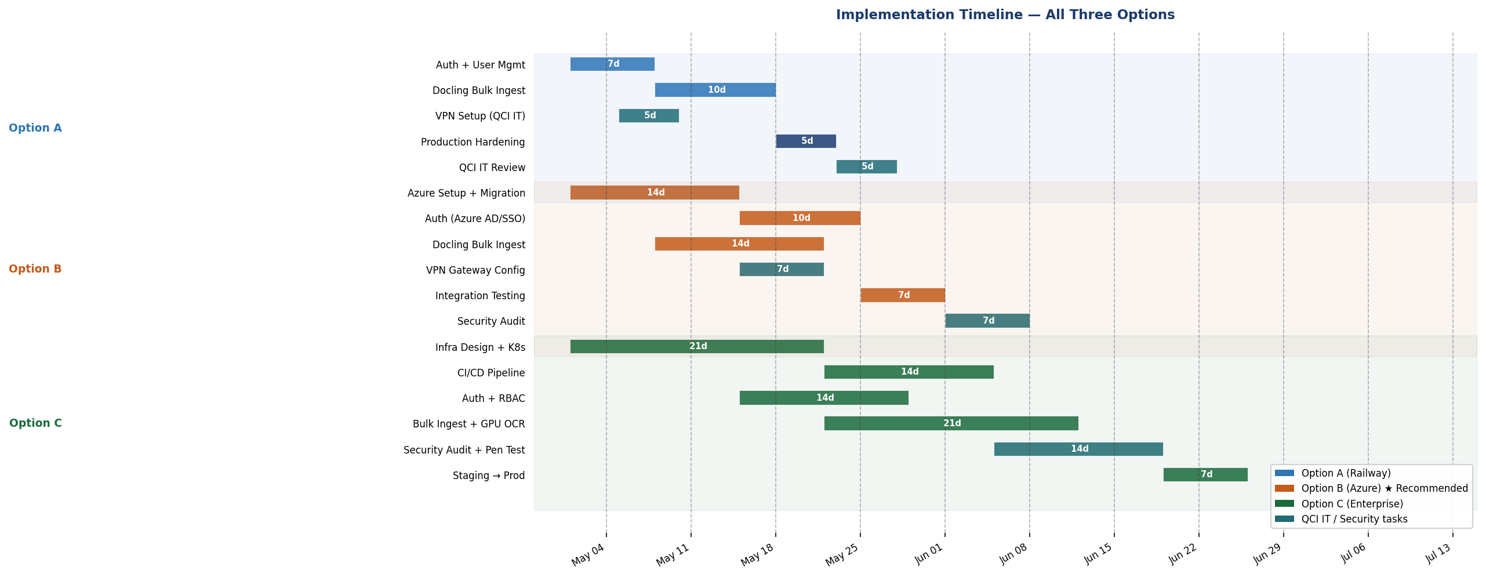
Figure 5: Implementation Gantt chart — all three options

Scenario | Option A (Railway) | Option B (Azure) ★ | Option C (Enterprise)
Best case | 4 weeks | 8 weeks | 16 weeks
Normal case | 6 weeks | 10 weeks | 20 weeks
Worst case | 8 weeks | 14 weeks | 24 weeks

6. Monthly Cost Comparison
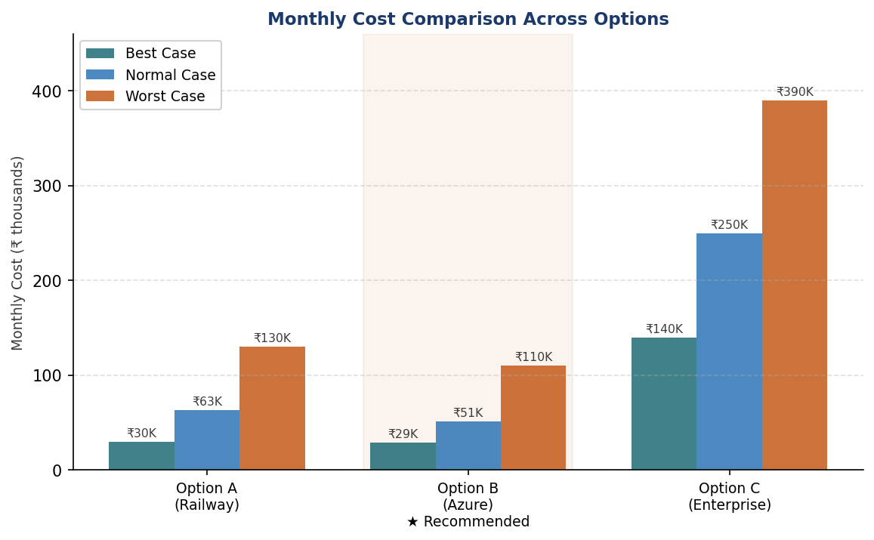
Figure 6: Monthly infrastructure cost across all three options (₹ thousands)

6.1 Maintenance & Ongoing Costs
Item | Monthly Estimate | Notes
Hosting infrastructure | ₹10–50K | Depends on option chosen
LLM API usage | ₹1–5K | Scales with generation volume
OCR for new documents | ₹2–15K | Depends on ingest frequency
Claude Pro (dev tool) | ₹8.5K | Can downgrade to Pro post-launch
Security patching + updates | 4–8 hrs/month | Prabhav’s time or QCI IT
Model/prompt tuning | 2–4 hrs/month | As document quality improves
Total ongoing | ₹25K–80K/mo | Excluding time given by Prabhav

7. Risk Matrix
Risk | Probability | Impact | Mitigation
QCI IT rejects Railway (data residency) | High | Blocks Option A | Default to Option B (Azure India)
RunPulse enterprise pricing exceeds budget | Medium | Increases OCR costs | Switch to Docling + Azure Doc Intel
Gemini free tier rate limits at scale | Medium | Degrades UX | Upgrade to paid tier or add caching
VPN setup delays (QCI network team) | High | Delays ingest | Start with manual upload as interim
80 GB ingest takes longer than expected | Medium | Delays go-live | Batch processing, run overnight
Key person risk (sole developer) | High | Project stalls | Document everything; use Claude for knowledge capture

8. Recommendation
⚠ IMPORTANT

Can Proceed with Option B (Azure Hybrid) with the specific action plan below. Total Year 1 Budget: ₹9–10L (normal case). Staffing: Prabhav (primary) + QCI IT (collaboration) + optional Azure consultant (₹50K–1L one-time).

Action Plan
- Immediately — Get Claude Max subscription (₹8.5K/mo): force multiplier
- Weeks 1–2 — Set up Azure subscription with QCI IT; provision PostgreSQL + App Service in Central India
- Weeks 2–3 — Migrate backend from Railway to Azure App Service (Docker container, same codebase)
- Weeks 2–4 — Run Docling bulk ingest of 80 GB corpus (can run in parallel on local machines or Azure VM)
- Weeks 3–4 — Configure Azure VPN Gateway with QCI IT for ongoing document sync
- Weeks 4–6 — Implement proper auth (Azure AD B2C or simple user management)
- Weeks 6–8 — Integration testing and QCI IT security review
- Weeks 8–10 — Soft launch with pilot group → full rollout

This option gives QCI data residency in India, government-grade compliance, and manageable costs — while remaining buildable primarily by Prabhav with AI-assisted development. It is the pragmatic middle ground between "ship fast" and "enterprise perfection".

Next step: Present to leadership for budget approval and option selection.

