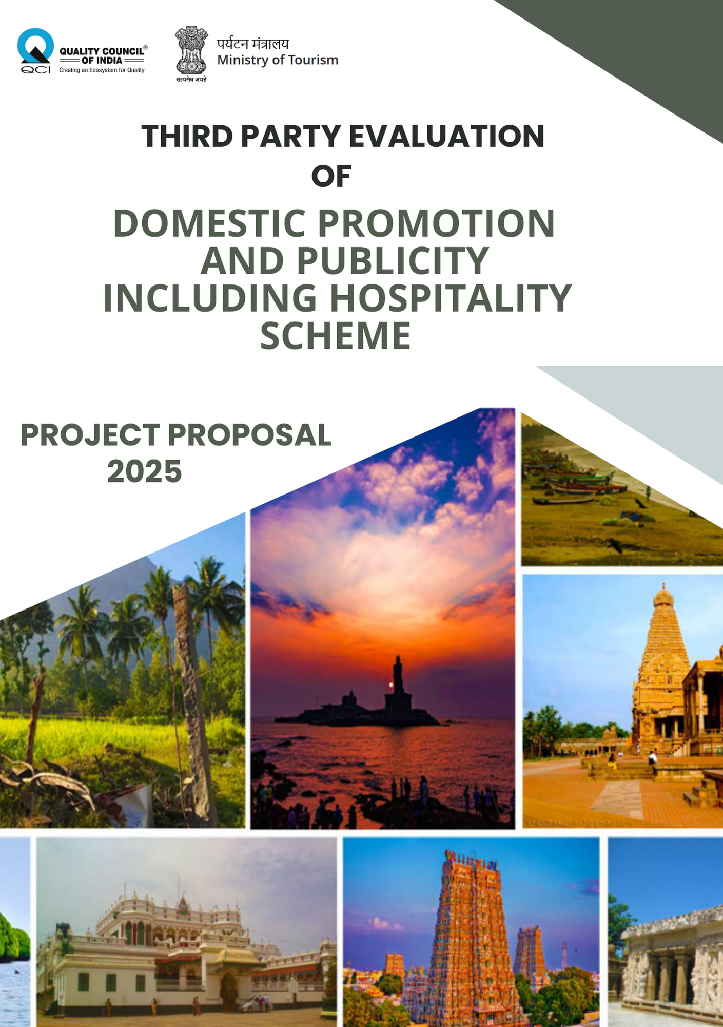
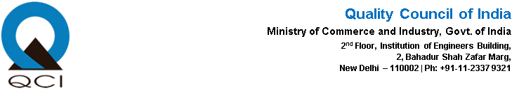

1. INTRODUCTION 4
2. ABOUT QUALITY COUNCIL OF INDIA 5
3. SIMILAR PROJECTS BY QCI 7
4. ABOUT THE SCHEME 8
5. OBJECTIVE 8
6. SCOPE OF WORK 8
7. APPROACH AND METHODOLOGY 9
8. DELIVERABLES 10
9. TIMELINE 10
10. FINANCIALS 11
11. GENERAL TERMS 12

(Page intentionally left blank)

INTRODUCTION
The Domestic Promotion and Publicity including Hospitality (DPPH) Scheme, implemented by the Ministry of Tourism, Government of India, plays a pivotal role in enhancing the visibility, appeal, and accessibility of India’s diverse tourism offerings to both domestic and international audiences. It focuses on promoting destinations, cultural heritage, and tourism products through targeted publicity campaigns, participation in fairs and festivals, and provision of hospitality to visiting delegations, media representatives, and influencers.

By strengthening the country’s tourism brand and fostering positive perceptions, DPPH stimulates travel demand and supports broader objectives such as economic growth, employment generation, and regional development. Its initiatives help bridge information gaps, encourage repeat visitation, and promote lesser-known destinations, contributing to balanced and inclusive tourism growth.

Recognizing the need for impactful outreach, the Ministry has engaged the Quality Council of India (QCI) to conduct a third-party assessment of the scheme. The review will evaluate the planning and execution of promotional and hospitality activities, effectiveness of outreach, and visibility generated. It will also assess the outreach mechanism of selected Domestic Tourism Offices (DTOs), examine financial resource utilization for cost-effectiveness and transparency, gauge stakeholder and beneficiary awareness, and identify operational gaps.

The insights from this assessment will guide strategic improvements, ensuring better planning, enhanced accountability, and more impactful governance. Ultimately, these efforts aim to position India as a preferred tourism destination on both domestic and global platforms.

ABOUT QUALITY COUNCIL OF INDIA
Quality Council of India (QCI) is an autonomous organisation established in 1997, through joint initiative of the Government of India and the Indian industry, pursuant to resolution of the Indian Cabinet in 1996. It is registered as a Society under the Societies Registration Act, 1860 with the mandate to establish and operate the national accreditation system in India and promote quality in all aspects of life, industry, environment, and governance. The Department for Promotion of Industry and Internal Trade (DPIIT), Ministry of Commerce and Industry, Government of India is the nodal point in the government for QCI and all matters concerning quality.
QCI has been engaged by several ministries and government institutions including the Ministry of Defence, NITI Aayog, Department of Industrial Policy and Promotion, Ministry of MSME, Ministry of Railways, Ministry of Petroleum and Natural Gas, Ministry of Housing and Urban Affairs, Ministry of Drinking Water and Sanitation, Ministry of Skills as well as several state governments such as Gujarat, Jharkhand, Punjab, Uttar Pradesh, Odisha among others on a variety of projects dedicated to improvement in quality.
Quality Council of India and its constituent boards are headed by the Chairman of QCI – Mr. Jaxay Shah and the Secretary General of QCI – Mr. Chakravarthy T. Kannan
Chairman – Quality Council of India
The Chairman of QCI is appointed by the Prime Minister of India. Over its history, QCI has had several illustrious chairmen such as –
• Shri Ratan Tata (1997 – 1999)
• Shri Venu Srinivasan (1999 – 2001)
• Shri Arun Maira (2010 – 2013)
• Shri Amitabh Kant (2014)
• Shri Adil Zainulbhai (2014 – 2022)
• Shri Jaxay Shah (2022- Current)

QCI is working in multiple sectors such as healthcare, education, trade & commerce, energy, water, sanitation, etc., and engaging with 50+ central governments, state governments, and public bodies. QCI coordinates its activities through the following boards:
- National Accreditation Board for Testing and Calibration Laboratories (NABL): It grants accreditation to a) testing and calibration laboratories; b) medical laboratories; c) proficiency testing providers; and d) reference material providers. NABL is an ILAC and APAC (earlier APLAC) MRA signatory for its accreditation programmes. NABL has the second-highest number of laboratory accreditations in the world.

- National Accreditation Board for Certification Bodies (NABCB): It grants accreditation to management system certification bodies, product certification bodies, personnel certification bodies, and inspection bodies. NABCB is a signatory to IAF/APAC MLA for its programmes under ISO/IEC 17021 (QMS, FSMS, EMS, ISMS, and EnMS), ISO/IEC 17065 for product certification, and Global GAP. NABCB is a signatory to the ILAC and APAC (earlier APLAC) MRAs for its inspection body programme.
- National Accreditation Board for Education and Training (NABET): Provides accreditation to certification bodies in the education and skills sectors.
- National Accreditation Board for Hospitals and Healthcare Providers (NABH): It grants accreditation to hospitals and healthcare providers. NABH maintains its international linkages with ISQua (International Society for Quality in Health Care) and ASQua (Asian Society for Quality in Health Care).
- National Board for Quality Promotion (NBQP): It is responsible for quality promotion and provides support in spreading the quality movement in the country.

Divisions of the Quality Council of India:
- Project Planning and Implementation Division (PPID): The Project Planning and Implementation Division (PPID), under the Special Project Group of QCI, is responsible for project initiation, development, planning, and execution, especially for the Government.
- Project Analysis and Documentation Division (PADD): The Project Analysis and Documentation (PAD) Division of the QCI handles projects that aim towards the design, development, and implementation of voluntary conformity assessment frameworks for governmental, inter-governmental, regional, and global organizations. The Division drives initiatives that have national, regional, and global relevance.
- National Division for Industry Excellence (NDIE): The National Division for Industry Excellence looks after the implementation of the ZED scheme and associated activities. The scheme is an integrated and holistic certification system that will account for quality, productivity, energy efficiency, and pollution mitigation, financial status, human resources, and technological depth, including design and IPR in both products and processes.

SIMILAR PROJECTS BY QCI
Project | Key Highlights
Third Party verification under Atal Bhujal Yojana (Atal Jal) | - QCI carried out verification of Atal Bhujal Yojana disbursement linked indicators (DLIs) as the Third-Party Government Verification Agency (TPGVA) in 7 states across the country. Water Security Plan (WSPs) were prepared by QCI based on water budgets. Water Security plans were prepared by QCI, specifying investments and interventions to meet the anticipated demands while ensuring sustainable water use. The plans were customized to meet specific challenges in the Gram Panchayat and include any water related investments/ intervention.
A comprehensive set of 7 schemes has been developed for National Critical Information Infrastructure Protection Centre (NCIIPC) | - A comprehensive set of 7 schemes has been developed for National Critical Information Infrastructure Protection Centre (NCIIPC) which includes Certification Scheme for Cyber Security Management System (CSMS) (Levels 1, 2, 3), Inspection Scheme, Personnel Certification Scheme for Cybersecurity Professionals, Accreditation Scheme for Certification Bodies (COs), Accreditation Scheme for Testing Bodies (TBs)
Impact Evaluation of Heritage City Development and Augmentation Yojana (HRIDAY) Scheme | - QCI conducted an impact assessment study in 2023 to evaluate the scheme’s impact on revitalizing heritage areas and enhancing overall quality of life.  - The study involved a multidisciplinary team and utilized a citizen perception survey covering dimensions such as sanitation, security, tourism, heritage revitalization, livelihoods.
ONDC: Open Network for Digital Commerce | - QCI suggested engagement for Digital Readiness and Seller Service Quality assessment.  - Studied and recommended an appropriate institutional structure for housing ONDC permanently  - Developed an initial framework for building ONDC that included, launch, early-stage growth and sustained growth Conducted pilot for ONDC and connected with 14 participants in selected domains working towards adopting ONDC
Prime Minister’s Research Fellowship Project – Third party Evaluation | - QCI conducted a Third-party evaluation of the PMRF scheme, assessing its impact and benefits to stakeholders.  - The study involved understanding the scheme’s influence on its beneficiaries and quantifying its benefits for all stakeholders.  - The evaluation provided insights into effectiveness and impact of PMRF scheme in fostering quality research and attracting top talent to higher institutions.

ABOUT THE SCHEME
The Domestic Publicity and Promotion Including Hospitality (DPPH) scheme is an initiative of the Ministry aimed at enhancing awareness, visibility, and participation in government programmes through targeted communication, promotional activities, and facilitation measures. It is designed to strengthen outreach among stakeholders, including industry bodies, trade associations, institutions, and the general public, by creating impactful platforms for information dissemination and engagement.
The scheme covers a wide range of activities such as organizing seminars, conferences, workshops, exhibitions, roadshows, trade fairs, stakeholder consultations, and awareness campaigns; producing and distributing promotional materials like brochures, videos, and case studies; and leveraging mass media, social media, and digital platforms for wider coverage. It also includes arrangements for hospitality to facilitate domestic delegations, invitees, and stakeholders participating in official events, ensuring smooth coordination and constructive engagement.

OBJECTIVE
The evaluation aims to:
- Assess the planning and execution of promotional and hospitality activities (events, campaigns) undertaken under DPPH, including effectiveness, outreach, and visibility generated.
- Examine the outreach mechanism of sampled Domestic Tourism Offices (DTOs) in enhancing regional and national tourism promotion.
- Evaluate the utilization of financial resources under the scheme with a focus on cost-effectiveness, transparency, and impact.
- Analyse the awareness level of relevant stakeholders and beneficiaries regarding the events, fairs and festivals.
- Identify operational bottlenecks, institutional gaps, and recommend strategic interventions to improve scheme delivery and impact.
- Suggest key recommendations to improve scheme responsiveness, and alignment with emerging domestic tourism priorities.

SCOPE OF WORK
The evaluation will broadly cover the following aspects:
- Scheme Guideline Review
- QCI will evaluate the existing DPPH scheme guidelines, assess their relevance and applicability in the current tourism promotion context, and recommend modifications to align with present-day needs and emerging trends.

- Activity and Outreach Assessment
- Events and Campaigns Assessment: QCI will assess the quality, and reach of events and campaigns conducted under the scheme. This will include evaluation of promotional impact and audience engagement.

- Financial Review
- Proper allocation and utilization of funds in all verticals (publicity, hospitality, cultural promotion, etc.)
- Review of financial estimates and actual expenditures for funded events and festivals to assess utilization efficiency.

- Stakeholder Consultations
- Engage with sampled Domestic Tourism Offices, trade associations, and beneficiaries to collect feedback and insights.

- Inclusivity & Representation
- Variety of destinations promoted
- Number of states/UTs, cities, and tourism circuits covered.

- Impact Assessment
- Evaluate contribution of DPPH activities toward increased domestic tourism footfall or awareness.
- Assess whether the scheme has improved regional tourism visibility.

APPROACH AND METHODOLOGY
QCI will adopt a comprehensive mixed-method evaluation framework to evaluate Relevance, Efficiency, Effectiveness, Impact, and Sustainability ensuring robust, evidence-based, and actionable assessment of the DPPH scheme. The evaluation will combine desk-based research, field assessments, and stakeholder consultations.
- Desk Review
- Review of Scheme Guidelines to assess relevance, adequacy, and operational clarity; identification of gaps; and formulation of recommendations to align with present-day tourism promotion needs.
- Examination of annual work plans, activity reports, fund utilization statements, publicity materials, and past evaluation reports.
- Mapping of all events and campaigns conducted at:
  - HQ Level – Central promotional events and hospitality programs.
  - State-Level – Activities conducted in partnership with State Governments.
  - Industry Level – Engagements with trade associations and tourism industry bodies.

- Tool Development
- To ensure consistency and contextual relevance of DPPH scheme, customized data collection instruments will be designed, including:
  - Structured questionnaires for DTOs staff, event participants, tourists, hospitality invitees and beneficiaries.
  - Institutional assessment checklists for evaluating the activity planning of DTOs, including documentation related to publicity events, hospitality partners, and financial utilization.

- Field Visits and Primary Data Collection
- Selection of Sample DTOs using a random sampling approach covering all zones (North, South, East, West).
- On-site assessment of DTO activity records and outreach mechanisms.
- Gather Feedback from Tourists, beneficiaries, hospitality invitees, and event participants to assess the awareness and satisfaction levels.
- Stakeholder Interactions with Ministry officials, DTO heads and industry associations.

- Data analysis
- Integrate data obtained from desk review, field visits, surveys, and stakeholder consultations to ensure consistency and reliability.
- Assessment of fund utilization efficiency, campaign reach, visitor footfall data, and participation metrics.

- Reporting & Recommendations
- The comprehensive evaluation report will present existing implementation gaps.
- Triangulation of findings from desk review, field visits, and stakeholder feedback.
- Development of practical, evidence-based recommendations for updating and refining scheme guidelines.

DELIVERABLES
The assignment will culminate in a single, consolidated evaluation report covering all the components of scheme. The report will serve as a strategic input for decision-making and future planning.

TEAM COMPOSITION
The following table shows the team composition for the project with their roles and responsibilities.

Position | Strength | Key Responsibilities
Sectoral Expert (domain expert) | 1 | – Guide the evaluation with subject-matter knowledge on scheme design, financial efficiency, and implementation effectiveness.  – Participate in on-ground assessments to validate delivery of activities, review stakeholder inputs, and ensure accurate findings.  – Suggest actionable measures to optimize fund utilization, strengthen outreach, and enhance the overall impact of the scheme.
Team Lead | 1 | -Overall project coordination and supervision.  - Liaise with Ministry of Tourism and QCI leadership.  - Ensure timely progress across desk review, field visits, and reporting.  - Quality assurance of deliverables
Analyst(s) | 3 | - Conduct desk review of scheme guidelines, DTO activity reports, fund utilization, publicity materials.  - Assist in tool development (questionnaires, checklists).  - Data compilation, analysis, and drafting of findings.
Coordinator(s) | 3 | -Logistics for field visits (travel, DTO scheduling, hospitality interactions).  - Support primary data collection during DTO visits (surveys, interviews).  - Documentation of field observations and follow-up calls.  - Ensure completeness and accuracy of data.

TIMELINE
The contract shall be in effect from date of issuance of work order. The same can be further extended based on mutual agreement between Ministry of Tourism and QCI.

Timeline (in weeks)
Particulars | T+2 | T+4 |  | T+6 |  |  | T+8
Desk Review and Data Collection
Tool Development
Desktop Assessment
Data Collection (Field Visit)
Data Analysis & Impact Evaluation
Findings, Gaps & Draft Recommendations
Report Submission
*T is the issuance of work order

FINANCIALS
Particulars | Unit | Unit cost | Qty. | Duration | Total (INR)
Sectoral Expert (Domain) | Man-Days | 30,000 | 1 | 20 | 600,000
Team Lead | Man- Month | 125,000 | 1 | 2 | 250,000
Analyst | Man- Month | 55,000 | 3 | 2 | 330,000
Coordinator | Man- Month | 40,000 | 3 | 2 | 240,000
Technology Cost | QCI Team | 1,000 | 10 | 2 | 20,000
On-ground visit | Travel (roundtrip) | 20,000 | 5 | 2 | 200,000
On-ground visit | Lodging (Days) | 8000 | 5 | 2 | 80,000
On-ground visit | Local conveyance & miscellaneous (Days) | 6000 | 5 | 2 | 60,000
Reports | - | 30000 | 1 | - | 30,000
Project Implementation Team Cost (A) |  |  |  |  | 1,810,000
Miscellaneous (5%) (B) |  |  |  |  | 90,500
Admin Cost (@12% of A + B) (C) |  |  |  |  | 228,060
Total (SUM of A+ B + C) (Exclusive of GST) |  |  |  |  | 2,128,560
* Note:
1) Any further increase in the frequency of the assessments or addition of locations will lead to an increase in cost.
2) Any addition in the area at any location over and above the current scope of work, leading to an increase in no. of assessment days, will lead to an increase in cost per the current man-day rate.

- TERMS OF PAYMENT
  - Bills shall be raised in accordance with the payment structure outlined in the next section.
  - ^Manpower Costs may vary depending on actuals in case of extended scope & timelines.
  - Travel cost may vary in case client requires an increment in the number of locations.

- PAYMENT STRUCTURE
Commencement of Field Assessment | 30%
Submission of Final Report | 70%

*GST and other taxes to be charged extra as applicable

GENERAL TERMS
- AMENDMENT OF AGREEMENT: No amendment or modification of the agreement authorising this project shall be valid unless it is made in writing jointly by both parties or by their authorized representatives and specially stating the reason for amendment to this agreement. The modification/changes shall be effective from the date of which they are made/executed unless otherwise agreed to.

- FORCE MAJEURE: The parties shall ensure due compliance with the terms of this agreement. However, no party shall be liable for any claim for any loss or damage whatsoever arising out of failure to carry out the terms of the agreement to the extent such a failure is due to force majeure events such as fire, rebellion, mutiny, civil commotion, riots, strike, lockout, force of nature, accident, act of God, or any other reason beyond the control of concerned party.

- ARBITRATION: The disputes, if arising, shall be settled by arbitration with sole arbitrator (to be jointly appointed in 30 days) in accordance with the procedure prescribed in the Indian Arbitration and Conciliation Act, 1996 or any statutory modification or re-enactment thereof and the rules made thereunder and for the time being in force. Proceedings shall, unless otherwise agreed by the parties, to be held in Delhi, India. Governing law will be laws of India. Language will be English.

- NOTICE: All notices permitted or required to be given under the provisions of this agreement shall be deemed to be sufficiently given if written and delivered personally or sent to the other party by telefax or certified or registered air mail or email and addressed to the registered office of the other party as follows or to such other party address as the party may give notice in writing. Unless otherwise provided herein all such notices shall be deemed to have been given as of the date they are personally delivered or transmitted by telefax or email or deposited in the mail.

- TERMINATION OF AGREEMENT: Either party shall have the right to terminate the agreement at any time by giving thirty days’ notice in writing in advance indicating reasons for same to the other party. The reasons, however, will need to be justified and in case the termination leads to delay/pause/abortion of the project, the Authority reserves the right to not make any payments further to the date of project termination as indicated by either party.

