## **Session : Introduction to Databases**

## **EXERCISE**

**By: Syed Shayan Nasir (EmployeeID: 4153)**

Problem Statement: There can be multiple customers, who can place multiple orders on the site. Now a sales person can handle these orders will distribute into multiple sales persons (One order will be assign to one salesperson only). So a sales person can have multiple orders of multiple customers

1. Create Database

Ans. **create database ecommerce;**

**use ecommerce**

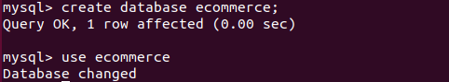

1. Design Schema

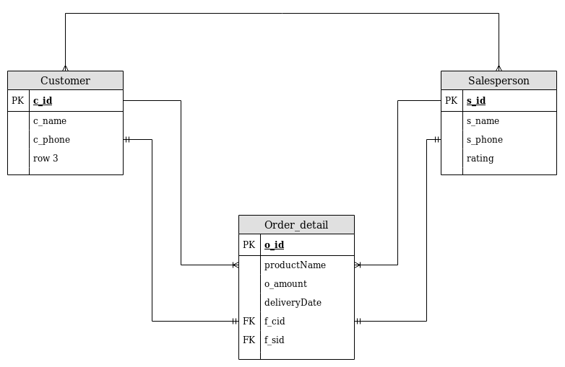

1. Create tables

**create table customer(**

**c_id int NOT NULL AUTO_INCREMENT PRIMARY KEY,**

**c_name varchar(32),**

**c_phone bigint(15));**

**create table salesperson(**

**s_id int NOT NULL AUTO_INCREMENT PRIMARY KEY,**

**s_name varchar(32),**

**s_phone bigint(15),**

**rating char);**

**create table order_detail(**

**o_id int not null primary key,**

**productName varchar(64),**

**o_amount float(7),**

**deliveryDate datetime,**

**f_cid int,**

**f_sid int,**

**foreign key(f_cid) references customer(c_id),**

**foreign key(f_sid) references salesperson(s_id));**

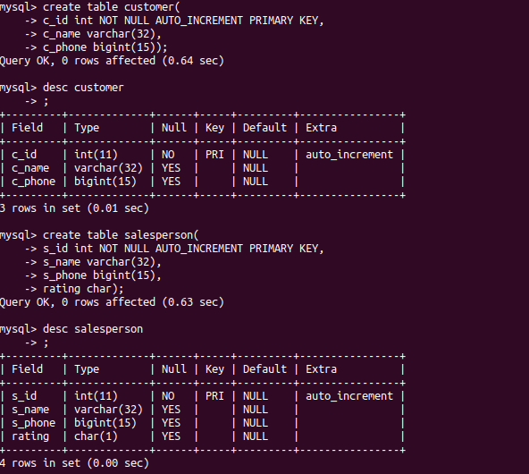

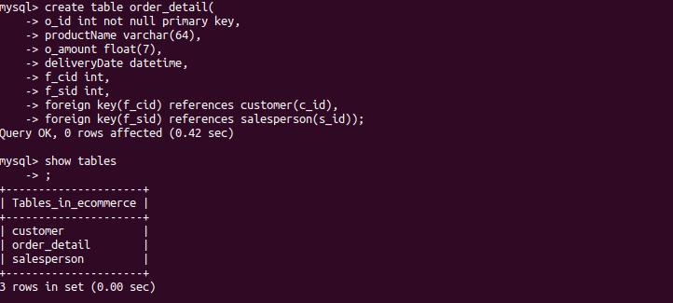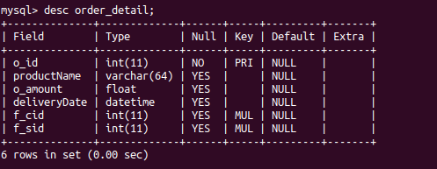

1. Insert sample data

**insert into customer values(1,"Shayan",7860763360),(2,"Zakwan",9044502365), (3,"Afnan",8922599997),(4,"Zainab",7795367254);**

**insert into salesperson values(1,"Abhishek",9988774561,2),(2,"Nadeem",7892541366,4), (3,"Dhawal",9874568745,3),(4,"Junaid",6958741265,4);**

**insert into order_detail values(1,"Aplacca",59830.37,now(),1,3), (2,"Umbrella",135.00,now(),2,4),(3,"Sleeping bag",250.00,now(),3,2);**

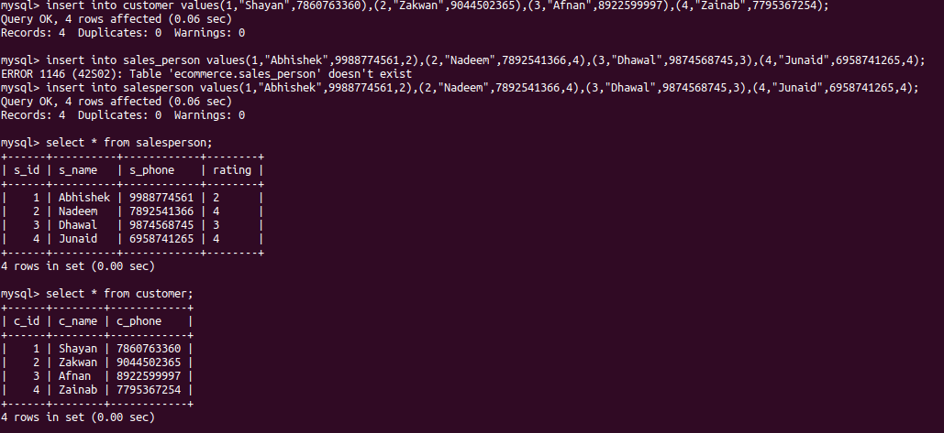

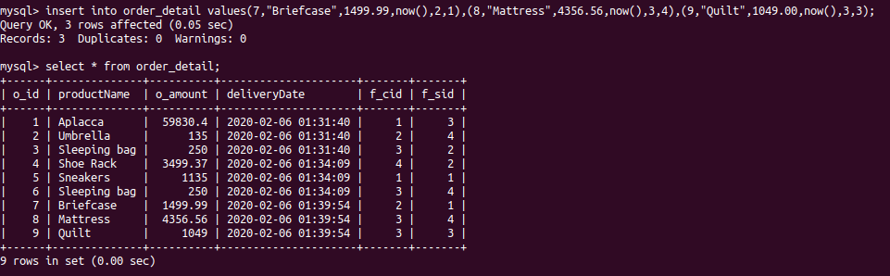

1. Find the sales person have multiple orders.

**select s.s_id, s.s_name from salesperson s inner join order_detail o on s.s_id=o.f_sid group by s_id having count(*)>1;**

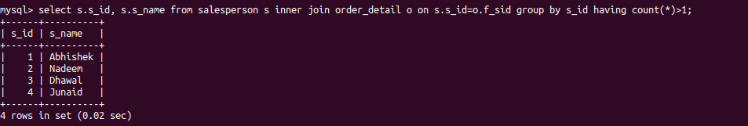

1. Find the all sales person details along with order details

**select o.productName,s.s_name from salesperson s inner join order_detail o on s.s_id=o.f_sid;**

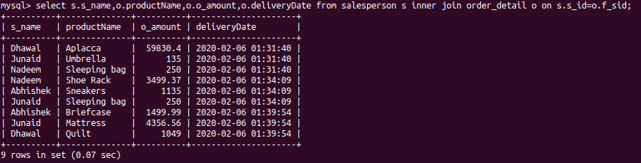

1. Create index

**ALTER table salesperson ADD INDEX salesperson_phone(s_phone);**



**ALTER table salesperson ADD INDEX salesperson_name(s_name);**



1. How to show index on a table

**show index from salesperson\G;**

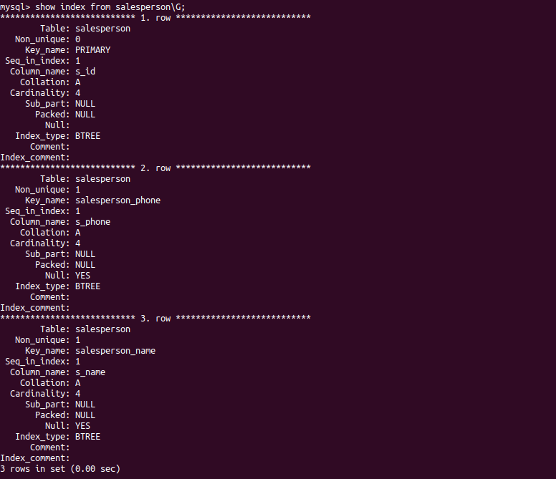

1. Find the order number, salesperson name, along with the customer to whom that order belongs to

**select o.o_id,s.s_name,c.c_name from salesperson s inner join order_detail o on s.s_id=o.f_sid inner join customer c on o.f_cid=c.c_id;**