## **Session : Introduction to HTML/CSS**

## **EXERCISE**

**By: Syed Shayan Nasir (EmployeeID: 4153)**

**1. How are inline and block elements different from each other?**

**Ans. Block elements** takeup/block the entire width of the parent container regardless of their own width. This prevents other elements from being in the same line as a block element. In other words, block elements always start on new lines.  
E.g **div** and **p** tags are both block level elements.

**Inline elements** on the other hand take up only the space that they require thereby allowing other elements (inline elements) to be in the same line as them. Inline elements start on the same line.  
E.g **span** element is an inline elements

**2. Explain the difference between visibility:hidden and display:none**

**Ans.** Both ***visibility:hidden*** and ***display:none*** make the element disappear from the screen, however allowing the element to be interacted by the DOM, but the difference lies in that ***visibility:hidden*** allocates space for the tag in the dom and display:none doesn't.

This means that if a tag has ***display:none*** property, other elements fill in the space as no space is allocated to the tag, whereas in case of ***visibility:hidden***, the tag has an allocated space in the dom that cannot be occupied by other tags.

**3. Explain the clear and float properties.**

**Ans. Float property** is used to define the positioning or flow of an element with regards to its container. An element can be made to **flow left** in its container, or **right**. The **inherit** value inherits the float value of its parent.   
E.g. float can be used to allow other elements to occupy the same line as that of a block element.

Source: Css-tricks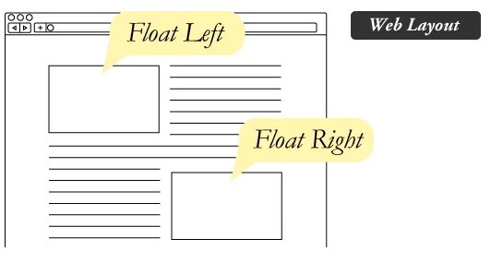

When we define the float property of an element to the left, it starts to flow on the left of its container, and all the other elements appear right to it.

**Clear property** is used to stop the flowing of an element. When we define the clear property of an element to **left, right or both**, it prevents elements from flowing on the **left** side, **right** side or **both** sides of the element respectfully.

**4. Explain the difference between absolute, relative,fixed and static.**

**Ans.** Like the name suggests the position property specifies the position of an element based on following values:

1. **Static**: By default most elements have a position property of static which states that they are positioned based on the normal flow of the document. For examples, each block elements is placed on a new line.
2. **Relative**: Relative position allows the element to be positioned top, left, right or bottom of its original position in the document flow.
3. **Absolute**: Similar to the relative position, absolute position allows elements to be positioned top, bottom, left or right of its parent or nearest parent element that is already positioned.
4. **Fixed**: Fixed value positions an element relative to the viewport. This means that the element will stay in its place regardless of scrolling the page

**6. Why do we use meta tags?**

**Ans.** Meta tags are used to convey information about the HTML documents to browsers, search engines and other web services. Meta tags are not displayed on the screen but are machine readable. Different meta tags provide different kinds of information.

1. **Keyword**: For identification by search engines
2. **Description**: General information about the webpage
3. **Author:** Name of the author of the webpage
4. **Viewport**: Most important meta tag used by the webpage to determine the width and height of the viewport the webpage is running on.

**7. Explain box model.**

**Ans.** The box model in CSS is used to describe the design and layout of every HTML element. According to the box model, every HTML element has the following components:

1. **Content**: The actual *content* of the element. For example the text in p tag and the actual image in img tag
2. **Padding**: It is a transparent area between the *content* of the elements and its *border*.
3. **Border**: Like the name suggests it is a *border* that covers the *content* along with its *padding*.
4. **Margin**: It is a transparent area outside the element, between its *border* and another element.

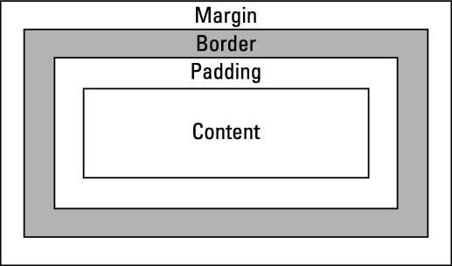

**8. What are the different types of CSS Selectors?**

**Ans.** CSS selectors are used to select the HTML that we wish to style. There are multiple CSS selectors but the three important categories of CSS selectors are:

1. Simple Selectors
   1. ID: The ID of an element is unique throughout the webpage and therefore ID selectors are used to uniquely select HTML elements.   
      Syntax **#id {property: value;}**
   2. CLASS: The class selector is used to select a number of elements and apply styles to all of them. Therefore, a single class selector may appear multiple times within the webpage.  
      Syntax **.class {property: value}**
2. Universal Selector ( **\*** )  
   The universal selector is used to select all the elements of the webpage at the same time. Mostly this is used when some styling is to be applied to all the elements of the webpage.  
   Syntax **\* {property: value}**
3. Pseudo Classes  
   They are used to select elements in a special state.  
   **a:visited** selects the links that have been visited  
   **a:hover** selects the link when the the cursor hovers on it  
   **a:focus** selects the link when it is in the focussed state  
   **a:active** select the active link
4. Pseudo Selectors  
   They are used to select the different child elements of a parent element  
   a. **:first-child()** selects the first child. E.g. First li element of a ul  
   b. **:nth-child(n)** selects the nth child. E.g 5th li of ul if n = 5  
   c. **:last-child()** select the last child. E.g Last li of ul.

**9. Define Doctype.**

**Ans.** The <!DOCTYPE> declaration is not an HTML tag, rather it;s an instruction to the web browsers informing about the version of HTML that the webpage is written in.

All HTML documents that begin with <!DOCTYPE> declaration inform the browser that the webpages is written in HTML5

**10. Explain 5 HTML5 semantic tags.**

**Ans.** Semantic tags are additional tags added to HTML5 with the main purpose of maing the HTML code more readable. Also, these semantic tags define the purpose of the element thereby making it easier for the browser to understand it rather than just displaying it. Apart from this, HTML5 semantic tags also help search engine read the oage and find the required information faster.

1. **<article>** - Defines an article in the document
2. **<aside>** - Defines some content aside from the page content on the left or right side.
3. **<footer>** - Defines a footer for the document or section.
4. **<header>** - Defines a header for the document or section.
5. **<nav>** - Defines the navigation bar containing navigation links
6. **<section>** - Defines a section in the document