**Twitter Bootstrap**

**Assignment**

**1. Please create the following web page using html5 tags and required css (using bootstrap).**

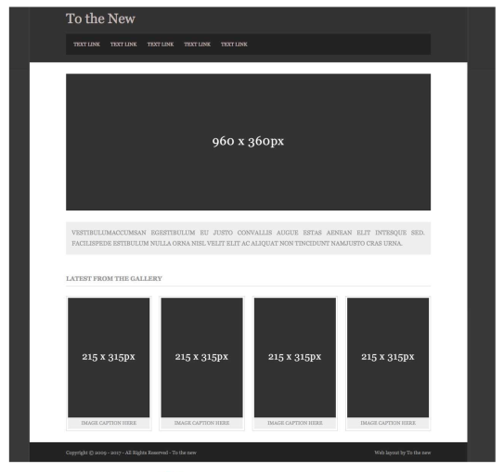

**2. Please create the following form using required html5 form tags (using bootstrap).**

