Session : Introduction to Version Control

EXERCISE
By: Syed Shayan Nasir (EmployeeID: 4153)
Public link: https://docs.google.com/document/d/10Z-drNiju5uKxRjLaWr55a78BHIlJ1jcnDN58p_B3vs/edit?usp=sharing

- Git Setup https://confluence.atlassian.com/bitbucket/set-up-git-744723531.html
Ans. sudo apt-get install git
git –version
git config –global user.email “sshayann7@gmail.com”
git config –global user.name “shayannasir”

- Initialize a Git Repository
Ans. mkdir gitPractice
cd gitPractice/
git init

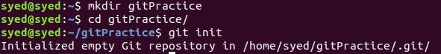

- Add files to the repository
Ans. touch file1 file2 secret
git status
git add .
git status

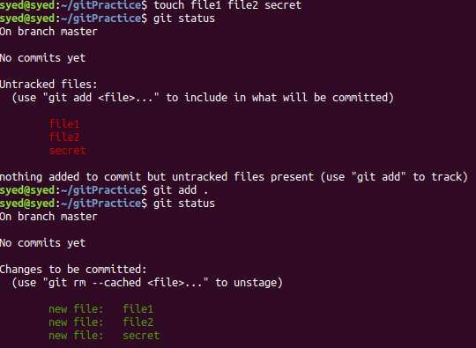

- Unstage 1 file
Ans. git rm –cached fileToRemove

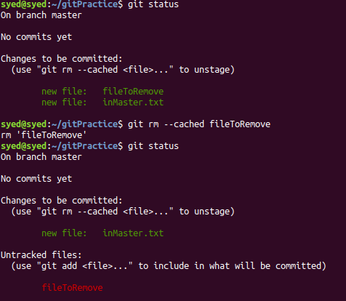

- Commit the file
Ans. git commit -m “Temporary changes to inMaster.txt”
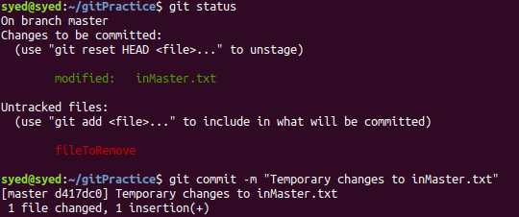
- Add a remote
Ans. git remote add mylocal git@github.com:shayannasir/gitPractice.git
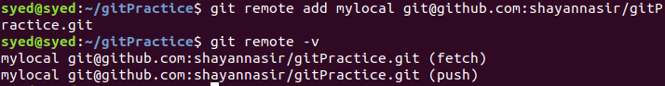

- Undo changes to a particular file
Ans. echo "Final edition to file" >> inMaster.txt
git checkout inMaster.txt

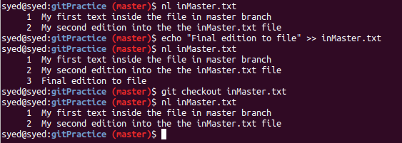

- Push changes to Github
Ans. git push mylocal master

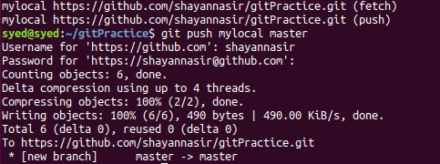

- Clone the repository
Ans. git clone https://github.com/shayannasir/gitPractice.git

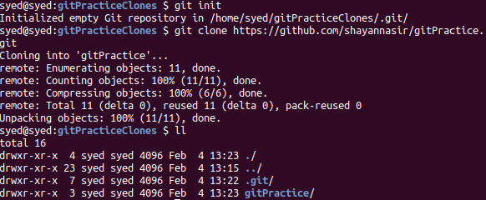

- Add changes to one of the copies and pull the changes in the other.
Ans. Adding changes and pushing from clone1

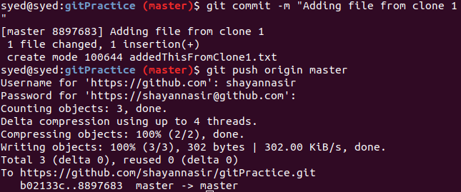

Pulling the clone1 made changes from github to clone2
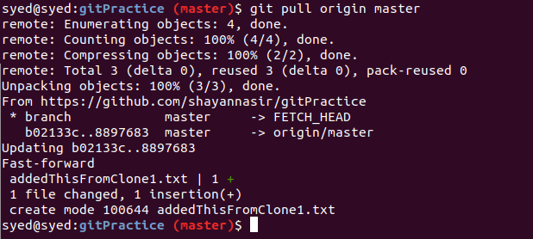

- Check differences between a file and its staged version
Ans. git add .
git diff --staged inMaster.txt

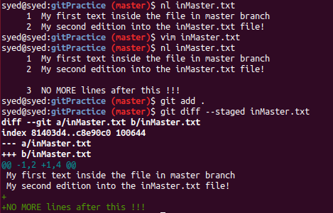

- Ignore a few files to be checked in
Ans. echo "secret.txt" >> .gitignore
git add .

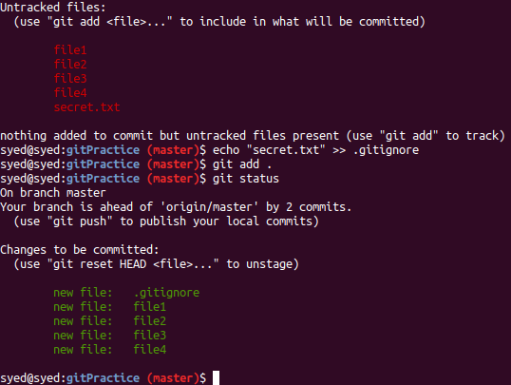

- Create a new branch.
Ans. git branch newBranch
git checkout newBranch
git branch

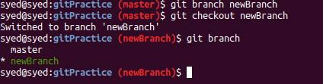

- Diverge them with commits
Ans. Moving newBranch ahead with two commits
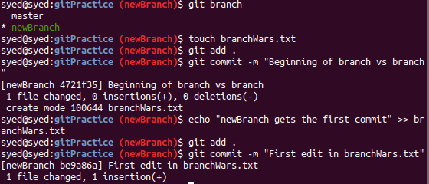
Diverging master branch with commits
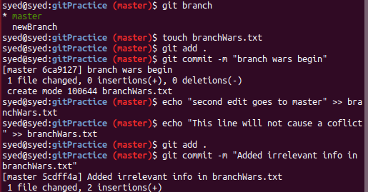

- Edit the same file at the same line on both branches and commit
Ans. Covered in the code snippets of the previous questions. First line of branchWars.txt in both the branches have been edited and committed

- Try merging and resolve merge conflicts

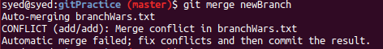

Merge Conflicts

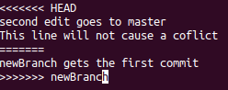



With conflict
Without conflict

- Stash the changes and pop them

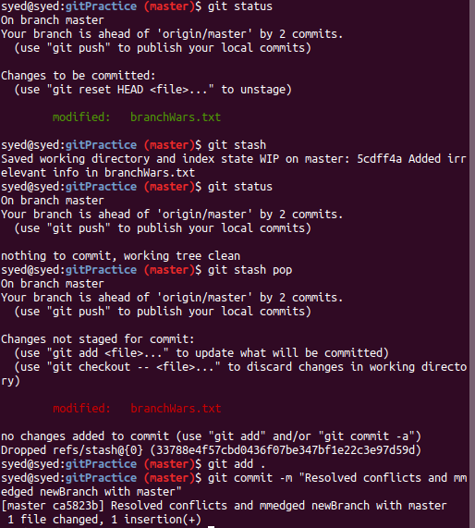

- Add the following code to your .bashrc file : color_prompt="yes"
parse_git_branch() {
git branch 2> /dev/null | sed -e '/^[^*]/d' -e 's/* \(.*\)/(\1)/'
}
if [ "$color_prompt" = yes ]; then
PS1='\u@\h\[\033[00m\]:\[\033[01;34m\]\W\[\033[01;31m\] $(parse_git_branch)\[\033[00m\]\$ '
else
PS1='\u@\h:\W $(parse_git_branch)\$ '
fi
unset color_prompt force_color_prompt
Ans. Step 1: Copy code
Step 2: sudo vim ~/.bashrc
Step 3: Write and quit
Step 4: Observe the change in color and the addition of branch name in the Terminal Prompt

