Session : Introduction to Linux

EXERCISE
By: Syed Shayan Nasir (EmployeeID: 4153)
Public link: https://docs.google.com/document/d/1jKWKAIDq53qK3Fp8-FXCUw23EICmlARrCsJwlW4k60o/edit?usp=sharing
- Create a directory "exercise" inside your home directory and create nested(dir1/dir2/dir3) directory structure inside "excerise" with single command.
Ans. mkdir -p exercise/dir1/dir2/dir3

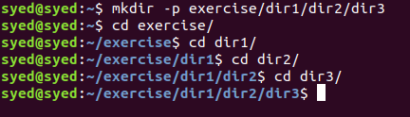

- Create two empty files inside dir2 directory: emptyFile1,emptyFile2 in single command
Ans. touch emptyFile1 emptyFile2

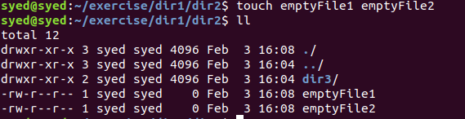

- Create one file file1.txt containing text "hello world" and save it.
Ans. echo "hello world" > file1.txt

- Find a "passwd" file using find command inside /etc. copy this files as passwd_copy and then rename this file as passwd_backup.
Ans. find /etc -name "passwd"
cp /etc/passwd ~/exercise/passwd_copy
mv ~/exercise/passwd_copy ~/exercise/passwd_backup

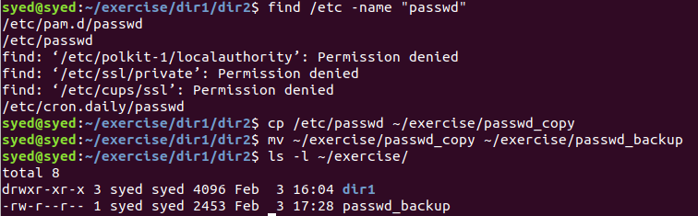

- Try reading passwd_backup file in multiple tools: less,more,cat,strings etc and find the difference in their usage.
Ans. Different File reading commands are:
- cat
It is the simplest of the tools, however it’s main purpose is to concatenate files and print them on the standard output.
cat passwd_backup
- less
Terminal based file viewing platform that allows to view one page at a time and allows both moving pages ahead and backwards
less passwd_backup
- more
It is similar to less but allows for moving pages ahead
more passwd_backup
- head
The head command can be customisd to view certain line of the files starting from the top (10 lines by default).
head passwd_backup
- tail
Similar to head but allows reading files from the bottom.
tail passwd_backup
- nl
Similar to the cat command but also attaches line numbers to each line
nl passwd_backup
- strings
Similar to cat but allows for reading of binary files along with text files.
strings passwd_backup

- Find out the number of line in password_backup containing "/bin/false".

Ans. grep "/bin/false" passwd_backup
Number of line: 5
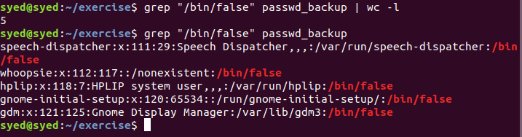

- Get the first 5 lines of a file “password_backup” and Redirect the output of the above commands into file "output".
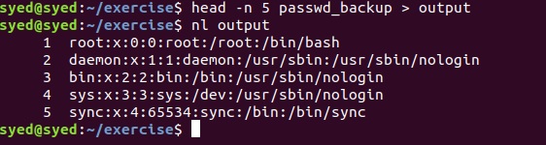
Ans. head -n 5 passwd_backup > output

- Create a "test" user,create its password and find out its uid and gid.
Ans. sudo useradd -m -g syed test
sudo passwd test
grep "test" /etc/passwd
uid: 1001
gid: 1000

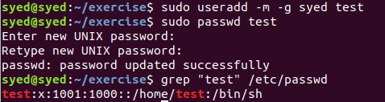

- Change the timestamp of emptyFile1,emptyFile2 which are exist in dir2
Ans. touch -amt 199505201330 emptyFile1 emptyFile2
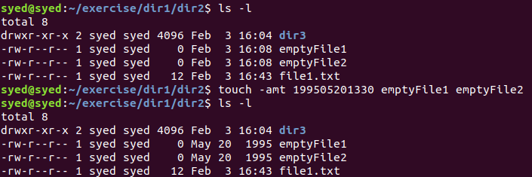
- Login as test user and edit the "output" file created above. Since the permission wont allow you to save the changes. Configure such that test user can edit it.
Ans. Permission denied on editing ‘output’ from the test user since test does not have the permission to write on the file output.
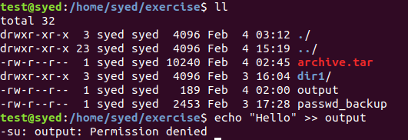
10.1 Add group owner of the "output" file as the secondary group of testuser and check/change the "output" file permission if it is editable by group. Once done revert the changes
Ans. Changing group owner of file output to test:
sudo chgrp test output
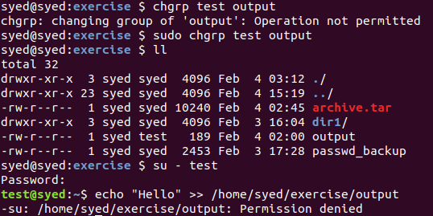

10.2 Make the file editable to the world so that test user can access it. Revert the changes after verification
Ans. Providing read and write permission of the file to owner, group and others:
chmod 666 ~/exercise/output
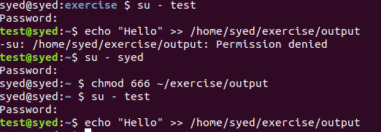

10.3 Change the ownership to edit the file.
Ans. sudo chown test ~/exercise/output
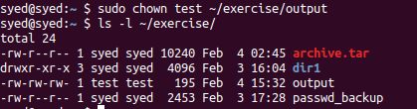

- Create alias with your name so that it creates a file as "/tmp/aliastesting".
Ans. alias shayan="touch /tmp/aliastesting"
shayan
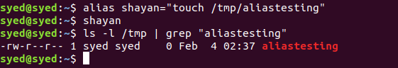

- Edit ~/.bashrc file such that when you change to "test" user it should clear the screen and print "Welcome".

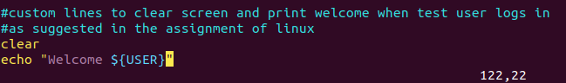
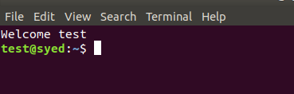

- Install “zip” package.
Ans. sudo apt-get install zip
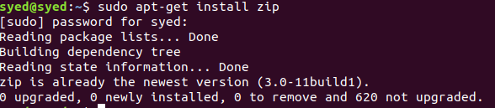
- Compress "output" and "password_backup" files into a tar ball. List the files present inside the tar created
Ans. tar -cvf archive.tar output passwd_backup
tar -tvf archive.tar
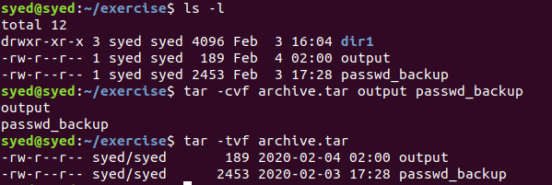

- scp this file to test user
Ans. scp archive.tar test@syed:/home/test/
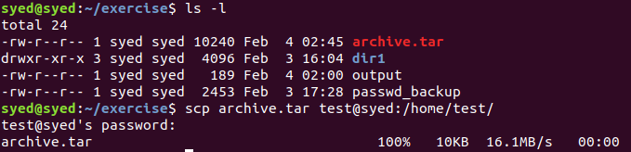

- Unzip this tar bar by logging into the remote server
Ans. scp archive.tar test@10.1.214.65:/home/test/
ssh test@10.1.214.64 ‘tar -xvf hometest/archive.tar’

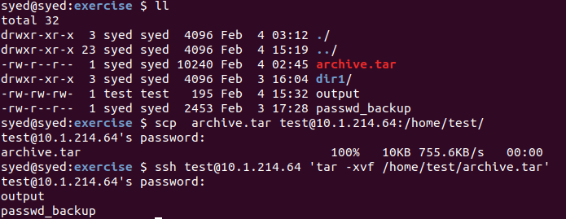

- Download any image from web and move to desktop
Ans. wget https://upload.wikimedia.org/wikipedia/commons/2/2b/Tux-simple.svg
mv Tux-simple.svg ~/Desktop/

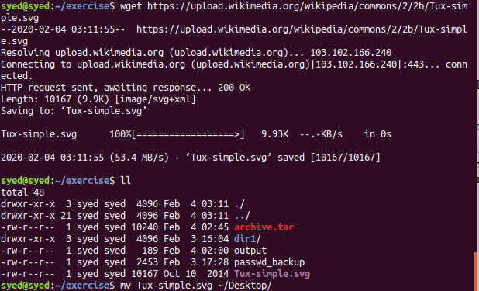

- How to get help of commands usages.
1. man pages
man(manual) pages contain comprehensive information about mot commands including their use, syntax, optitons, etc.
e.g. man grep
2. whatis command
The whatis command shows a single line definition of what the command does
e.g. whatis grep
3. -h or –help option
Most commands have a -h or –help option that can be used with the command to display information regarding the same command
e.g. grep –help
4. info command
Simila to man pages, info command displays the information document for the specified command
e.g. info grep
- Create a symlink of /etc/services into /tmp/ports-info
Ans. ln -s /etc/services /tmp/ports-info

- You are appointed as a Software/DevOps Engineer in ABC media services. On your first day you need to troubleshoot a problem. There is a command “xyz” somewhere installed in that linux system. But as a new joinee you do not have any idea about where is that Installed. How can you check that?

Ans. whereis xyz

