Session : Introduction to Databases

EXERCISE
By: Syed Shayan Nasir (EmployeeID: 4153)

Problem Statement: There can be multiple customers, who can place multiple orders on the site. Now a sales person can handle these orders will distribute into multiple sales persons (One order will be assign to one salesperson only). So a sales person can have multiple orders of multiple customers

- Create Database
Ans. create database ecommerce;
use ecommerce



- Design Schema

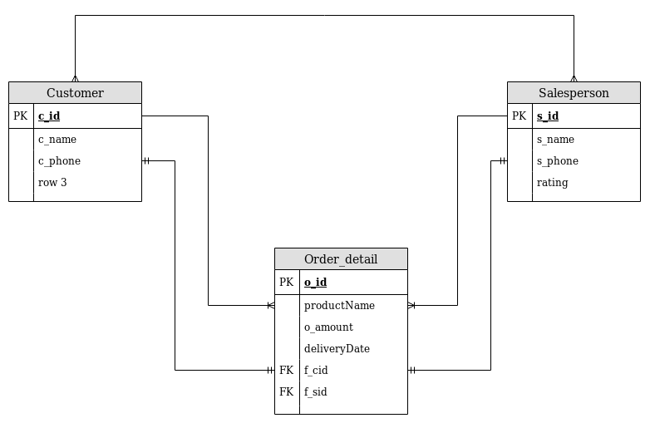

- Create tables

create table customer(
c_id int NOT NULL AUTO_INCREMENT PRIMARY KEY,
c_name varchar(32),
c_phone bigint(15));

create table salesperson(
s_id int NOT NULL AUTO_INCREMENT PRIMARY KEY,
s_name varchar(32),
s_phone bigint(15),
rating char);

create table order_detail(
o_id int not null primary key,
productName varchar(64),
o_amount float(7),
deliveryDate datetime,
f_cid int,
f_sid int,
foreign key(f_cid) references customer(c_id),
foreign key(f_sid) references salesperson(s_id));

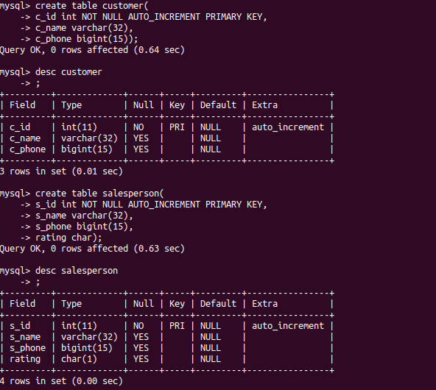

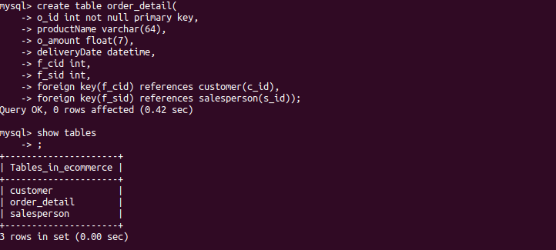

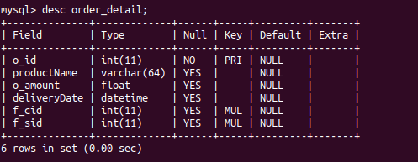

- Insert sample data

insert into customer values(1,"Shayan",7860763360),(2,"Zakwan",9044502365), (3,"Afnan",8922599997),(4,"Zainab",7795367254);

insert into salesperson values(1,"Abhishek",9988774561,2),(2,"Nadeem",7892541366,4), (3,"Dhawal",9874568745,3),(4,"Junaid",6958741265,4);

insert into order_detail values(1,"Aplacca",59830.37,now(),1,3), (2,"Umbrella",135.00,now(),2,4),(3,"Sleeping bag",250.00,now(),3,2);

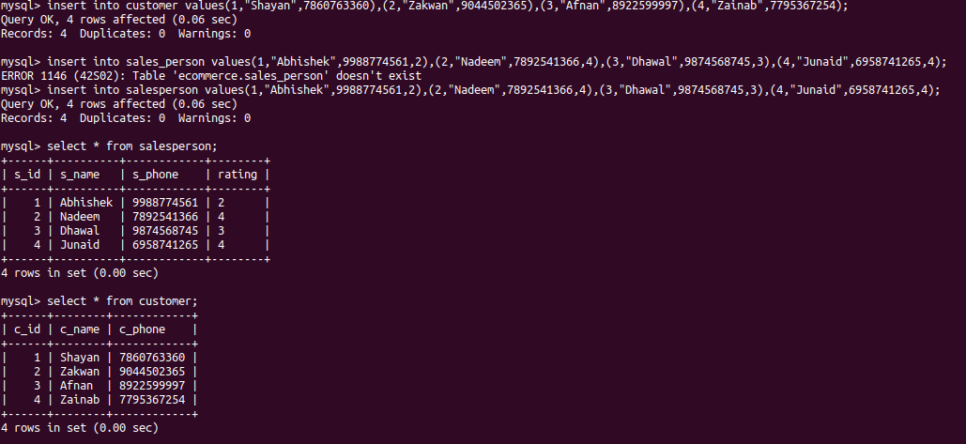
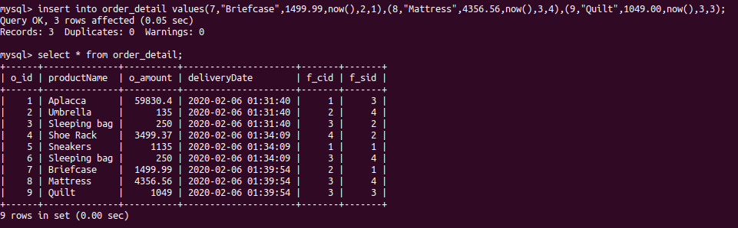

- Find the sales person have multiple orders.

select s.s_id, s.s_name from salesperson s inner join order_detail o on s.s_id=o.f_sid group by s_id having count(*)>1;

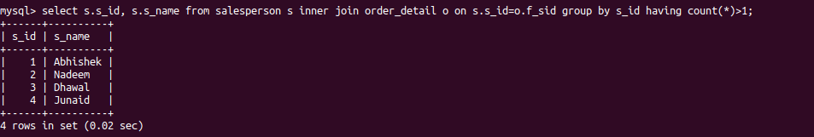

- Find the all sales person details along with order details

select o.productName,s.s_name from salesperson s inner join order_detail o on s.s_id=o.f_sid;

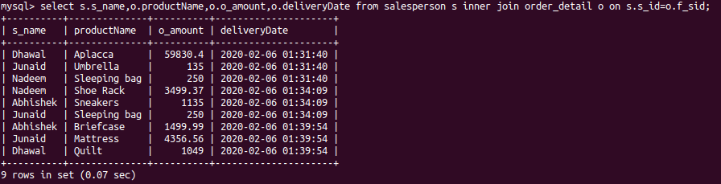

- Create index

ALTER table salesperson ADD INDEX salesperson_phone(s_phone);

ALTER table salesperson ADD INDEX salesperson_name(s_name);

- How to show index on a table

show index from salesperson\G;

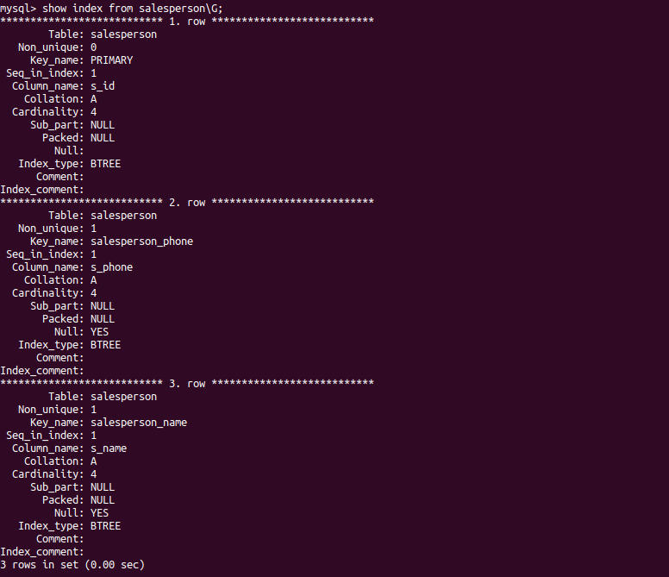

- Find the order number, sale person name, along with the customer to whom that order belongs to
select o.o_id,s.s_name,c.c_name from salesperson s inner join order_detail o on s.s_id=o.f_sid inner join customer c on o.f_cid=c.c_id;

