1. Write a programe do to demonstrate the use of volatile keyword.

package com.company;
import java.util.Scanner;
class Processor extends Thread {
private volatile boolean running = true; //The values of volatile variable will never be cached.
public void run() {
while(running) {
System.out.println("hello");
try {
Thread.sleep(500);
} catch (InterruptedException e) {
e.printStackTrace();
} } }
public void stopthread() {//The values of volatile variables will always be updated directly from the main memory.
running = false; //It will change the value to false so as to stop the thread.
}}
public class q1 {
public static void main(String[] args) {
Processor proc1 = new Processor();
proc1.start(); //The thread is now in running state
new Scanner(System.in).nextLine(); //The thread will stop after pressing enter key.
proc1.stopthread();
}}
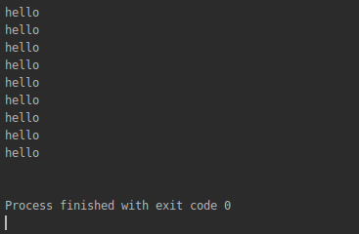

2. Write a programe do to demonstrate the use of volatile keyword.
Through Thread Class
package com.company;
class runner extends Thread{ //Using thread class by extending it..
public void run() {
for (int i = 0; i < 3; i++) {
System.out.println("thread is running " + i);
try {
Thread.sleep(1000);
} catch (InterruptedException e) {
e.printStackTrace();
}}}}
public class q2 {
public static void main(String[] args) {
runner t1 = new runner();
t1.start();
Thread t2= new Thread(new runner());
t2.start();
}}
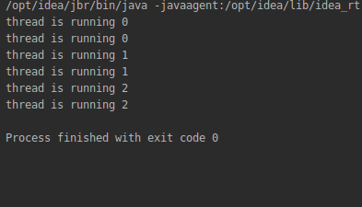

Through Runnable Interface

class Runnableinterface implements Runnable{ //Creating thread using implement method.
public void run() {
System.out.println("Creating thread ");}

}
public class q2{
public static void main(String[] args) {
//First way to create thread in implement method
Runnable runnable = new Runnableinterface();
Thread thread = new Thread(runnable);
thread.start();
//Second way of creating thread in implements method
Thread t1= new Thread(new Runnableinterface());
t1.start();
}}
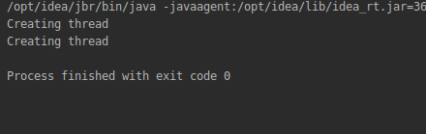

3. Write a program using synchronization block and synchronization method
Through Synchronized Method
package com.company;
class Process extends Thread {
private int x = 0;
public synchronized void sum() { //synchronized method that will call sum
x++;}
Thread t1 = new Thread(new Runnable() { //anonymous thread class t1
public void run() {
for (int i = 0; i < 1000; i++) {
sum();
}
//System.out.println("exit 1");
try {
Thread.sleep(3000);
} catch (InterruptedException e) {
e.printStackTrace(); }}}
);
Thread t2 = new Thread(new Runnable() { //anonymous thread class t2
public void run() {
for (int i = 0; i < 1000; i++) {
sum(); }
//System.out.println("exit");
try {
Thread.sleep(3000); //thread will sleep for 3 sec after incrementing for 1000 times
} catch (InterruptedException e) {
e.printStackTrace();
}}});
public void callsum() { //method that will call run method of thread class
long start = System.currentTimeMillis();
t1.start();
t2.start();
try {
t1.join(); //to join the output of t1 and t2 so main class will wait until threads are executed
t2.join();//to join the output of t1 and t2 so main class will wait until threads are executed
} catch (InterruptedException e) {
e.printStackTrace(); }
long end = System.currentTimeMillis();
System.out.println("The value of count variable by synchronized method:" + x);
long y=end -start;
System.out.println("Total time taken is: " + y); }}
//main class
public class q3 {
public static void main(String[] args) {
Process obj1 = new Process(); //object for class
obj1.callsum();}} // object call in main method

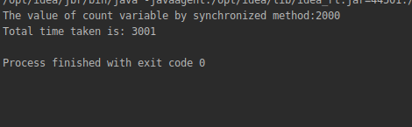

Through Synchronized block
package com.company;
public class q3 {
int a = 0;
int b = 0;
Object lock1 = new Object(); // created object for lock
public void sum1() { // created method that will increment a
synchronized (lock1) { //using our own intrinsic lock object
a++;
}
try {
Thread.sleep(1);
} catch (InterruptedException e) {
e.printStackTrace();
}}
public void sum2() { // created method that will increment b
synchronized (this) { // using intrinsic lock of this
b++;
try {
Thread.sleep(1);
} catch (InterruptedException e) {
e.printStackTrace();
}} }
public void addblock() { // created method that will call sum1
for (int i = 0; i < 1000; i++) {
sum1();
} }
public void addblock2() { // created method that will call sum2
for (int i = 0; i < 1000; i++) {
sum2(); }
}
Thread t3 = new Thread(new Runnable() { // anonymous inner thread class for creating thread 1
public void run() {
addblock();
}});
Thread t4 = new Thread(new Runnable() {// anonymous inner thread class for creating thread 2
public void run() {
addblock2();
}});
public void callsum2() {
long start1 = System.currentTimeMillis();
t3.start();
t4.start();
try {
t3.join();
t4.join();
} catch (InterruptedException e) {
e.printStackTrace();
}
long end1 = System.currentTimeMillis();
System.out.println("The value of count variable by synchronized block" +
":" + (a + b));
long y1 = end1 - start1;
System.out.println("Total time taken is: " + y1);
}
public static void main(String[] args) { // main class to create object for class and call it in main class
q3 obj2 = new q3();
obj2.callsum2();}}
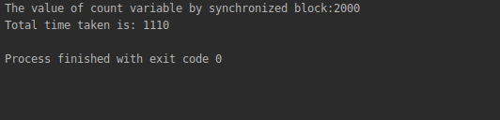
4. Write a program to create a Thread pool of 2 threads where one Thread will print even numbers and other will print odd numbers.
package com.company;
import java.util.concurrent.ExecutorService;
import java.util.concurrent.Executors;
class Executor extends Thread {
public int PRINT_NUMBERS_UPTO = 10; //It will print numbers upto 10
static int number = 1;
int remainder;
static Object lock = new Object(); //It will create lock
Executor(int remainder) {
this.remainder = remainder;
}
public void run() {
while (number < PRINT_NUMBERS_UPTO) { //It will check the value of number should be less than 10
synchronized (lock) {
while (number % 2 != remainder) { // wait for numbers other than remainder
try {
lock.wait();
Thread.sleep(1000);//
} catch (InterruptedException e) {
e.printStackTrace();
}} //While loop ended
System.out.println(Thread.currentThread().getName() + " " + number);
number++;
lock.notifyAll();
}}}}
public class q4 {
public static void main(String[] args) {
ExecutorService pool = Executors.newFixedThreadPool(2);// created thread pool
pool.execute(new Executor(1)); //for odd number we take remainder as 1
pool.execute(new Executor(0));//for even number we take remainder as 0
pool.shutdown();}} //To stop the executor service
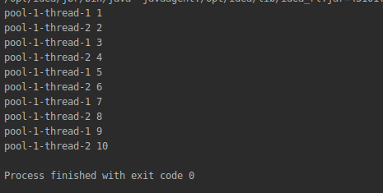

5. Write a program to demonstrate wait and notify methods.
package com.company;
import java.util.Scanner;
import java.util.concurrent.ExecutorService;
import java.util.concurrent.Executors;
class waitnotify {
public void produce() throws InterruptedException {
synchronized (this) {
System.out.println("Producer thread running ....");
System.out.println("Entering into wait");
wait(); //It will enter into wait state
System.out.println("Resumed.");
} }
public void consume1() throws InterruptedException {
Scanner scanner = new Scanner(System.in);
Thread.sleep(2000); //parallelly this thread will also start and will sleep for 2 sec
synchronized (this) {
System.out.println("Waiting for return key to exit wait");
scanner.nextLine(); //on pressing enter key it will notify.
System.out.println("Return key pressed.");
notify();
Thread.sleep(2000);
}}
void calling() throws InterruptedException { // method for creating two threads.
Thread t1 = new Thread(new Runnable() {
public void run() {
try {
produce();
} catch (InterruptedException e) {
e.printStackTrace();
} }});
Thread t2 = new Thread(new Runnable() {
public void run() {
try {
consume1();
} catch (InterruptedException e) {
e.printStackTrace();
} }});
t1.start();
t2.start();
t1.join();
t2.join();
}}
public class q5 {
public static void main(String[] args) throws InterruptedException {
waitnotify nn=new waitnotify(); //created object for class
nn.calling(); }}
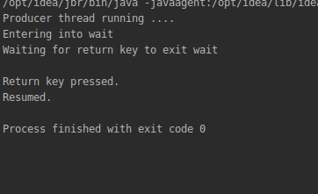

6. Write a program to demonstrate sleep and join methods.

package com.company;
class Processor2 extends Thread {
private int x = 0;
public synchronized void sum() { //synchronized method so only one thread could occupy it.,
x++;
}
Thread t1 = new Thread(new Runnable() { //two threads
public void run() {
for (int i = 0; i < 1000; i++) {
sum();
}
try {
Thread.sleep(3000);
} catch (InterruptedException e) {
e.printStackTrace();
}
}
});
Thread t2 = new Thread(new Runnable() { //second thread
public void run() {
for (int i = 0; i < 1000; i++) {
sum();//calling synchronized sum method
}
try {
Thread.sleep(3000);
} catch (InterruptedException e) {
e.printStackTrace();
}
}
});
public void callsum() {
long start = System.currentTimeMillis();
t1.start();
t2.start();
System.out.println("value of x before joining: " + x); //value of x before joining.
try {
t1.join(); //values are joined
t2.join(); //values are joined
} catch (InterruptedException e) {
e.printStackTrace();
}
long end = System.currentTimeMillis();
System.out.println("value of x after joining :" + x);
long y = end - start;
System.out.println("Thread sleeping for 3 sec ");
System.out.println("Total time taken is: " + y);
}
}
public class q6{
public static void main(String[] args) {
Processor2 obj1 = new Processor2();
obj1.callsum();}}
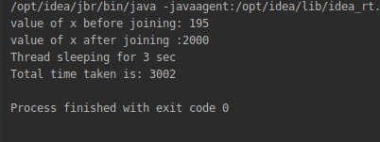

7. Run a task with the help of callable and store it's result in the Future.

package com.company;
import java.io.IOException;
import java.util.Random;
import java.util.concurrent.Callable;
import java.util.concurrent.ExecutionException;
import java.util.concurrent.ExecutorService;
import java.util.concurrent.Executors;
import java.util.concurrent.Future;
public class q7 {
public static void main(String[] args) {
ExecutorService executor = Executors.newCachedThreadPool(); //thread pool
Future<Integer> future = executor.submit(new Callable<Integer>() { //future contains value of call() method
public Integer call() throws Exception {
Random random = new Random();
int duration = random.nextInt(1000);
if(duration > 2000) {
throw new IOException("Sleeping for too long.");
}
System.out.println("Starting ...");
try {
Thread.sleep(duration);
} catch (InterruptedException e) {
e.printStackTrace();
}
System.out.println("Finished.");
return duration;
}});
executor.shutdown();
try {
System.out.println("Result is: " + future.get()); //printing the value stored in future
} catch (InterruptedException e) {
e.printStackTrace();
} catch (ExecutionException e) {
IOException ex = (IOException) e.getCause();
System.out.println(ex.getMessage());
}}}
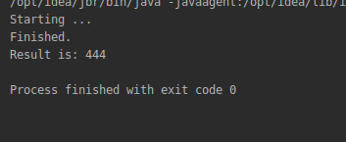

8. Write a program to demonstrate the use of semaphore
package com.company;
import java.util.concurrent.*;
class Shared
{
static int count = 0;
}
class MyThread extends Thread
{
Semaphore sem; //semaphore
String threadName;
public MyThread(Semaphore sem, String threadName)
{
super(threadName);
this.sem = sem;
this.threadName = threadName;
}
public void run() {
if(this.getName().equals("A"))
{
System.out.println("Starting " + threadName);
try
{
System.out.println(threadName + " is waiting for a permit.");
sem.acquire(); //acquire the permit to use
System.out.println(threadName + " gets a permit.");
for(int i=0; i < 3; i++)
{
Shared.count++;
System.out.println(threadName + ": " + Shared.count);
Thread.sleep(10);
}
} catch (InterruptedException exc) {
System.out.println(exc);
}
System.out.println(threadName + " releases the permit.");
sem.release(); //release the permit so next thread could use it.
}
else
{
System.out.println("Starting " + threadName);
try
{
System.out.println(threadName + " is waiting for a permit.");
sem.acquire();
System.out.println(threadName + " gets a permit.");
for(int i=0; i < 3; i++)
{
Shared.count++;
System.out.println(threadName + ": " + Shared.count);
Thread.sleep(10);
}
} catch (InterruptedException exc) {
System.out.println(exc);
}
System.out.println(threadName + " releases the permit.");
sem.release();
} }}
public class q8
{
public static void main(String args[]) throws InterruptedException
{
Semaphore sem = new Semaphore(1); //defining the limit of semaphore that is 1
MyThread t1 = new MyThread(sem, "A");
MyThread t2 = new MyThread(sem, "B");
t1.start();
t2.start();
t1.join();
t2.join();
System.out.println("count: " + Shared.count);
}}

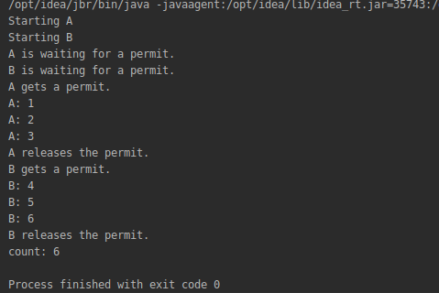

9. Write a program to demonstrate the use of CountDownLatch
package com.company;
import java.util.concurrent.CountDownLatch;
import java.util.concurrent.ExecutorService;
import java.util.concurrent.Executors;
class Processor9 implements Runnable {
private CountDownLatch latch;
public Processor9(CountDownLatch latch) {
this.latch = latch;
}
public void run() {
System.out.println("Started.");
try {
Thread.sleep(3000);
} catch (InterruptedException e) {
e.printStackTrace();
}
latch.countDown();
}
}
public class q9 {
public static void main(String[] args) {
CountDownLatch latch = new CountDownLatch(3); //created three latch
ExecutorService executor = Executors.newFixedThreadPool(3);
for(int i=0; i < 3; i++) {
executor.submit(new Processor9(latch));
}
try {
latch.await(); //decrease the value by1
} catch (InterruptedException e) {
e.printStackTrace();
}
System.out.println("Completed.");
executor.shutdown();

}}
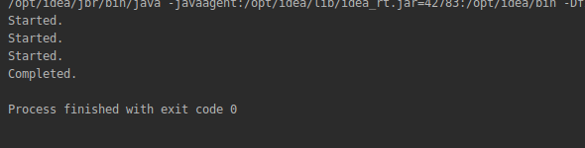
10. Write a program which creates deadlock between 2 threads

package com.company;
import java.util.*;
class Work {
public void produce() throws InterruptedException {
synchronized (this) {
for (int i = 0; i < 3; i++) {
System.out.println(i);
System.out.println("Loop 1 Running....");
wait(); // after first iteration of loop1 , loop2 will complete its whole task and there will be no notify so loop1 will enter into deadlock as it has only wait method.
}
System.out.println("Loop 1 ended");
} }
public void consume() throws InterruptedException {
synchronized (this) {
System.out.println("Loop 2 started");
for (int i = 0; i < 3; i++) {
System.out.println("Value of i :" + i);
notify(); //There is no wait so it will execute its whole task and exit the loop so loop1 will never come out of wait state after second iteration.
}
System.out.println("Loop2 ended");}}}
public class q10 {
public static void main(String[] args) throws InterruptedException {
Work work = new Work();
Thread t1 = new Thread(new Runnable() { //creating thread 1
public void run() {
try {
work.produce();
} catch (InterruptedException e) {
e.printStackTrace();
}}});
Thread t2 = new Thread(new Runnable() { //creating thread 2
public void run() {
try {
work.consume();
} catch (InterruptedException e) {
e.printStackTrace();
} } });
t1.start();
t2.start();
t1.join();
t2.join(); }}
