1. Add a gradle dependency and its related repository url.

Ans. Dependency added by including the dependency URL in the dependencies closure and repository in the repositories closure

dependencies {
compile 'com.google.code.gson:gson:2.8.6'
testCompile group: 'junit', name: 'junit', version: '4.12'
}
repositories {
mavenCentral()
}

2. Using java plugin, make changes in the manifest to make the jar executable. Using java -jar JAR_NAME, the output should be printed as "Hello World"

jar{
manifest {
attributes(
"Main-Class": 'App'
)
}
}

Ans. Made the generated jar executable by providing the path to the entry-point class.

3. Differentiate between the different dependency scopes: compile, runtime, testCompile, testRuntime using different dependencies being defined in your build.gradle.

Ans. The dependency scopes allow us to limit/define the scope of dependencies in our application. Following are the scopes available:

a. testCompile: Like the name suggests, testCompile specifies the list of dependencies that are needed to compile the test source of our application.

b. Compile: compile on the other hand specifies dependencies needed to build our application

c. Runtime: Runtime provides dependencies that are needed to run our application in the production environment. By default, all dependencies in the compile are automatically available in the runtime scope but not vice versa

d. testRuntime: Similar to testCompile, testRuntime specifies group of dependencies required to perform tests in the runtime environment.

From the below snapshot of the project; junit dependency is used to compile the test sources of the project whereas gson dependency is used during the building of the project

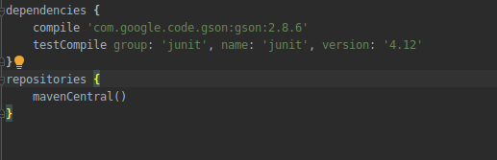

4. Create a custom plugin which contains a custom task which prints the current date-time. Using that plugin in your project, execute that task after the jar task executes.

Ans. Created a plugin module with the showDate task. Overridden the dependOn method to depend on the ‘jar’ task. Setup a buildscript closure referring to the show-date plugin’s dependency thereby connecting the plugin to the main application

buildscript {
dependencies {
classpath files('show-date/build/libs/show-date-1.0-SNAPSHOT.jar')
}
}
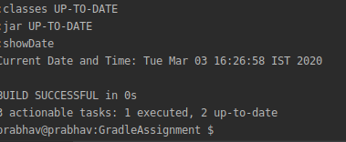

5.Instead of using default source set, use src/main/javaCode1, src/main/javaCode2 to be taken as code source. Make sure that the JAR created contains files from both the directories and not from src/main/java. Ans. Created the two source directories and added them to the sourceSets.

Ans. Created the two source directories and added them to the sourceSets.

sourceSets{
main {
java {
srcDirs = ['src/main/javaCode1', 'src/main/javaCode2']
}
}
}
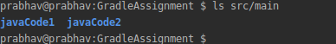

6. Override the Gradle Wrapper task to install a different version of gradle. Make sure that the task written in Q4 also executes with it.

Ans. Below snapshots show
a. Current gradle version
b. Earlier gradlew wrapper version
c. Over-riding gradle wrapper class to install gradle version 4.4.1
d. Running the showDate task with gradlew

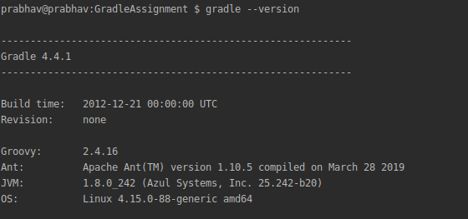
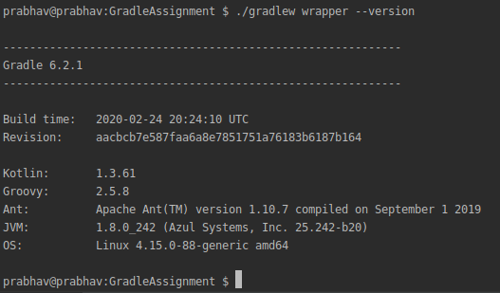

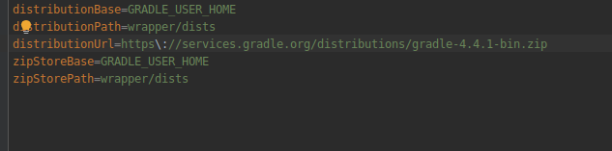

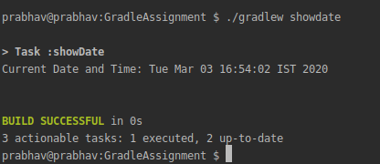

7. Run the gradle profile command and attach the resulting files.

Ans. Ran the ‘gradle build --profile’ command. Attached the report in the build directory.

