1. Create Java classes having suitable attributes for Library management system.Use OOPs concepts in your design.Also try to use interfaces and abstract classes.

package com.company;
import java.util.ArrayList;
import java.util.List;
import java.util.Scanner;
interface issue {
void issueBooks();
}
class Books {
public void display() {
System.out.println("Harry Potter");
}
}
//inheritance
class Chapters extends Books implements issue {
public void issueBooks() {
List<String> Books=new ArrayList<String>();
Books.add("DBMS");
Books.add("SQL");
Books.add("JAVA");
Books.add("DAA");
Books.add("gradle");
Books.add("linux");
Scanner sc=new Scanner(System.in);
String input1=sc.next();
boolean ans = Books.contains(input1);
if(ans){
System.out.println("BOOK IS AVAILABLE YOU CAN ISSUE IT");
}
else{
System.out.println("BOOK IS NOT AVAILABLE YOU CANNOT ISSUE IT");
}
}
@Override
public void display() {
System.out.println("Chapter 1: Prologue");
}
public int addtotalchapters(int x, int y) {
System.out.println("Total chapters:");
return x+y;
}
//Overload
public double addtotalchapters(double x,double y) {
System.out.println("Total chapters including Prologue:");
return x+y;
}
}
//encapsulation example
class Author {
private String name;
public String getName() {
return name;
}
public void setName(String newName) {
name = newName;
}
}
//abstraction
abstract class Publisher {
public abstract void run();
}
class Edition extends Publisher{
public void run(){
System.out.println("\nEdition 3 published by bloomsburry");
}
}
public class JAVA2 {
public static void main(String[] args) {
Books a=new Books();
a.display();
Chapters b=new Chapters();
b.issueBooks();
System.out.println(b.addtotalchapters(4,2));
System.out.println(b.addtotalchapters(5.,2.)); //polymorphism
Author encap = new Author();
encap.setName("J.K. Rowling");
System.out.print("Name : " + encap.getName() );
Publisher test = new Edition();
test.run();
}
}

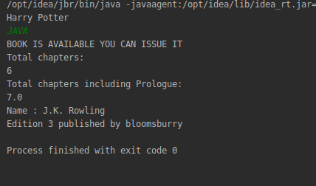

2. WAP to sorting string without using string Methods?.
package com.company;
import java.lang.String;
public class calculator {
public static void main(String[] args) {
String str = "ddecaf";
char[] ch = str.toCharArray();
for (int i = 0; i < ch.length; i++) {
for (int j = i+1; j < ch.length-1; j++) {
if (ch[i] > ch[j]) {
char temp = ch[i];
ch[i] = ch[j];
ch[j] = temp;
}
}
System.out.print(ch[i]);
}
}
}
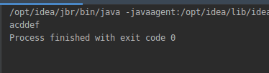

3. WAP to produce NoClassDefFoundError and ClassNotFoundException exception.
package com.company;
public class calculator {
public static void main(String[] args) {
try{
calc c= new calc();
}
catch (Throwable t){
System.out.println(t);
}
//Exception in thread "main" java.lang.NoClassDefFoundError: Could not initialize class calc
calc c1= new calc();
}
}
class calc{
static int j=1/0;
}
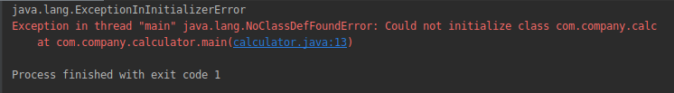
package com.company;
public class calculator {
public static void main(String[] args) {
try{
//java.lang.ClassNotFoundException because there is no such class present
Class.forName("java.java");
}
catch(ClassNotFoundException e){
e.printStackTrace();;
}
school emp1 =new school();
emp1.hi();
}
}
class school{
void hi(){
System.out.println("hey");
}
}
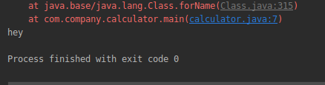

4. WAP to create singleton class.
package com.company;
public class calculator {
public static void main(String[] args) {
Abc obj1=Abc.getInstance();
Abc obj2=Abc.getInstance();
Abc obj3=Abc.getInstance();
if(obj1==obj2){
System.out.println("objects are equal");
}
}
}
class Abc{
// static Abc obj=new Abc(); //by default it is eager
static Abc obj; //to create lazy
private Abc() {
System.out.println("instance created");
}
public static Abc getInstance(){
if(obj == null){
obj = new Abc();
}
return obj;
}
}
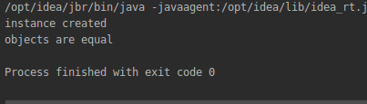

5. WAP to show object cloning in java using cloneable and copy constructor both.
package com.company;
import java.sql.SQLOutput;
class Emp implements Cloneable{
String name;
int id;
public Emp(String name, int id) {
this.name = name;
this.id = id;
}
public Object clone() throws CloneNotSupportedException {
return super.clone();
}
}
public class calculator implements Cloneable{
public static void main(String[] args) {
try{
Emp e=new Emp("prabhav",4087);
Emp e1=(Emp)e.clone();
System.out.println("Employee name is:"+e1.name+" "+"Employee id is:"+e1.id);
}
catch(CloneNotSupportedException c ){
c.printStackTrace();
}
}
}
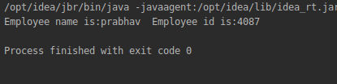

package com.company;
class copy {
int a,b,c;
public copy(int a, int b, int c) {
this.a = a;
this.b = b;
this.c = c;
}
copy(copy c){
a=c.a;
b=c.b;
}
}
public class calculator{
public static void main(String[] args) {
copy c= new copy(1,2,3);
copy c1= new copy(c);
System.out.println("Copy of object c in c1 is:"+c1.a+" "+c1.b+ " "+ c.b);
}
}
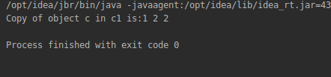

6. WAP showing try, multi-catch and finally blocks.
package com.company;
public class calculator {
public static void main(String[] args) {
int x=10,y=20,z=30;
try{
if(1==0){
System.out.println("x is 10");
}
int b=x/0;
System.out.println(b);
}
catch(ArithmeticException e){
System.out.println("ArithmeticException is occurring");
}
catch (NumberFormatException e){
System.out.println("NumberFormatException is occurring");
}
finally{
int a=x+y+z;
System.out.println(a);
}
}
}
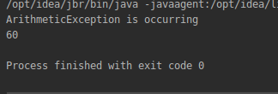

7. WAP to convert seconds into days, hours, minutes and seconds.
package com.company;
import java.util.Scanner;
public class calculator {
public static void main(String[] args) {
Scanner sc= new Scanner(System.in);
System.out.println("enter seconds you want to convert into days");
int input=sc.nextInt();
// Double day=(input/((60.0)*(60.0)*(24.0)));
// int hour =(input/((60)*(60)));
// int min =(input/60);
//
// System.out.println(input+" seconds is converted into "+day+ " number of days");
// System.out.println(input+" seconds is converted into "+hour+ " number of hour");
// System.out.println(input+" seconds is converted into "+min+ " number of min");
// System.out.println(day+":"+hour+":"+min );
int d=input/(60*60*24);
int dh=(input)%(60*60*24);
int h=dh/(60*60);
int hm=dh%(60*60);
int s=hm/(60);
int ss=hm%(60);
System.out.println("Time in DAY/HOUR/MINUTES/SECONDS="+d+":"+h+":"+s+":"+ss);
// int var=129666%86400;
// int var1=var%(60*60);
// System.out.println(var);
// System.out.println(var1);
// System.out.println(hm);
}
}
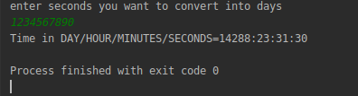

8. WAP to read words from the keyboard until the word done is entered. For each word except done, report whether its first character is equal to its last character. For the required loop, use a
a)while statement
b)do-while statement

package com.company;
import java.sql.SQLOutput;
import java.util.Scanner;
public class calculator {
public static void main(String[] args) {
Scanner sc= new Scanner(System.in);
System.out.println("enter a string");
String entry=sc.next();
while(!entry.equals("done")){
if(entry.charAt(0)==entry.charAt(entry.length()-1)){
System.out.println("first and last char is same of word: "+entry);
}
else{
System.out.println("first and last char is not same of word: "+entry);
}
entry=sc.next();
}
}
}
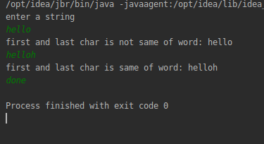

package com.company;
import java.util.Scanner;
public class calculator {
public static void main(String[] args) {
Scanner sc= new Scanner(System.in);
System.out.println("enter some words to check");
String word=sc.next();
do{
char ch1=word.charAt(0);
char ch2=word.charAt(word.length()-1);
if(ch1==ch2){
System.out.println("last and first char are same of : " +word);
}
else {
System.out.println("last and first char are not same of word : " + word);
}
word=sc.next();
}
while(!word.equals("done"));
}
}

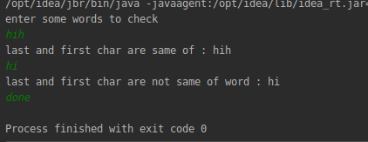

9. Design classes having attributes for furniture where there are wooden chairs and tables, metal chairs and tables. There are stress and fire tests for each products.
package com.company;
public class calculator {
public static void main(String[] args) {
calculator c= new Chair();
((Chair)c).stress_test_W();
((Chair)c).stress_test_M();
((Chair)c).fire_test_M();
((Chair)c).fire_test_W();
System.out.println("-----------");
calculator t= new Table();
((Table)t).stress_test_W();
((Table)t).stress_test_M();
((Table)t).fire_test_M();
((Table)t).fire_test_W();
}
}
interface wooden {
void stress_test_W();
void fire_test_W();
}
interface Metal {
void stress_test_M();
void fire_test_M();
}
class Chair extends calculator implements wooden,Metal{
@Override
public void stress_test_W(){
System.out.println("wooden chairs have stress");
}
@Override
public void stress_test_M(){
System.out.println("metal chairs have stress");
}
@Override
public void fire_test_M(){
System.out.println("wooden chairs have stress");
}
@Override
public void fire_test_W(){
System.out.println("metal chairs have stress");
}
}
class Table extends calculator implements wooden,Metal{
@Override
public void stress_test_W(){
System.out.println("wooden TABLE table have stress");
}
@Override
public void stress_test_M(){
System.out.println("metal TABLE have stress");
}
@Override
public void fire_test_M(){
System.out.println("wooden TABLE have fire");
}
@Override
public void fire_test_W(){
System.out.println("metal TABLE have fire");
}
}
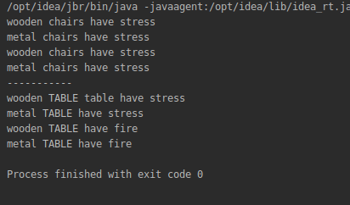

10. Design classes having attributes and method(only skeleton) for a coffee shop. There are three different actors in our scenario and i have listed the different actions they do also below
* Customer
- Pays the cash to the cashier and places his order, get a token number back
- Waits for the intimation that order for his token is ready
- Upon intimation/notification he collects the coffee and enjoys his drink
( Assumption: Customer waits till the coffee is done, he wont timeout and cancel the order. Customer always likes the drink served. Exceptions like he not liking his coffee, he getting wrong coffee are not considered to keep the design simple.)
* Cashier
- Takes an order and payment from the customer
- Upon payment, creates an order and places it into the order queue
- Intimates the customer that he has to wait for his token and gives him his token
( Assumption: Token returned to the customer is the order id. Order queue is unlimited. With a simple modification, we can design for a limited queue size)
* Barista
- Gets the next order from the queue
- Prepares the coffee
- Places the coffee in the completed order queue
- Places a notification that order for token is ready
package com.company;
import java.util.*;
class Order {
int orderId;
int price;
public Order(int orderId, int price) {
this.orderId = orderId;
this.price = price;
}
public int getOrderId() {
return orderId;
}
}
class Cashier {
static int count=0;
static Queue<Integer> orderIdList=new PriorityQueue<>() ;
static Queue<Integer> completedorderIdList=new PriorityQueue<>();
public int paymentGenerateToken (int pay,String orderItem) {
boolean paymentReceived;
if(pay>0)
{
int orderId = ++count;
paymentReceived=true;
orderIdList.add(orderId);
new Barista().orderPreparation(orderId,orderItem);
return orderId;
}
else
{
paymentReceived=false;
}
return 0;
}
}
class Barista extends Cashier {
public void orderPreparation(int id,String Item) {
completedorderIdList.add(id);
if(orderIdList.remove(id))
{
System.out.println("Notification :: order no:"+ id +" prepared! ");
}
}
}
class Customer {
public int order() {
System.out.println("Order and Payment Please:");
Scanner sc=new Scanner(System.in);
String item=sc.next();
int pay=sc.nextInt();//user will give the payment
return new Cashier().paymentGenerateToken(pay,item);
}
}
public class JAVA2 {
public static void main(String[] args) {
Customer customer = new Customer();
int orderId= customer.order();
}
}
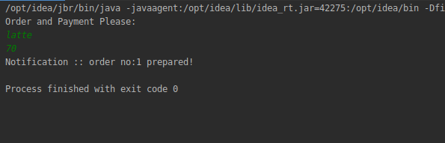

11. Convert the following code so that it uses nested while statements instead of for statements:
int s = 0;
int t = 1;
for (int i = 0; i < 10; i++)
{
s = s + i;
for (int j = i; j > 0; j−−)
{
t = t * (j - i);
}
s = s * t;
System.out.println("T is " + t);
}
System.out.println("S is " + s);
package com.company;
public class calculator {
public static void main(String[] args) {
int s=0, t=1,i=0,j = 0;
while(i<10){
s = s + i;
while(j>0){
t = t * (j - i);
j--;
}
s = s * t;
System.out.println("T is " + t);
i++;
}
System.out.println("S is " + s);
}
}
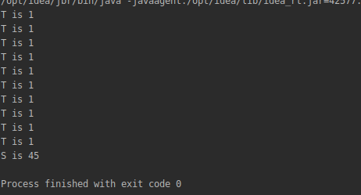

12.What will be the output on new Child(); ?
class Parent extends Grandparent {
{
System.out.println("instance - parent");
}
public Parent() {
System.out.println("constructor - parent");
}
static {
System.out.println("static - parent");
}
}
class Grandparent {
static {
System.out.println("static - grandparent");
}
{
System.out.println("instance - grandparent");
}
public Grandparent() {
System.out.println("constructor - grandparent");
}
}
class Child extends Parent {
public Child() {
System.out.println("constructor - child");
}
static {
System.out.println("static - child");
}
{
System.out.println("instance - child");
}
}

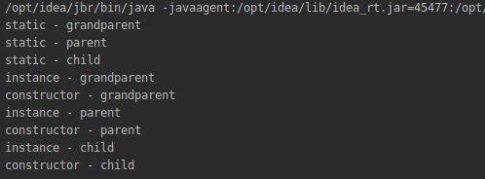

Q13. Create a custom exception that do not have any stack trace.

package com.company;
public class calculator {
public static void main(String[] args) {
try{
//it will throw and object of user defined exception like what i created customException
throw new customException("prabhav custom exception");
}
catch(customException CE){
System.out.println("caught");
CE.printStackTrace();
//IT WIL SHOW WHAT HAPPEN AND WHERE
}
}
}
//To create a custom exception, we have to extend the java.lang.Exception class.
class customException extends Exception{
customException(String name){
super(name);
}
}
