1.Create Database

CREATE DATABASE dbs;
SHOW DATABASES;

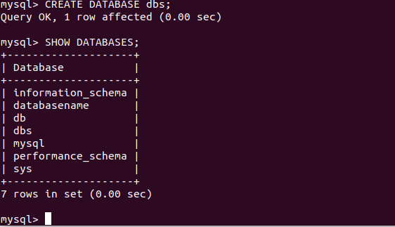

2. Design Schema

desc CUSTOMER;

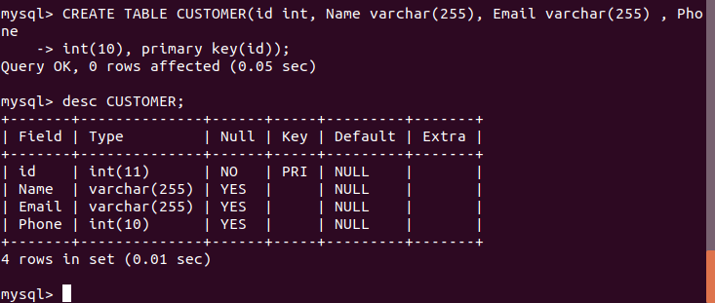

desc salesman;
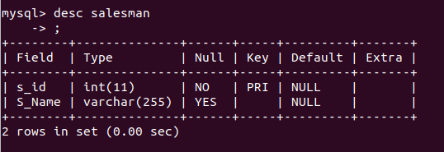

desc orderstable;
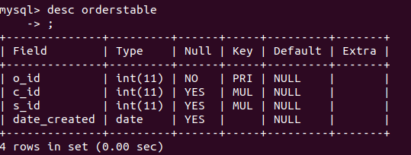

3. Create tables

CREATE TABLE CUSTOMER(id int, Name varchar(255), Email varchar(255) , Phone
int(10), primary key(id));

CREATE TABLE salesman(s_id int primary key, S_Name varchar(255));

CREATE TABLE orderstable(o_id int primary key ,c_id int,s_id int, date_created date,
foreign key (c_id) references CUSTOMER(id), foreign key (s_id) references
salesman(s_id));

4. Insert sample data
INSERT INTO CUSTOMER values (1, 'PRABHAV SOLANKI' ,'PRABHAV.SOLANKI@GMAIL.COM', 9156441292);
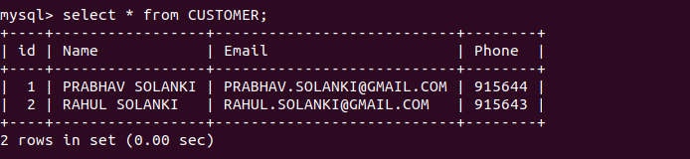

INSERT INTO salesman values(1,’SUNIL’);
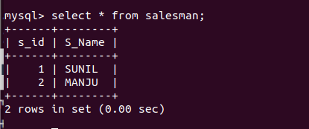

INSERT INTO orderstable values (2, 1 ,1, '2025-02-02');

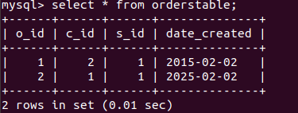

5. Find the sales person have multiple orders.
select S_Name,count(o.o_id) from salesman c LEFT JOIN orderstable o on c.s_id = o.s_id group by c.s_id having count(o.o_id)>1;
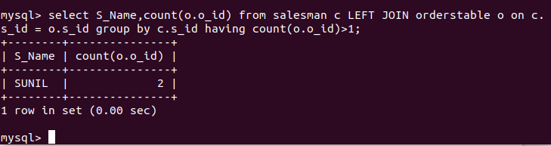

6. Find the all sales person details along with order details.

select * from salesman c JOIN orderstable o ORDER BY S_Name ;
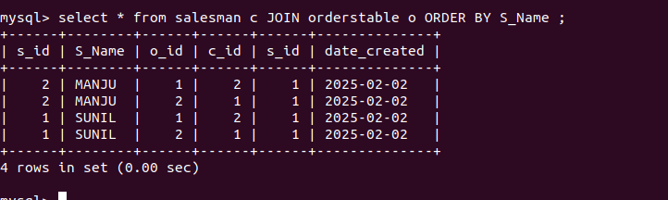

7. Create index
create index abc on CUSTOMER(Name);

8. How to show index on a table
show index from CUSTOMER;

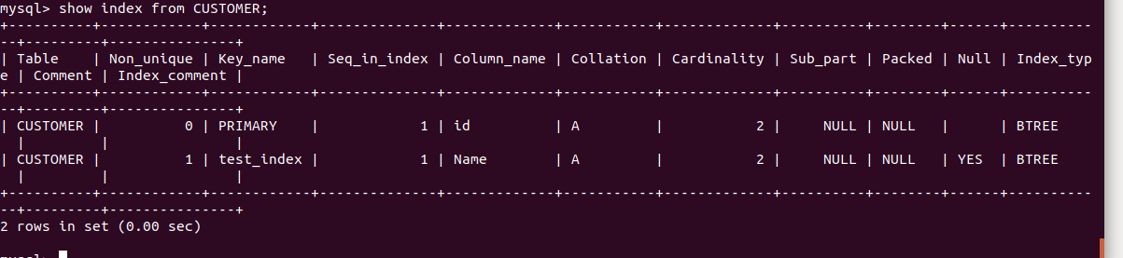

9. Find the order number, sale person name, along with the customer to whom that order
belongs to

Select orderstable.o_id,salesman.S_Name,CUSTOMER.Name,CUSTOMER.Email,CUSTOMER.Phone from orderstable left join salesman on salesman.s_id =
orderstable.s_id left join CUSTOMER on
CUSTOMER.id=orderstable.c_id;

