Q1. Write a program to replace a substring inside a string with other string ?

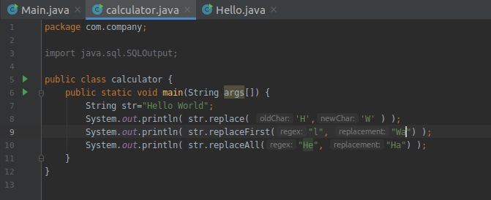
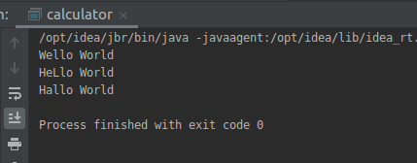

Q2. Write a program to find the number of occurrences of the duplicate words in a string and print them ?
package com.company;
import java.sql.SQLOutput;
public class calculator {
public static void main(String[] args) {
String string = "A mad man would always be mad man";
int count;
//Converts the string into lowercase
string = string.toLowerCase();
//Split the string into words using built-in function
String words[] = string.split(" ");
System.out.println("Duplicate words in this given string are: ");
for(int i = 0; i < words.length; i++) {
count = 1;
for(int j = i+1; j < words.length; j++) {
if(words[i].equals(words[j])) {
count++;
//Set words[j] to 0 to avoid printing visited word
words[j] = "0";
}
}
//Displays the duplicate word if count is greater than 1
if(count > 1 && words[i] != "0")
System.out.println(words[i]+" "+count);
}
}
}
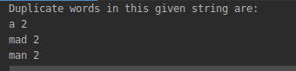

Q3. Write a program to find the number of occurrences of a character in a string without using loop?
import java.sql.SQLOutput;
public class calculator {
public static void main(String[] args) {
String str = "Hi, I'm new here";
str=str.toLowerCase();
int count;
String st="h";
count = str.length() - str.replace(st,"").length();
//System.out.println(count);
System.out.println( "Count for "+st+" is "+count);
}
}
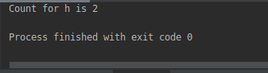

Q4. Calculate the number & Percentage Of Lowercase Letters,Uppercase Letters, Digits And Other Special Characters In A String
package com.company;
public class calculator {
public static void main(String[] args) {
String str = "Prabhav@4087";
int count=0,uppercase=0,lowercase=0,digits=0,special_char=0;
float ucase_percentage,lcase_percentage,d_percentage,sp_percentage;
count = str.length();
for (int var=0;var<count; var++)
{
if (Character.isUpperCase(str.charAt(var)))
{
uppercase++;
}
else if (Character.isLowerCase(str.charAt(var)))
{
lowercase++;
}
else if (Character.isDigit(str.charAt(var)))
{
digits++;
}
else
{
special_char++;
}
}
ucase_percentage = (float)uppercase/(float)count * 100;
lcase_percentage = (float)lowercase/(float)count * 100;
d_percentage = (float)digits/(float)count * 100;
sp_percentage = (float)special_char/(float)count * 100;
System.out.println("Total characters: " + count);
System.out.println("uppercase letters number: " + uppercase + " " +"uppercase percentage: "+
ucase_percentage);
System.out.println("lowercase letters number: " + lowercase + " " +"lowercase percentage: "+
lcase_percentage);
System.out.println("digits number: " + digits + " " +"digits percentage: "+ d_percentage);
System.out.println("special letters number: " + special_char + " " +"special letters percentage: "+
sp_percentage);
}
}
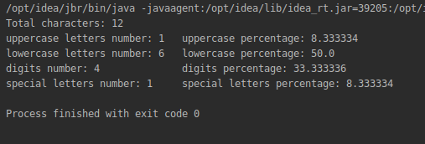

Q5. Find common elements between two arrays.
package com.company;
public class calculator {
public static void main(String[] args) {
int[] arr1 = {1, 7, 77, 89, 16, 6, 3, 91, 72, 85, 32, 11};
int[] arr2 = {56, 7, 85, 3, 67, 4, 91, 16, 6, 23, 77, 1};
int count = 0;
for (int loop1 = 0; loop1 < arr1.length; loop1++) {
count = 0;
for (int loop2 = 0; loop2 < arr2.length; loop2++) {
if (arr1[loop1] == arr2[loop2]) {
count++;
}
}
if (count > 0)
System.out.println(arr1[loop1]);
}
}
}

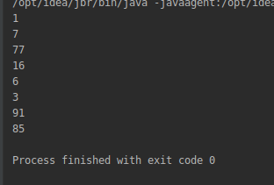

Q6. There is an array with every element repeated twice except one. Find that element
package com.company;
public class calculator {
public static void main(String[] args) {
int[] arr1 = {1,2,3,4,5,6,7,8,9,1,2,3,4,6,7,8,9};
int count=0;
for (int i=0; i < arr1.length; i++) {
count=0;
for (int j = 0; j < arr1.length; j++) {
if (arr1[i] == arr1[j]) {
count++;
}
}
if (count < 2)
System.out.println(arr1[i]);
}
}
}
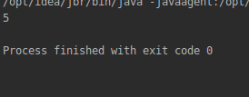

Q7. Write a program to print your Firstname,LastName & age using static block,static method & static variable respectively
package com.company;
public class calculator {
public static void main(String[] args)
{
System.out.println(calculator.s);
showdata();
System.out.println("Printing using variables");
System.out.println(age);
}
static String s;
static String s1;
static int age;
static{
s="Prabhav";
s1="Alok";
age=23;
System.out.println("Printing using Static block");
}
private static void showdata() {
System.out.println("Printing using static method");
System.out.println(s1);
}
}
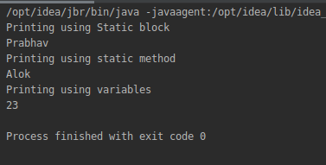

Q8. Write a program to reverse a string and remove character from index 4 to index 9 from the reversed string using String Buffer
package com.company;
public class calculator{
public static void main(String[] args) {
StringBuffer stringBuffer = new StringBuffer("PrabhavSolanki");
stringBuffer.reverse();
System.out.println(stringBuffer);
stringBuffer.replace(4,9,"");
System.out.println(stringBuffer);
}
}
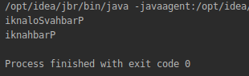

Q9.Write a program to display values of enums using a constructor & getPrice() method (Example display house & their prices)
package com.company;
enum House {
Greater_Noida(100000), New_Delhi(9200000), Gurugram(8000000);
private double hprice;
House(double pr) {
hprice = pr;
}
double getPrice() {
return hprice;
}
}
public class calculator {
public static void main(String args[]){
System.out.println("House List :");
for (House p : House.values()) System.out.println(
p + "'s" +" price is "+ p.getPrice()+" INR" ) ;
}
}

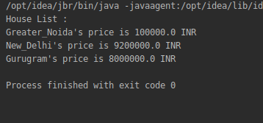

Q10.Write a single program for following operation using overloading
A) Adding 2 integer number
B) Adding 2 double
C) multiplying 2 float
D) multiplying 2 int
E) concate 2 string
F) Concate 3 String

package com.company;
public class calculator {
public void add(int a, int b)
{
int sum= a+b;
System.out.println(sum);
}
public void add(double a, double b)
{
double sum= a+b;
System.out.println(sum);
}
public void add(float a, float b)
{
float flm= a*b;
System.out.println(flm);
}
public void add(int a, int b,int c)
{
c= a*b;
System.out.println(c);
}
public void add(String a, String b)
{
String con= a+b;
System.out.println(con);
}
public void add(String a, String b,String c)
{
String d= a+b+c;
System.out.println(d);
}
public static void main(String[] args) {
calculator j =new calculator();
j.add (5,8);
j.add(34,22);
j.add(7.8,6.5);
j.add(5,3,6);
j.add("Prabhav","Solanki");
j.add("Prabhav","Solanki","Noida");
}
}
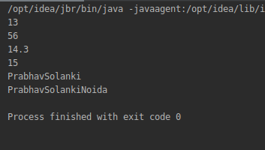

Q11.Create 3 sub class of bank SBI,BOI,ICICI all 4 should have method called getDetails which provide there specific details like rateofinterest etc,print details of every banks
package com.company;
public class calculator {
public void getDetails() {
System.out.println("Details of the bank :");
}
public static void main(String[] args) {
calculator d=new calculator();
calculator b = new BOI();
calculator s = new SBI();
calculator i = new ICICI();
d.getDetails();
b.getDetails();
s.getDetails();
i.getDetails();
}
}
class BOI extends calculator {
public void getDetails() {
System.out.println("====================================");
System.out.println("\nName: SBI");
System.out.println("\nInterest Rate: 7%");
}
}
class SBI extends calculator {
public void getDetails() {
System.out.println("====================================");
System.out.println("\nName: Oriental Bank of India");
System.out.println("\nInterest Rate: 6%");
}
}
class ICICI extends calculator {
public void getDetails() {
System.out.println("====================================");
System.out.println("\nName: ICICI");
System.out.println("\nInterest Rate: 8%");
}
}
