Login Screen

We have put the Log In features for the security purpose in this project. For the different users type to access to the different form of specific form.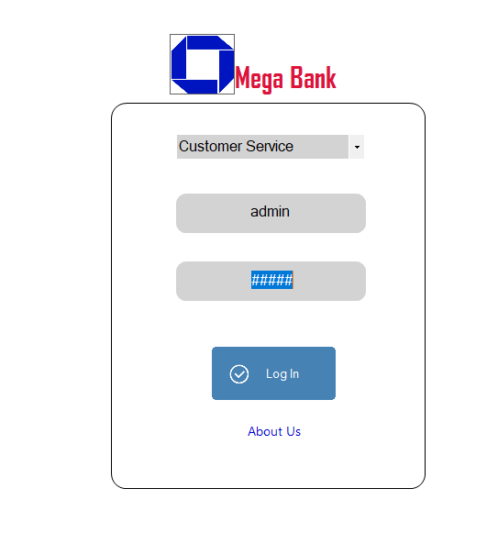

Fig. Login Screen

# Input and Output Screen of Main Form

Customer Service:

In this form we can obtain following form.

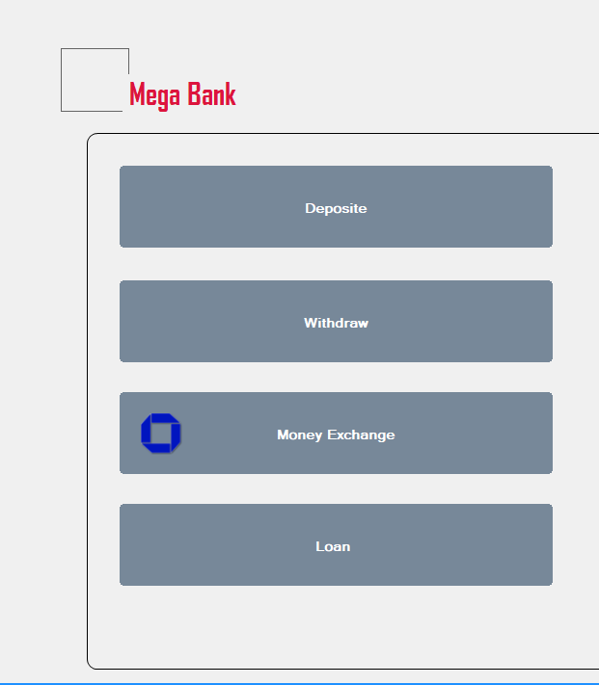

Fig. Customer Service form

**Deposit Form:** in this form we can obtain the deposit form and the output. Following is the form of the deposit.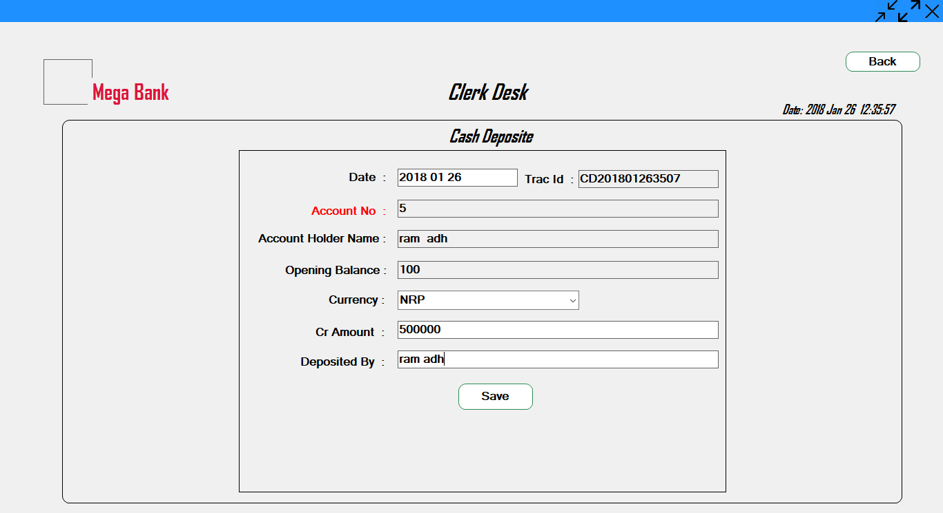

Fig. deposit form

**Withdraw:** In this form we get the withdraw form in which a person can withdraw the money. Following is the form of the withdraw.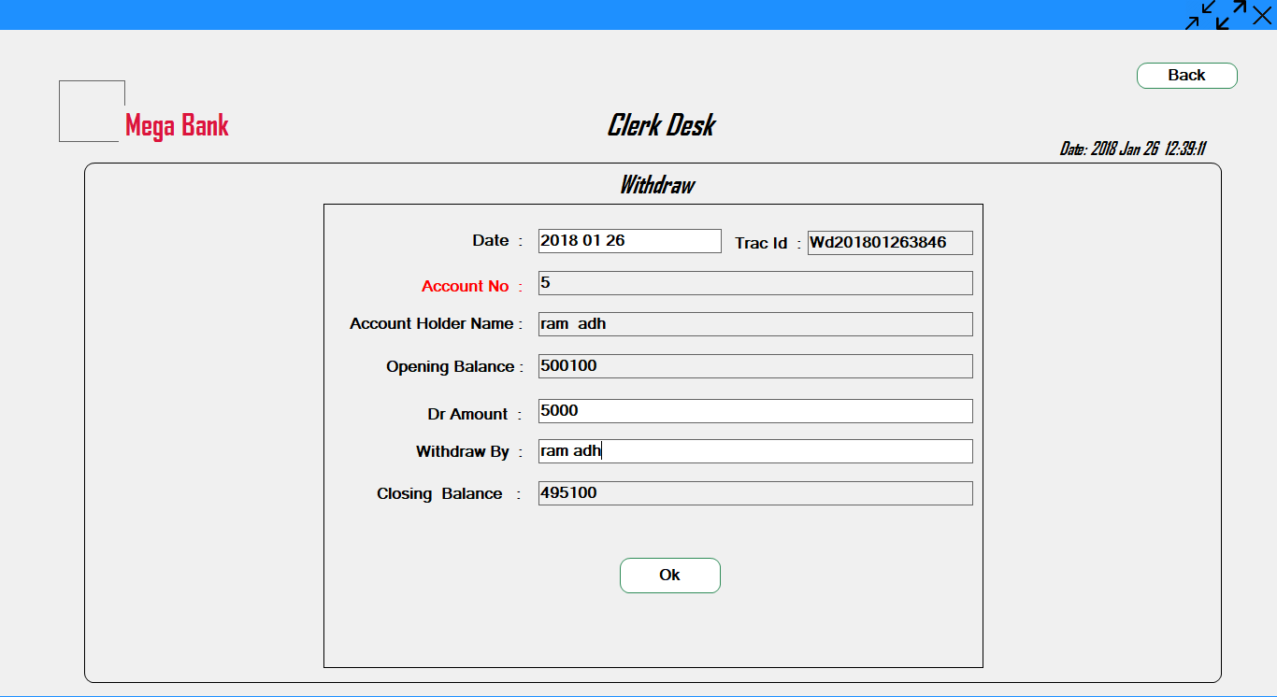

Fig. withdraw form

Loan form: In this form we can obtain the loan form where we can get the loan of the any type. The form of the loan is shown below: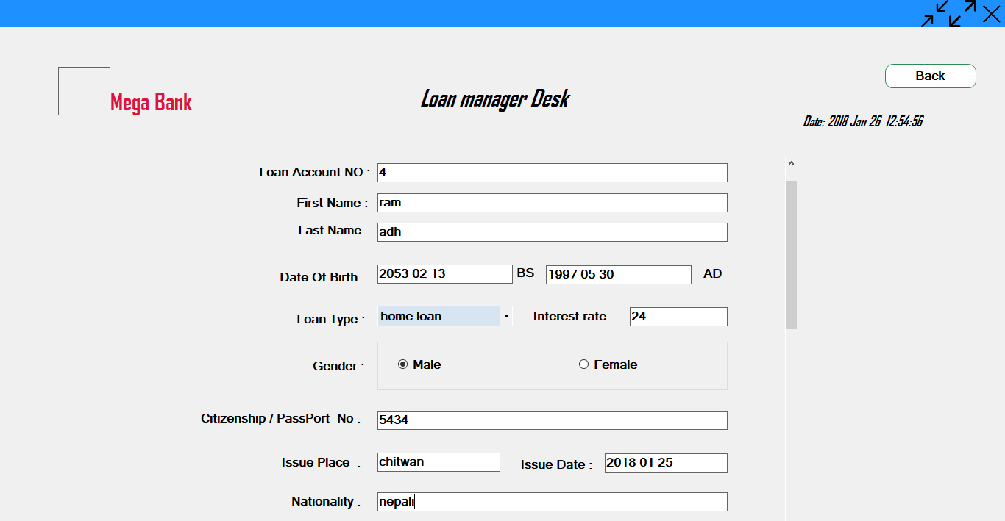

Create account Form:

In this form we can create the account. The following form is the form of the create account.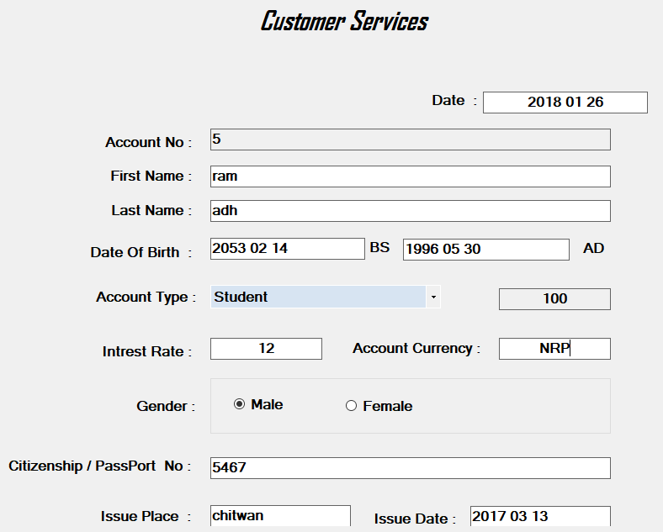

Fig. Create Account Form

**Existing Account Form:**

In this existing account form we can view the account holder of account that are already created. The form of existing account form is: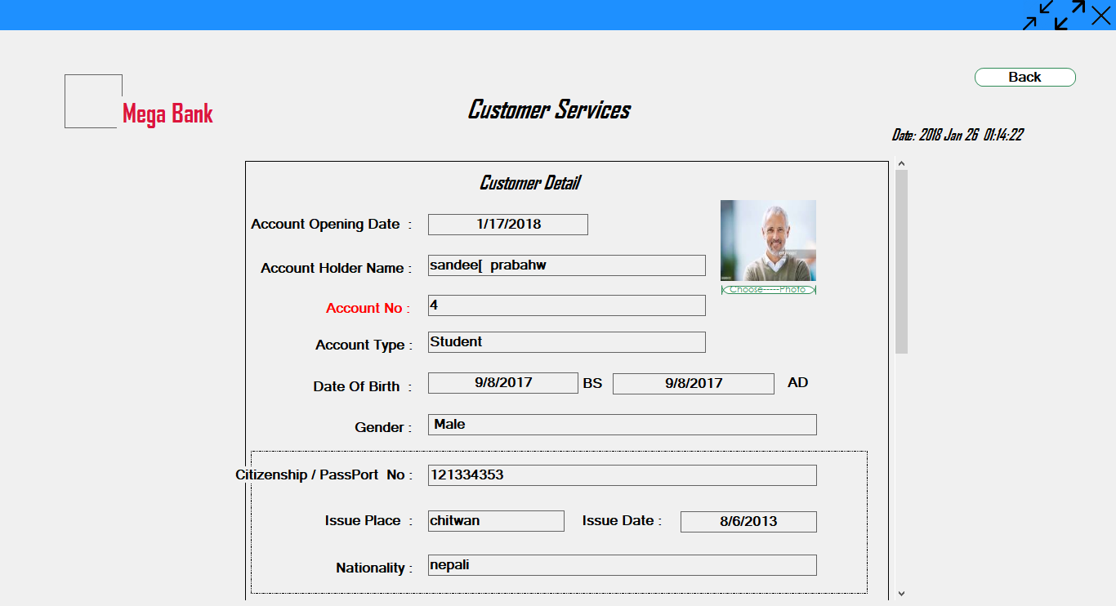

Fig. Existing Account form

**Loan Account Form:**

In this loan detail form we can see the loan detail.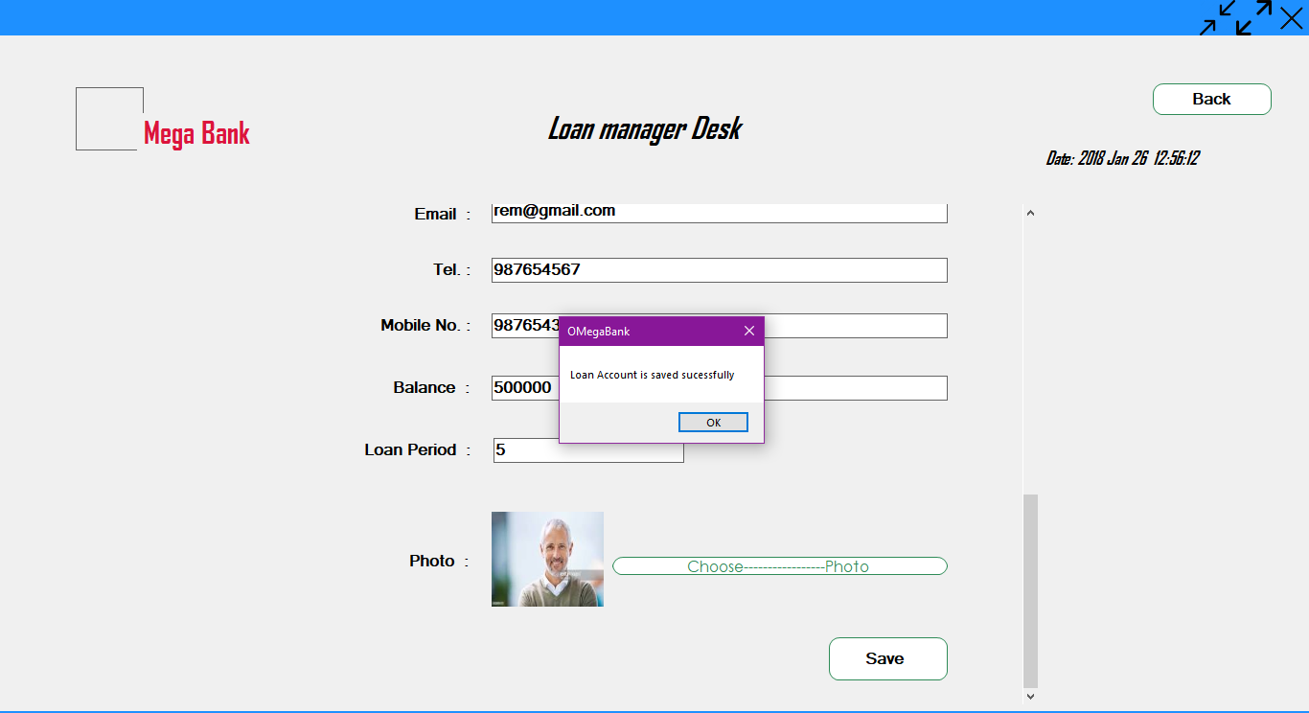

Fig. loan account form

Administration Form:

In this administration form we can modified the account.

