**Index.html**

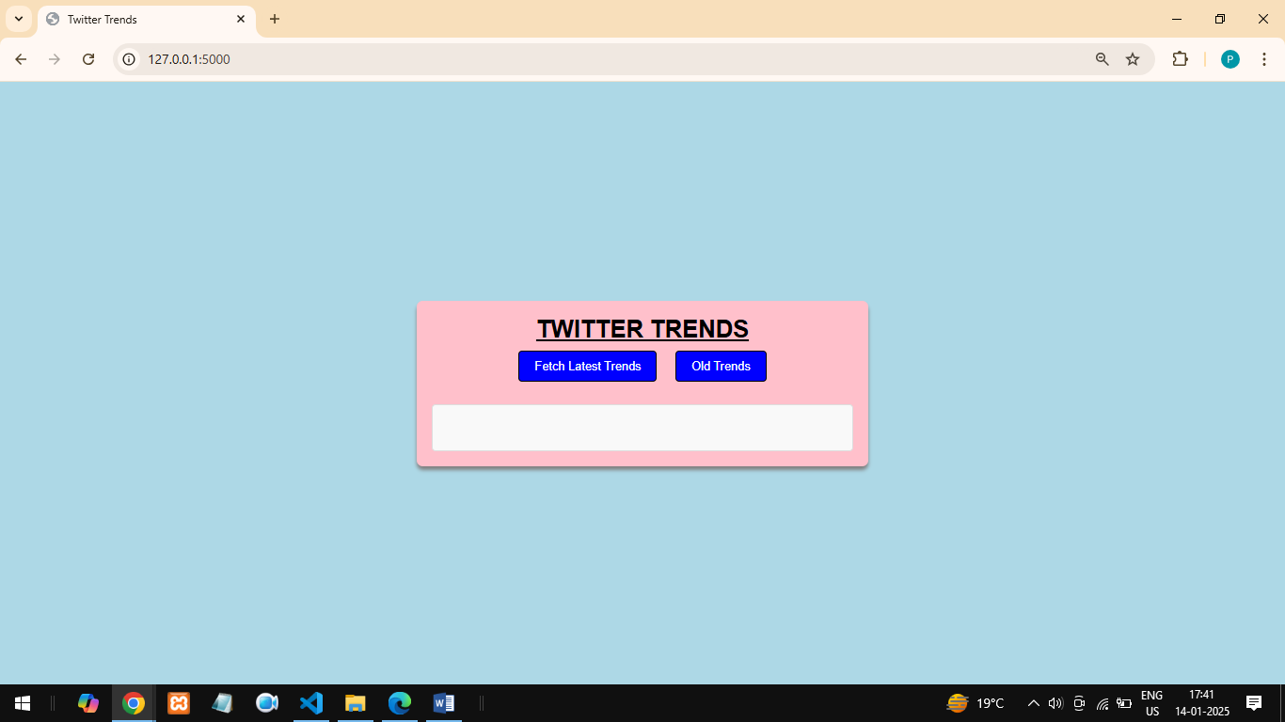

**OLD TRENDS SAVED IN MONGODB**

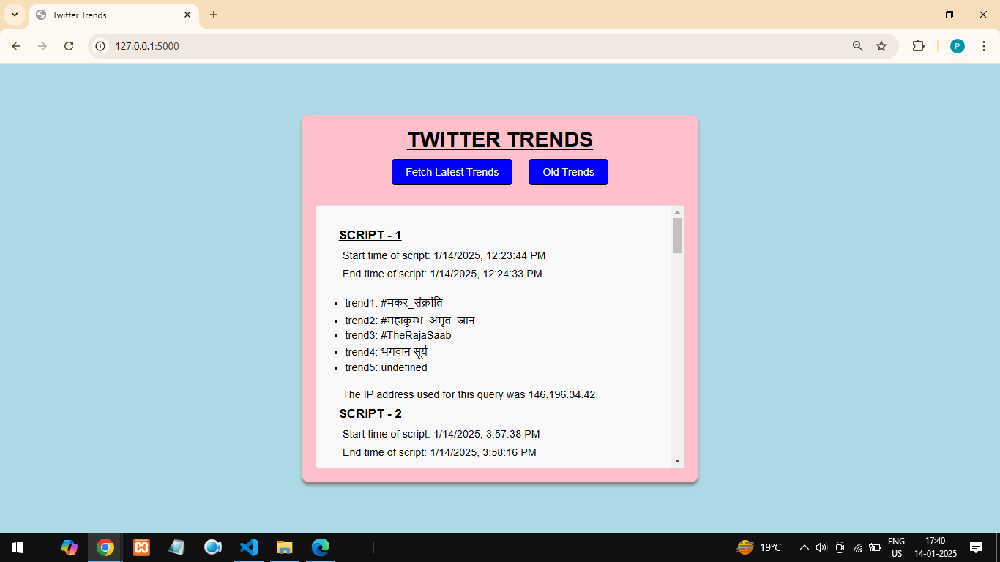

**FETCH LATEST TREND FROM TWITTER**

