**HOME PAGE CONTAINS SIDEBAR AND FLOW GRAPH**

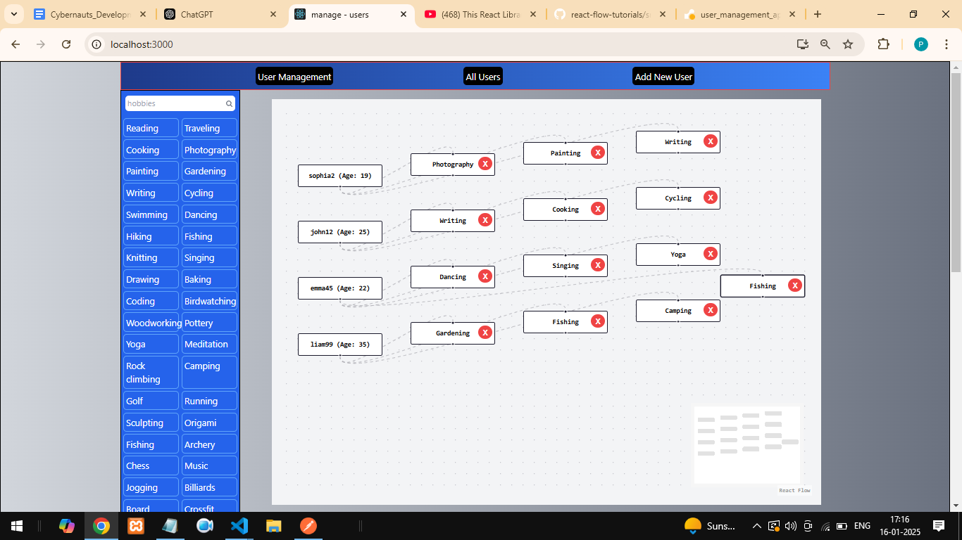

**SEARCHING HOBBIES IN SEARCH BAR**

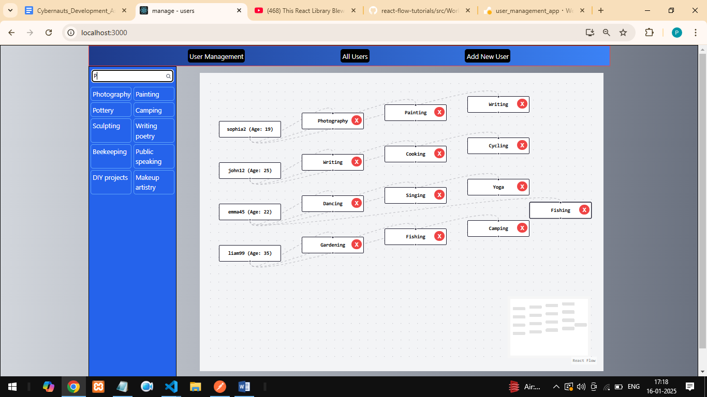

**ADD USER FORM**

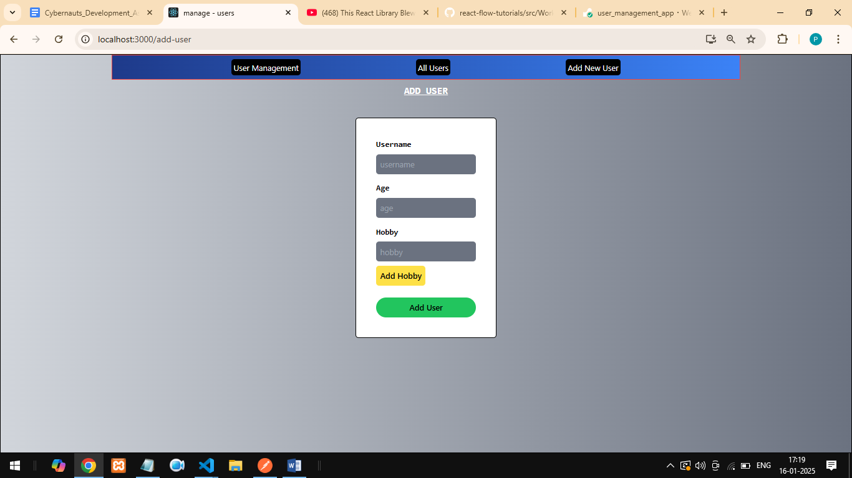

**FORM with VALIDATIONS: THROUGH TOASTS**

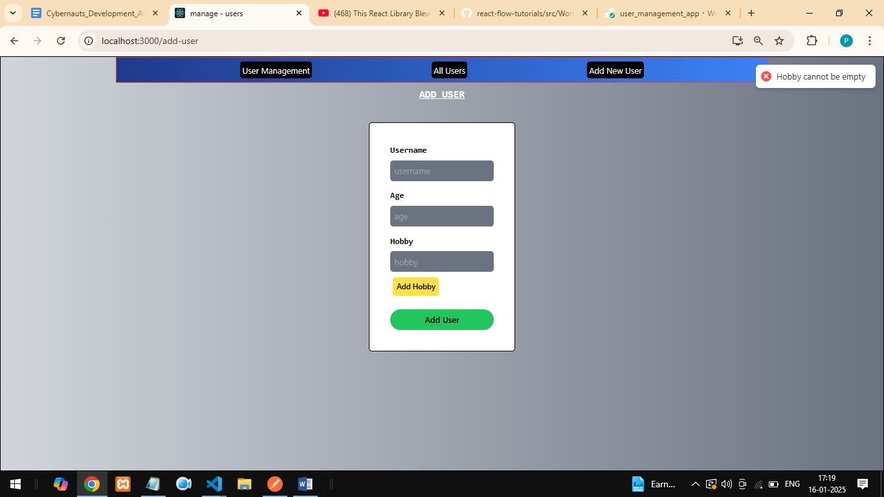

**LIST of ALL THE USERS**

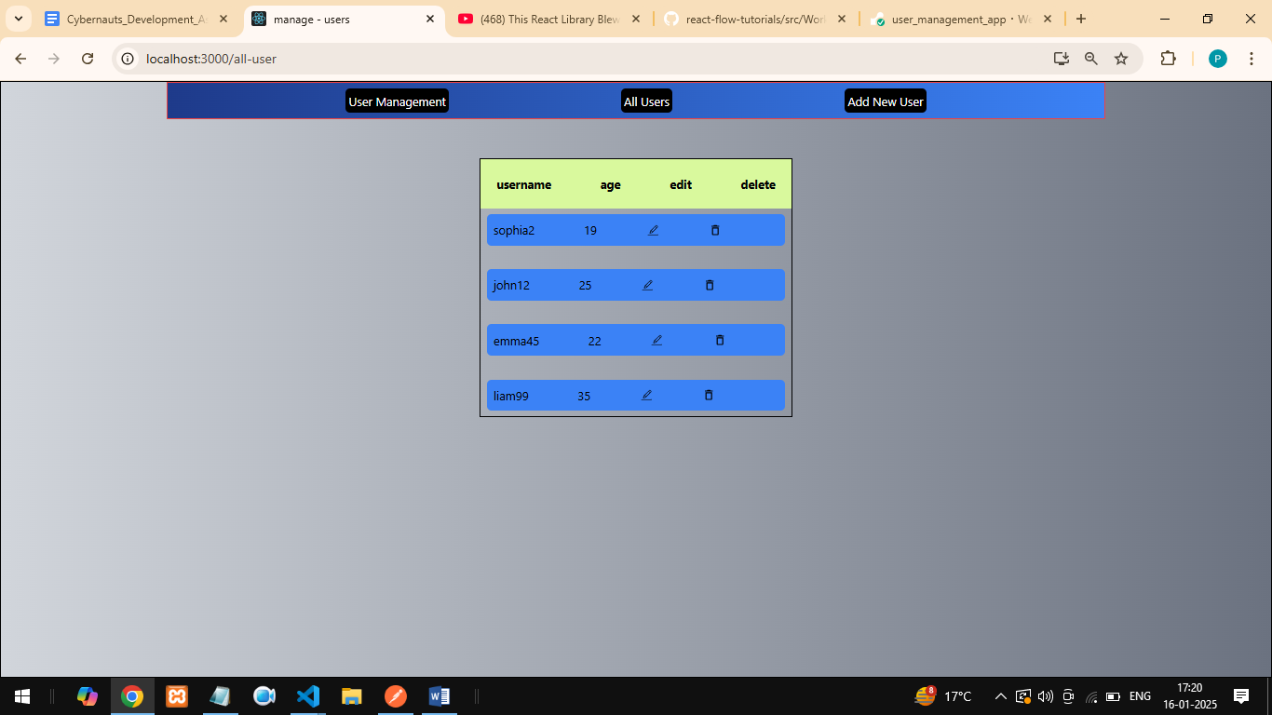

**AFTER PRESSING THE EDIT BUTTON THEN EDIT FORM WILL APPEAR**

