{} global Execution ede vich this key word hunda hai
te e dhyan rakhna hai kyu ki node js and browser dona da EC change haiga hai
EC means = Execution Context

type of EC:
Global Execution Context
function EC
Eval EC

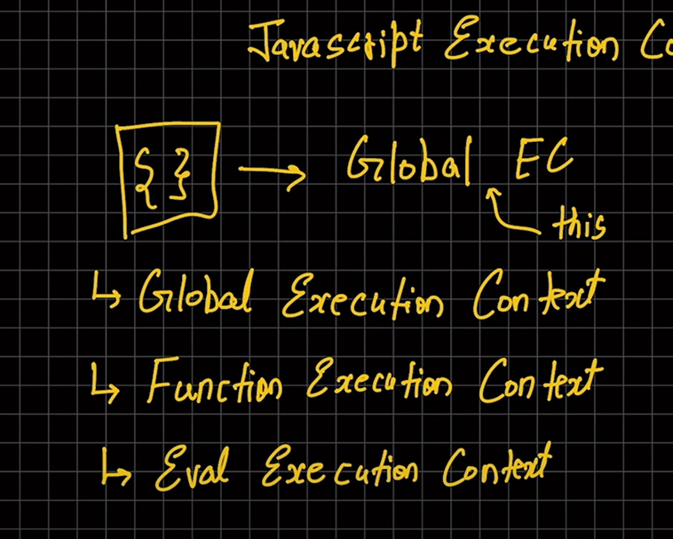
Code 2 phase me chalta hai Memory creation phase and Execution phase
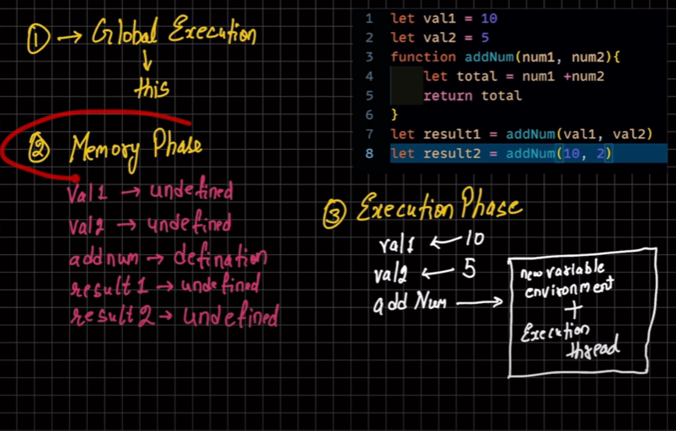
Jini var add num nu call hovegi oni var new sandbox bange te fer dubara to 2, 3 step repeat hoavega add num layi
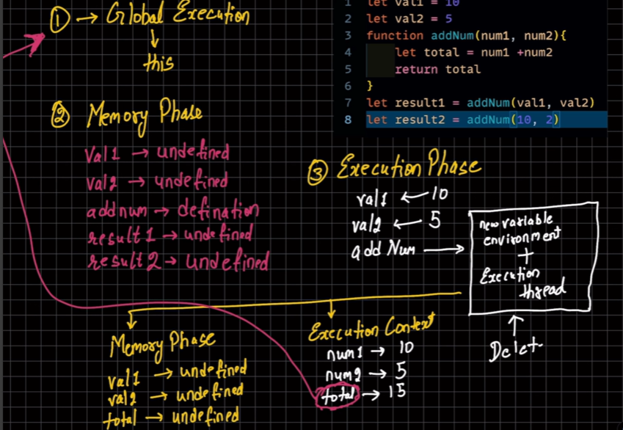
Te jive ki dsya hoya oo small box to arrow de nal us nal run ho k te last te sab kuj hon to baa doo small box delete ho janda te value agge chal jandi te fer agge line 8 layi fer new sandbox Banega te 22,3 step fer repeat hovega
CALL STACK(works as LIFO) way

