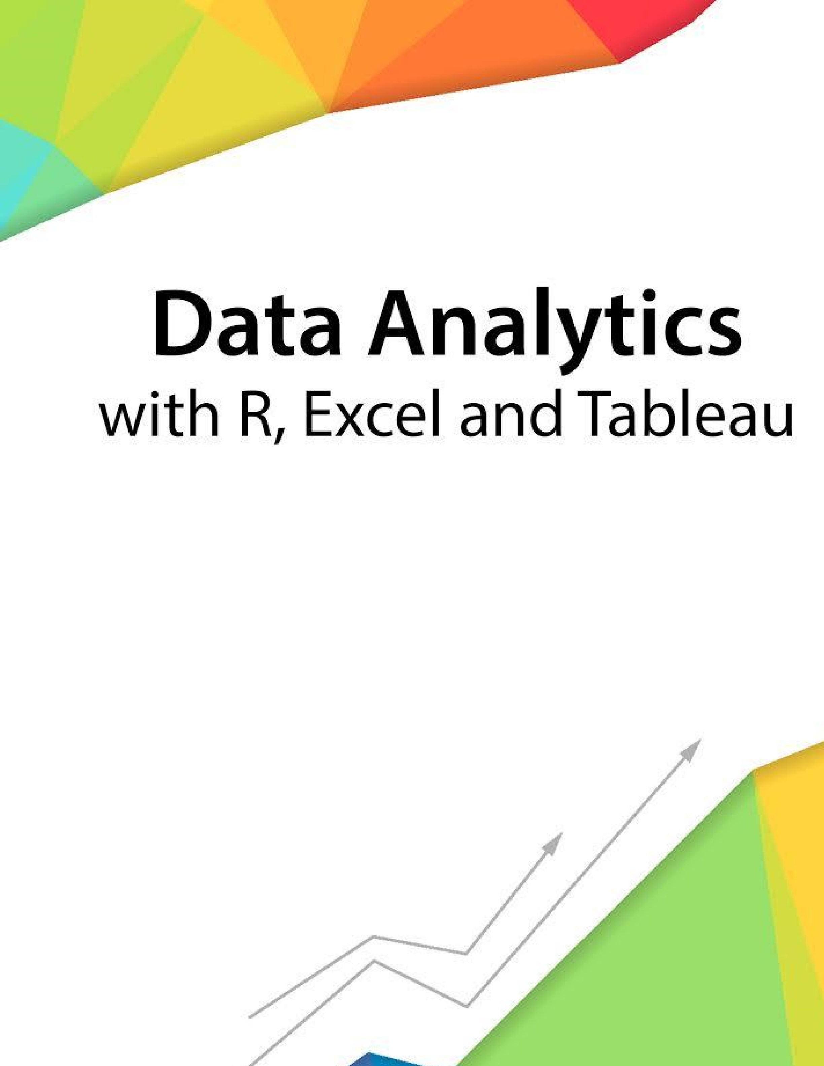

Session 1

–

Introduction

to

Working with R

Assignment

-

2

Contents

1. Introduction ..................................................................................................................................................... 2
2. Objective .......................................................................................................................................................... 2
3. Prerequisites .................................................................................................................................................... 2
4. Associated Data Files ....................................................................................................................................... 2
5. Problem Statement ......................................................................................................................................... 2
6. Expected Output .............................................................................................................................................. 2

# Introduction

This assignment will help you to understand the key concepts learnt in this session.

# Objective

This assignment will test your skills on the basics of R.

# Prerequisites

Not Applicable

# Associated Data Files

Not Applicable

# Problem Statement

1. What should be the output of the following Script?

v <- c( 2,5.5,6)

t <- c(8, 3, 4) print(v%/%t)

output- [1] 0 1 1

1. You have 25 excel files with names as xx_1.xlsx, xx_2.xlsx…xx_25.xlsx in a dir.

Write a program to extract the contents of each excel sheet and make it one df.

Ans- import pandas as pd()

Df = pd.DataFrame #data frame

For i in range (1 ,26):

Current = pd. Read_excel(“xx_”+str(i)+”.xlx”) #read files one by one

df = pd.concat([df, current],axix=1) #concatenate excel files in data frame

1. If the above 25 files were csv files, what would be your script to read?

Ans- just change pd.read_excel to pd.read_csv and .xlsx to .csv

# Expected Output

Not Applicable

**The Approximate time to complete this task is 20 Minutes.**