**session_23_90_days_AAPL_index.R**

Problem Statement

1. Perform the below given activities:

1. Take Apple Stock Prices from Yahoo Finance for last 90 days
2. Predict the Stock closing prices for next 15 days.
3. Submit your accuracy
4. After 15 days again collect the data and compare with your forecast

|  |  |
| --- | --- |
| **setwd**("C:/Users/prabhjot/Desktop/sv R related/acadgild/assignments/session 23/N |  |
| ew folder") **library**(readr)  AAPLMay10toAug102018 <- **read.csv**("AAPLMay10toAug102018.csv")  **View**(AAPLMay10toAug102018) df<-AAPLMay10toAug102018 **head**(df)  ## Date Open High Low Close Adj.Close Volume  ## 1 2018-05-10 187.74 190.37 187.65 190.04 188.6484 27989300  ## 2 2018-05-11 189.49 190.06 187.45 188.59 187.9309 26212200  ## 3 2018-05-14 189.01 189.53 187.86 188.15 187.4924 20778800  ## 4 2018-05-15 186.78 187.07 185.10 186.44 185.7884 23695200  ## 5 2018-05-16 186.07 188.46 186.00 188.18 187.5223 19183100 ## 6 2018-05-17 188.00 188.91 186.36 186.99 186.3365 17294000 **str**(df)  ## 'data.frame': 65 obs. of 7 variables:  ## $ Date : Factor w/ 65 levels "2018-05-10","2018-05-11",..: 1 2 3 4 5 6 7 8 9 10 ...  ## $ Open : num 188 189 189 187 186 ...  ## $ High : num 190 190 190 187 188 ...  ## $ Low : num 188 187 188 185 186 ...  ## $ Close : num 190 189 188 186 188 ...  ## $ Adj.Close: num 189 188 187 186 188 ...  ## $ Volume : int 27989300 26212200 20778800 23695200 19183100 17294000 1 8297700 18400800 15240700 19467900 ...  new_date <- **as.Date**(df**$**Date) new_date |

|  |  |
| --- | --- |
| ## [1] "2018-05-10" "2018-05-11" "2018-05-14" "2018-05-15" "2018-05-16"  ## [6] "2018-05-17" "2018-05-18" "2018-05-21" "2018-05-22" "2018-05-23"  ## [11] "2018-05-24" "2018-05-25" "2018-05-29" "2018-05-30" "2018-05-31"  ## [16] "2018-06-01" "2018-06-04" "2018-06-05" "2018-06-06" "2018-06-07"  ## [21] "2018-06-08" "2018-06-11" "2018-06-12" "2018-06-13" "2018-06-14"  ## [26] "2018-06-15" "2018-06-18" "2018-06-19" "2018-06-20" "2018-06-21"  ## [31] "2018-06-22" "2018-06-25" "2018-06-26" "2018-06-27" "2018-06-28"  ## [36] "2018-06-29" "2018-07-02" "2018-07-03" "2018-07-05" "2018-07-06"  ## [41] "2018-07-09" "2018-07-10" "2018-07-11" "2018-07-12" "2018-07-13"  ## [46] "2018-07-16" "2018-07-17" "2018-07-18" "2018-07-19" "2018-07-20"  ## [51] "2018-07-23" "2018-07-24" "2018-07-25" "2018-07-26" "2018-07-27"  ## [56] "2018-07-30" "2018-07-31" "2018-08-01" "2018-08-02" "2018-08-03" ## [61] "2018-08-06" "2018-08-07" "2018-08-08" "2018-08-09" "2018-08-10" **str**(df)  ## 'data.frame': 65 obs. of 7 variables:  ## $ Date : Factor w/ 65 levels "2018-05-10","2018-05-11",..: 1 2 3 4 5 6 7 8 9 10 ...  ## $ Open : num 188 189 189 187 186 ...  ## $ High : num 190 190 190 187 188 ...  ## $ Low : num 188 187 188 185 186 ...  ## $ Close : num 190 189 188 186 188 ...  ## $ Adj.Close: num 189 188 187 186 188 ...  ## $ Volume : int 27989300 26212200 20778800 23695200 19183100 17294000 1 8297700 18400800 15240700 19467900 ...  **format**(new_date,format="%B %d %Y")  ## [1] "May 10 2018" "May 11 2018" "May 14 2018" "May 15 2018"  ## [5] "May 16 2018" "May 17 2018" "May 18 2018" "May 21 2018"  ## [9] "May 22 2018" "May 23 2018" "May 24 2018" "May 25 2018"  ## [13] "May 29 2018" "May 30 2018" "May 31 2018" "June 01 2018"  ## [17] "June 04 2018" "June 05 2018" "June 06 2018" "June 07 2018"  ## [21] "June 08 2018" "June 11 2018" "June 12 2018" "June 13 2018"  ## [25] "June 14 2018" "June 15 2018" "June 18 2018" "June 19 2018"  ## [29] "June 20 2018" "June 21 2018" "June 22 2018" "June 25 2018"  ## [33] "June 26 2018" "June 27 2018" "June 28 2018" "June 29 2018"  ## [37] "July 02 2018" "July 03 2018" "July 05 2018" "July 06 2018"  ## [41] "July 09 2018" "July 10 2018" "July 11 2018" "July 12 2018"  ## [45] "July 13 2018" "July 16 2018" "July 17 2018" "July 18 2018"  ## [49] "July 19 2018" "July 20 2018" "July 23 2018" "July 24 2018"  ## [53] "July 25 2018" "July 26 2018" "July 27 2018" "July 30 2018"  ## [57] "July 31 2018" "August 01 2018" "August 02 2018" "August 03 2018" ## [61] "August 06 2018" "August 07 2018" "August 08 2018" "August 09 2018" ## [65] "August 10 2018"  *# %d - day as number 1-31*  *# %a - weekday such as Mon*  *# %A- complete day name ex.Monday*  *# %m - month as a number* | |
| *# %b - short form of month Jan, Feb* | ) |
| *# %B - full form of month, January*  *# %y - two digit year*  *# %Y- four digit year*    data = **ts**(df**$**Close,frequency =12)    **plot**(data,main="Monthly Closing Prices" |

|  |  |
| --- | --- |
| *# Additive Time Series* | *# additive model is easy to explain, easy to forecast and interpret*  *# multiplicate models can be converted to additive models using log of the ti*  Feb Mar Apr May Jun Jul Aug |
| *# Trend + Seasonality+ Cyclicity+ error*  *# Multiplicative Time Series*  ## Trend * Seasonality * Cyclicity * error    *me series* **log**(data)  ## Jan |

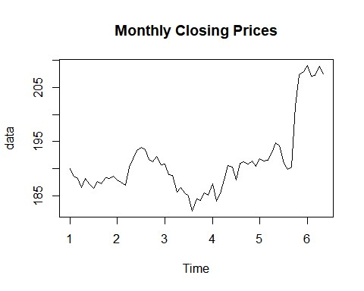

## 5 5.256870 5.254574 5.255462 5.262690 5.272076 5.268940 5.252169 5.246550 ## 6 5.342669 5.333250 5.333926 5.341760 5.335276 ## Sep Oct Nov Dec

|  |
| --- |
| ## 1 5.231964 5.238355 5.237239 5.239522  ## 2 5.255932 5.253477 5.258953 5.250701  ## 3 5.217270 5.215805 5.223055 5.220950  ## 4 5.254000 5.251802 5.254627 5.249127  ## 5 5.248549 5.305789 5.334601 5.337490 ## 6  *# assumption for time series forecst:*  *#1- the time series should be stationary*    *# Identify the stationarity of a time series*  *#1- mean value of the time series is constant over time, the trend should not be present in the series*  *#2- the variance does not increase over time*  *#3- the seasonality impact is minimal, deseasonalization of the time series d ata*    **decompose**(data) *# default method is additive*  ## $x  ## Jan Feb Mar Apr May Jun Jul Aug Sep Oct  ## 1 190.04 188.59 188.15 186.44 188.18 186.99 186.31 187.63 187.16 188.36  ## 2 187.90 187.50 186.87 190.24 191.83 193.31 193.98 193.46 191.70 191.23  ## 3 190.80 188.84 188.74 185.69 186.50 185.46 184.92 182.17 184.43 184.16  ## 4 187.18 183.92 185.40 187.97 190.58 190.35 187.88 191.03 191.33 190.91  ## 5 191.88 191.44 191.61 193.00 194.82 194.21 190.98 189.91 190.29 201.50 ## 6 209.07 207.11 207.25 208.88 207.53  ## Nov Dec  ## 1 188.15 188.58  ## 2 192.28 190.70  ## 3 185.50 185.11  ## 4 191.45 190.40  ## 5 207.39 207.99  ## 6  ##  ## $seasonal  ## Jan Feb Mar Apr May Jun  ## 1 0.58831620 -0.99907935 -0.82543364 0.07509057 1.44529961 0.94269711  ## 2 0.58831620 -0.99907935 -0.82543364 0.07509057 1.44529961 0.94269711  ## 3 0.58831620 -0.99907935 -0.82543364 0.07509057 1.44529961 0.94269711  ## 4 0.58831620 -0.99907935 -0.82543364 0.07509057 1.44529961 0.94269711  ## 5 0.58831620 -0.99907935 -0.82543364 0.07509057 1.44529961 0.94269711  ## 6 0.58831620 -0.99907935 -0.82543364 0.07509057 1.44529961  ## Jul Aug Sep Oct Nov Dec  ## 1 -0.94316286 -1.23007568 -1.40158058 0.50225588 1.87600261 -0.03032988  ## 2 -0.94316286 -1.23007568 -1.40158058 0.50225588 1.87600261 -0.03032988  ## 3 -0.94316286 -1.23007568 -1.40158058 0.50225588 1.87600261 -0.03032988  ## 4 -0.94316286 -1.23007568 -1.40158058 0.50225588 1.87600261 -0.03032988  ## 5 -0.94316286 -1.23007568 -1.40158058 0.50225588 1.87600261 -0.03032988  ## 6 |

##

## $trend

## Jan Feb Mar Apr May Jun Jul Aug

|  |
| --- |
| ## 6 NA NA NA NA NA  ## Sep Oct Nov Dec  ## 1 187.5592 187.6642 187.9746 188.3900  ## 2 191.3479 191.2362 190.8246 190.2754  ## 3 185.1758 185.1317 185.3967 185.7704  ## 4 190.3104 190.7788 191.1650 191.5025  ## 5 198.8083 200.1217 201.3129 NA  ## 6  ##  ## $random  ## Jan Feb Mar Apr May Jun  ## 1 NA NA NA NA NA NA  ## 2 -1.66123862 -1.03633707 -2.27207090 -0.11133461 -0.18321332 1.53896851  ## 3 0.64085296 1.11615847 1.61585564 -1.73717174 -1.72029982 -1.74227386  ## 4 0.49417750 -1.67092228 -1.02123907 0.07949335 0.79011876 0.59439235  ## 5 -0.50081275 0.56407997 0.65043343 0.74199210 0.08637347 -1.41810790  ## 6 NA NA NA NA NA  ## Jul Aug Sep Oct Nov Dec  ## 1 -0.53933810 1.20216485 1.00241853 0.19357891 -1.70059198 0.22033175  ## 2 3.88565965 3.47591660 1.75366124 -0.50850984 -0.42058669 0.45491017  ## 3 -0.01267264 -2.11992615 0.65574078 -1.47391751 -1.77266827 -0.63008483  ## 4 -0.40599889 2.52174060 2.42116470 -0.37100334 -1.59100723 -1.07217800  ## 5 -4.21142614 -6.36367202 -7.11676138 0.87607566 4.20107806 NA ## 6 ##  ## $figure  ## [1] 0.58831620 -0.99907935 -0.82543364 0.07509057 1.44529961  ## [6] 0.94269711 -0.94316286 -1.23007568 -1.40158058 0.50225588 ## [11] 1.87600261 -0.03032988  ##  ## $type  ## [1] "additive"  ##  ## attr(,"class") ## [1] "decomposed.ts" **decompose**(data, type='multi')  ## $x  ## Jan Feb Mar Apr May Jun Jul Aug Sep Oct  ## 1 190.04 188.59 188.15 186.44 188.18 186.99 186.31 187.63 187.16 188.36  ## 2 187.90 187.50 186.87 190.24 191.83 193.31 193.98 193.46 191.70 191.23 |

## 1 NA NA NA NA NA NA 187.7925 187.6579

|  |
| --- |
| ## 3 190.80 188.84 188.74 185.69 186.50 185.46 184.92 182.17 184.43 184.16  ## 4 187.18 183.92 185.40 187.97 190.58 190.35 187.88 191.03 191.33 190.91  ## 5 191.88 191.44 191.61 193.00 194.82 194.21 190.98 189.91 190.29 201.50 ## 6 209.07 207.11 207.25 208.88 207.53  ## Nov Dec  ## 1 188.15 188.58  ## 2 192.28 190.70  ## 3 185.50 185.11  ## 4 191.45 190.40  ## 5 207.39 207.99 ## 6  ##  ## $seasonal  ## Jan Feb Mar Apr May Jun Jul  ## 1 1.0031182 0.9946632 0.9956196 1.0003478 1.0075902 1.0049535 0.9951287  ## 2 1.0031182 0.9946632 0.9956196 1.0003478 1.0075902 1.0049535 0.9951287  ## 3 1.0031182 0.9946632 0.9956196 1.0003478 1.0075902 1.0049535 0.9951287  ## 4 1.0031182 0.9946632 0.9956196 1.0003478 1.0075902 1.0049535 0.9951287  ## 5 1.0031182 0.9946632 0.9956196 1.0003478 1.0075902 1.0049535 0.9951287 ## 6 1.0031182 0.9946632 0.9956196 1.0003478 1.0075902  ## Aug Sep Oct Nov Dec  ## 1 0.9937153 0.9929736 1.0025480 1.0095161 0.9998259  ## 2 0.9937153 0.9929736 1.0025480 1.0095161 0.9998259  ## 3 0.9937153 0.9929736 1.0025480 1.0095161 0.9998259  ## 4 0.9937153 0.9929736 1.0025480 1.0095161 0.9998259  ## 5 0.9937153 0.9929736 1.0025480 1.0095161 0.9998259 ## 6 ##  ## $trend  ## Jan Feb Mar Apr May Jun Jul Aug  ## 1 NA NA NA NA NA NA 187.7925 187.6579 |

## 6 NA NA NA NA NA

## Sep Oct Nov Dec

## 1 187.5592 187.6642 187.9746 188.3900

## 2 191.3479 191.2362 190.8246 190.2754

## 3 185.1758 185.1317 185.3967 185.7704

## 4 190.3104 190.7788 191.1650 191.5025

## 5 198.8083 200.1217 201.3129 NA

## 6

##

## $random

## Jan Feb Mar Apr May Jun Jul

## 1 NA NA NA NA NA NA 0.9969622

## 2 0.9912315 0.9945689 0.9880225 0.9994619 0.9990398 1.0080115 1.0203733

## 3 1.0033553 1.0059892 1.0086237 0.9907840 0.9910057 0.9907993 0.9997277

## 4 1.0026902 0.9909792 0.9944940 1.0004751 1.0042463 1.0031716 0.9977305

|  |
| --- |
| ## 5 0.9973463 1.0030862 1.0034832 1.0039024 1.0003316 0.9926410 0.9784856 ## 6 NA NA NA NA NA  ## Aug Sep Oct Nov Dec  ## 1 1.0061748 1.0049329 1.0011569 0.9914980 1.0011829  ## 2 1.0181439 1.0089291 0.9974259 0.9981287 1.0024060  ## 3 0.9881529 1.0030199 0.9922233 0.9911258 0.9966185  ## 4 1.0131751 1.0124715 0.9981447 0.9920504 0.9944160  ## 5 0.9676326 0.9639259 1.0043284 1.0204763 NA ## 6 ##  ## $figure  ## [1] 1.0031182 0.9946632 0.9956196 1.0003478 1.0075902 1.0049535 0.9951287  ## [8] 0.9937153 0.9929736 1.0025480 1.0095161 0.9998259 ##  ## $type  ## [1] "multiplicative"  ##  ## attr(,"class") ## [1] "decomposed.ts"  **par**(mfrow=**c**(1,2))  **plot**(**decompose**(data, type='multi')) **library**(forecast) |

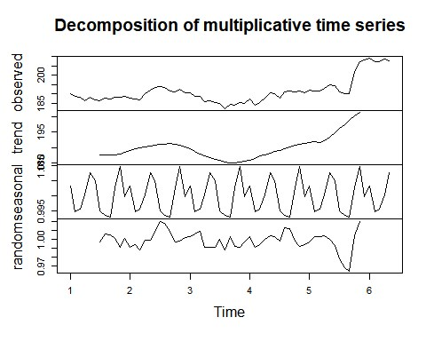

|  |  |
| --- | --- |
| **seasonplot**(data) |  |
| **lag**(data,10) |

|  |
| --- |
| ## Jan Feb Mar Apr May Jun Jul Aug Sep Oct  ## 0 190.04 188.59 188.15 186.44 188.18 186.99 186.31 187.63  ## 1 188.15 188.58 187.90 187.50 186.87 190.24 191.83 193.31 193.98 193.46  ## 2 192.28 190.70 190.80 188.84 188.74 185.69 186.50 185.46 184.92 182.17  ## 3 185.50 185.11 187.18 183.92 185.40 187.97 190.58 190.35 187.88 191.03  ## 4 191.45 190.40 191.88 191.44 191.61 193.00 194.82 194.21 190.98 189.91 ## 5 207.39 207.99 209.07 207.11 207.25 208.88 207.53  ## Nov Dec  ## 0 187.16 188.36  ## 1 191.70 191.23  ## 2 184.43 184.16  ## 3 191.33 190.91  ## 4 190.29 201.50  ## 5 **lag.plot**(data) |

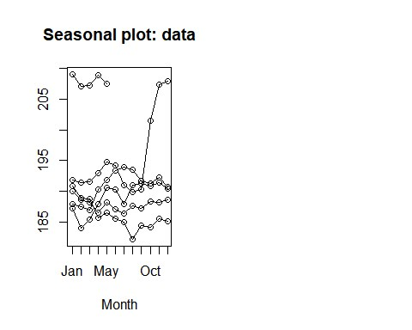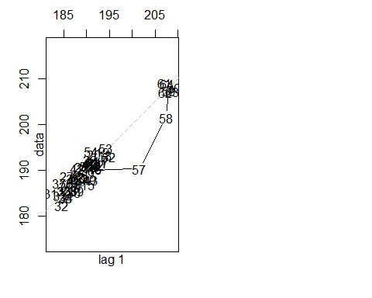

|  |  |
| --- | --- |
| *# Calculation of Autocorrelation and Partial Autocorrelation* |  |
| data  ## Jan Feb Mar Apr May Jun Jul Aug Sep Oct  ## 1 190.04 188.59 188.15 186.44 188.18 186.99 186.31 187.63 187.16 188.36  ## 2 187.90 187.50 186.87 190.24 191.83 193.31 193.98 193.46 191.70 191.23  ## 3 190.80 188.84 188.74 185.69 186.50 185.46 184.92 182.17 184.43 184.16 ## 4 187.18 183.92 185.40 187.97 190.58 190.35 187.88 191.03 191.33 190.91  ## 5 191.88 191.44 191.61 193.00 194.82 194.21 190.98 189.91 190.29 201.50 ## 6 209.07 207.11 207.25 208.88 207.53 ## Nov Dec |

|  |
| --- |
| ## 1 188.15 188.58  ## 2 192.28 190.70  ## 3 185.50 185.11  ## 4 191.45 190.40  ## 5 207.39 207.99  ## 6  ac<-**acf**(data)    ac**$**acf  ## , , 1  ##  ## [,1]  ## [1,] 1.000000000  ## [2,] 0.897834549  ## [3,] 0.766959609  ## [4,] 0.642380728  ## [5,] 0.540362058  ## [6,] 0.435258811  ## [7,] 0.329717557  ## [8,] 0.213959913  ## [9,] 0.130089131  ## [10,] 0.108939188  ## [11,] 0.096442343  ## [12,] 0.081448406  ## [13,] 0.048226570  ## [14,] 0.012083704  ## [15,] -0.008036572  ## [16,] -0.024501683  ## [17,] -0.027889568  ## [18,] -0.018651269  ## [19,] -0.020409708  *# data time series may not have stationarity*    pac<-**pacf**(data) |

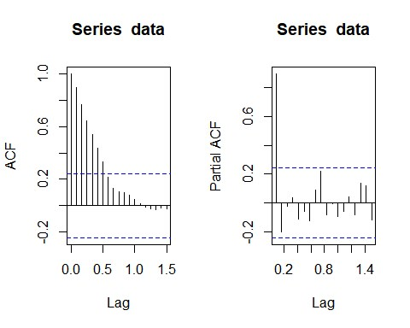

|  |  |
| --- | --- |
| pac**$**acf | ## [,1]  ## [1,] 0.897834549 -0.201901271  -0.021388111  ## [4,] 0.033830089 -0.113123217  -0.061245804  -0.127001529 ## [8,] 0.089593010  ## [9,] 0.222548229 -0.084860931  -0.006016842  -0.096866419  -0.060046996  ## [14,] 0.039563483  -0.084282971 ## [16,] 0.133672152  ## [17,] 0.117993466  -0.118439370  *# looking at the ACF and PACF graph we can conclude that the time series is n* |
| ## , , 1 ##  ## [2,]  ## [3,]  ## [5,]  ## [6,]  ## [7,]  ## [10,]  ## [11,]  ## [12,]  ## [13,]  ## [15,]  ## [18,]  *ot stationary* |

|  |  |
| --- | --- |
| model <- **lm**(data**~c**(1**:length**(data))) | .33272 138.253 < 2e-16 ***  -08 ***      , Adjusted R-squared: 0.3566  -value: 9.126e-08 |
| **summary**(model)  ##  ## Call:  ## lm(formula = data ~ c(1:length(data)))  ##  ## Residuals:  ## Min 1Q Median 3Q Max  ## -8.8666 -4.0286 -0.5626 2.9954 11.8853  ##  ## Coefficients:  ## Estimate Std. Error t value Pr(>|t|)  ## (Intercept) 184.25256 1  ## c(1:length(data)) 0.21200 0.03511 6.039 9.13e  ## ---  ## Signif. codes: 0 '***' 0.001 '**' 0.01 '*' 0.05 '.' 0.1 ' ' 1 ##  ## Residual standard error: 5.31 on 63 degrees of freedom  ## Multiple R-squared: 0.3666  ## F-statistic: 36.46 on 1 and 63 DF, p  **plot**(**resid**(model),type='l')    *# the series is not stationary*    *# deseasonalize the time series*      tbl <- **stl**(data,'periodic')    stab<-**seasadj**(tbl)    **seasonplot**(stab,12) |

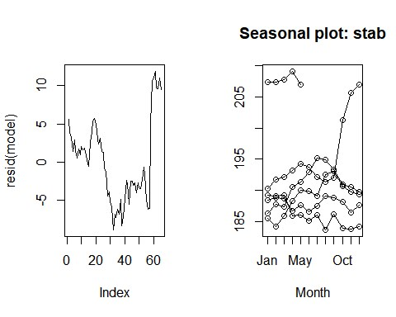

|  |  |
| --- | --- |
| *# statistically we need to test out if the series is stationary or not* |  |
| *# Augmented Dickey Fuller Test*    **library**(tseries)    **adf.test**(data)  ##  ## Augmented Dickey-Fuller Test  ##  ## data: data  ## Dickey-Fuller = -0.86015, Lag order = 3, p-value = 0.9516 ## alternative hypothesis: stationary  *# if the p-value is less than 0.05, then the time series is stationary, else not*    *# Time Series Forecasting Models*    *# Simple Exponential Smoothing*  *# Double Expo. Smoothing*  *# Tripple Expo. Smoothing*  *# AR-I-MA model*    *#PACF- p*  *#diff - d*  *#ACF- q* |
| model2<-**auto.arima**(data) **accuracy**(model2)  ## ME RMSE MAE MPE MAPE MASE ## Training set 0.2720007 2.171997 1.452924 0.1307485 0.7549219 0.2304089 ## ACF1 ## Training set 0.1700406  **plot**(**forecast**(model2,h=12))    **adf.test**(**diff**(data))  ## Warning in adf.test(diff(data)): p-value smaller than printed p-value  ##  ## Augmented Dickey-Fuller Test  ##  ## data: diff(data)  ## Dickey-Fuller = -4.5932, Lag order = 3, p-value = 0.01  ## alternative hypothesis: stationary **plot**(**diff**(data)) | |

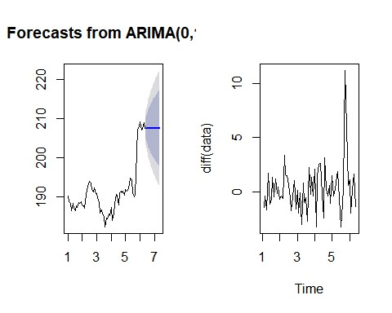

|  |  |
| --- | --- |
| **diff**(data,differences = 3) |  |
| ## Jan Feb Mar Apr May Jun  ## 1 -2.279985 4.719973 -6.379962  ## 2 -1.750031 1.390030 -0.510025 4.230026 -5.780028 1.670012  ## 3 4.310013 -3.740021 3.920029 -4.810028 6.810013 -5.709992  ## 4 4.189986 -7.789978 10.069978 -3.649980 -1.050017 -2.879991  ## 5 4.120010 -4.450028 2.530016 0.609998 -0.789992 -2.860015  ## 6 5.769989 -3.520004 5.140013 -0.609999 -4.470017  ## Jul Aug Sep Oct Nov Dec  ## 1 3.439960 1.490033 -3.790022 3.460006 -3.080002 2.050019  ## 2 -0.699997 -0.379989 -0.050034 2.530030 0.229995 -4.150009  ## 3 2.349975 -2.709975 7.219986 -7.539979 4.139969 -3.339980  ## 4 0.599992 7.860000 -8.469986 2.129990 1.679992 -2.549987 ## 5 -0.190004 4.780030 -0.710038 9.380037 -16.150026 0.030015 ## 6  *#running a model on diff data* model3<-**auto.arima**(**diff**(data))    **accuracy**(model3)  ## ME RMSE MAE MPE MAPE MASE ACF1 ## Training set 0.2732813 2.188771 1.472657 100 100 0.7590256 0.1695623  **acf**(**diff**(data))    **pacf**(**diff**(data)) | |

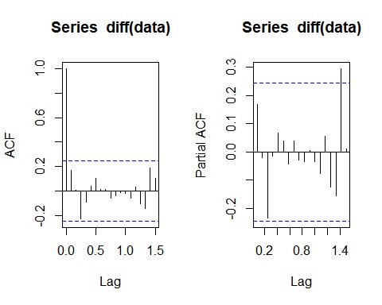

|  |  |
| --- | --- |
| *#taking random order* | (data),order=**c**(4,0,5))    -zero mean  ## Warning in sqrt(diag(x$var.coef)): NaNs produced  ## ar1 ar2 ar3 ar4 ma1 ma2 ma3 ma4  1.4150 -0.0641 -0.4746 0.4821 1.7941 0.1249 0.6766  ## s.e. NaN 0.1265 NaN 0.1483 NaN NaN NaN NaN        ## sigma^2 estimated as 4.095: log likelihood=-133.78    ## ME RMSE MAE MPE MAPE MASE  .0006347165 1.858786 1.406267 92.29461 131.9952 0.7248077      (data),order=**c**(4,0,4))    -zero mean  ar2 ar3 ar4 ma1 ma2 ma3 ma4  -0.1777 0.5375 -0.3143 -0.0540 -0.0711 -0.5606  ## s.e. 0.6682 0.5270 0.4503 0.4737 0.6114 0.5523 0.3712 0.6958  ## sigma^2 estimated as 4.847: log likelihood=-137.17    ## ME RMSE MAE MPE MAPE MASE  0.1080514 2.040884 1.479593 108.6686 139.0467 0.7626008 |
| model4 <- **Arima**(**diff** model4  ## Series: diff(data)  ## ARIMA(4,0,5) with non  ##  ## Coefficients:  ## -0.2803 -  ## ma5 mean ## -0.2638 0.2614 ## s.e. 0.1724 0.2747  ##  ## AIC=289.56 AICc=294.64 BIC=313.31 **accuracy**(model4)  ## Training set 0  ## ACF1 ## Training set 0.01349565  model5 <- **Arima**(**diff** model5  ## Series: diff(data)  ## ARIMA(4,0,4) with non  ##  ## Coefficients:  ## ar1  ## 0.4456 0.0444  ## mean  ## 0.2479 ## s.e. 0.1483  ##  ## AIC=294.34 AICc=298.49 BIC=315.93 **accuracy**(model5)  ## Training set -  ## ACF1  ## Training set 0.01210928 |

|  |  |
| --- | --- |
| model6<-**Arima**(data,order=**c**(3,0,5)) | r1 ar2 ar3 ma1 ma2 ma3 ma4 ma5  0.7050 0.8166 0.3971 1.1226 0.1251 0.0658 -0.1386  ## s.e. 0.2638 0.1838 0.1065 0.2880 0.2760 0.2585 0.2129 0.1412  -140.1    ## ME RMSE MAE MPE MAPE MASE 38 0.2329479  ,0,4))    ma3 ma4  -0.3143 -0.0540 -0.0711 -0.5606  ## s.e. 0.6682 0.5270 0.4503 0.4737 0.6114 0.5523 0.3712 0.6958  -137.17    ## ME RMSE MAE MPE MAPE MASE 0.1080514 2.040884 1.479593 108.6686 139.0467 0.7626008  ,0,1)) |
| model6  ## Series: data  ## ARIMA(3,0,5) with non-zero mean  ##  ## Coefficients: ## a  ## 0.7731 -  ## mean  ## 193.6317 ## s.e. 4.8020  ##  ## sigma^2 estimated as 4.67: log likelihood= ## AIC=300.2 AICc=304.27 BIC=321.94 **accuracy**(model6)  ## Training set 0.0750624 2.005746 1.468935 0.02667925 0.7638  ## ACF1 ## Training set 0.02072704  model7<-**Arima**(**diff**(data),order=**c**(4 model7  ## Series: diff(data)  ## ARIMA(4,0,4) with non-zero mean  ##  ## Coefficients:  ## ar1 ar2 ar3 ar4 ma1 ma2 ## 0.4456 0.0444 -0.1777 0.5375  ## mean  ## 0.2479  ## s.e. 0.1483  ##  ## sigma^2 estimated as 4.847: log likelihood= ## AIC=294.34 AICc=298.49 BIC=315.93 **accuracy**(model7)  ## Training set -  ## ACF1 ## Training set 0.01210928  model8<-**Arima**(**diff**(data),order=**c**(0 model8 |

|  |
| --- |
| ## Series: diff(data)  ## ARIMA(0,0,1) with non-zero mean  ##  ## Coefficients:  ## ma1 mean  ## 0.1565 0.2648  ## s.e. 0.1127 0.3090  ##  ## sigma^2 estimated as 4.734: log likelihood=-139.56  ## AIC=285.12 AICc=285.52 BIC=291.59 **accuracy**(model8)  ## ME RMSE MAE MPE MAPE MASE ## Training set 0.00374748 2.141417 1.506563 111.3245 117.7739 0.7765016 ## ACF1 ## Training set 0.01275007  model9<-**Arima**(**diff**(data),order=**c**(1,0,0)) model9  ## Series: diff(data)  ## ARIMA(1,0,0) with non-zero mean  ##  ## Coefficients:  ## ar1 mean  ## 0.1702 0.2626  ## s.e. 0.1233 0.3214  ##  ## sigma^2 estimated as 4.726: log likelihood=-139.51  ## AIC=285.01 AICc=285.41 BIC=291.49 **accuracy**(model9)  ## ME RMSE MAE MPE MAPE MASE ## Training set 0.004944389 2.139586 1.507873 110.3545 118.8004 0.7771767 ## ACF1 ## Training set 0.004464458  model10<-**Arima**(**diff**(data),order=**c**(1,0,1)) model10  ## Series: diff(data)  ## ARIMA(1,0,1) with non-zero mean  ##  ## Coefficients:  ## ar1 ma1 mean  ## 0.1386 0.0329 0.2629 ## s.e. 0.3916 0.3809 0.3199 ##  ## sigma^2 estimated as 4.802: log likelihood=-139.5  ## AIC=287 AICc=287.68 BIC=295.64 |

|  |  |
| --- | --- |
| **accuracy**(model10) | ## ME RMSE MAE MPE MAPE MASE ng set 0.004743348 2.139462 1.508693 110.7547 119.1916 0.7775994      **diff**(data),order=**c**(1,0,2))    -zero mean  ar1 ma1 ma2 mean  0.4792 0.6771 0.2237 0.2612  ## s.e. 0.6182 0.5892 0.1329 0.3388  ## sigma^2 estimated as 4.782: log likelihood=-138.87  ## AIC=287.74 AICc=288.77 BIC=298.53    ## ME RMSE MAE MPE MAPE MASE  ## Training set 0.003565339 2.117405 1.510722 105.7682 123.4363 0.7786448    0.009002027 **diff**(data),order=**c**(1,1,3))    ## ar1 ma1 ma2 ma3  -0.3667 -0.3947 -0.2341  ## s.e. 0.5693 0.7264 0.5525 0.1834  ## sigma^2 estimated as 4.876: log likelihood=-139.02 IC=288.04 AICc=289.09 BIC=298.75    ## ME RMSE MAE MPE MAPE MASE  ## Training set 0.2818303 2.120099 1.452976 88.80578 112.3296 0.748882    0.03927055  *MAPE = mean absolute percentage error (should be < 10%) for a good model*    model5,h=12)) |
| ## Traini  ## ACF1 ## Training set 0.001901816  model11<-**Arima**( model11  ## Series: diff(data)  ## ARIMA(1,0,2) with non  ##  ## Coefficients:  ##  ## -  ##  **accuracy**(model11)  ## ACF1  ## Training set -  model12<-**Arima**( model12  ## Series: diff(data)  ## ARIMA(1,1,3)  ##  ## Coefficients:  ## -0.4163  ##  ## A **accuracy**(model12)  ## ACF1  ## Training set -  *#*  **par**(mfrow=**c**(1,2)) **plot**(**forecast**( |

**plot**(**log**(data))

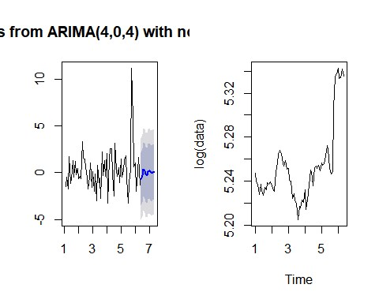

|  |  |
| --- | --- |
| *# Holt Winters Exponential Smoothing Model* | F)  end and without seasonal comp |
| *# if series is stationary then use simple exponential smoothing model* model4<-**HoltWinters**(data,beta = F, gamma = **summary**(model4)  ## Length Class Mode  ## fitted 128 mts numeric  ## x 65 ts numeric  ## alpha 1 -none- numeric  ## beta 1 -none- logical  ## gamma 1 -none- logical  ## coefficients 1 -none- numeric  ## seasonal 1 -none- character  ## SSE 1 -none- numeric ## call 4 -none- call model4  ## Holt-Winters exponential smoothing without tr onent. ##  ## Call:  ## HoltWinters(x = data, beta = F, gamma = F) |

|  |
| --- |
| ##  ## Smoothing parameters:  ## alpha: 0.9999498  ## beta : FALSE  ## gamma: FALSE  ##  ## Coefficients:  ## [,1] ## a 207.5301  **library**(forecast)  **plot**(**forecast**(model4,12))    *# Holt Winters Exponential Smoothing Model*    *# if series is not stationary and only trend component is present, then use d ouble exponential smoothing model* model5<-**HoltWinters**(data,gamma = F) **summary**(model5)  ## Length Class Mode  ## fitted 189 mts numeric  ## x 65 ts numeric  ## alpha 1 -none- numeric  ## beta 1 -none- numeric  ## gamma 1 -none- logical  ## coefficients 2 -none- numeric  ## seasonal 1 -none- character  ## SSE 1 -none- numeric ## call 3 -none- call model5  ## Holt-Winters exponential smoothing with trend and without seasonal compone nt. ##  ## Call:  ## HoltWinters(x = data, gamma = F)  ##  ## Smoothing parameters:  ## alpha: 1  ## beta : 0.08842156  ## gamma: FALSE  ##  ## Coefficients:  ## [,1]  ## a 207.5299990 ## b 0.7924614 **plot**(**forecast**(model5,12)) |

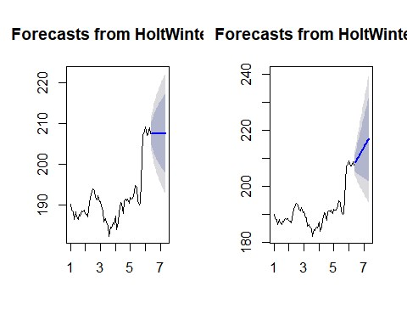

|  |  |
| --- | --- |
| **plot**(**log**(data)) | *# Holt Winters Exponential Smoothing Model*  *# if series is not stationary and trend, seasonality component is present, th en use tripple exponential smoothing model*  (data)    ## Length Class Mode  ## fitted 212 mts numeric  65 ts numeric -none- numeric  -none- numeric  -none- numeric  -none- numeric  -none- character  -none- numeric  -none- call  Winters exponential smoothing with trend and additive seasonal compon |
| model6<-**HoltWinters summary**(model6)  ## x  ## alpha 1  ## beta 1  ## gamma 1  ## coefficients 14  ## seasonal 1  ## SSE 1 ## call 2 model6  ## Holtent. ##  ## Call:  ## HoltWinters(x = data) ## |
| ## Smoothing parameters:  ## alpha: 0.9039743  ## beta : 0 ## gamma: 1  ##  ## Coefficients:  ## [,1]  ## a 206.47238517  ## b 0.33351689  ## s1 2.15703648  ## s2 -0.63318618  ## s3 -0.23391222  ## s4 -0.11991297  ## s5 1.47358988  ## s6 1.27297528  ## s7 0.29666706  ## s8 -0.05308394  ## s9 -1.96662951  ## s10 -2.49227872  ## s11 -0.54306702 ## s12 1.05761383 **plot**(**log**(data)) | |

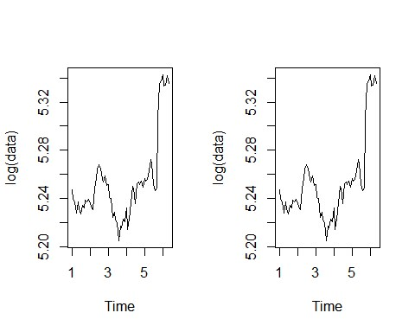

|  |  |
| --- | --- |
| **plot**(**forecast**(model6,12)) |  |
| *# MAPE* |

|  |  |
| --- | --- |
| *# Automatic Exponential Smoothing Model* | ME RMSE MAE MPE MAPE MASE    E MAPE MASE |
| model7<-**ets**(data) **summary**(model7)  ## ETS(M,N,N)  ##  ## Call:  ## ets(y = data)  ##  ## Smoothing parameters:  ## alpha = 0.9999  ##  ## Initial states:  ## l = 190.0165  ##  ## sigma: 0.0115  ##  ## AIC AICc BIC  ## 378.0199 378.4133 384.5431  ##  ## Training set error measures:  ##  ## Training set 0.2694668 2.171911 1.450364 0.1294136 0.7535737 0.230003 ## ACF1 ## Training set 0.1710693 **accuracy**(model7)  ## ME RMSE MAE MP  ## Training set 0.2694668 2.171911 1.450364 0.1294136 0.7535737 0.230003 ## ACF1 ## Training set 0.1710693 **plot**(**log**(data)) |

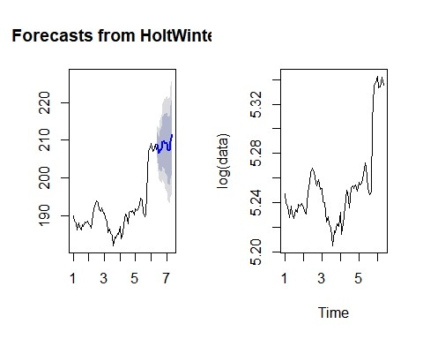

|  |  |
| --- | --- |
| **plot**(**forecast**(model7,12)) |  |

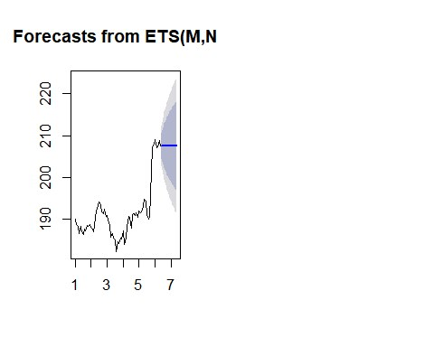

d. After 15 days again collect the data and compare with your forecast

library(readr)

AAPLAug10toAug25 <- read.csv("AAPLAug10toAug25.csv")

View(AAPLAug10toAug25) df<-AAPLAug10toAug25 head(df)

|  |  |  |  |
| --- | --- | --- | --- |
|  | | Date Open High Low Close Adj.Close Volume |  |
|  | 1 2018-08-10 207.36 209.10 206.67 207.53 207.53 24611200 | |  |
|  | 2 2018-08-13 207.70 210.95 207.70 208.87 208.87 25869100 | |  |
|  | 3 2018-08-14 210.16 210.56 208.26 209.75 209.75 20748000 | |  |
|  | 4 2018-08-15 209.22 210.74 208.33 210.24 210.24 28807600 | |  |
|  | 5 2018-08-16 211.75 213.81 211.47 213.32 213.32 28500400 | |  |
|  | 6 2018-08-17 213.44 217.95 213.16 217.58 217.58 35427000 | |  |

str(df)

'data.frame': 11 obs. of 7 variables:

$ Date : Factor w/ 11 levels "2018-08-10","2018-08-13",..: 1 2 3 4 5 6 7 8 9 10 ...

$ Open : num 207 208 210 209 212 ...

$ High : num 209 211 211 211 214 ...

$ Low : num 207 208 208 208 211 ...

$ Close : num 208 209 210 210 213 ...

$ Adj.Close: num 208 209 210 210 213 ...

$ Volume : int 24611200 25869100 20748000 28807600 28500400 35427000 30287700 261598

00 19018100 18883200 ...

new_date <- as.Date(df$Date) new_date

[1] "2018-08-10" "2018-08-13" "2018-08-14" "2018-08-15" "2018-08-16" "2018-08-17" "2018 -08-20"

[8] "2018-08-21" "2018-08-22" "2018-08-23" "2018-08-24" str(df)

'data.frame': 11 obs. of 7 variables:

$ Date : Factor w/ 11 levels "2018-08-10","2018-08-13",..: 1 2 3 4 5 6 7 8 9 10 ...

$ Open : num 207 208 210 209 212 ...

$ High : num 209 211 211 211 214 ...

$ Low : num 207 208 208 208 211 ...

$ Close : num 208 209 210 210 213 ...

$ Adj.Close: num 208 209 210 210 213 ...

$ Volume : int 24611200 25869100 20748000 28807600 28500400 35427000 30287700 261598

00 19018100 18883200 ... format(new_date,format="%B %d %Y")

[1] "August 10 2018" "August 13 2018" "August 14 2018" "August 15 2018" "August 16 2018

"

[6] "August 17 2018" "August 20 2018" "August 21 2018" "August 22 2018" "August 23 2018 "

[11] "August 24 2018"

>

> # %d - day as number 1-31

> # %a - weekday such as Mon

> # %A- complete day name ex.Monday

> # %m - month as a number

> # %b - short form of month Jan, Feb

> # %B - full form of month, January

> # %y - two digit year

> # %Y- four digit year

>

> data = ts(df$Close,frequency =12)

>

> plot(data,main="Monthly Closing Prices")

> # Additive Time Series

> # Trend + Seasonality+ Cyclicity+ error

> # Multiplicative Time Series

> ## Trend * Seasonality * Cyclicity * error

>

> # additive model is easy to explain, easy to forecast and interpret

# multiplicate models can be converted to additive models using log of the time series log(data)

Jan Feb Mar Apr May Jun Jul Aug Sep

Oct

1 5.335276 5.341712 5.345916 5.348250 5.362793 5.382567 5.372775 5.370824 5.370871 5.372

915

Nov

1 5.376019