1. Due Date is getting populated automatically. It shall be filled manually and only future date shall be selected.

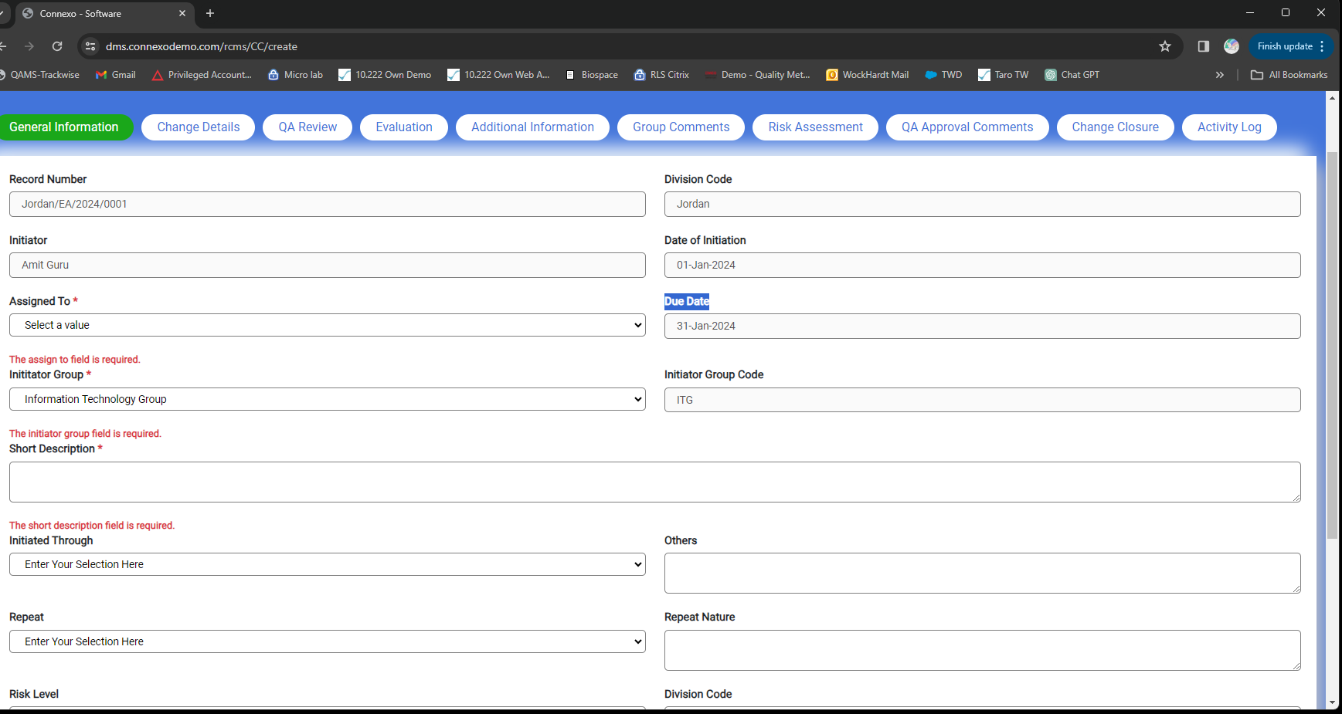

1. If I am saving the record without filling other mandatory data fields data is getting vanished.

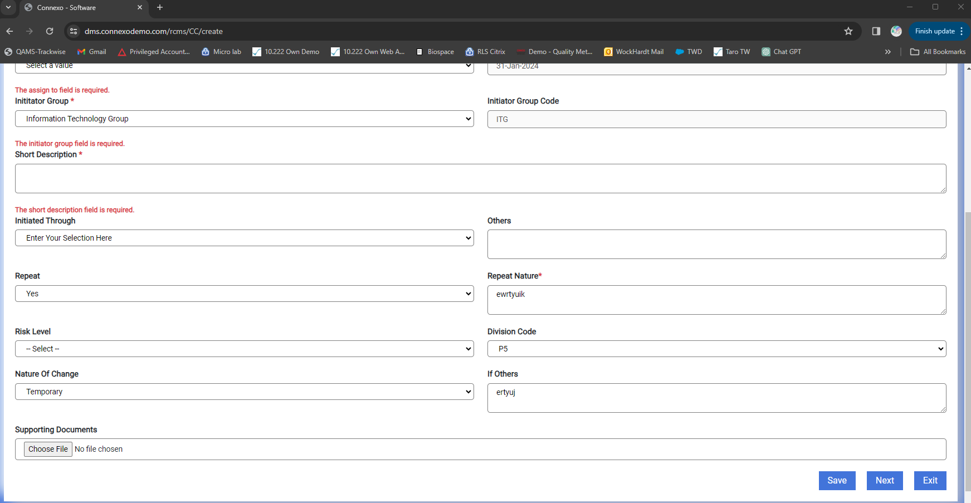

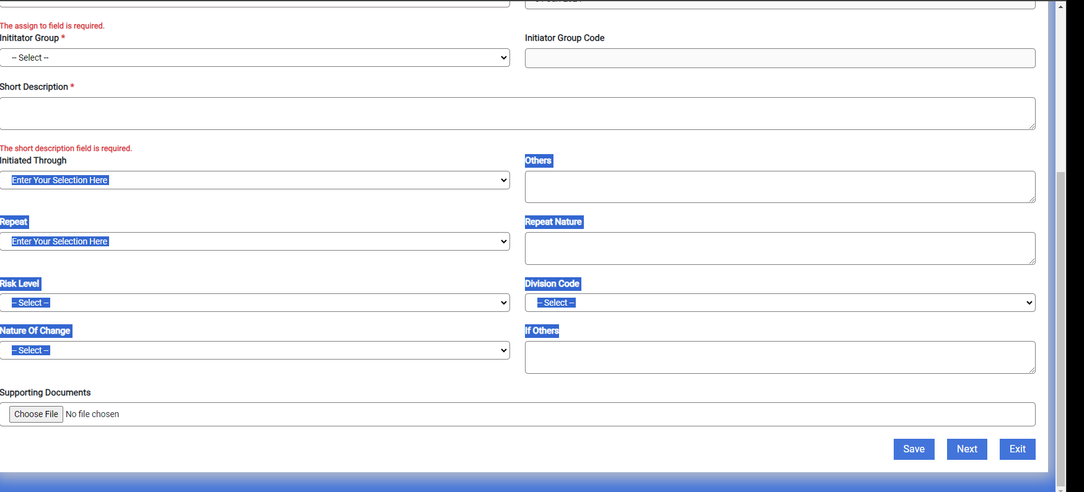

1. Not able to attach multi attachments

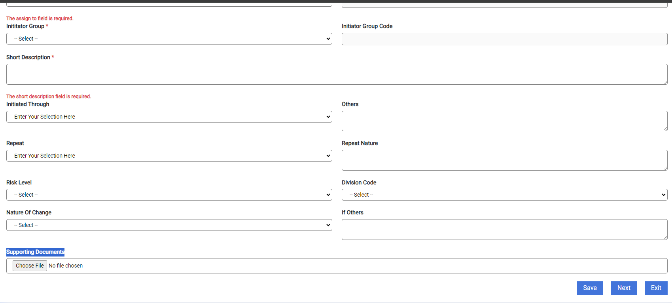

1. In Place of Extension Child write Child and in Child menu write Extension

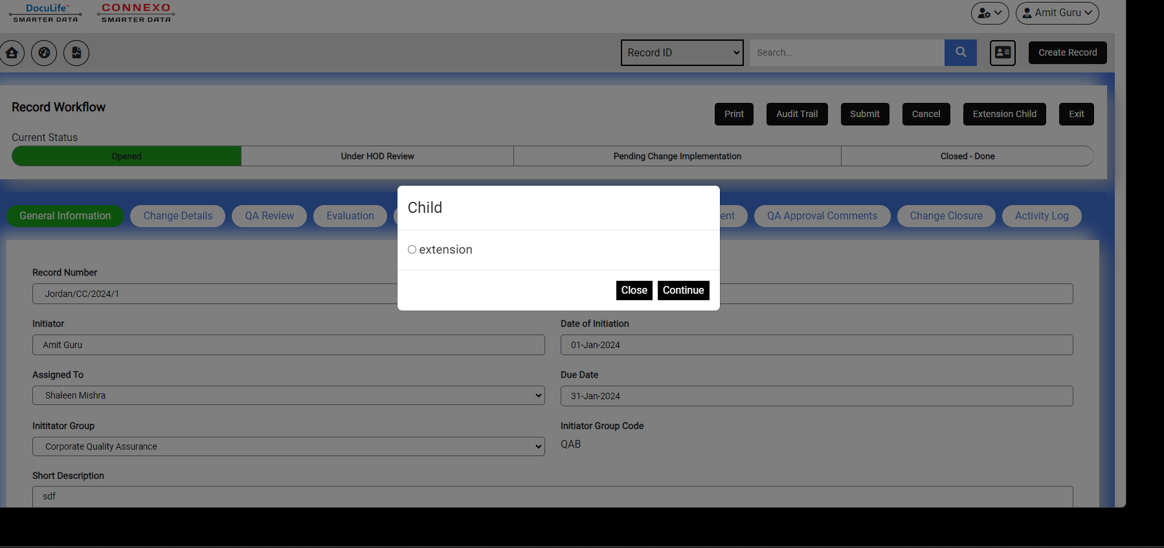

1. Change Control form is totally wrong it is copied from reliance but we have updated to update it from our DMS. Need Proper clarification from Ved.

