1. 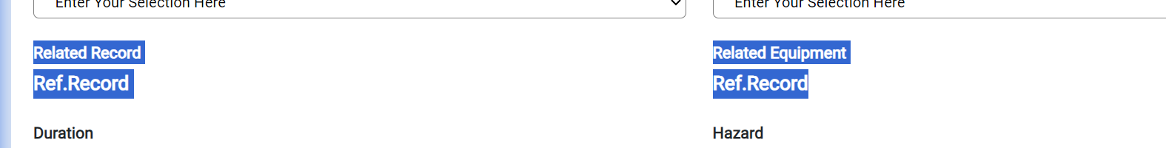
2. Only Future or Current Date shall be selected

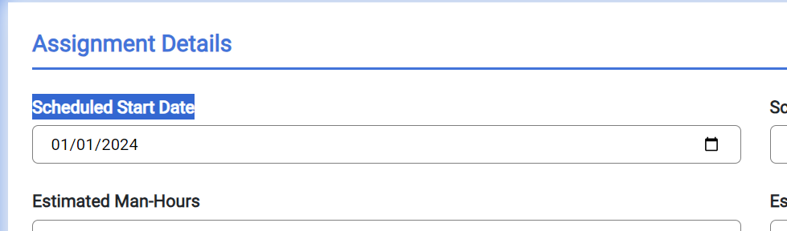

1. Date After Scheduled Start Date shall be selected.

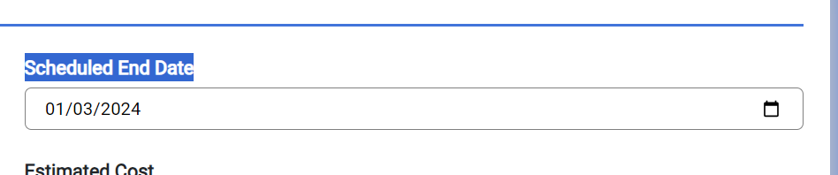

1. This shall be person data field

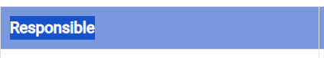

1. This shall be Referenced records datafield where user shall be able to add existing action item records



1. Whatever user is selecting is the datafield that should get mandatory.

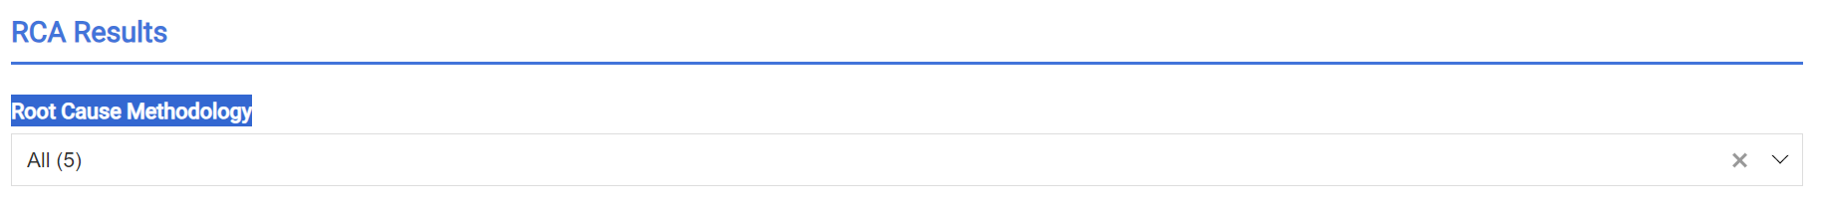

1. Delete button is not there

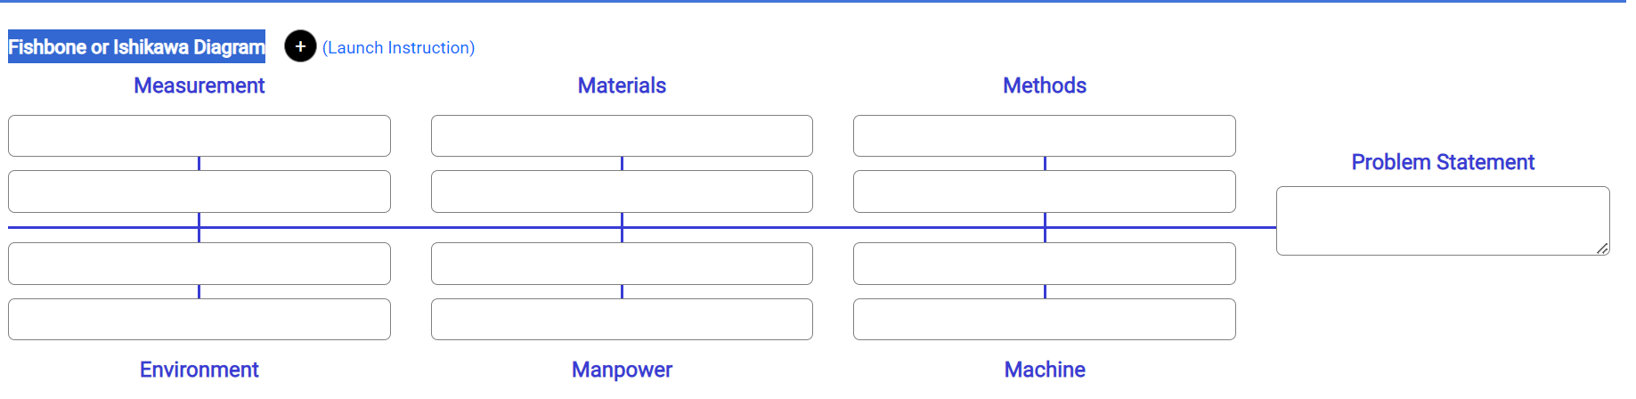

1. Delete button is not there

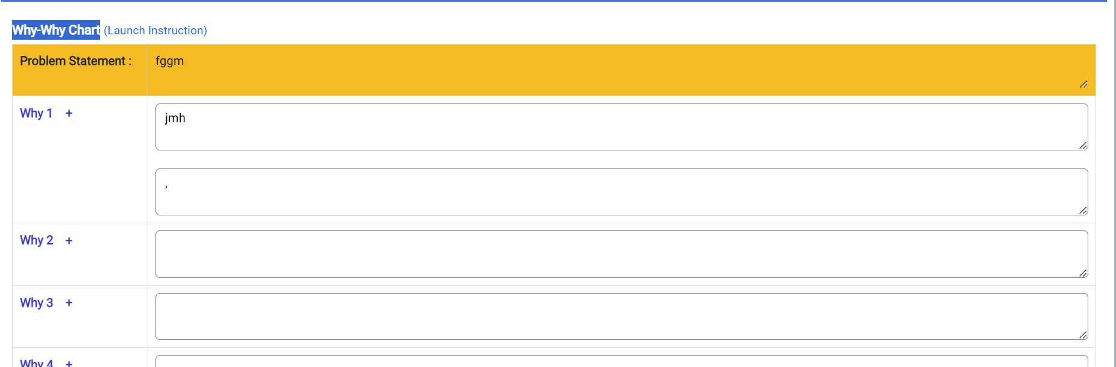

1. When Yes is selected mitigation Plan shall get mandatory

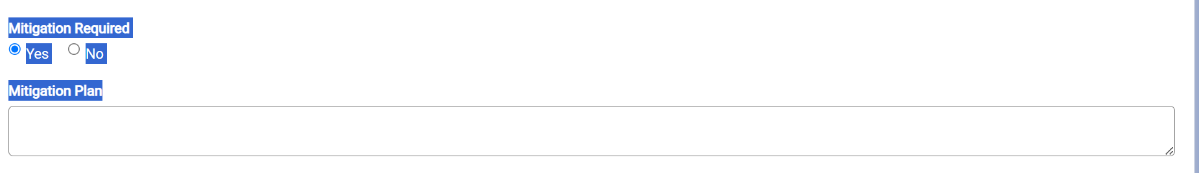

1. Audit Trail is totally wrong

