1. If Others shall get mandatory when Others is selected in Type of Audit

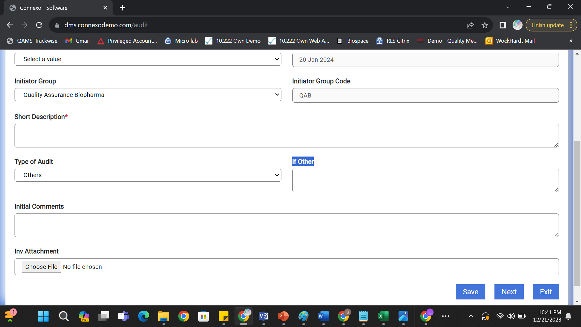

1. Not able to select multi attachments in File attachments data field. And fill name shall be available whichever file are uploaded

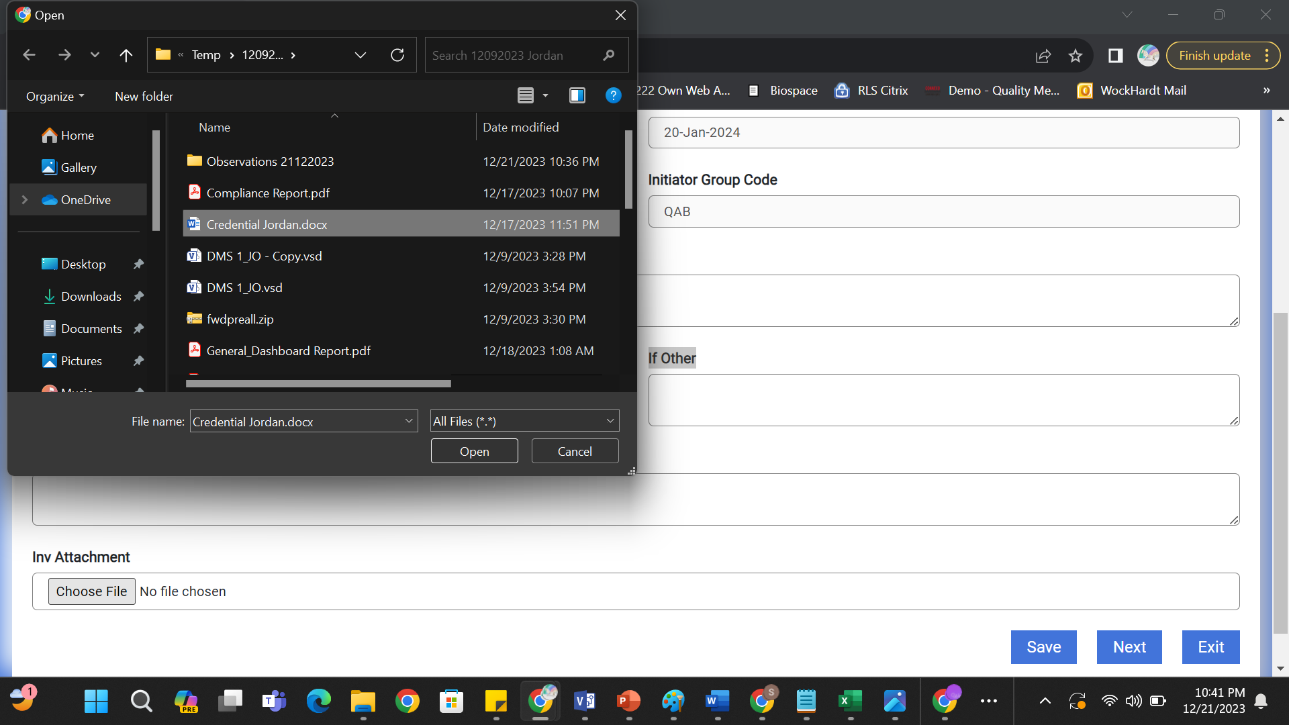

1. Auditor and Auditee data field shall be Person Data Field

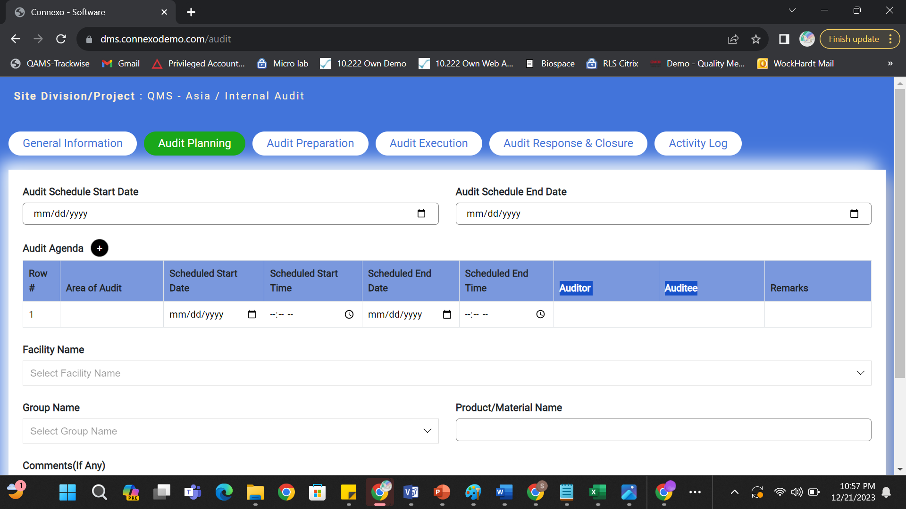

1. Add Due Date Data field in General Information Tab

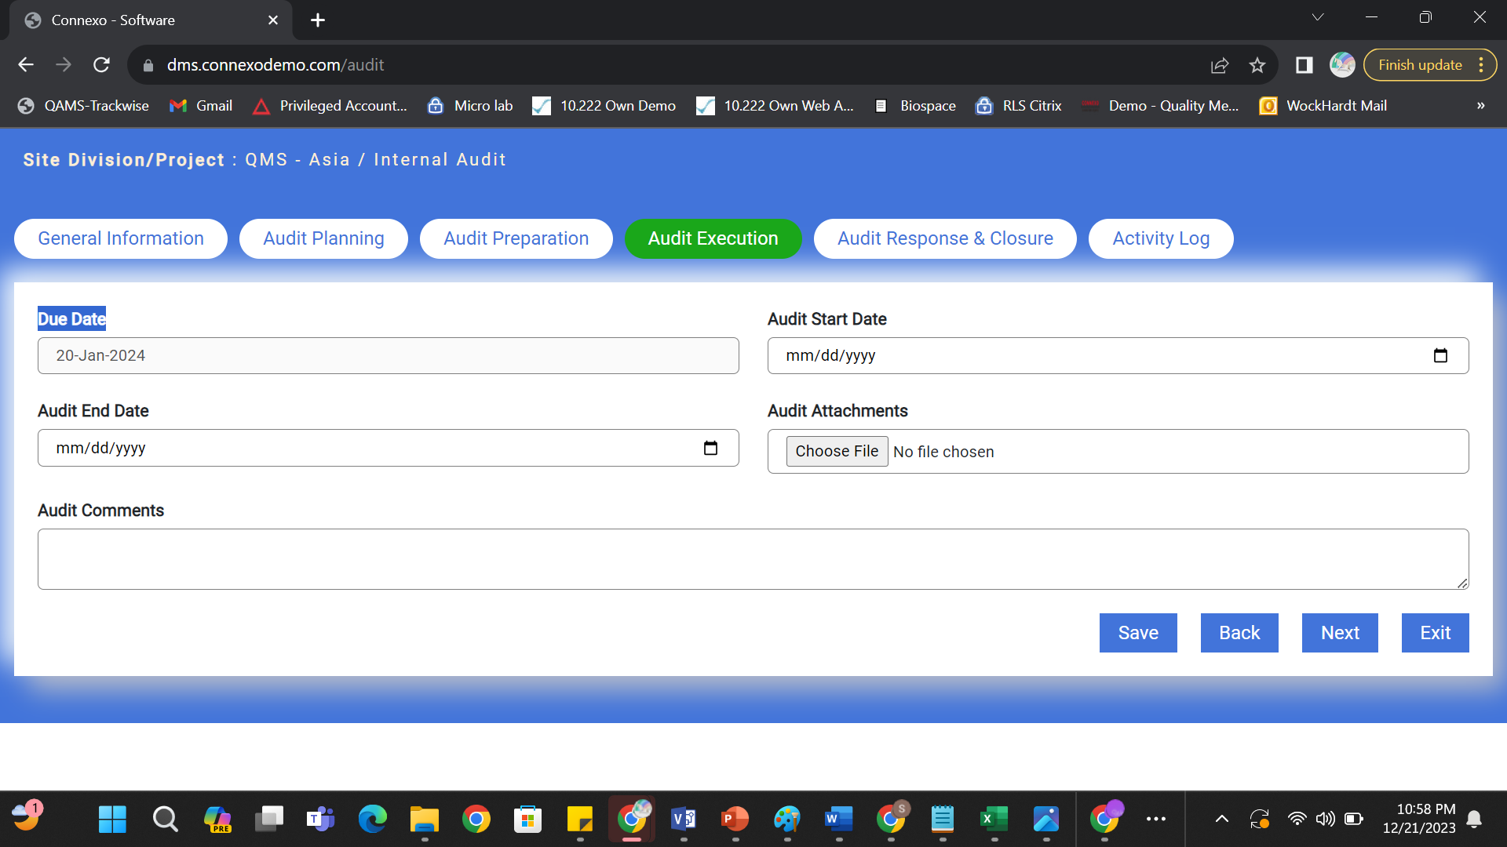

1. These Data fields are getting Repeated

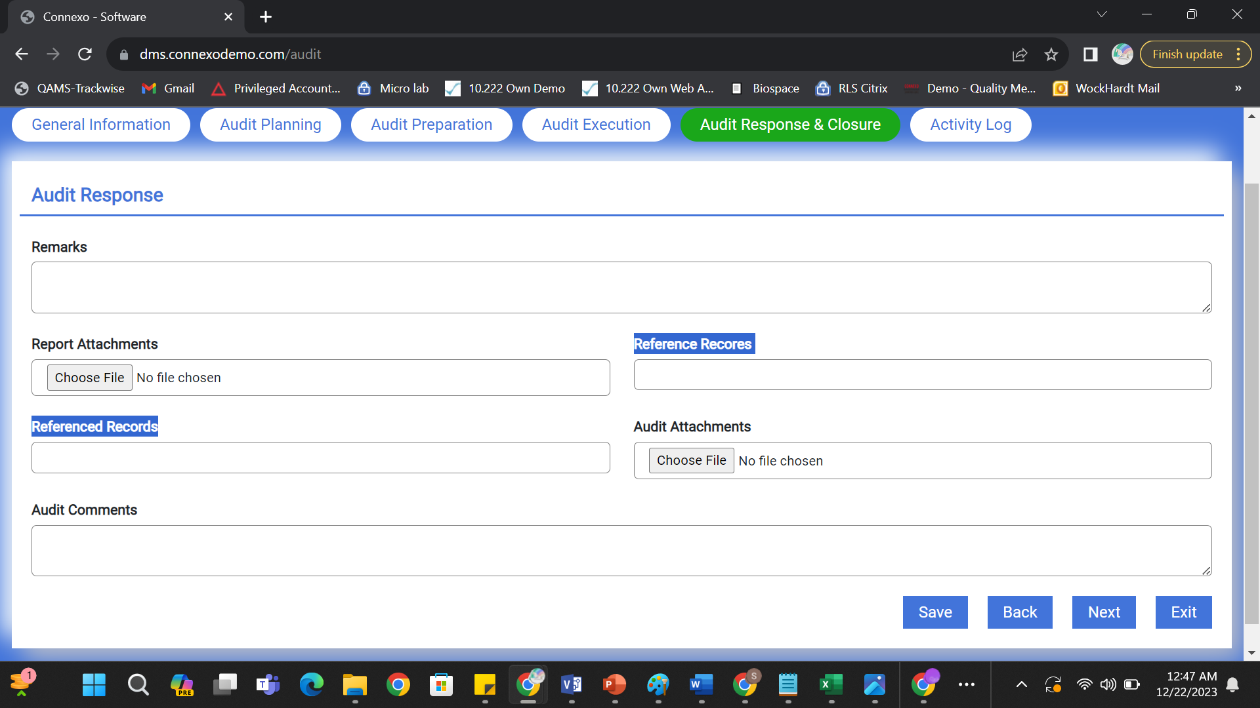

1. The data fields shall be referenced record type where user can attach old records



1. Information is Wrong

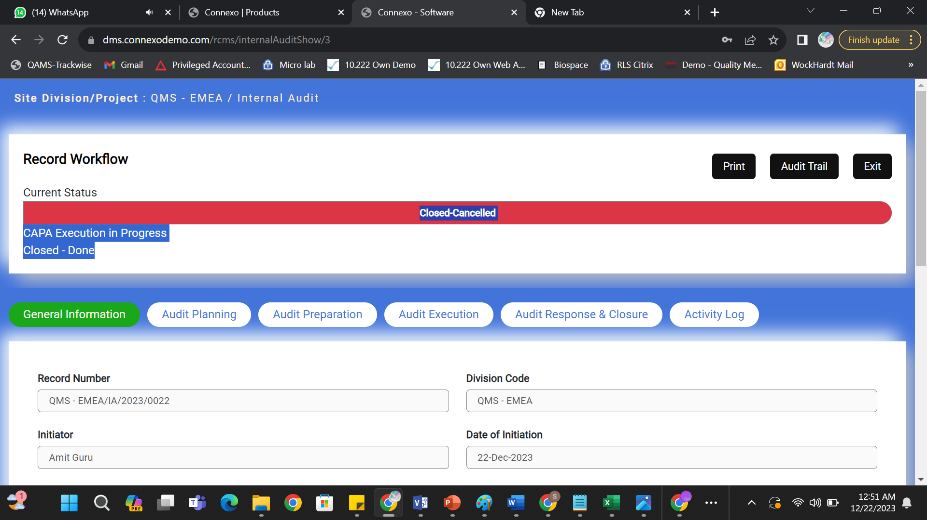

1. Information is getting editied when record is closed cancelled same is happening when record is closed done.

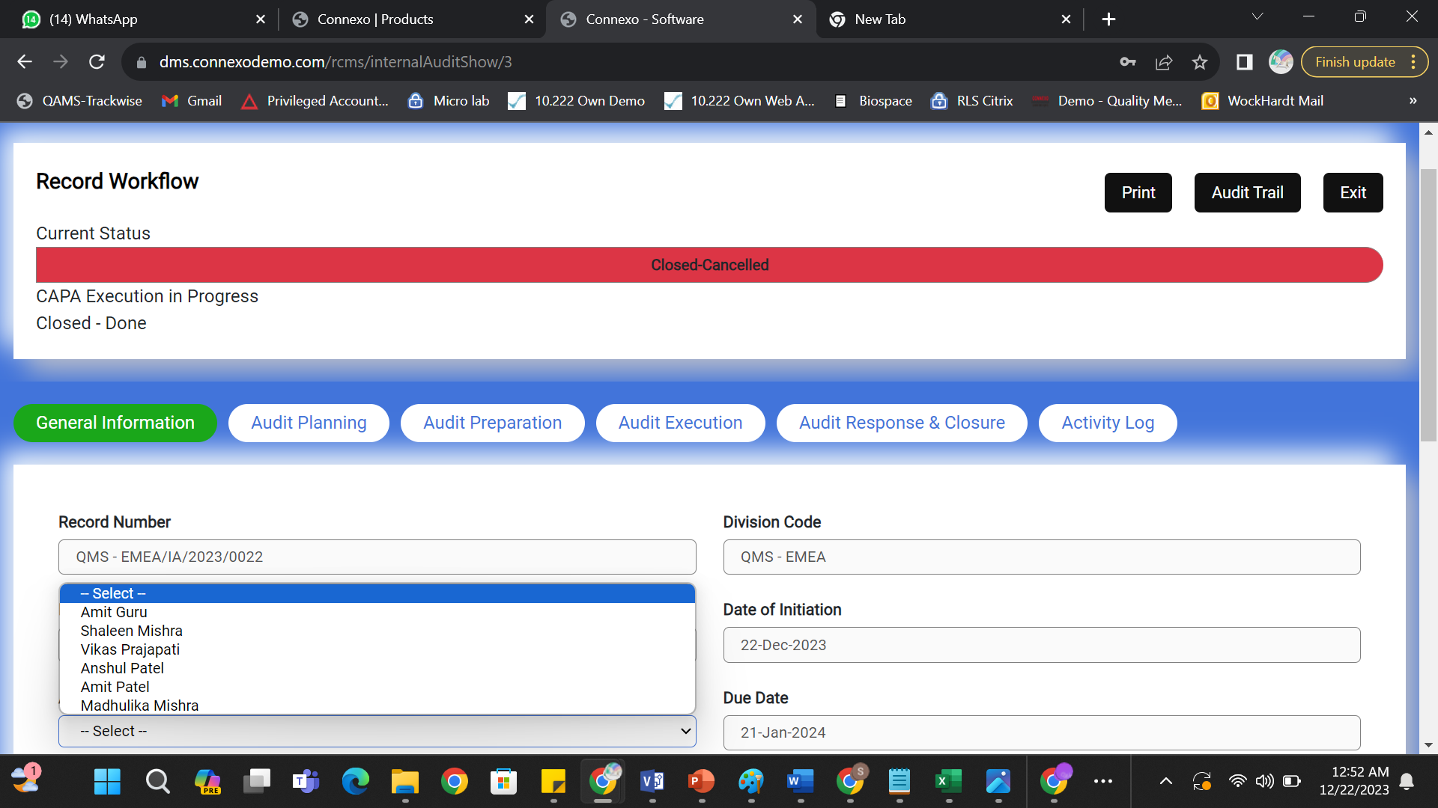

1. Save button is enabled when record is closed cancelled or closed done it should not appear

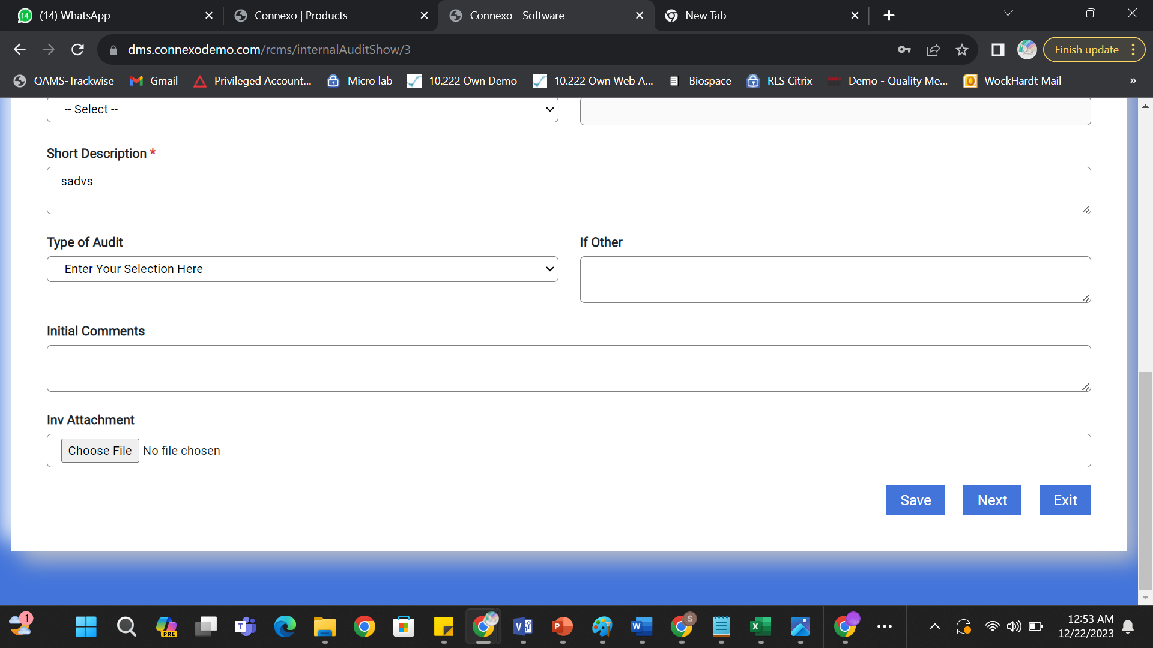

1. Audit Trail is totally wrong Please correct

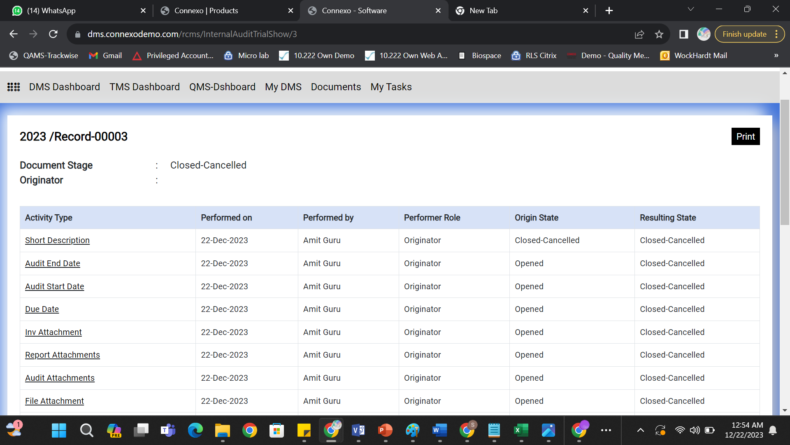

1. Configure report templates inline with Audit Trail Preview

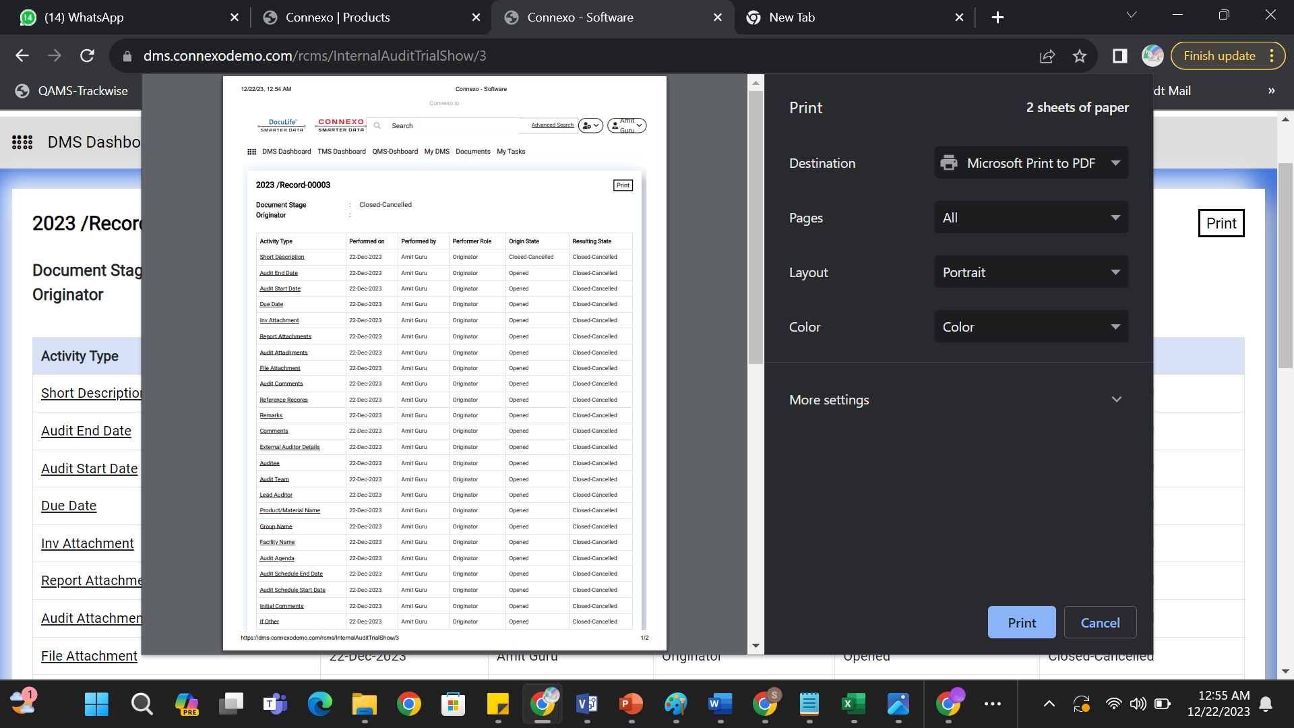

1. Make all the data fields dynamic