1. Document is created successfully is getting populated it should replaced with “Record is created successfully”

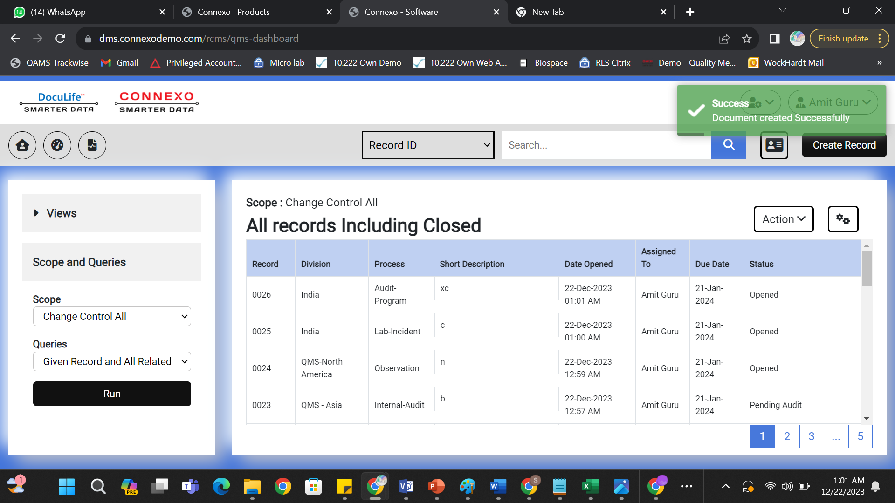

1. Scopes and Queries shall be dynamic

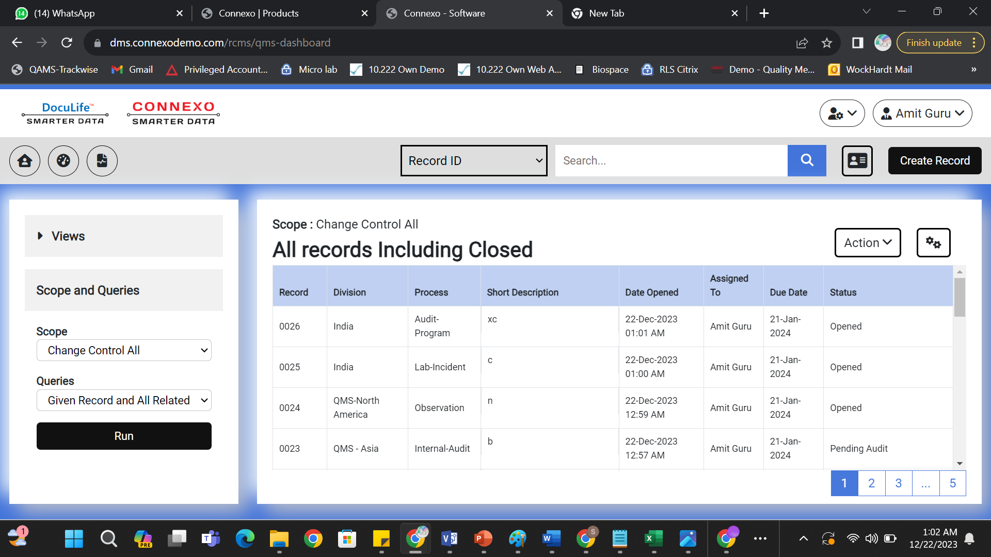

1. Dashboards (Logs) shall be dynamic

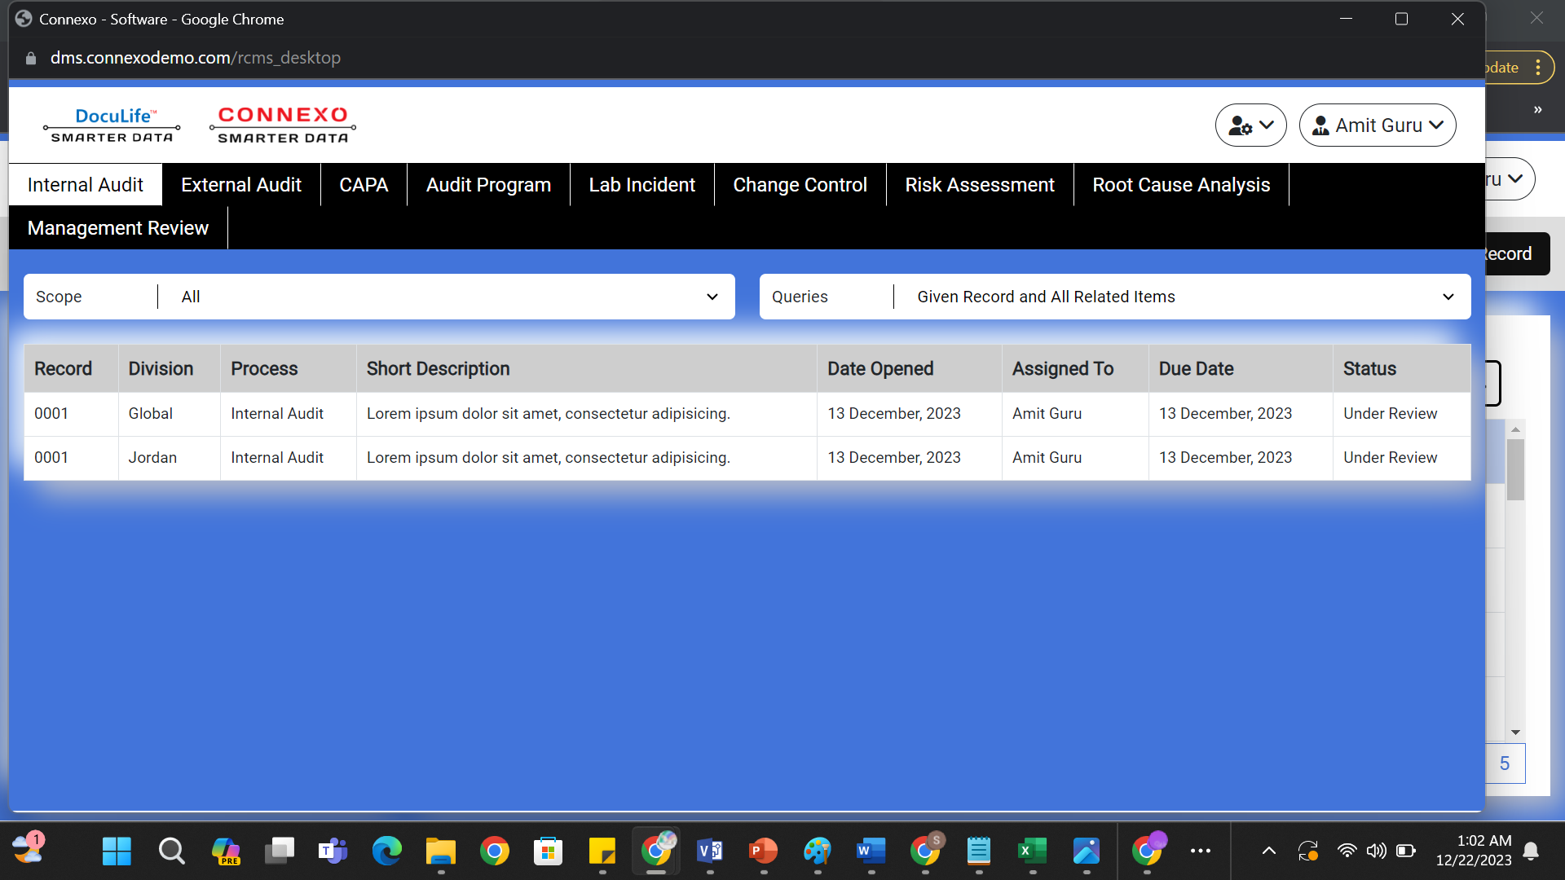

1. These Buttons shall be dynamic (1,2,3…,5) Right now they are not working

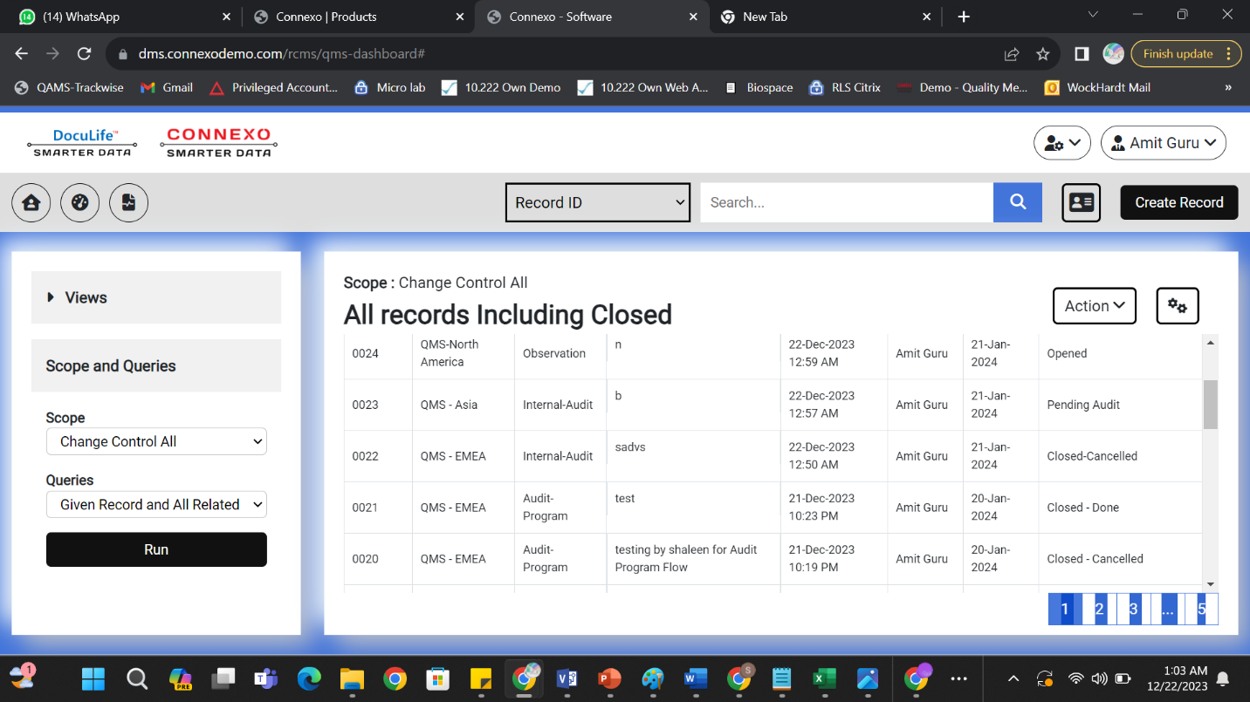

1. Make scopes and queries dynamic in dashboards

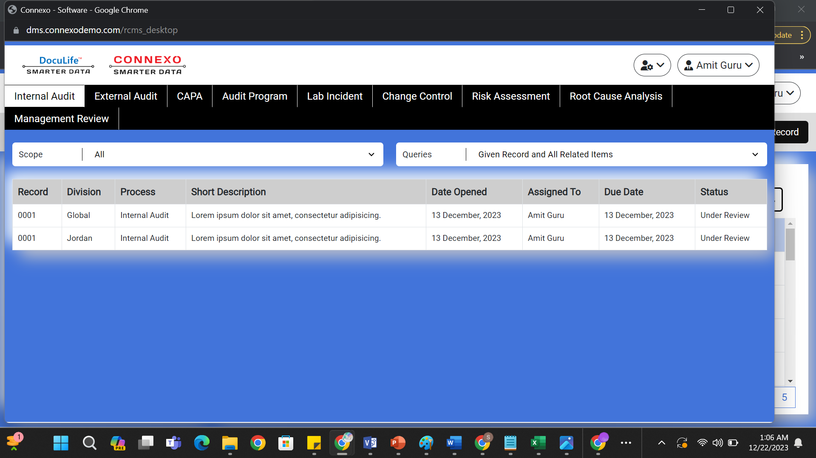

1. Give PDF Export feature for dashboards



1. Make these buttons dynamic right now they are static

