1. Initiator Group code is populating without any selection in Initiator Group

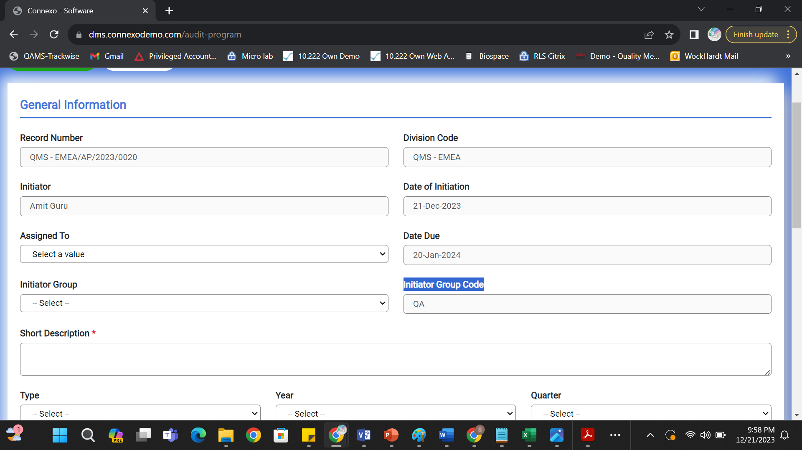

1. Auditees shall be person datafield.

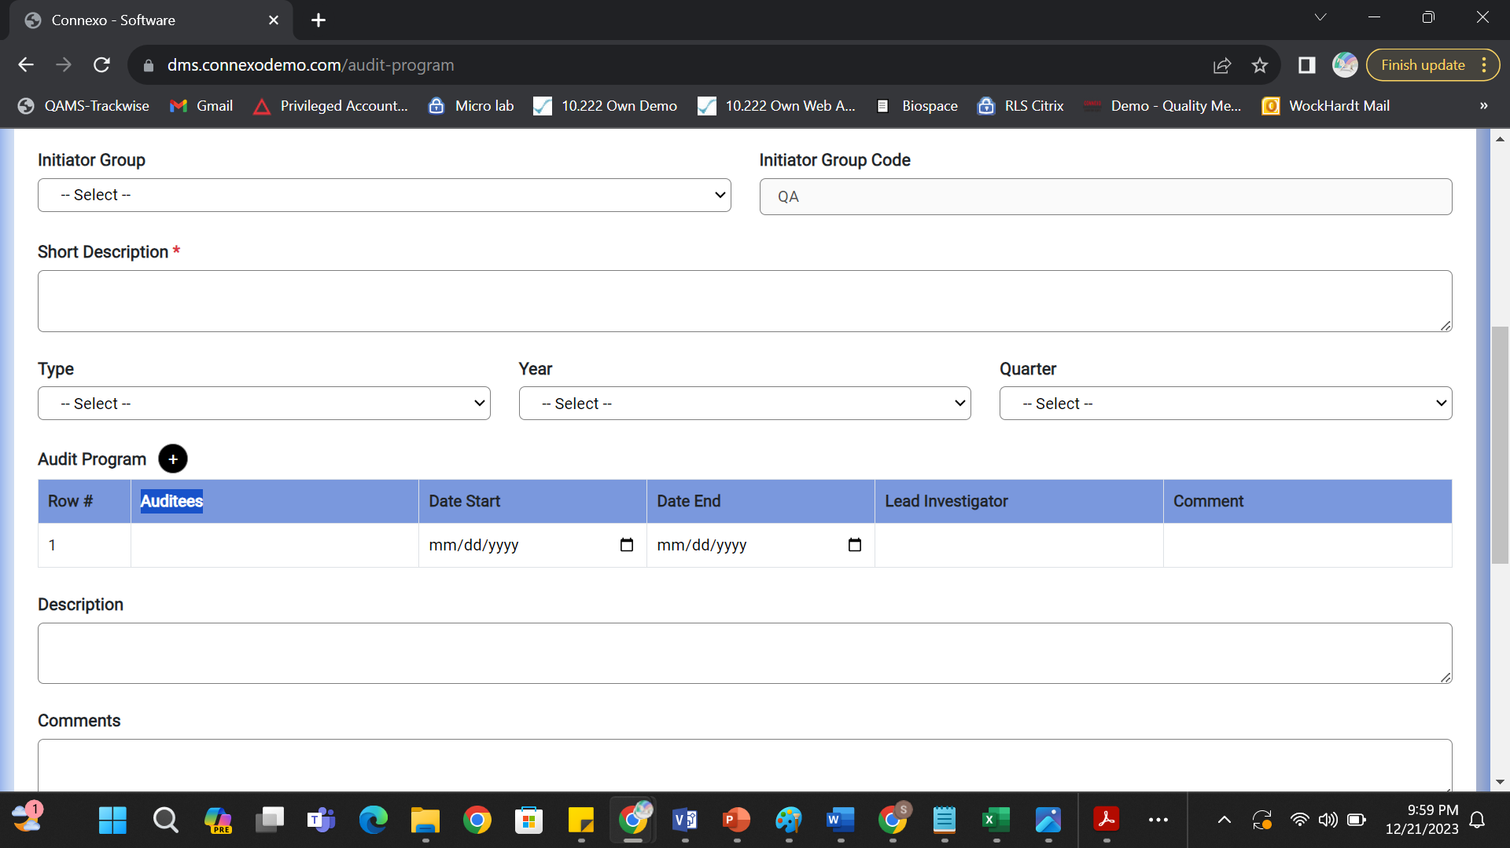

1. Lead Investigator shall be Person data field.

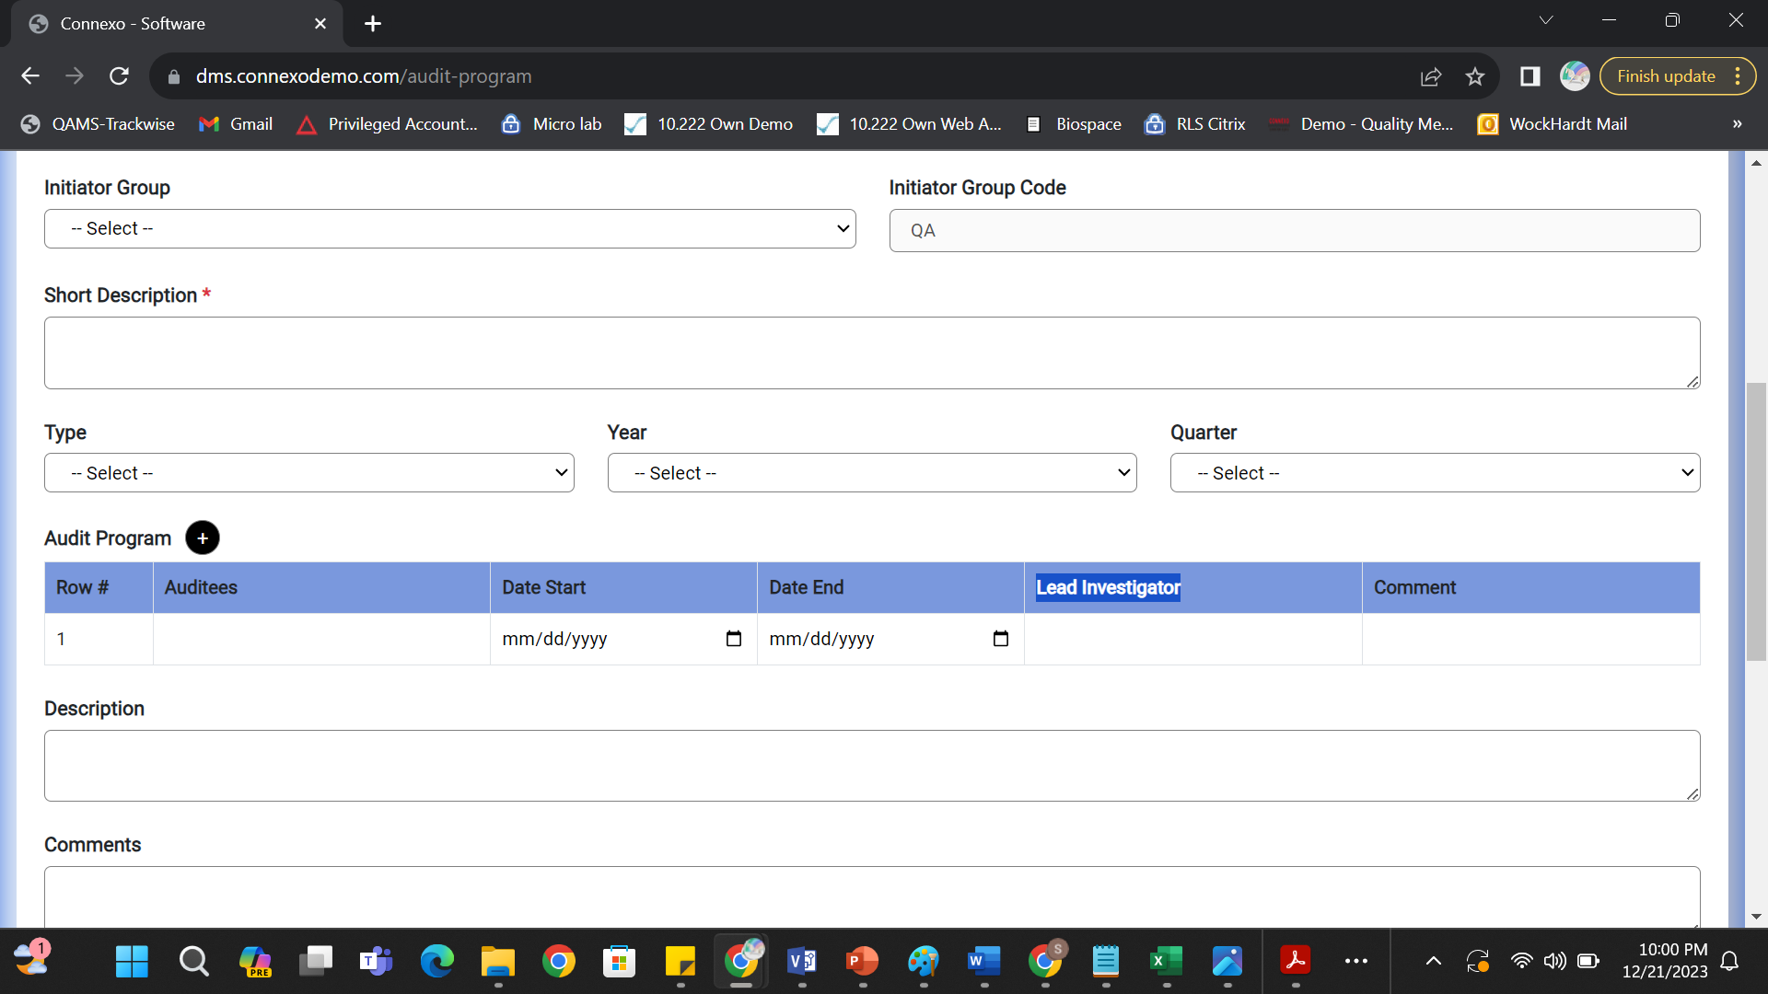

1. Related URL shall be web URL based data field.

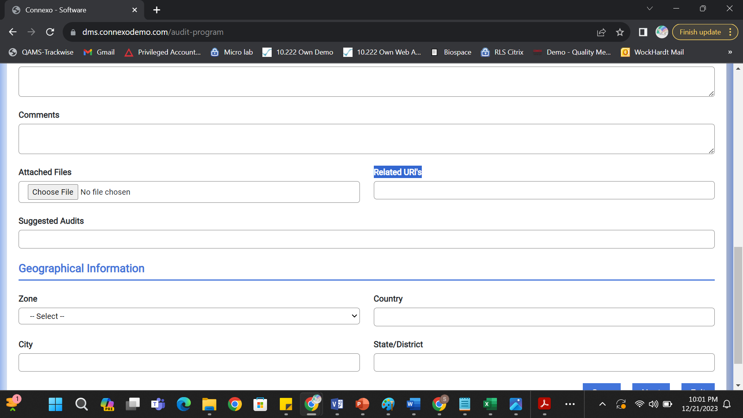

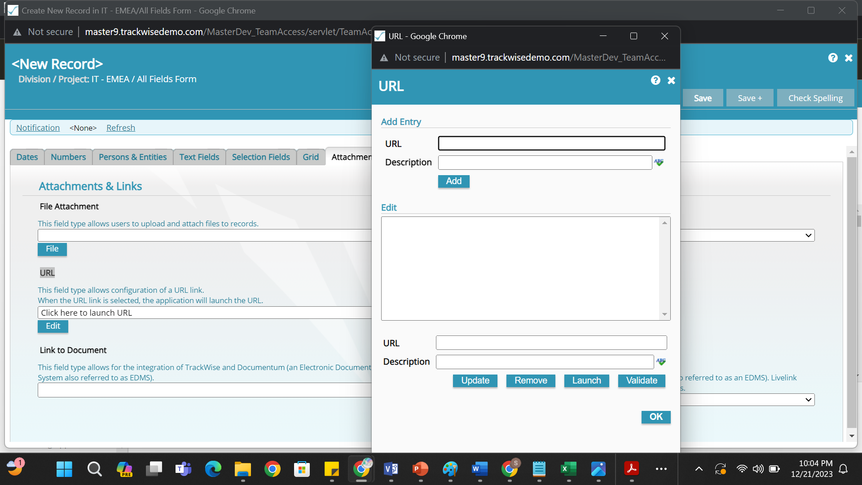

1. Country, City and State shall be single selection Data Fields

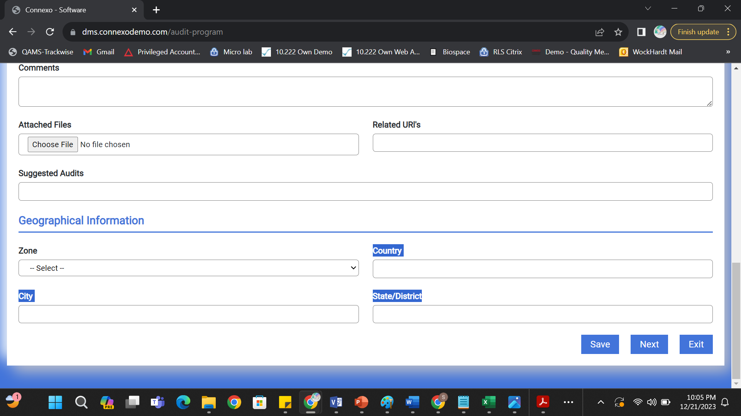

1. Population Rules

Country shall populate on the basis of Zone

City shall populate on the basis of Country selection

State/District shall populate on the basis of Country

1. Not able to attach multiple files in File Attachment data field (This is applicable to all the file attachments data fields)

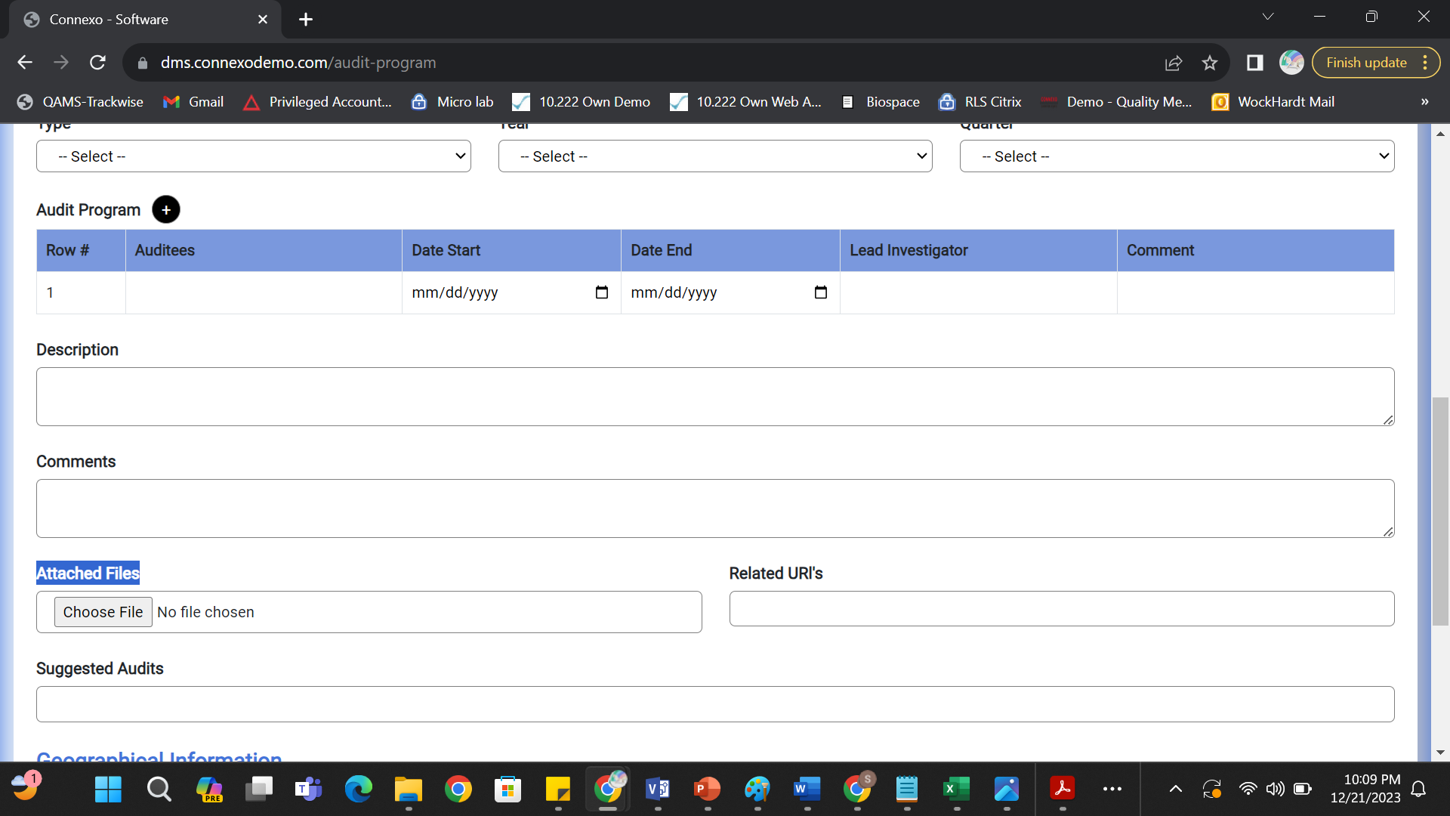

1. Signatures Tab is not working for any Config form kindly correct and do the same for every configform.

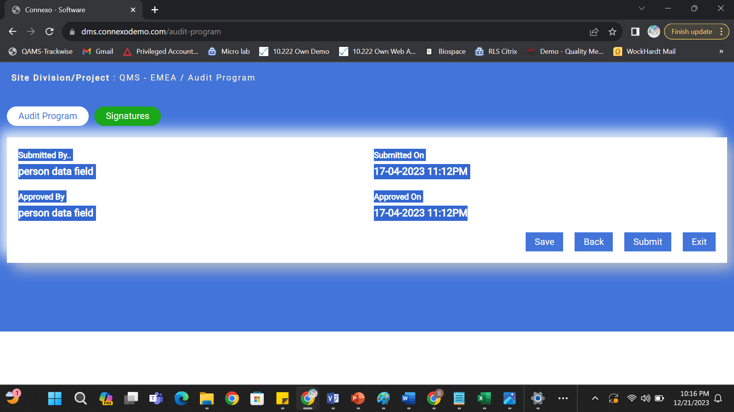

1. Exit button is not working please check

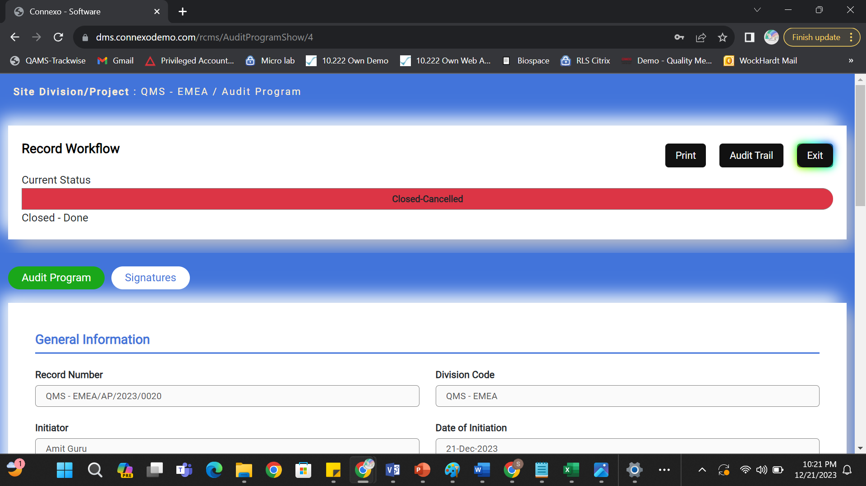

1. While cancelling the record comments shall be mandatory.



1. While Performing Reject Activity Comments shall get mandatory.

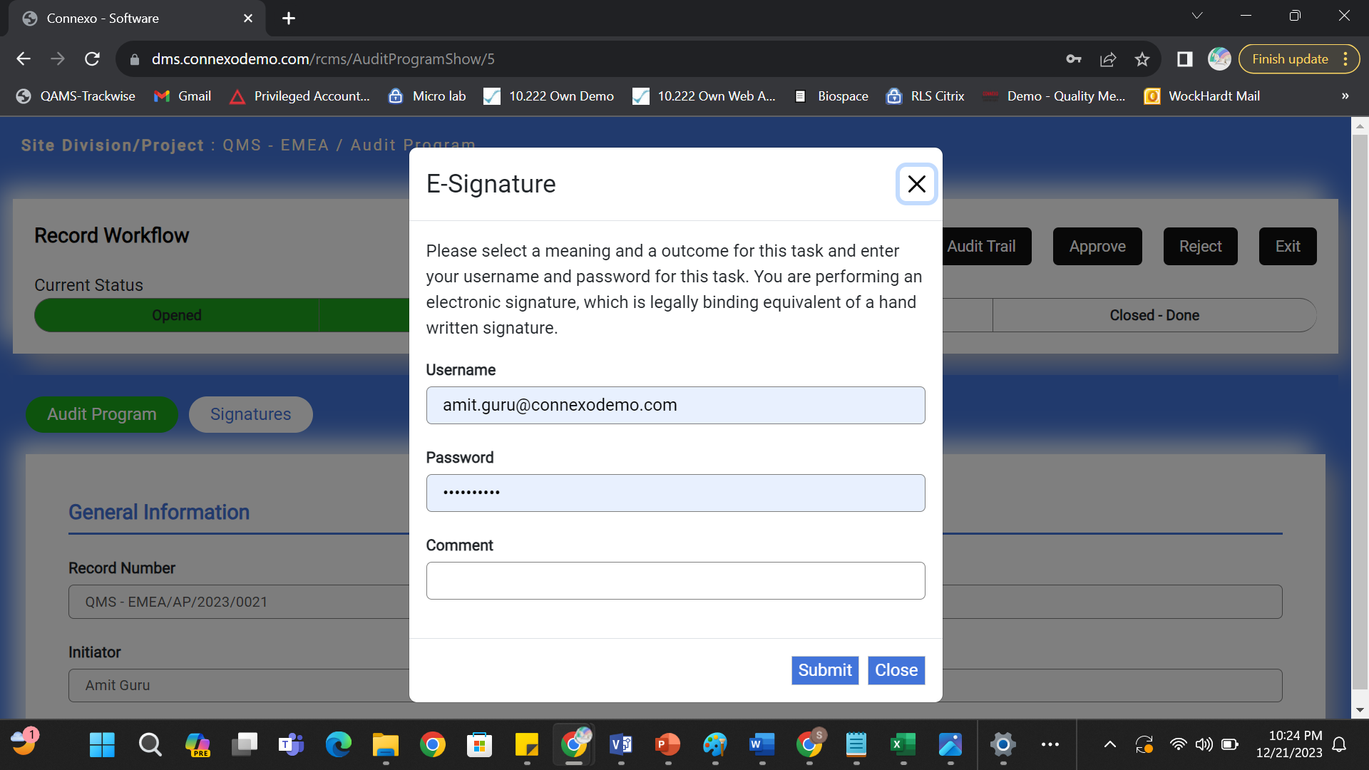

1. Clicking on Cancel Button Record is moving to Closed-Done Please check.

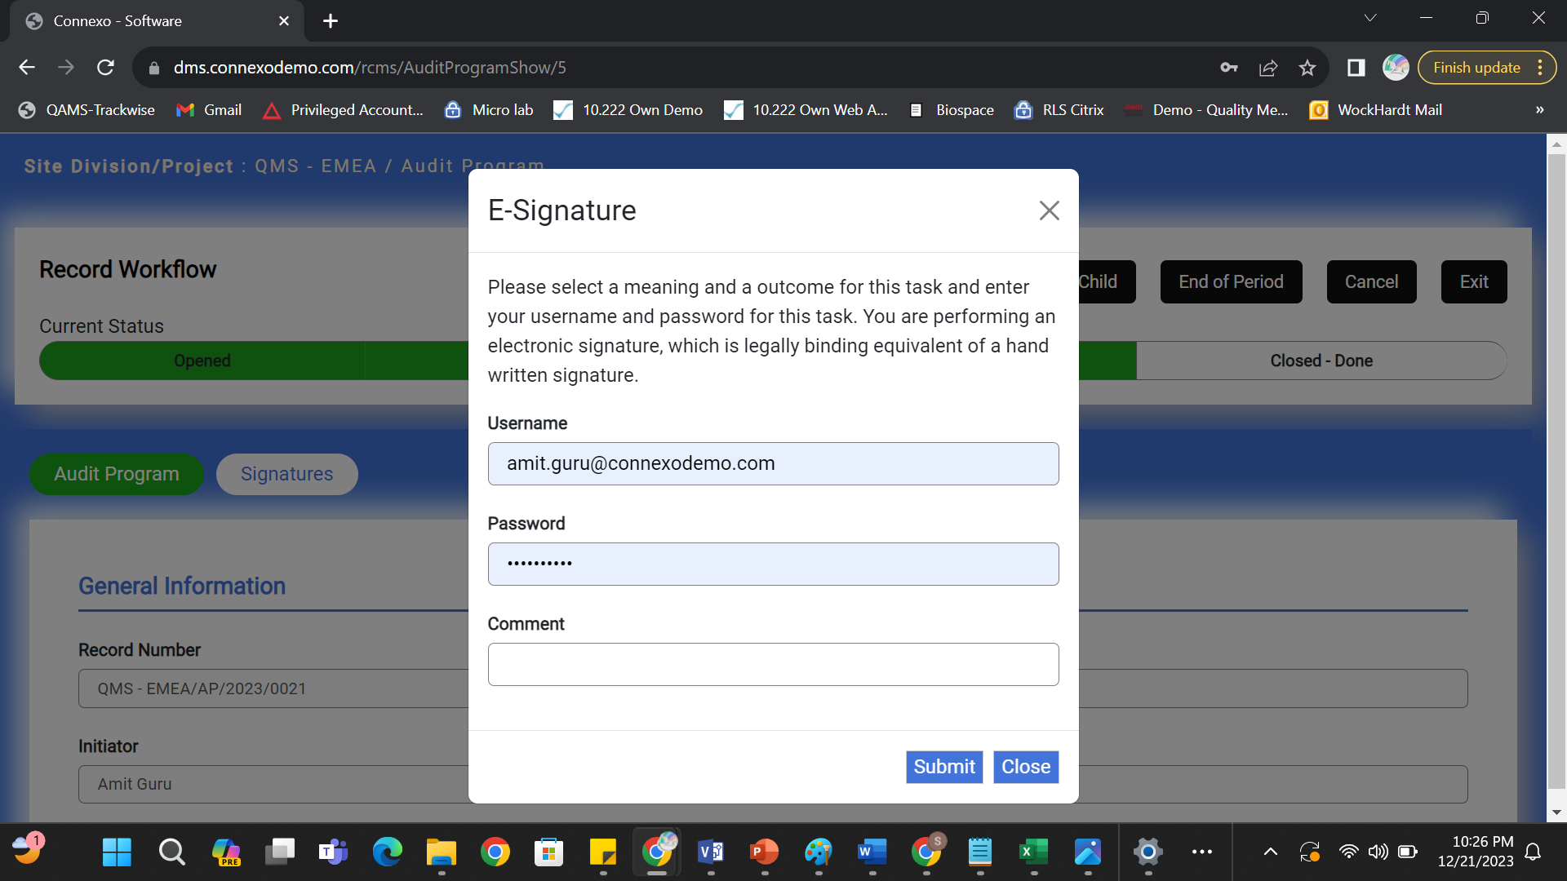

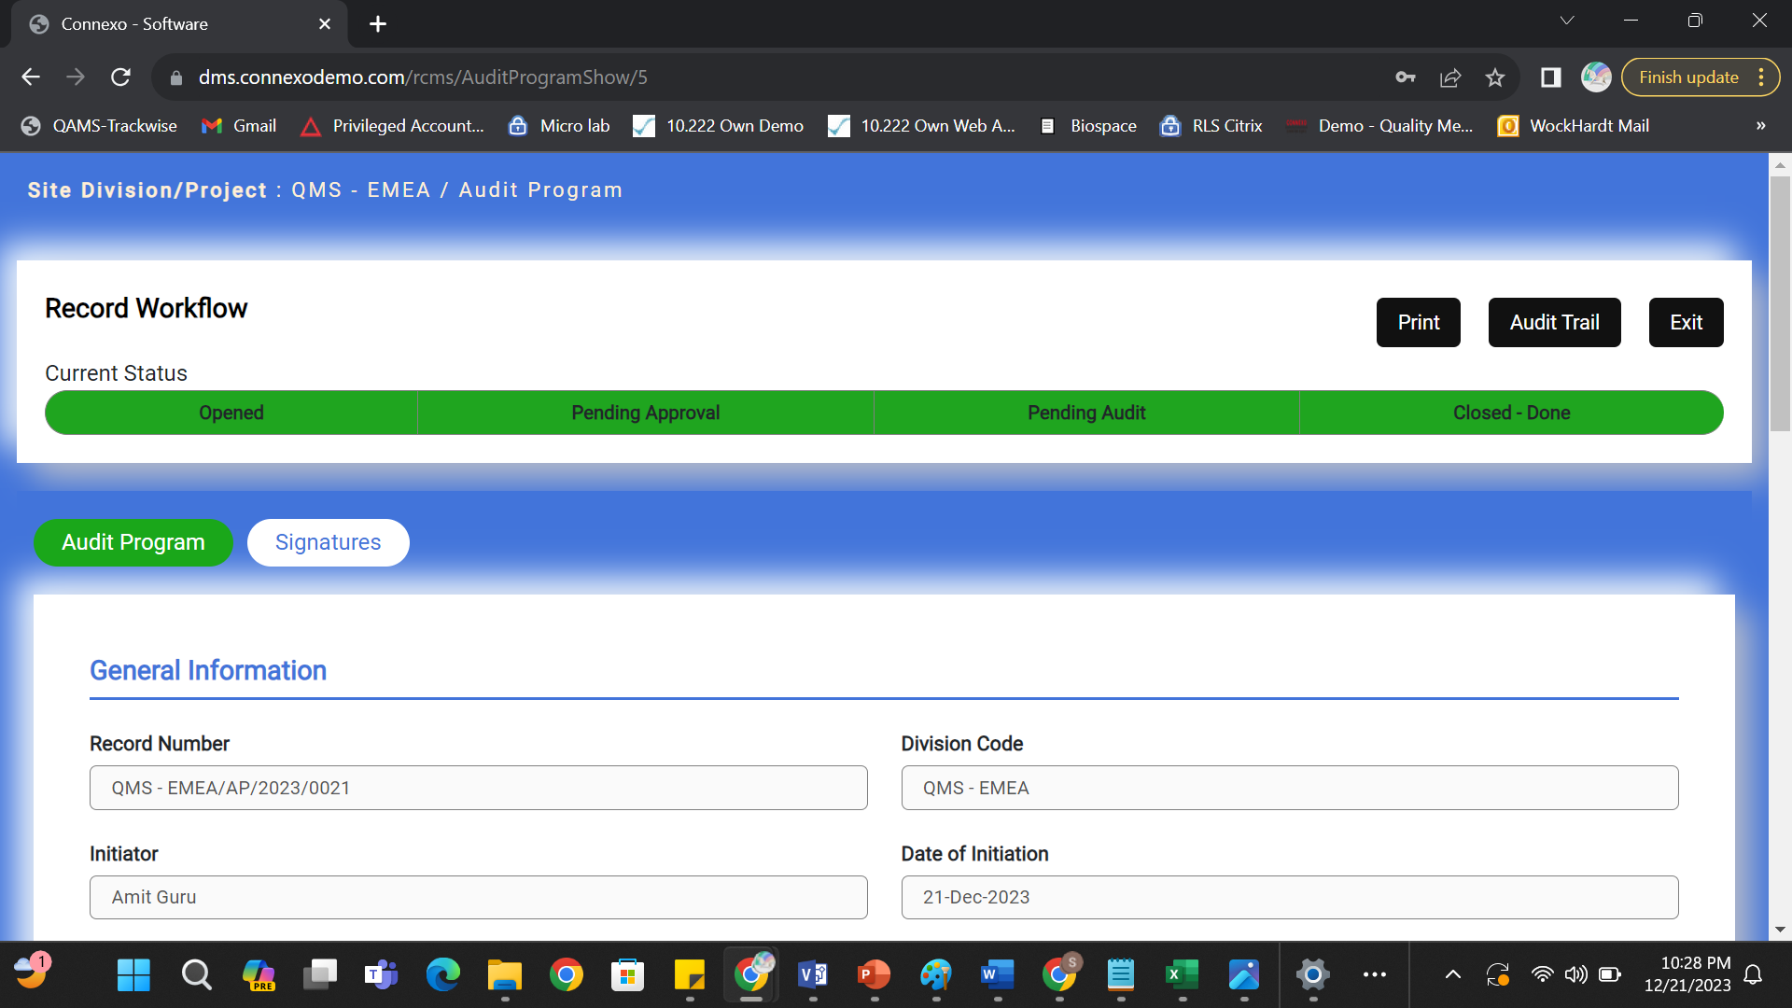

1. When Record is in Closed Done state the data present in Short Description Data field is getting deleted please check it should not happen as it is against data integrity.

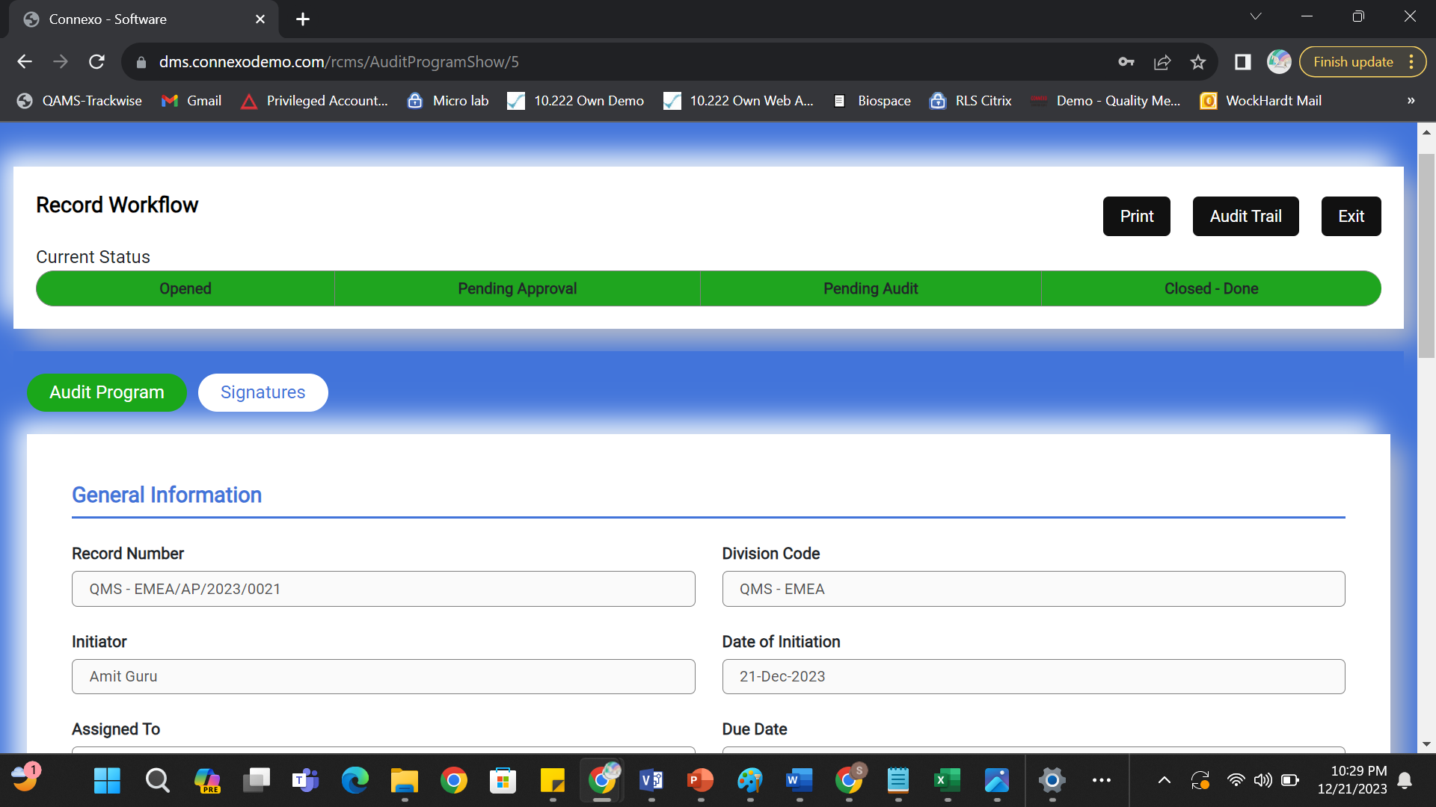

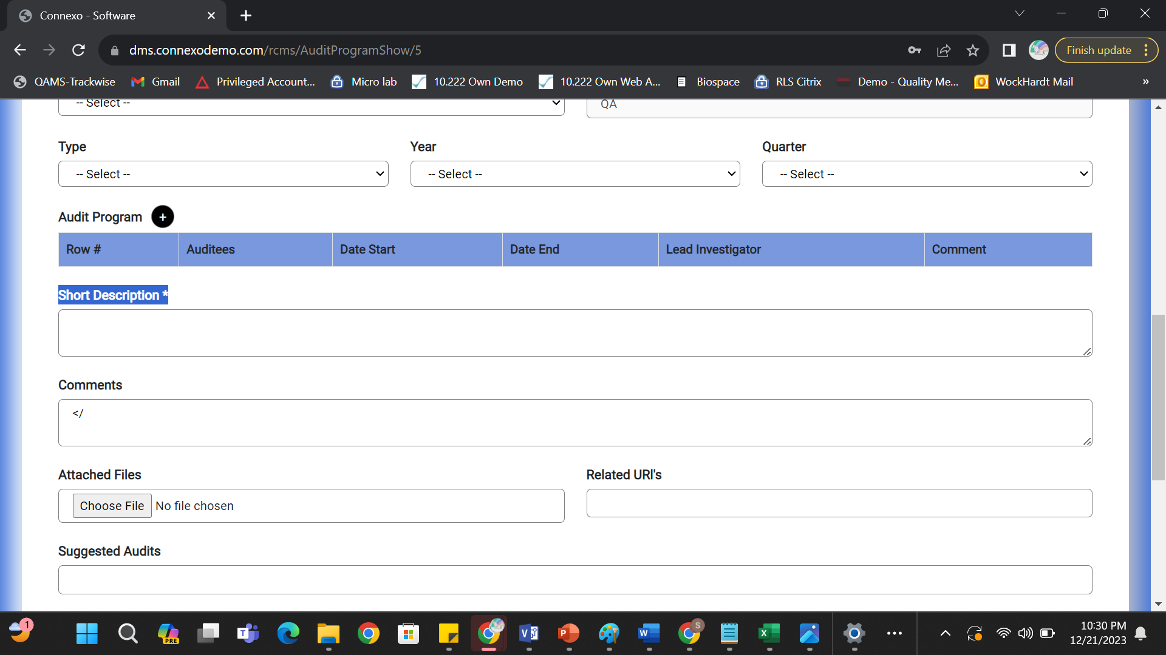

1. </ is available in Comments data field but I have not filled any data in data field please check 
2. Data Fields shall not be editable when record is closed cancelled or closed done right now they are getting editable.



1. Highlight Closed States with Red Color.

