1. In row only row number shall populate

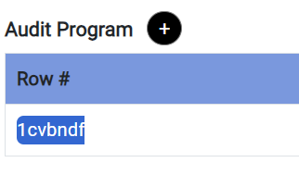

1. State District/City datafield is blank



1. Replace it with child



1. Cancel button is not working



1. In place of End of Period, Audit Completed is their correct it



1. Error is coming when re