**Bootstrap 4 Jumbotron**

Jumbotron is a lightweight, flexible component that can optionally extend the entire viewport to showcase key marketing messages on a site. This is a simple hero unit for calling extra attention to featured content or information.

Following are the steps to use Jumbotron in your HTML.

1. Start a HTML page.

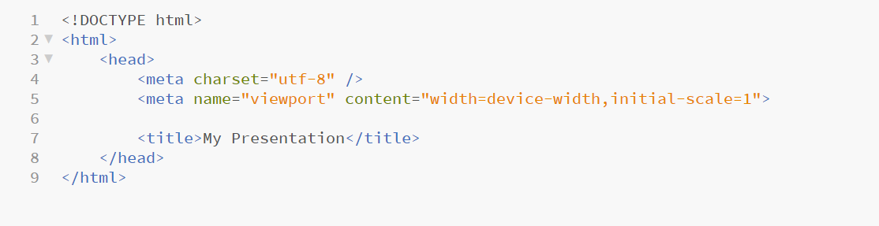

1. Add a link of Bootstrap under the <title> tag. For adding this link you have to download Bootstrap and save into a folder where your index.html file is saved.

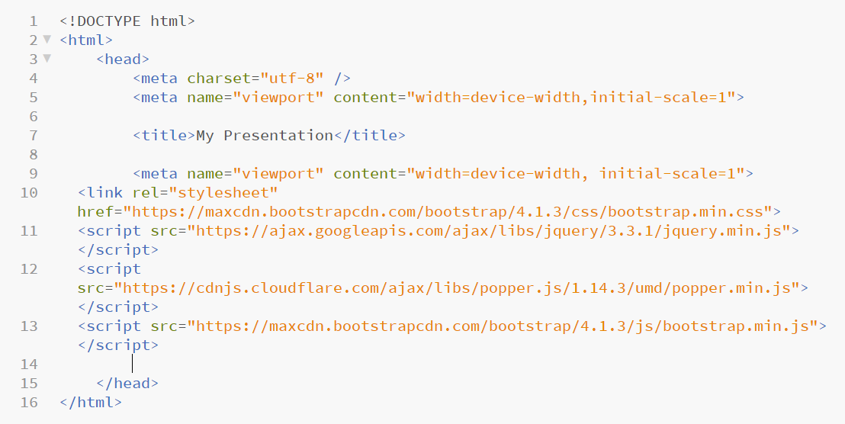

1. Use a <div> element with class “.jumbotron” to create a jumbotron under the <body> tag.

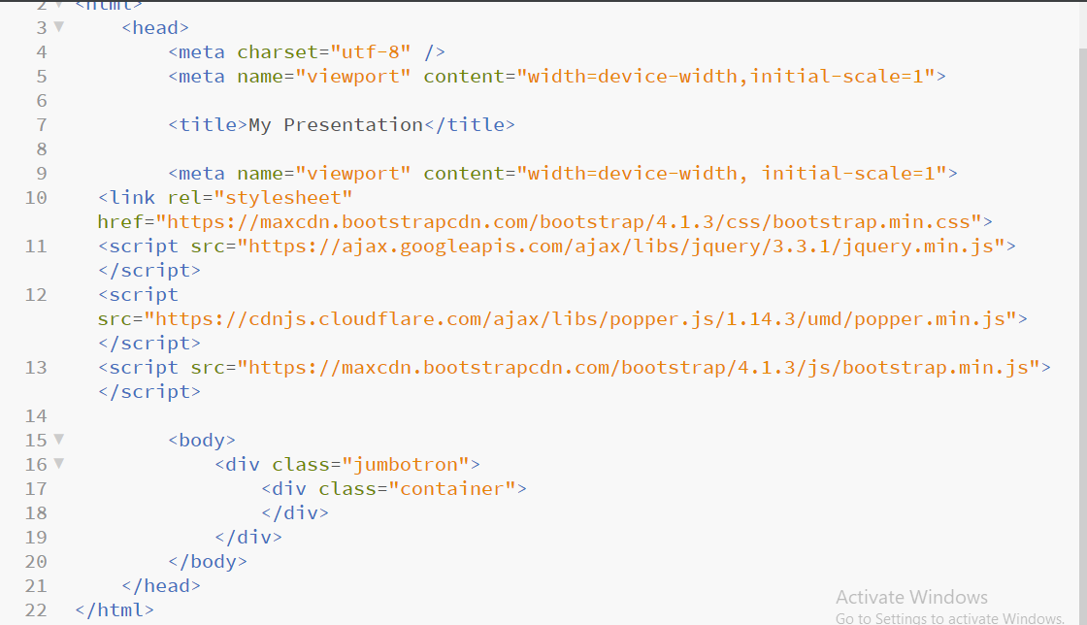

1. Write something using <h1> and <p> tag on which you wants to attract the attention of a viewer.

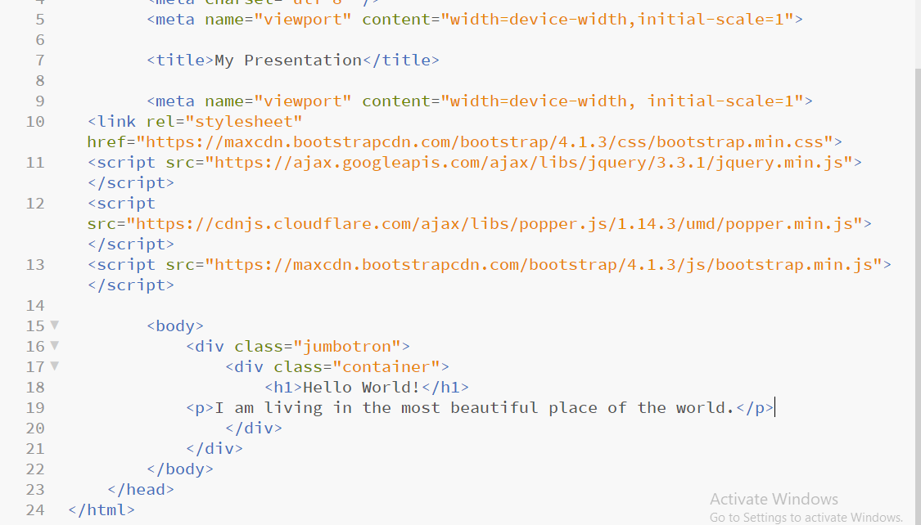

1. After doing these 4 steps, save your index.html file and open it in the explorer. Below image is a result that you will get after this coding.

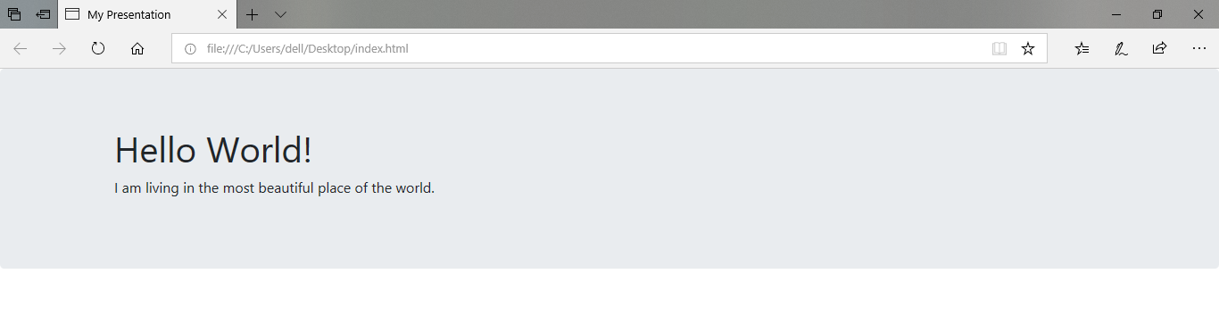

1. If you want a full-width jumbotron without rounded borders, add the “.jumbotron-fluid” class inside the <div> element.

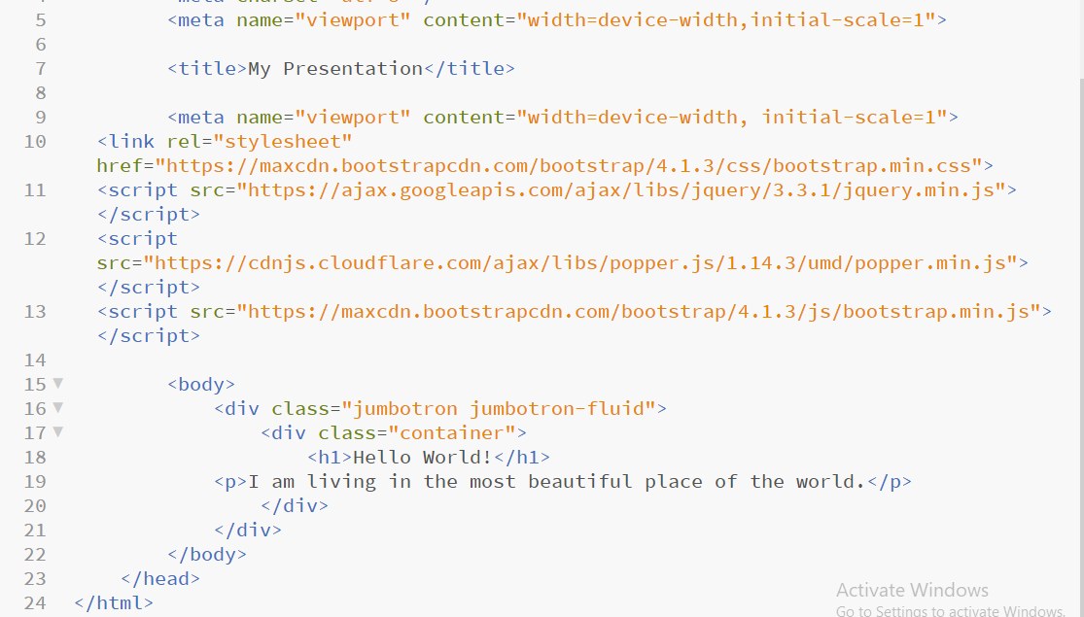

1. After adding “.jumbotron jumbotron-fluid” class, save your index.html file and open it the explorer. Below image is a result that you will get. The rounded corner will be no more there.

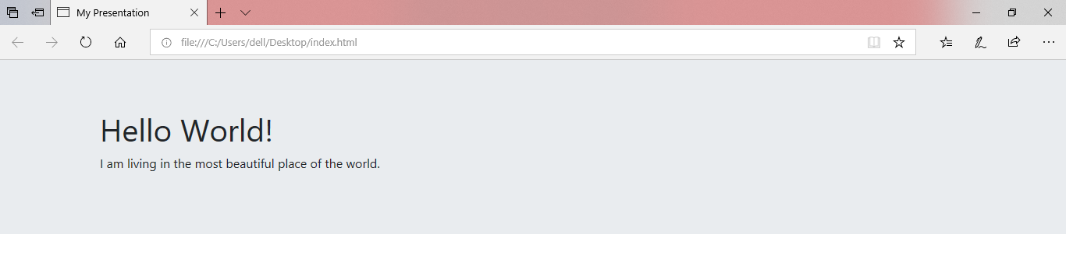

1. To make your output more effective you can add CSS into it using style. The CSS can make your site more energetic by using different background-color, text color, font-size, font-family, etc.

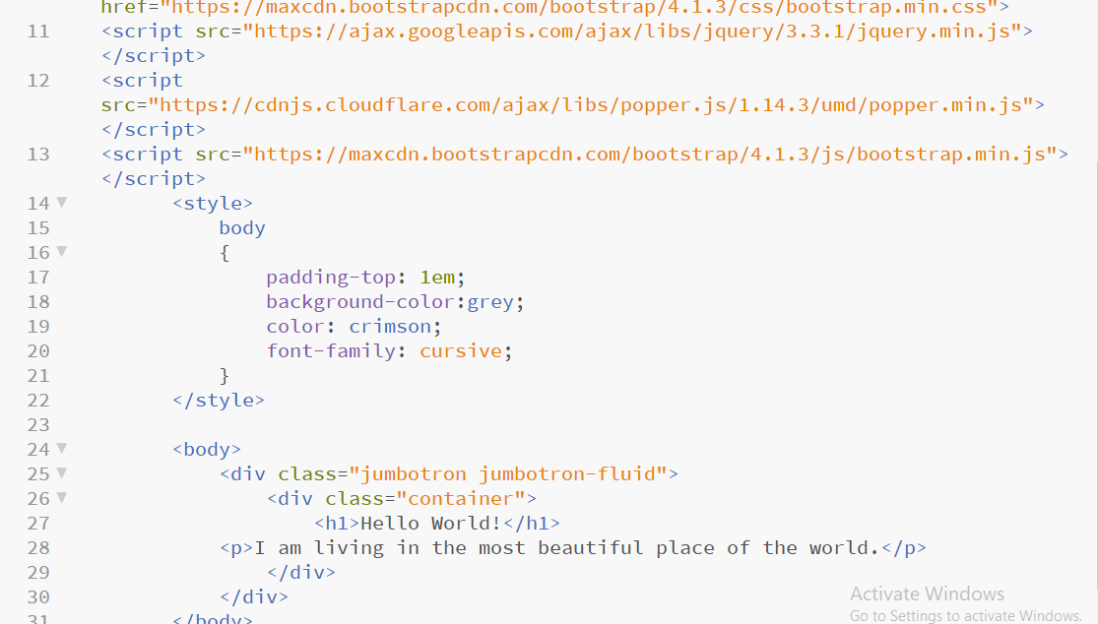

1. After adding CSS your index.html file, below image will be your final result after doing all the required coding to make your site look beautiful. You can see the font-family, text color, background-color are changed using the style tag.

