WORKIT
(HR Workflow Designer)
Full Stack Engineering Intern -- Case Study
Tredence Analytics

Submitted By:
Prabhleen Kaur
Mail To : prabhleen6003@gmail.com
Branch : Computer Science and Engineering
GitHub: https://github.com/prabhleen003/Work-It
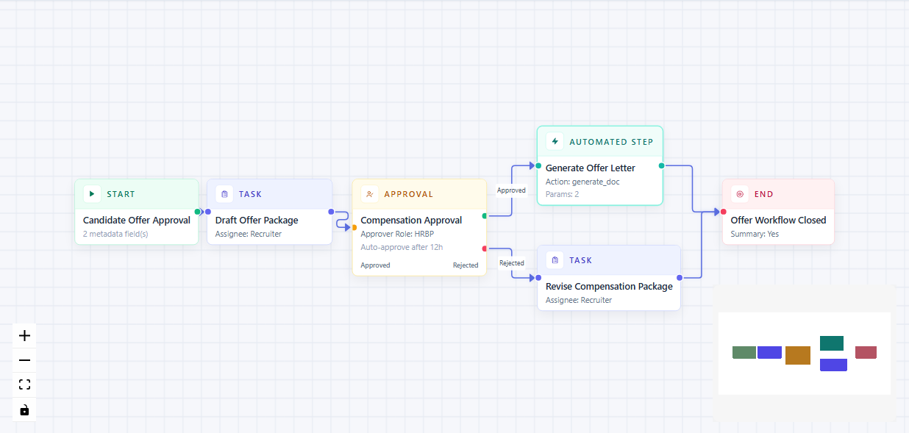

1. Overview
WorkIt is a browser-based HR Workflow Designer built as a React prototype. An HR admin can build, configure, validate, and test internal workflows on a visual canvas. The app uses React Flow for the graph editor, a typed node model, a mock API layer, and a sandbox panel for validation and simulation.

Property | Details
Stack | React 18, TypeScript, Vite, React Flow, Tailwind CSS, Vitest
Node Types | Start, Task, Approval, Automated Step, End
API Layer | apiClient.ts (facade) -> mockApi.ts (in-memory): GET /automations, POST /simulate
Testing | Vitest unit tests covering validation.ts and mockApi.ts
Bonus | Minimap, zoom controls, debounced auto-validation, approval branching

2. Architecture Overview
App.tsx owns all workflow state and acts as the orchestration layer. The rest of the project is divided by responsibility: rendering, editing, graph interaction, and pure logic.

2.1 Folder Structure
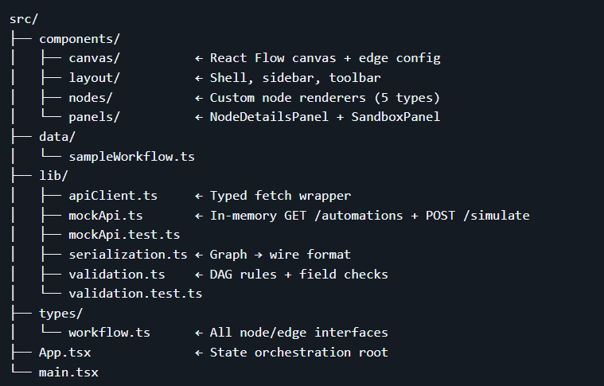

2.2 Component Hierarchy
The tree below shows how components are nested:
- App (ReactFlowProvider)
- WorkflowApp
- Header
- Sidebar
- WorkflowCanvas -> ReactFlow -> all node components
- NodeDetailsPanel -> NodeForm -> per-node form sections
- SandboxPanel -> LogTab, ValidationTab

2.3 State Ownership and Data Flow
Workflow App is the single source of truth. It holds nodes, edges, selectedNode, automations, validationResult, simulationResult, and UI tab state. Child components are kept narrow in scope.

Data moves through the app as follows:
- Sidebar writes node kind into dataTransfer on drag.
- Workflow Canvas reads the kind on drop and creates a node using default Node Data.
- Clicking a node sets selected Node in App.
- Node Details Panel edits the node and returns patched data to App via on-update.
- App updates nodes and triggers debounced auto-validation.
- The Test Workflow button calls serializeWorkflow then apiClient.post('/simulate').
- Mock Api runs the simulation and returns a Simulation Result.
- Sandbox Panel displays the JSON output, validation state, and execution log.

2.4 Separation of Concerns
Layer | File | Responsibility
Canvas Logic | WorkflowCanvas.tsx | Node registration, drag-drop creation, edge connection, keyboard deletion, minimap and controls.
Node Rendering | components/nodes/* | Visual render only. Receive data and selected state. No state mutations.
Node Editing | NodeDetailsPanel.tsx | Typed form shell. Switches on node kind. Each type gets its own form section.
API Facade | apiClient.ts | Frontend-facing interface. Swap mock Api for a real backend here with no component changes.
Mock Backend | mockApi.ts | GET /automations and POST /simulate. Handles graph traversal and approval-branch logic.
Validation | validation.ts | Pure TypeScript rules. No React dependency. Fully unit-tested.
Serialization | serialization.ts | Converts React Flow state to transport JSON. Used for export, persistence, and API requests.

3. Design Decisions
The choices below reflect the constraints of the assignment: a graph-heavy UI, typed node forms, mock API integration, and a 4 to 6 hour time box.

3.1 Library Choices
React + TypeScript
The workflow is a typed graph with structurally different nodes. A discriminated union in workflow.ts keeps each node shape strict and avoids loose, untyped objects.
Vite
No SSR, auth, or routing is needed. Vite keeps setup minimal and build feedback fast.
React Flow
The core problem is a graph editor. React Flow provides node rendering, edge management, drag and drop, handles, minimap, controls, and event hooks out of the box.
Tailwind CSS
Utility classes stay close to components, which speeds up iteration across many small, distinct node cards and panels.
Vitest
The most critical logic is pure TypeScript. Vitest runs natively with Vite and gives fast feedback without extra configuration.

3.2 What Was Left Out and Why
- Redux / Zustand: Not needed. One screen with a clear ownership model does not benefit from a global store.
- react-hook-form: Node forms are heterogeneous and tied to immediate graph updates. Controlled components are simpler and easier to trace.
- MSW / JSON Server: The assignment permits local mocks. The apiClient -> mockApi split maintains a clean backend boundary without extra runtime setup.

3.3 State Management
All state lives in WorkflowApp. React Flow's useNodesState and useEdgesState manage the graph. useState handles the rest. Two deliberate choices were made:
- Validation is debounced to avoid recalculating on every small change.
- Simulation is blocked unless the graph passes validation first.

3.4 Discriminated Union Node Model
Each node kind has its own TypeScript interface. WorkflowNodeData is the union of all of them. This prevents the common anti-pattern of one large node object with optional fields for every type.

Adding a new node type involves these steps in order:
- Add the kind to NodeKind in workflow.ts.
- Define its interface in workflow.ts.
- Add defaults in defaultNodeData.ts.
- Add it to the sidebar palette.
- Write a renderer in components/nodes/.
- Add a form branch in NodeDetailsPanel.tsx.
- Extend validation.ts and mockApi.ts if needed.

3.5 Explicit Forms Over a Generic Renderer
Each node type has different field semantics, not just different labels. Approval nodes control branching logic. Automated nodes load fields dynamically from API data. Start and Task nodes have key-value collections. A generic schema renderer would hide this complexity without simplifying it.

4. What Was Built

4.1 Workflow Canvas
The canvas in WorkflowCanvas.tsx is the main interaction surface. It supports:
- Drag-and-drop node creation from the sidebar palette.
- Edge connections between nodes with styled arrows.
- Node selection that opens the configuration panel.
- Keyboard deletion of selected nodes and edges.
- Minimap for navigation on large canvases.
- Zoom controls and fit-view behaviour.

4.2 Node Types and Configuration Forms
Start Node
Entry point of the workflow. Has a configurable title and optional metadata as key-value pairs.
Task Node
Represents a human step such as collecting documents or drafting an offer. Fields include title, description, assignee, due date, and custom key-value pairs.
Approval Node
Handles manager or HR approvals. Supports linear flow or branching with separate approved and rejected handles. Fields include title, approver role, and an auto-approve threshold.
Automated Step Node
Represents a system action such as sending an email or generating a document. The action dropdown is populated from GET /automations. Parameters render dynamically based on the selected action.
End Node
Marks workflow completion. Fields include an end message and a summary flag toggle.

4.3 Mock API Layer
The API has two layers. Api Client.ts is the frontend interface. Mock Api.ts is the in-memory implementation behind it.
- GET /automations: returns action definitions that populate the automated step dropdown.
- POST /simulate: accepts serialised workflow JSON and returns a step-by-step execution result with timestamps and status.

4.4 Validation Engine
Written in pure TypeScript with no React dependency. Fully unit-tested. Rules enforced:
- Exactly one Start node is required.
- At least one End node is required.
- No disconnected or isolated nodes.
- All required fields on every node must be filled.
- Approval nodes in branching mode must have both an approved and a rejected outgoing edge.
- Cycle detection across the full graph.

4.5 Sandbox Panel
Located at the bottom of the app. Serialises the graph, sends it to POST /simulate, and shows results in three tabs:
- JSON Tab: the serialised graph in formatted JSON.
- Validation Tab: structural and field-level errors with clear labels.
- Execution Log Tab: step-by-step simulation output with node type, timestamp, and status.

4.6 Bonus Features
- Minimap with zoom controls.
- Debounced auto-validation on every graph change.
- Approval node branching with dual source handles.
- Unit tests for validation logic and simulation engine.
- Seeded sample workflow loads on first launch via sample Workflow.ts.

How To Run
This is a frontend-only project. No backend, database, or authentication is required.

5.1 Prerequisites
- Node.js 18 or higher and npm.
- A modern desktop browser (Chrome, Firefox, Edge, or Safari).

5.2 Steps
1. Clone the repository:
git clone https://github.com/prabhleen003/Work-It.git
cd Work-It/assessment_2
2. Install dependencies:
npm install
3. Start the development server:
npm run dev
4. Open in browser:
http://localhost:5173

5.3 Verification Commands
npm test -- run unit tests
npm run build -- production build
npm run typecheck -- TypeScript check
npm run preview -- preview production build

5.4 Environment Variables
None required. The app runs entirely on an in-memory mock API.

Assumptions

Assumption | Reason
No authentication | The brief stated it was out of scope.
No backend persistence | Workflows reset on refresh. Client state only.
Fully local mock API | GET /automations and POST /simulate run in-browser with no external calls.
Primary user is an HR admin | Typical workflows: onboarding, approvals, document processing.
One Start node, one or more End nodes | Standard directed graph model for a workflow.
Simplified approval branching | Approved and rejected paths. Auto-approve uses an hour threshold.
Lightweight simulation | Proves graph traversal and branching logic, not production orchestration.
Mocked automations | send_email and generate_doc are static definitions, not real service calls.
Functional UI over visual polish | The brief prioritised working architecture over pixel-perfect design.
React state is sufficient | A single-page app of this size does not need a global store.

7. Completed Work and Future Improvements

7.1 Completed
- React, TypeScript, and Vite app with a fully working React Flow canvas.
- All five node types with individual renders and typed data models.
- All canvas interactions: drag from sidebar, drop, connect edges, select to edit, delete.
- Typed configuration forms for every node type, including dynamic fields for Automated Step.
- Two-layer API abstraction (apiClient.ts and mockApi.ts) for GET /automations and POST /simulate.
- Sandbox panel with serialised JSON, validation results, and execution logs.
- Validation: missing Start or End nodes, disconnected nodes, required fields, incomplete approval branches, cycle detection.
- Unit tests in validation.test.ts and mockApi.test.ts.
- Bonus: minimap, zoom controls, debounced auto-validation, approval branching, seeded sample workflow.

7.2 Future Improvements
- Extract custom hooks from App.tsx: useWorkflowValidation, useWorkflowSimulation, use Workflow Designer State.
- JSON import and export using the existing serialization layer.
- Undo and redo history for canvas actions.
- Inline validation error indicators on affected nodes, not only in the sandbox.
- Persistence via local Storage or a simple backend save and load flow.
- More deterministic simulation with configurable approval path decisions.
- Component interaction and accessibility tests.
- Improved keyboard shortcuts for canvas navigation.

8. Bugs Solved

Approval Node Branching -- Consistent Semantics Across Four Layers
Adding two handles to the Approval node was straightforward. The real problem was keeping consistent branch semantics across four separate parts of the application at the same time.

The four layers that had to agree:
- ApprovalNode.tsx: which handles are rendered and where.
- sampleWorkflow.ts: which sourceHandle IDs are used in the seed graph.
- validation.ts: both branches must exist when branching mode is on.
- mockApi.ts: the simulator must pick the correct outgoing edge based on the approval decision.

The bug was subtle. A branching node could look correct visually, but if the simulator did not know which edge was the approved path and which was rejected, execution would follow the wrong path.

Fix: Standardise on explicit sourceHandle IDs ('approved' and 'rejected'), validate that both branches exist before simulation runs, and make the simulator match only the edge that corresponds to the decision outcome.

Tests written to confirm the fix:
- validation.test.ts: a missing rejected branch is caught and reported.
- mockApi.test.ts: auto-approved branching follows the approved path correctly.

The root cause was not in one component. It was a contract issue across UI, data model, validation, and execution. All four had to agree on the same identifiers and rules.

9. Self Evaluation
Criteria | Evidence
React Flow Proficiency | Custom renders for all 5 node types with correct handle placement. Edge management, drop positioning, connection events, minimap, and controls in WorkflowCanvas.tsx.
React Architecture | useState, useEffect, useCallback, useRef hooks used correctly. ReactFlowProvider context applied. Folder structure divided by concern: layout, canvas, nodes, panels, lib, types.
Complex Form Handling | Five distinct typed form sections. Controlled components throughout. Dynamic fields for Automated Step. Key-value pair fields. Boolean toggles.
Mock API Interaction | Two-layer abstraction with async patterns and loading states. Graph simulation with traversal and branching logic.
Scalability | Discriminated union makes adding new node types predictable. API facade is the seam for replacing the mock with a real backend. Validation and serialization are independent of React.
Communication | README covers architecture, setup, design decisions, assumptions, completed work, planned improvements, and a real debugging story.
Delivery Speed | Full prototype with canvas, 5 node types, forms, mock API, validation, simulation, unit tests, and bonus features built within the 4 to 6 hour time box.

10. UI Screenshots
The screenshots below show the running application.
(a). The Workspace in Light Theme
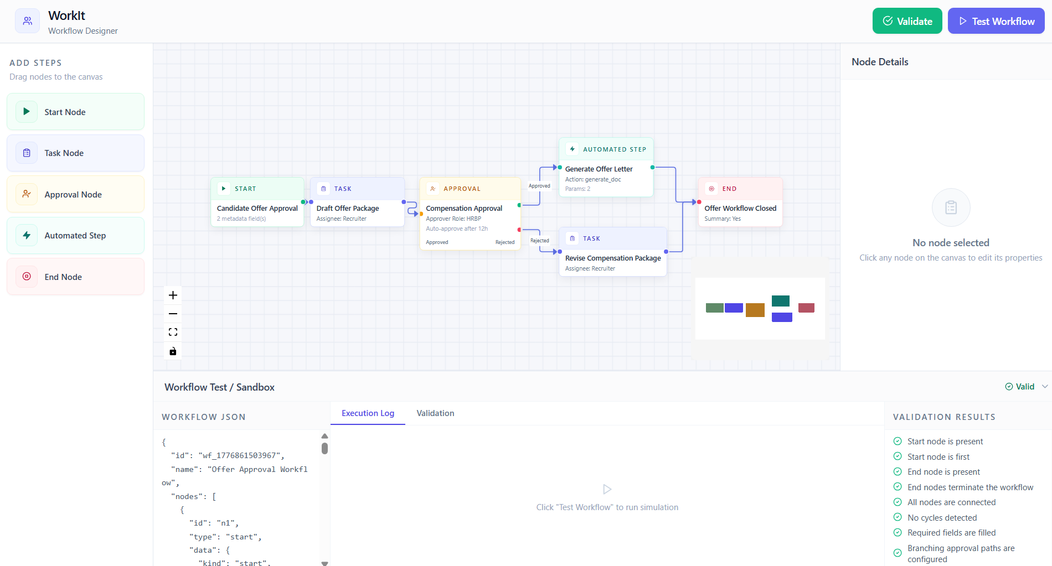
(b). The Workspace in Dark Theme
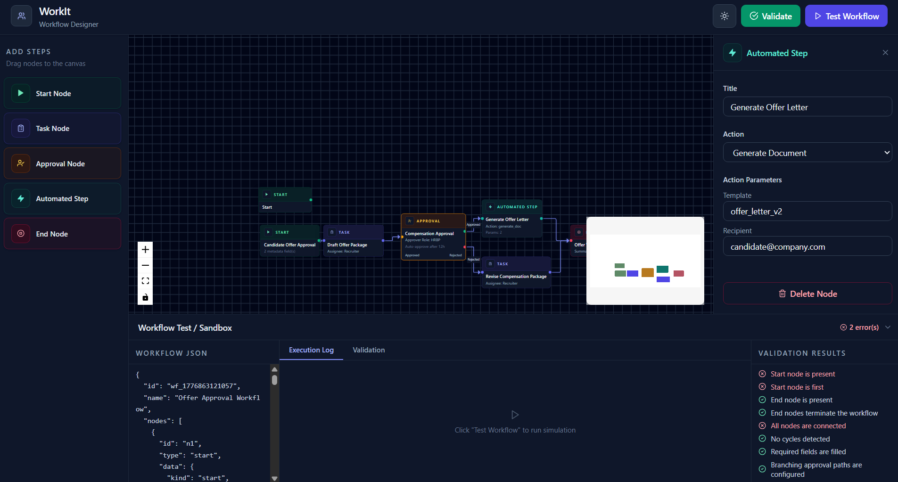

(c). The sample WorkFlow that appears on the dashboard


(d). The Execution Log
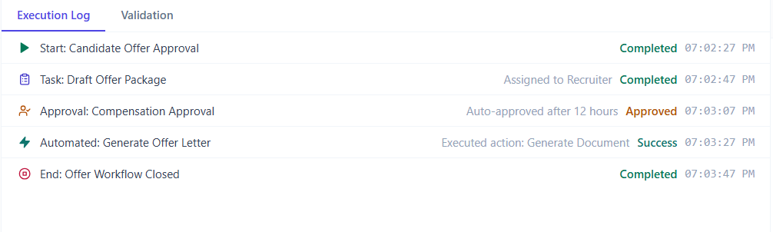
(e). The Available Nodes. (f). The validation Results.
