Puzzle – 01

<https://youtu.be/KX7fDZQUtd0>

Q- How many squares are there on a Chessboard?

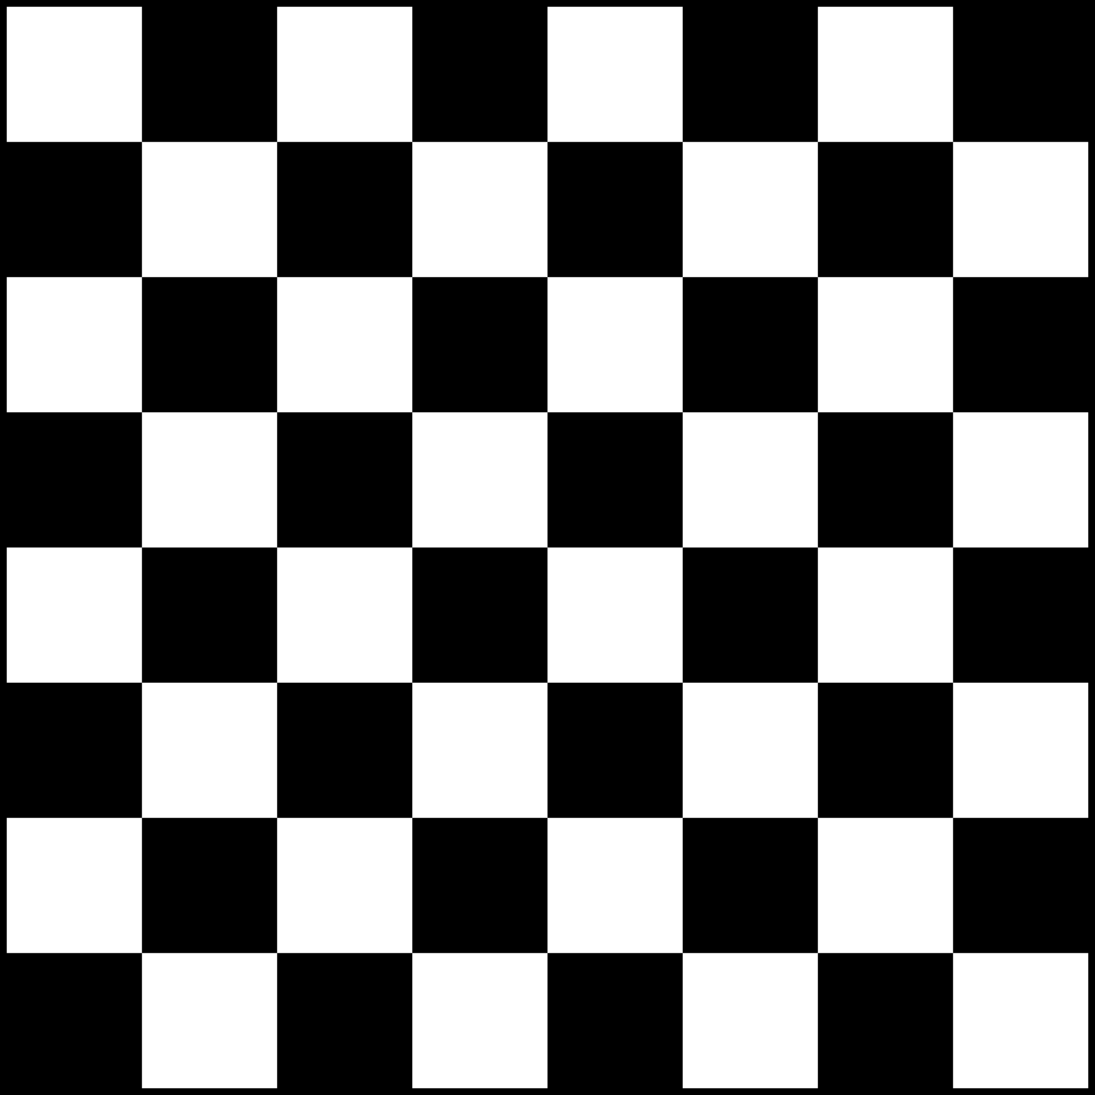

My Approach and Solution –

We need to consider both the smaller and larger squares present on the board.

1. Start by counting the individual squares of each size on the chessboard.

2. Count the number of 1x1 squares. There are 64 of these.

3. Count the number of 2x2 squares. We can find these by subtracting 1 from the number of rows and columns. Since there are 8 rows and 8 columns, there are (8-1) x (8-1) = 7 x 7 = 49 2x2 squares.

4. Continue this process for larger squares: 3x3 squares, 4x4 squares, and so on, up to 8x8 squares.

5. Sum up the counts from each step to get the total number of squares on the chessboard.

1x1 squares = 64 2x2 squares = 49

3x3 squares = 36 4x4 squares = 25

5x5 squares = 16 6x6 squares = 9

7x7 squares = 4 8x8 squares = 1

Adding up all the counts: 64 + 49 + 36 + 25 + 16 + 9 + 4 + 1 = 204.