# Mix-Or-Match

### A MINI PROJECT REPORT

#### Submitted by

#### Group/Team No: G29/T16

**PRAJYANT SINGH SIAG, 2310992494**

**PRABHNOOR SINGH, 2310992493**

#### in partial fulfillment for the award of the degree of

## BACHELEOR OF ENGINEERING

***in***

COMPUTER SCIENCE & ENGINEERING



**CHITKARA UNIVERSITY**

**CHANDIGARH-PATIALA NATIONAL HIGHWAY**

**RAJPURA (PATIALA) PUNJAB-140401 (INDIA)**

NOVEMBER/2023

**ABSTRACT**

A card matching game, also known as a memory game or concentration game, is a type of game that requires players to match cards based on their characteristics. A card game challenges your memory, concentration, and cognitive skills. With its simple yet addictive gameplay, Mix-Or-Match is suitable for players of all ages. So, gather your friends and family, sharpen your mind, and get ready for an unforgettable gaming experience! We have introduced a time limit, adding an element of urgency to the gameplay. Players must race against the clock to find all the matching pairs before time runs out, enhancing the thrill and boosting their cognitive agility. In Memory Match, the objective is to uncover matching pairs of cards by flipping them over, one at a time. The game starts with a set of face-down cards arranged in a grid. The cards are laid out face down in rows and columns, forming a grid. The size of the grid is 4 x 4. Each card has a unique design on the back, hiding a matching pair on the other side.

Players take turns flipping over two cards of their choice. If the cards match, the player gets points and gets to take another turn. However, if the cards don't match, they are flipped back face down, and it becomes the next player's turn. The challenge lies in remembering the positions of the cards as they are flipped back if they don't form a pair.The game requires strategy, as players need to remember where each card was located and what its value was. They also need to plan ahead to maximize their chances of finding matches. The game helps develop memory, spatial reasoning, and strategic thinking skills. It can also help children learn the ranks and suits of playing cards. The game can be played in anywhere from 1-5 minutes, depending on the number of players and the difficulty level. By default, the time limit is 100s. Memory Match is not just a fun pastime; it also has numerous cognitive benefits. The gameplay stimulates memory recall, as players must remember the positions of the cards to uncover matching pairs. Furthermore, it enhances concentration and focus, as players strive to memorize patterns and track their opponents' moves. These cognitive exercises have been scientifically linked to improved brain function and long-term memory retention, making Memory Match an engaging and educational activity. Memory Match is a captivating card matching game that offers endless entertainment and cognitive stimulation. Whether you're playing solo or competing with friends and family, you'll enjoy the challenge of uncovering matching pairs and improving your memory skills. So, gather around, deal the cards, and let the memory-matching adventure begin!

**TABLE OF CONTENTS**

|  |  |  |
| --- | --- | --- |
| Sr.no | Section | Page no |
| 1. | **Introduction** |  |
| 2. | **Problem Statement** |  |
| 3. | **Technical Details** |  |
| 4. | **Key features** |  |
| 5. | **Project Advantages** |  |
| 6. | **Bonus Features** |  |
| 7. | **Result** |  |
| 8. | **Conclusion with Future Scope** |  |
| 9. | **References** |  |

**Introduction**

* 1. **Definition:**

A memory card mix-or-match game is a type of card-based puzzle game designed to challenge a player's memory and pattern recognition skills. In this game, a set of face-down cards, often arranged in a grid, is presented to the player. Each card has a hidden image or symbol on its face. The objective is to find pairs of matching cards by flipping them over two at a time.

**Need:**

1.Cognitive exercise

2.Entertainment and relaxation

3.Educational Value

4.Therapeutic Use

5.Stress Relief

6. Skill Development

**Use:**

1. Cognitive Training
2. Educational Tool
3. Stress Reduction
4. Social Interaction
5. Therapeutic Use
6. Skill Development
7. Entertainment for all ages
   1. **Motive**

**Reason:** The reason for memory card mix-or-match games can encompass a wide range of objectives, from personal enjoyment and skill development to educational and therapeutic benefits.

**Aim:**

We as a owner Aims to see our platform as a game changer towards a revolution of reducing stress and as an entertainment base for all age groups,

**Problem Statements**

* The Memory Card Match Game aims to address the challenge of cognitive decline and the need for engaging, accessible tools to improve memory and mental agility.

**Solution:**

* Cognitive decline is a common concern among aging populations and individuals of all ages due to increasing screen time and information overload. Memory and cognitive abilities play a vital role in daily life, from basic tasks to complex problem-solving. Research shows that engaging in activities that challenge and stimulate the brain can help delay cognitive decline and enhance cognitive abilities.
* Traditional memory games have demonstrated benefits in memory improvement and cognitive enhancement. However, in today's digital age, there's a need for accessible, online alternatives. The Memory Card Match Game leverages the familiarity of the classic memory game format while providing an interactive, web-based solution that can be enjoyed by a wide range of individuals.

**Technical Details**

* HTML (Hypertext Markup Language): HTML is the foundation of the game's structure. It is used to define the layout and content of the web page, including headings, text, images, and the game board.

1. **<div> tag:** The <div> tag defines a division or a section in an HTML document. The <div> tag is used as a container for HTML elements - which is then styled with CSS or manipulated with JavaScript. The <div> tag is easily styled by using the class or id attribute.
2. **<br> tag:** The <br> tag inserts a single line break. The <br> tag is useful for writing addresses or poems. The <br> tag is an empty tag which means that it has no end tag.
3. **<img> tag:** The <img> tag is used to embed an image in an HTML page. Images are not technically inserted into a web page; images are linked to web pages. The <img> tag creates a holding space for the referenced image.
4. **<footer> tag:** The <footer> element is a structural element used to identify the footer of a page, document, article, or section. A <footer> typically contains copyright and authorship information or navigational elements pertaining to the contents of the parent element.
5. **<p> tag:** The <p> tag defines a paragraph. Browsers automatically add a single blank line before and after each <p> element.
6. **<hr> tag:** The <hr> tag defines a thematic break in an HTML page (e.g. a shift of topic). The <hr> element is most often displayed as a horizontal rule that is used to separate content (or define a change) in an HTML page.

* CSS (Cascading Style Sheets): CSS is used to style and format the game's elements. It defines the visual presentation of the game, including fonts, colors, positioning, and responsive design.

1. **Color property:** The color property in CSS is used to set the color of text, the background of the webpage, and also to set the color of borders.
2. **Border Color property:** The border-color property sets the color of an element's four borders. This property can have from one to four values.
3. **Display property:** The display property specifies the display behavior (the type of rendering box) of an element. In HTML, the default display property value is taken from the HTML specifications or from the browser/user default style sheet.
4. **Font size property:** The font-size property sets the size of a font.
5. **Font family property:** The font-family property specifies the font for an element. The font-family property can hold several font names.
6. **Transform property:** The transform property applies a 2D or 3D transformation to an element. This property allows you to rotate, scale, move, skew, etc., elements.

* JavaScript has been used to generate random cards, checking for matches, for sound effects and to display the scores of the user. JavaScript has been used to create interactive client-side functionality for the website.

1. **This property:** In JavaScript, the “this” keyword refers to an object. Alone, this refers to the global object. In a function, this refers to the global object.
2. **New property:** New keyword in JavaScript is used to create an instance of an object that has a constructor function.
3. **Return property:** The return statement stops the execution of a function and returns a value
4. **getElementByID method:** The getElementById() method returns an element with a specified value. The getElementById() method returns null if the element does not exist.
5. **if-else statements:** The if/else statement executes a block of code if a specified condition is true. If the condition is false, another block of code can be executed.
6. **Arrays:** Arrays are Objects. Arrays are a special type of objects. The typeof operator in JavaScript returns "object" for arrays.

* Python: We have implemented python to create the login page. The access to our website is only granted if the user enters correct username and password. Moreover, the login window has also been styled using python.

1. **tkinter module:** Tkinter is a Python interface to the Tk graphics library.It can be used to create Graphical User interfaces (GUIs).
2. **import:** In Python, you use the import keyword to make code in one module available in another. Imports in Python are important for structuring your code effectively.
3. **def keyword:** The def () keyword in python is used to define the function that users can use to built their own function.
4. **if-else statements:** The if/else statement executes a block of code if a specified condition is true. If the condition is false, another block of code can be executed.
5. **window.geometry():** This method is used to set the dimensions of the Tkinter window and is used to set the position of the main window on the user’s desktop.
6. **window.mainloop():** window.mainloop() tells Python to run the Tkinter event loop. This method listens for events, such as button clicks or keypresses, and blocks any code that comes after it from running until you close the window where you called the method.

**Key Features**

* To create an effective memory card mix-or-match game, you'll need several key features to solve the problem and ensure an enjoyable gaming experience. Here are the essential features:
* Card Generation: Dynamically generate a grid of cards, each with a unique identifier, to serve as the game board. The cards should be shuffled randomly at the beginning of each game.
* Timer: Add a countdown timer to create a time limit for completing the game. Display the remaining time to players and end the game when the timer reaches zero.
* Flips: The number of flips a user makes have also been added to the website so the player can beat it’s own score.
* Victory screen at the end of the gameplay to tell the score of the player.
* Custom cursor style which changes when hovered to cards makes the game even more engaging.
* Responsive design has been incorporated in the game so that it can be enjoyed on various screen sizes.

**Project Advantages**

* Cognitive Development: Memory card mix or match games are known to enhance cognitive skills such as attention, concentration, and memory. These games require players to remember the position of different cards, improving their memory and mental acuity.
* Skill Enhancement: Playing memory card games can improve various skills, including problem-solving, pattern recognition, and critical thinking. Players need to strategize and make quick decisions to match the cards, enhancing their overall cognitive abilities.
* Educational Value: Memory card games can be designed to incorporate educational content, making them an effective tool for learning. By using cards with numbers, letters, or images related to specific subjects, players can reinforce their knowledge while having fun.
* Portable and Convenient: Memory card games are typically compact and easy to carry, making them ideal for on-the-go entertainment. They can be played anywhere, whether it's during a long journey or a short break, providing a convenient source of amusement.
* Stress Relief: Engaging in memory card games can be a great way to relax and unwind. The focused and repetitive nature of the game helps to reduce stress and anxiety, providing a calming effect and improving overall well-being.
* Age-Appropriate: Memory card games can be designed to cater to different age groups and skill levels. From simple matching games for young children to more complex versions for adults, these games can be customized to suit the target audience, making them suitable for people of all ages.
* Cost-Effective: Memory card games are relatively inexpensive compared to other forms of entertainment. They require minimal equipment and can be created using readily available materials, making them a cost-effective option for individuals, families, or educational institutions.
* Endless Variations: Memory card games offer endless possibilities for customization and variation. From changing the number of cards to introducing special rules or themes, the game can be modified to keep it fresh and exciting each time it is played.

**Bonus Features**

• The cards are randomly shuffled at the beginning of each game.

• A review website has been incorporated into the game to give a glimpse of the game to the new users.

• Social Sharing: Players can share their progress and achievements on social media platforms.

• Custom audio has been incorporated in the game. The music changes on card flip and card match.

• Animations have been added on all cards

**Result**

* Welcome screen at the beginning of the game

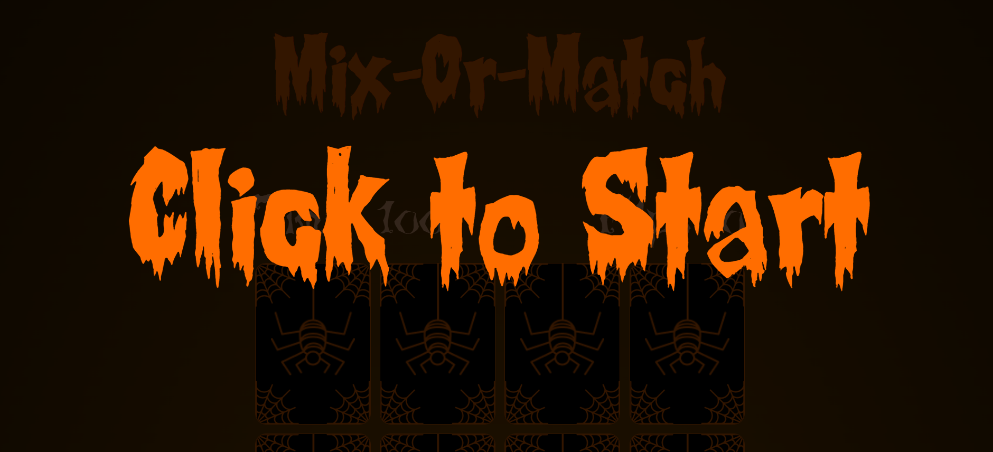

* Change of cursor style on hover

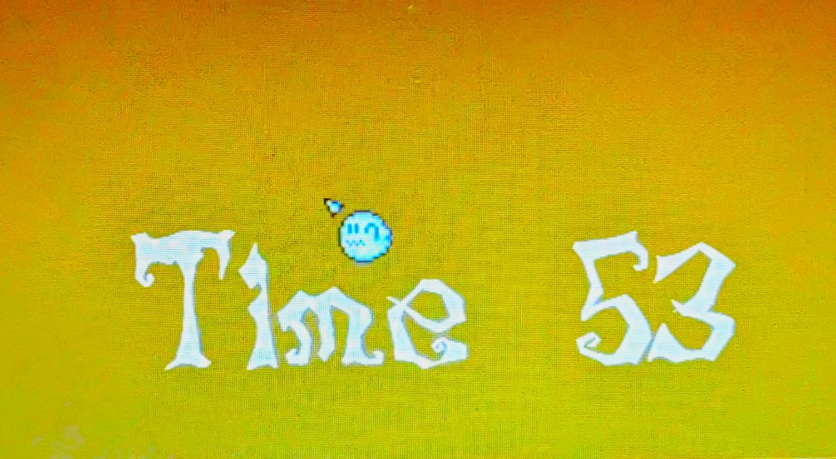 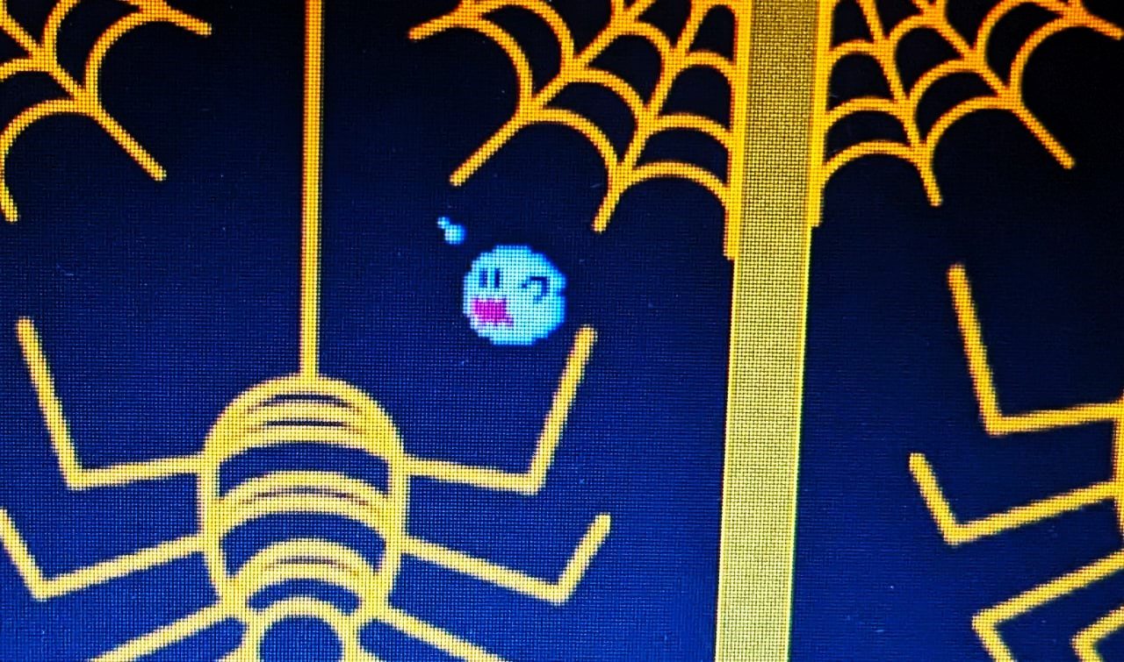

* Free of cost for everyone.
* Engaging and suitable for all age groups.
* Radial background colour, No. of flips and Timer

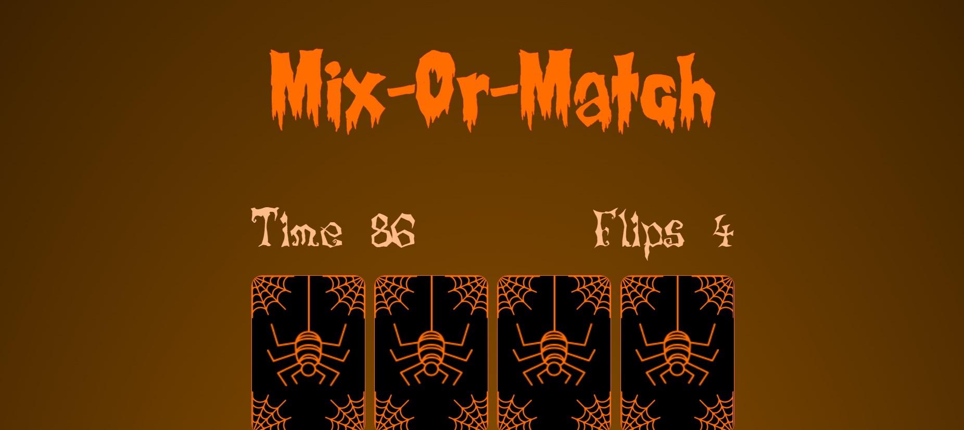

* Back of the card face and the grid containing 16 cards

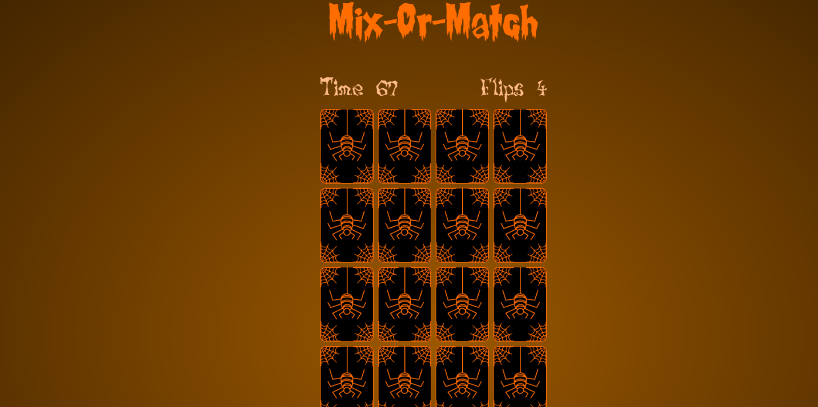

* About section of the game

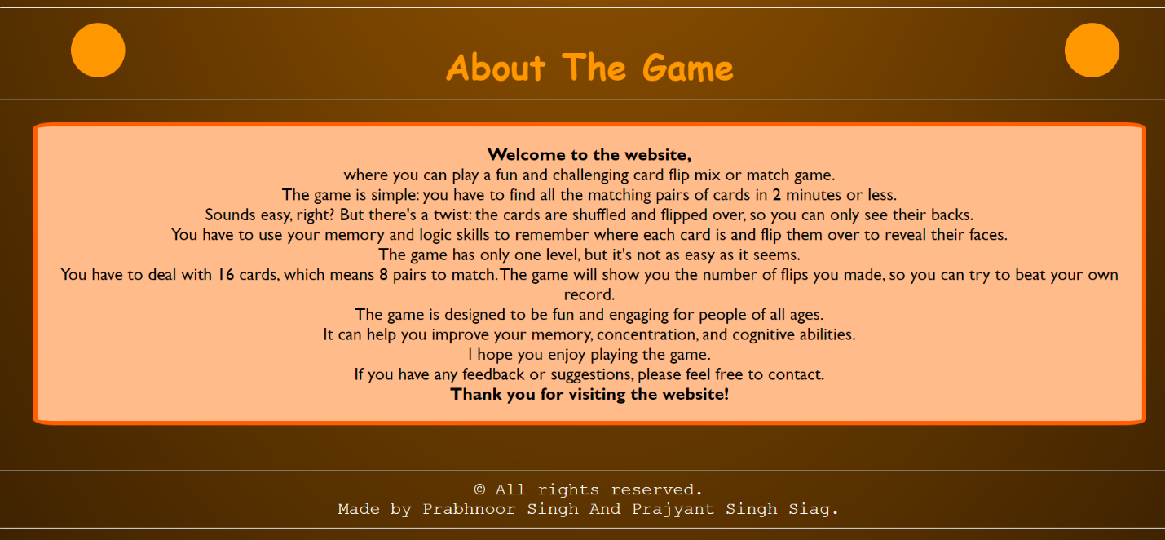

* Animation effects added using CSS





* Back face of the cards

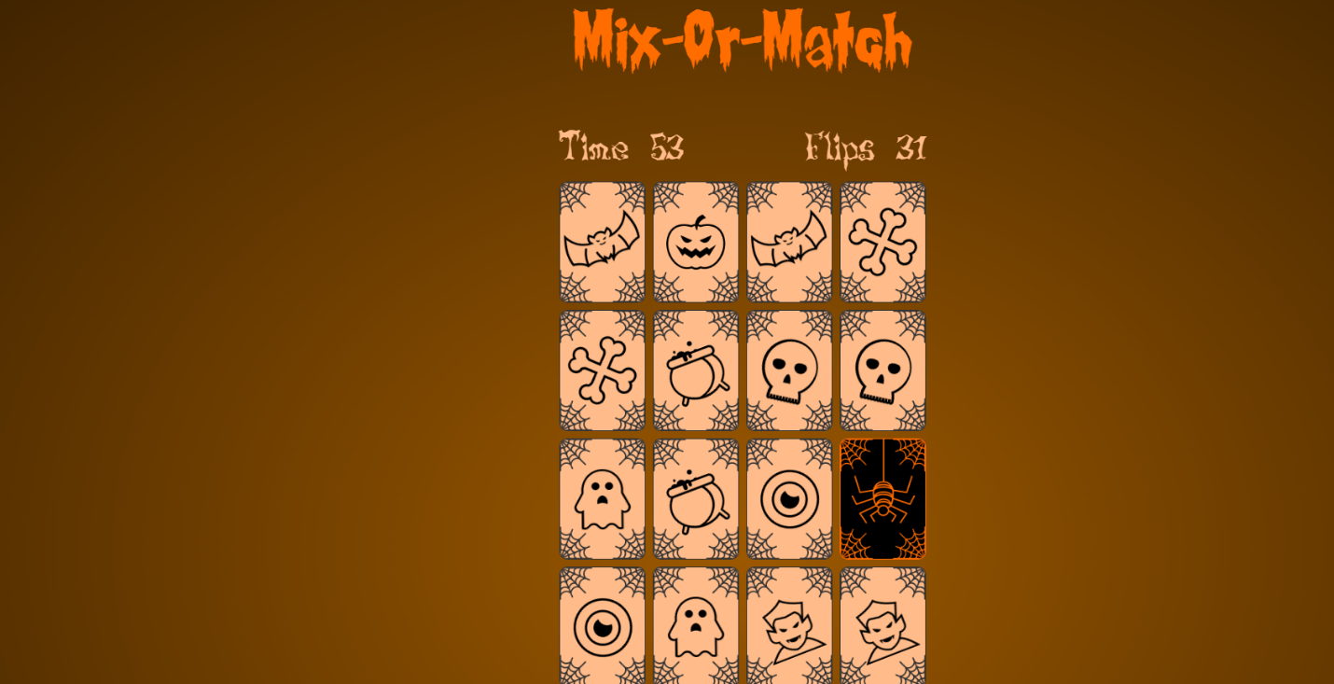

* Animation added at the back of card face (The spider moves down)

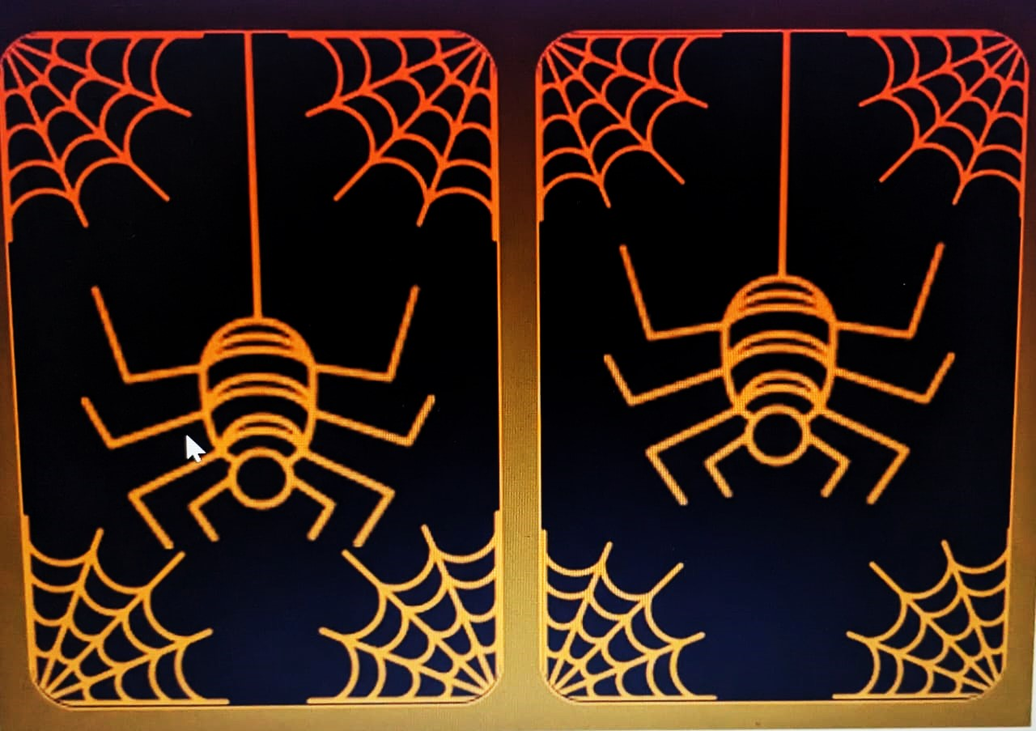

* Not very much complicated to get used to it.
* Easy to play game.
* Animation added at the front of card face

 

* Different card styles



* Victory screen if the user finds all the matching pairs within the time limit



* Game Over screen if the user is unable to find all the matching pairs within the time limit

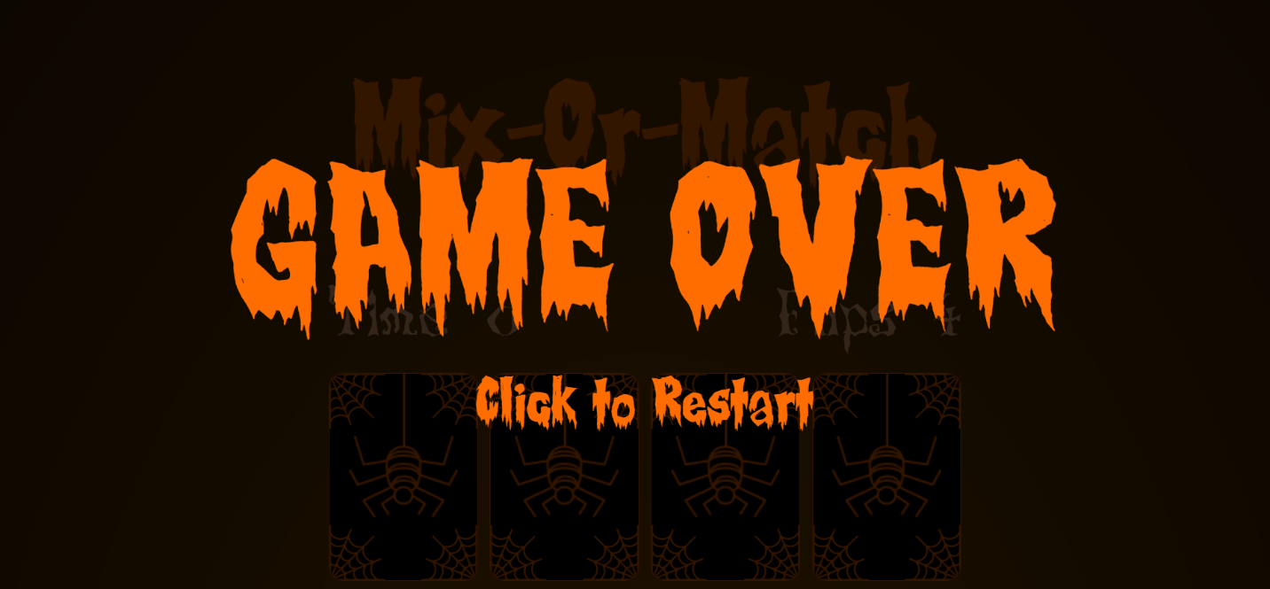

Figure Welcome Page

* Created reviews of users under the review tab

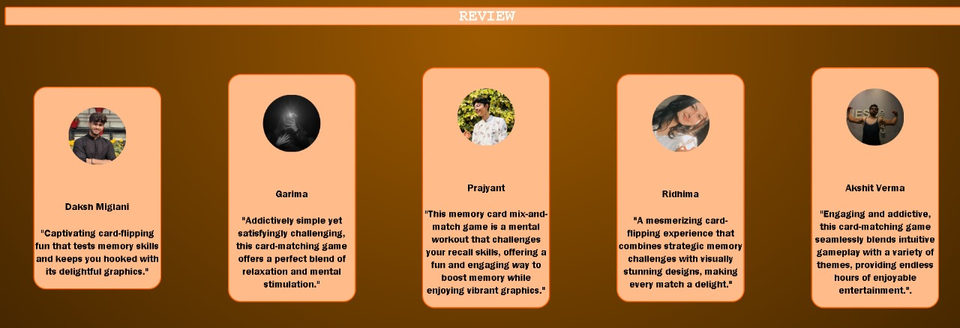

* Animation added to the game review tab



* A review button which lands the user into the review page.



* This game is entertaining for all age groups.
* Last but not least, card matching games are simply enjoyable and fun to play! They provide a stimulating challenge and a sense of accomplishment

**Conclusion and future scope**

* Thus at last, we would like to say please support our platform , which is not just a platform but a revolution , to swap the social media to a educative game .
* We affirm your support in our motion. We also want our users to feel free to evaluate our game .
* The project's core focus was the creation of a memory card mix-or-match game, leveraging HTML, CSS, and JavaScript. The team effectively implemented critical game features such as card generation, flipping mechanics, matching logic, and responsive design for varying screen sizes.
* A card matching game can be developed into a multiplayer platform where players can compete or cooperate with each other in real-time. This could include online leaderboards, tournaments, and social media integration

**List of References**

* <https://www.w3schools.com/js/>
* <https://www.codewithfaraz.com/content/112/creating-flip-card-memory-game-with-html-css-and-javascript>
* <https://www.codingnepalweb.com/build-memory-card-game-html-javascript/>
* <https://www.pexels.com/>