## **Assignment – 2 (MAD5234)**

## GROUP : KAMALDEEP KAUR DHUHRHE(C0710019)

## NAVNEET KAUR(C0728699)

## PRABHJOT KAUR(C0730124)

**Ques 3. Code Coverage.**

**Ans.**

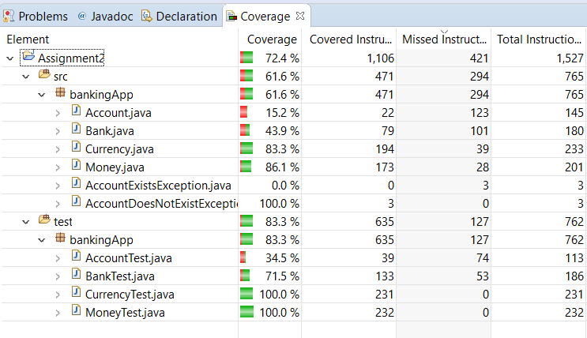

**Ques 5 Which test case fails?**

**Ans. BankTest.java :**

**Method Failed:**

1. transfer()
2. withdraw()
3. deposit()
4. getbalance()

**Reason:** All these methods are failed due to when person tries to deposit the money but he doesn’t have an existing account in the bank.

1. **transfer():**Test fails on 104 line. The error shows as:

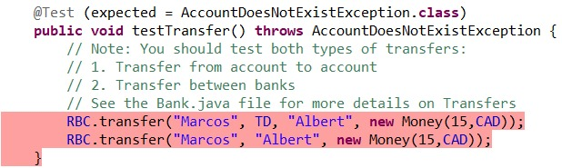

1. **withdraw():** Test fails on 85 line. The error shows as:

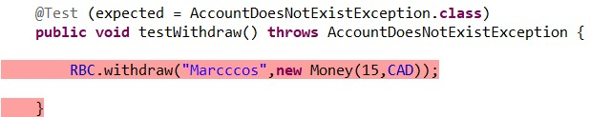

1. **deposit():** Test fail in deposit case on 79 line number. .The error shows as: 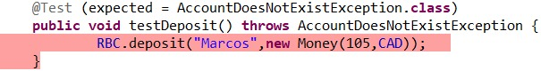
2. **getBalance(): Test fails on 120 line. The error shows as:**

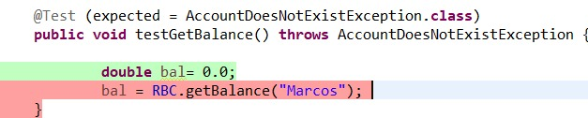

**AccountTest.java :**

**Method failed:**

1. **testAddWithdraw():** When person’s withdrawal amount exceeds the available amount in the bank, then this method give an error.

