**Prabhpreet Singh**

**40068870**

**Function arccos(x)**

The arccosine(x) function is the inverse of cosine of x. It returns the angle at which the cosine is x. It is called by the abbreviated form acos(x). arccos(x) = cos-1(x).

**Domain and Co-Domain of arcos(x)**

y = arccos(x)

**Domain**: -1≤x≤1

**Range**: 0°≤y≤180°

**Graph of arccos(x)**

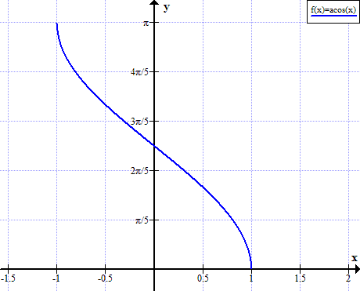

Fig: Graph of arccos(x)

**Characteristics of arccos(x)**

* The value of angle is the highest at -1 and it decreases and becomes zero at +1.
* The arccosine(x) is a one-to-one function. Its range is limited to 180° because after that values repeat itself which violates one-to-one property.
* The function can be used to calculate the base angle in a triangle by calculating base/hypotenuse to that angle if we know cos-1 of that value.

**References**

* <https://www.mathopenref.com/arccos.html>
* <https://www.rapidtables.com/math/trigonometry/arccos.html>