Wings & Weights:
CNN vs. Vision Transformer for Butterfly Species Recognition

Prabhupada Samantaray
School of Computer Engineering
KIIT University
BBSR, Odisha
22052483@kiit.ac.in
Aradhana Behura
School of Computer Engineering
KIIT University
BBSR, Odisha
aradhana.behurafcs@kiit.ac.in

Abstract: Butterflies are important indicators of ecosystem health. Their population changes are the result of environment changes. So monitoring them is crucial for biodiversity conservation. There are thousands of species in the world. Identifying them using human experts is not so scalable and effective. Thus Automated image-based recognition can very much solve it. But it is also important to know which models are actually efficient for this purpose. This paper is about the comparative study between Convolutional Neural Network(CNNs) and Vision Transformers (ViTs) for butterfly species recognition across 50 different species from a standard dataset. A controlled 2-phase transfer learning protocol was used for the evaluation. For CNN representation; EfficientNet-B0 , MobileNetV3-Small and for Vision Transformer;DeiT-Tiny were used. The first phase uses frozen backbone feature extraction and the second phase uses partial fine-tuning on the last blocks. Parameters of evaluation were accuracy, F1 score, parameter count, model size and inference time. The result shows that DeiT-Tiny with accuracy of 98.00% outperforms EfficientNet(96.40%) and MobileNetV3-Small(96.00%). Two ablation studies quantify data augmentation across all architectures. Gradient-weighted Class Activation Maps (Grad-CAM) ensures that the models are attending only the meaningful features from the sample images. This study provides a practical efficiency-accuracy overview along with deployment readiness via locally hosted Streamlit.

Index terms: Butterfly species recognition, Convolutional neural networks, vision transformers, transfer learning,fine-tuning, EfficientNet, MobileNetV3, DeiT, Grad-CAM, biodiversity conservation.

- INTRODUCTION:

For large-scale biodiversity monitoring, automated species identification is crucial. Butterflies are sensitive ecological indicators. Their population dynamics shows the health of an ecosystem. The visual diversity is characterized by wing patterns, colour morphs, and species level mimicry, making their classification a challenging task.

In recent years, deep learning models are used for the image classification problems. CNNs are one of the most commonly used model in this regard. Transfer learning makes it possible to create much accurate models using limited data. More recently, Vision Transformers have emerged as an alternative approach to CNNs. They (ViTs) use attention mechanism, that can handle more complex pattern across the image, making them somewhat more effective than CNNs.

Most researches focus on accuracy but ignore practical limitations. Theoretical prowess does not necessarily ensures real world competency. In real world conditions, mobile and edge devices are often used. They do not possess that much computational power. So it is important to balance accuracy with resource usage. This work compares lightweight models to see whether they can be accurate being efficient enough for such environments.

The main contributions of this work are as follows:

- A fair comparison between two lightweight CNN models (EfficientNet-B0 and MobileNetV3-Small) and a lightweight Vision Transformer (DeiT-Tiny) for classifying 50 butterfly species under the same conditions.
- An analysis of two training approaches, comparing models where most layers are kept fixed with partially tuned models, to understand their importance on accuracy.
- A study of the trade-off between accuracy and efficient, considering factors like accuracy, number of parameters, model size and inference time.
- Visualization results using Grad-CAM shows that all models are focusing on the meaningful parts of butterfly attributes during classification.
- Two focused ablation studies shows how data augmentation and the depth of fine-tuning affect model performance.

The rest of the paper is organized as follows:
Section II reviews existing research in this area.
Section III explains the dataset and how the data is prepared.
Section IV shows the models and their training.
Section V outlines the evaluation of the models.
Section VI gives us the results. Section VII the observations and
Section VIII the conclusion.

- RELATED WORK:

A. CNN-Based Butterfly Classification:
Earlier work on butterfly classification mainly used standard CNN models. Almryad and Kutchu tested models like VGG16, VGG19, and ResNet50 on a dataset of 17,769 images covering 10 species from Turkey. They showed that removing background noise during preprocessing improves performance, even while using transfer learning.

Rajeena and others compared five popular pre-trained CNN models like VGG16, VGG19, MobileNet, ResNet50, and InceptionV3 on 75 butterfly species. Among these InceptionV3 achieved the highest accuracy of 94.66%.

Theivaprakasham and team created a large benchmark for Indian butterfly species using 315 species and around 34,000 images. They tested 11 CNN models and found that ResNet-152 performed the best, reaching a Top-1 accuracy of 94.44%.

Sagar and colleagues worked on a much larger dataset containing 1,300 species and 170,000 images. They used an EfficientNet-B6 ensemble along with data augmentation, achieving 86.5% Top-1 accuracy. However this approach required higher computational resources.

Singh and team focused on improving generalization across 10 species using 10 species using augmentation techniques and achieved accuracy of 93.84%.

- Detection-Classification Pipelines:

Some studies combine object detection with classification. Mattins and others proposed a pipeline using YOLOv3 for detection and an Efficient CNN for classification. They achieved 98% detection accuracy and 98.20% classification accuracy on a small dataset of 832 images across 10 species, although the limited dataset affects how well the results generalize.
Bohan and colleagues used multi-scale YOLO ensembles and showed better detection performance compared to single-model approaches. Xin and team compared YOLOv3 and YOLO v5, focusing on the balance between speed and accuracy, and reported competitive results.

- Vision Transformer Approaches:

The use of Vision Transformers for butterfly classification is still relatively limited. Yang fine-tuned a ViT based model on 75 species and achieved over 95% validation accuracy, highlighting its ability to capture global image features.

Dima806 applied a Vision Transformer for detecting 75 butterfly types and showed that it could capture fine details, although it required more computational power. Berger compared CNNs and transformers on 110 species and found that Transformers performed well in handling visually similar species.

Pucci and team proposed a hybrid model combining T2T-ViT, EfficientNet, and ViTAE, and showed that hybrid approaches can outperform both CNN-only and Transformer-only models.

More recently, Vincent and others carried out a detailed study on ViTs and concluded that , when properly trained, they can balance very well between inference time and performance parameters.

- Research Gap:
Even after all these studies there is a clear gap vividly noticeable. No significant work has been done around lightweight CNN models and Vision Transformers under the same conditions on a standard dataset.

Most of the previous studies clearly focused on accuracy using different datasets, ignoring efficiency, speed and model size. This work addresses all of these important aspects together.

- DATASET AND PREPROCESSING

- Dataset Description

The dataset available on Kaggle [16] was used as the primary data source for the classification. The dataset contains nearly 13,000 images spanning 100 butterfly species. For easy computation using GPU, we randomly selected 50 species using fixed random seed of 42. It gave us a set of 6,273 training images, 250 validation images and 250 test images. The class imbalance ratio was 1.66x with a mean of 125.5 training images per class. The standard deviation was 14.4.

- Exploratory Data Analysis

All images in the datasets were standardized to 224×224 pixels prior to the EDA. As a result resolution distribution became trivial having mean width and height 224px each. The statistics about the pixels, the results of analyzing 300 samples, mean values of [0.5313, 0.5106, 0.3122] and standard deviations of [0.2137, 0.1996, 0.1832] for the red, green, and blue channels respectively. These values were sufficiently close to the ImageNet statistics [0.485, 0.456, 0.406] / [0.229, 0.224, 0.225].

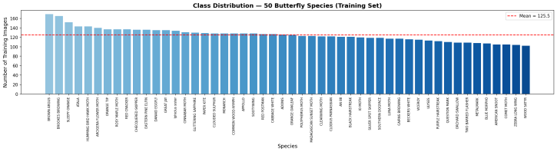
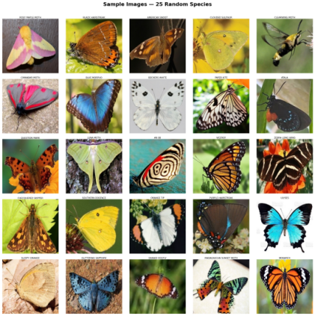
Fig. 1. Training set class distribution across 50 butterfly species. Red dashed line indicates mean images per class (125.5). Class imbalance ratio: 1.66×.
Fig. 2. Representative 5×5 sample grid showing visual diversity across 25 randomly selected butterfly species from the training set.
- Data Augmentation

For data augmentation a simple pipeline was used. We used Random Resized Crop(224), Random Horizontal Flip(p=0.5), Random Rotation(15 degrees), and Color Jitter (brightness = 0.3, contrast = 0.3 saturation = 0.2) followed by ImageNet normalization.For validation and test set, we used Resize(256) , Center Crop(224) and normalization only. Weighted cross-entropy loss was used to adjust class-imbalance. In this method the class weights are computed as the inverse of class sample counts.

- METHODOLOGY

- Model Architechtures

Three lightweight architectures were selected from timm library [17] with ImageNet pretrained weights. The final classification heads are replaced to 50 output classes using linear mapping.

- EfficientNet-B0 : It is a type of neural network model. It uses a smart method called compound scaling.This method is used to increase the model’s width, depth and image resolution using a fixed value. The model has about 4.07 million parameters and 16.3 MB space. It is like a basic CNN model. To make a balance between accuracy with efficiency, It uses depth-wise separable convolutions and squeeze-and-excitation modules. It makes the model lightweight.

- MobileNetV3-Small : It is a very lightweight neural network used for mobile devices.It has 1.57 million parameters. The small size of 6.3 MB makes it fast and efficient. The model useds techniques like hard-swish activation and squeeze-and-excitation (SE) blocks. It this paper , it is used as a baseline model.

Model | Type | Params (M) | Size (MB) | Phase 1 LR | Phase 2 LR
EfficientNet-B0 | CNN | 4.07 | 16.3 | 1e-3 | 1e-4
MobileNetV3-Small | CNN | 1.57 | 6.3 | 1e-3 | 1e-4
DeiT-Tiny | ViT | 5.53 | 22.1 | 1e-3 | 1e-4
- DeiT-Tiny : It is a type of vision transformer. It is the smallest practical version of vision transformer. It can perform well even with less training data using a special technique called distillation.It has 12 transformer layers, each with 3 attention heads. It can process image of small size. The model has about 5.53 million parameters and a size of 22.1 MB.

- Two-Phase Training Strategy
All the models were trained in two steps using transfer learning.In Phase 1(Epoch 1-7), The main part of the model was kept frozen. Only the final classification layer was trained. The learning rate was 0.001. In Phase 2 (Epoch 8-14), some of the last layer of the backbone were unfrozen. Then it was trained along with the classification layer. A smaller learning rate of 0.0001 was used to make fine adjustments.Then different optimizers were used . Adam for CNN and AdamW for Deit-Tiny were used. During Phase 2, a cosine annealing scheduler is applied to adjust the learning rate. Mixed-precision training was used to reduce memory usage and increase efficiency. The best model is saved after every epoch.
Model | Top-1 (%) | Top-3 (%) | F1 Score | Params (M) | Size (MB) | Inf. (ms)
EfficientNet-B0 | 96.40 | 99.60 | 0.9632 | 4.07 | 16.3 | 11.40
MobileNetV3-Small | 96.00 | 100.00 | 0.9597 | 1.57 | 6.3 | 5.55
DeiT-Tiny | 98.00 | 99.60 | 0.9798 | 5.53 | 22.1 | 4.85

For specific models:
- EfficientNet-B0: The last block(block 6), head layer and classifier were unfrozen in Phase 2.
- MobileNetV3-Small: Block 5 and 6 were unfrozen.
- Deit-Tiny: Transformer blocks 10 and 11 were normalized. Then these normalized blocks and header layers were unfrozen.

- Reproducibility

A fixed random seed value of 42 was used in Python, Numpy and PyTorch (including CUDA).As a result we can make sure that the results can be repeated. Pytorch is set to run in a deterministic mode for consistent outputs. All experiments were performed in a single NVDIA Tesla T4 GPU with 15.6 GB memory. A batch size of 32 was used. Two workers were used to load the dataset.

- EVALUATION FRAMEWORK

Each model was tested on a separate test dataset of 250 images across 50 classes using different performance metrics.Top-1 Accuracy checks how often the model’s main prediction is correct.Top-3 Accuracy checks if the correct answer is among the model’s top 3 predictions.Macro F1 Score calculates the average F1 score for all classes, treating each class equally and handling class imbalance.Inference Time measures how long (in milliseconds) the model takes to process one image. This was calculated over 100 runs after 10 initial warm-up runs. Parameter Count and Model Size show how large the model is, in terms of number of parameters (in millions) and file size (in MB).In order to better understand the results, Efficiency vs Accuracy graphs were created to compare models. Confusion matrices (50×50) were used to see where the model makes mistakes for different classes. Training and validation graphs (loss and accuracy) were plotted for all 14 epochs of two training phases.

- EXPERIMENTAL RESULTS

- Main Model Comparision

Table-II shows the final test results of all three models after Phase 2 training.DeiT-Tiny performs the best.It gave 98.00% Top-1 accuracy and 0.9798 F1 score.EfficientNet-B0 achieved 96.40% accuracy and 0.9698 F1 score. MobileNetV3-Small has 96.00% accuracy and 0.9597 F1 score. MobileNetV3-Small secured the highest Top-3 accuracy(100%).That means even if the first prediction is sometimes wrong, the correct answer is always included in its top 3 predictions.

- Phase-wise Accuracy Analysis

Table III shows how much each model improved after fine-tuning.DeiT-Tiny improved the most (+3.20%). That means it benefited a lot from fine-tuning. EfficientNet-B0 improved by +1.20%. MobileNetV3-Small improved by +2.00%. DeiT-Tiny gains the most from learning task specific details.

Model | Phase 1 Val Acc. | Phase 2 Val Acc. | Gain
EfficientNet-B0 | 0.9640 | 0.9760 | +0.0120
MobileNetV3-Small | 0.9560 | 0.9760 | +0.0200
DeiT-Tiny | 0.9320 | 0.9640 | +0.0320

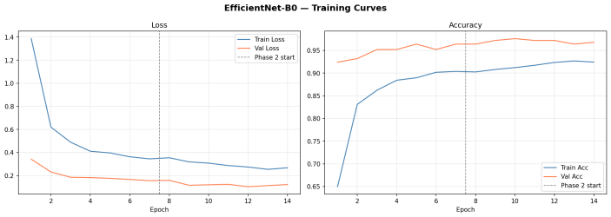
Fig. 3. EfficientNet-B0 training and validation loss/accuracy curves over 14 epochs. Dashed vertical line marks Phase 2 boundary at epoch 7.

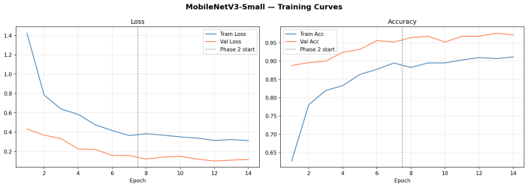
Fig. 4. MobileNetV3-Small training and validation loss/accuracy curves over 14 epochs.
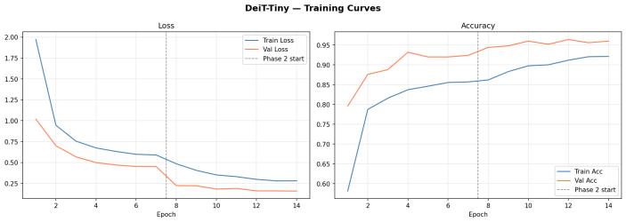
Fig. 5. DeiT-Tiny training and validation loss/accuracy curves over 14 epochs. Note the steeper Phase 1 validation accuracy rise characteristic of ViT attention mechanisms adapting to the butterfly domain.

- Efficiency-Accuracy Tradeoff Analysis

Figure 6 shows graphs comparing accuracy with model size and speed. DeiT-Tiny performs the best overall.It has the highest accuracy and the fastest interference time (4.85 ms).It uses parallel processing which works very efficiently on GPUs. As a result it is able to handle a huge number of parameters.MobileNetV3-Small is the best choice when resources are limited. It gives 96% accuracy and speed of 5.55ms being a very small (1.57M parameters, 6.3 MB) model.
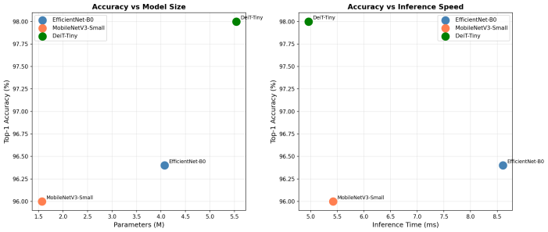
That’s why, for powerful systems with GPUs, DeiT-Tiny is best and MobileNetV3-Small is more suitable for lightweight or edge devices.

Fig. 6. Efficiency-accuracy Pareto scatter plots. Left: Top-1 accuracy vs. parameter count. Right: Top-1 accuracy vs. per-image inference time. DeiT-Tiny achieves the best accuracy-speed tradeoff on GPU.

D. Confusion Matrix Anamysis
Figures 7-9 shows the 50x50 confusion matrices for all three models. The strong diagonal dominance of all the matrices ensures high accuracy in each class. Basically in all of them , most of the values are concentrated along the diagonal . It means that models are correctly classifying most of the images. The main mistakes occurs between the species that looks similar. For Example Brown Argus is generally confused with Adonis Blue in many models because their patterns looks almost same . Even the experts finds it difficult to tell the difference. Among the three , DeiT-Tiny(Fig.9) has the lowest errors outside the diagonal which matches its higher accuracy overall.
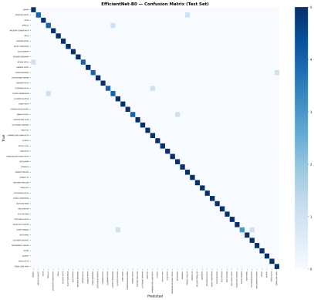
Fig. 7. EfficientNet-B0 confusion matrix on the test set (50 classes). Colour intensity indicates misclassification frequency.

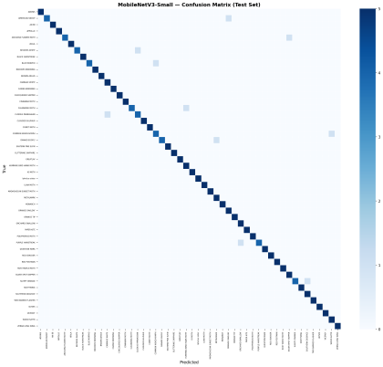
Fig. 8. MobileNetV3-Small confusion matrix on the test set (50 classes).
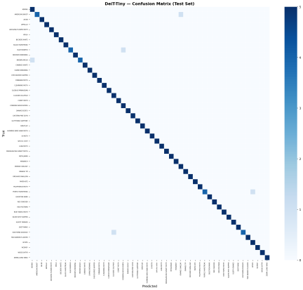
Fig. 9. DeiT-Tiny confusion matrix on the test set (50 classes). Sparser off-diagonal entries reflect superior classification accuracy.

- Ablation Study 1 - Effect of Data Augmentation
To understand how much data augmentation helps , EfficientNet-B0 (Phase 1) is generally trained two ways: one with full data augmentation and other with basic steps only without any augmentation. Result of the table IV shows that the model which is without augmentation performs better . It achieved higher validation accuracy of 0.9760 compared to 0.9640 with augmentation.
The 1.20% drop in the performance with augmentation can be explained by the nature of the data set . The butterfly images are already resized to 224x224 pixels. It has clean background and each class has about 125 images. This helps the model to learn the useful features without reading heavy augmentation. Some of the augmentation methods , especially Random Resized Crop can by mistake remove important parts of the butterfly wings . This makes it tough to the model to learn in Phase 1. Here only the final layer is being trained..
However augmentation may still be helpful later in Phase 2 where the complete model is fine tuned especially for handling new or little different images
Training Condition | Best Val Accuracy | Delta
With Augmentation | 0.9640 | —
Without Augmentation | 0.9760 | +0.0120 (no-aug better)
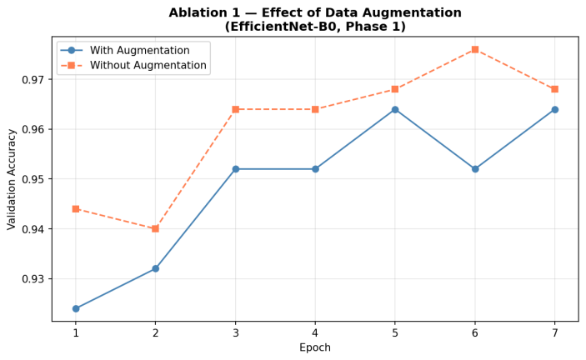
TABLE IV. Ablation 1: Effect of Data Augmentation on EfficientNet-B0 Phase 1 Validation Accuracy

Fig. 10. Ablation Study 1: Validation accuracy curves with and without augmentation for EfficientNet-B0 Phase 1. The no-augmentation baseline converges faster and achieves higher peak accuracy on this standardized data set.

- Ablation Study 2 — Fine-tuning Benefit per Architecture

Table V shows how the test set accuracy increases from Phase 1 to Phase 2 for every model . DeiT -Tiny has the largest gain of +0.0640 (6.40%) , after this MobileNetV3-Small (+0.0240) and then EfficientNet-B0(+0.0200). This order supports the idea that ViTs, which learns basics batch attention in Phase-1 gains the most learning domain specific visual details in this task setting
Model | Phase 1 Test Acc. | Phase 2 Test Acc. | Gain
EfficientNet-B0 | 0.9440 | 0.9640 | +0.0200
MobileNetV3-Small | 0.9360 | 0.9600 | +0.0240
DeiT-Tiny | 0.9160 | 0.9800 | +0.0640
TABLE V. Ablation 2: Phase 1 vs. Phase 2 Test Accuracy and Fine-tuning Gain per Architecture

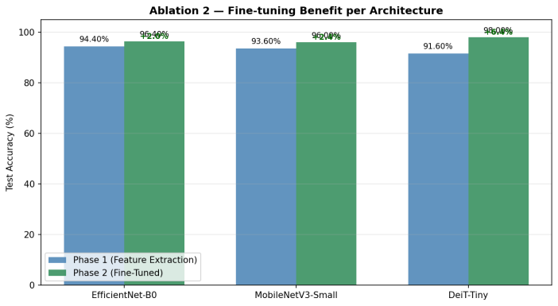
Fig. 11. Ablation Study 2: Phase 1 vs. Phase 2 test accuracy for all three architectures. DeiT-Tiny shows the largest fine-tuning gain, indicating stronger domain adaptation through partial backbone unfreezing.

VII. GRAD-CAM INTERPRETABILITY ANALYSIS
Grad CAM and GradCAM++ are used to show that which parts of images each model focus on when it makes predictions. For CNN models like EfficientNet-B0 and MobileNetV3-Small , GradCAM++ is applied to the last Convolutional layer. For DeiT-Tiny , the 196 patch tokens are changed into spatial feature map so that the GradCAM++ can be applied in a similar way.
For the correct predictions, all three models mainly focuses o butterfly wings , especially areas with some important features like eye-spots, color bands and wings edges. For incorrect predictions, the heat-maps shows that mistakes usually happen when the model focuses too much on the background or on the parts of the wings that looks very same to the other species. Overall this analysis presents that how the models are learning meaning visual features that matches the ones experts use to identify the butterfly species.
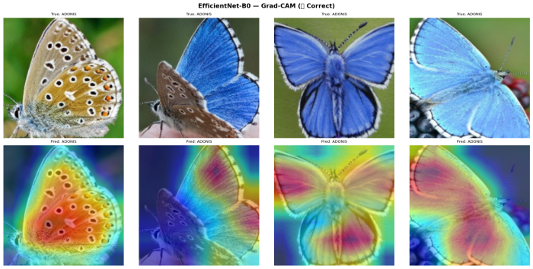
Fig. 12. EfficientNet-B0 Grad-CAM heatmaps for correctly classified samples. Warm regions indicate model attention. Models consistently attend to wing patterns and eyespots.
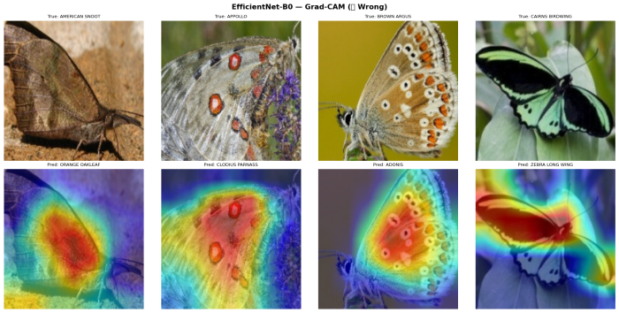
Fig. 13. EfficientNet-B0 Grad-CAM heatmaps for misclassified samples. Attention diffusion to background or similar wing undersides explains classification errors.
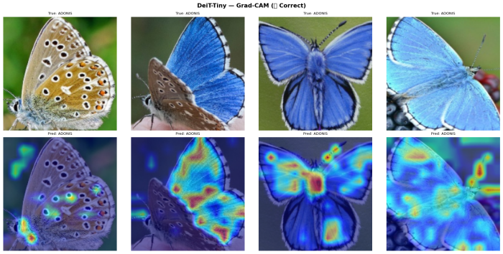
Fig. 14. DeiT-Tiny GradCAM++ heatmaps for correctly classified samples. The transformer's global attention produces more spatially coherent heatmaps covering wing regions holistically.
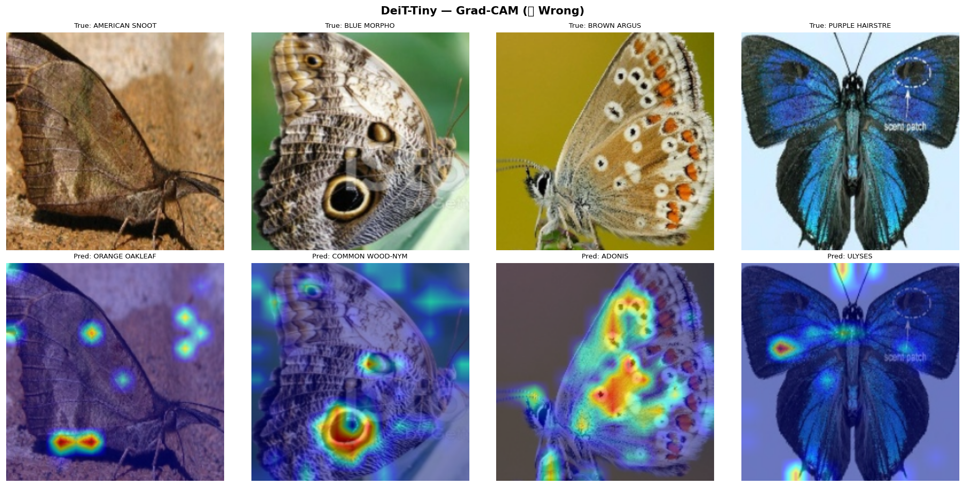
Fig. 15. DeiT-Tiny GradCAM++ heatmaps for misclassified samples. Even in failure cases, attention remains on the butterfly subject, reflecting stronger global context.

Fig. 16. Prediction dashboard showing top-5 confidence scores and Grad-CAM attention overlays for 6 representative test samples (3 correct, 3 incorrect) from DeiT-Tiny.
VII. DISCUSSION

- DeiT-Tiny as a Practical Choice for GPU Deployment
The Important result of this study is that DeiT-Tiny achieves the highest the highest accuracy (98.00%) while also having the fastest inference time (4.85 ms) among the three models on the T4 GPU . This goes against the common belief about Vision Transformers are always slower because of their complex attention mechanism . with an input size of 224x224 and the patch size 16, DeiT-Tiny only processes 196 patches . It makes the computation easy to run efficiently on modern GPUs.

- MobileNetV3 for Edge Deployment
For the devices without the GPU, like phones or small embedded systems , MobileNetV3-Small is the best choice because it is small and lightweight. It still performs well, with 96% Top-1 accuracy and 100% Top-3 accuracy. This implies that the correct species is always in its top three guesses , which is good enough when a user can choose the right one .

- Fine-tuning is Essential for ViTs
Ablation Study 2 shows that DeiT-Tiny has the lowest accuracy in Phase 1 (91.60%), but after fine- tuning in Phase 2 , it reaches the highest accuracy (98.00%). 6.40% improvement is much larger than the other models.
This means DeiT-Tiny needs fine tuning to work well. It learns general features first ,but after fine tuning it can focus n small butterfly details and performs much better .

D. Augmentation Observations
Ablation study 1 shows that the augmentation has reduced the performance . This is normally because the data set already has clean and same size images . The strong augmentation can remove important details in place of helping .

E . Limitations
The study has some limitations. First is that it uses only 50 species not all the 100+ in the data set . Second is all the test are done on the GPU , so there is no way to measure the CPU performance . Third is only the ViT model (DeiT-Tiny ) is tested , while other small models might perform even better. Fourth and the last, the data set comes form clean kaggle source , not the real field photos so it may not represent completely real world conditions.

IX. CONCLUSION
This paper compares the three lightweight models - EfficientNet-B0, MobileNetV3-Small, and DeiT-Tiny - for classifying 50 butterfliy species. By using 2 phase training - method , DeiT-Tiny performs the best , reaching 98.00% accuracy and the fastest speed (4.85) on GPU . MobileNetV3-Small is very much efficient and perfect for small devices because of its small size(1.57M parameter).
The experiments shows that the fine tuning is very important for transformer models like Deit-Tiny , providing a big improvement(6.40%) . They also shows that the data augmentation does not help always all depending on the dataset. Grad-Cam results confirms that the model focuses on the important wing features, almost same to how experts identify the species . The complete system, including training and a Stramlit app, shows a complete working solution for real world use case.
In the future, the study can be expanded to all the 100 species , tested on real field images, and better using techniques like knowledge distillation to make DeiT-Tiny smaller while keeping its high accuracy.

REFERENCES

[1] M. Teke and G. Elsamoly, "Innovative deep learning solutions for Turkish butterfly species identification," Knowledge-Based Systems, 2025.
[2] P. P. Rajeena et al., "A novel method for classification of butterfly species using pre-trained CNN," Journal of Intelligent Systems and Engineering, 2022.
[3] R. F. Mattins et al., "Object detection and classification of butterflies using Efficient CNN," Proc. IECT, 2024.
[4] A. Krizhevsky, I. Sutskever, and G. E. Hinton, "ImageNet classification with deep convolutional neural networks," Advances in Neural Information Processing Systems, vol. 25, 2012.
[5] A. S. Almryad and H. Kutucu, "Automatic identification for field butterflies by convolutional neural networks," Engineering Applications of Artificial Intelligence, vol. 94, 2020.
[6] H. Theivaprakasham et al., "Identification of Indian butterflies using deep convolutional neural network," Expert Systems with Applications, 2021.
[7] V. Sagar et al., "Indian butterfly and moth classification using EfficientNet ensemble," IEEE Access, 2020.
[8] K. Singh et al., "CNN with augmentation for 10-species butterfly recognition," Proc. ICACITE, 2024.
[9] B. Li et al., "Butterfly detection and classification with multi-scale YOLO ensemble," Proc. CVPR Workshop, 2020.
[10] X. Xin et al., "Speed-accuracy balanced butterfly detection with YOLOv3/YOLOv5," Pattern Recognition Letters, 2023.
[11] L. Yang, "Fine-grained butterfly classification with fine-tuned Vision Transformer," arXiv preprint, 2024.
[12] Dima806, "ViT architecture for 75 butterfly type detection," Kaggle Notebook, 2024.
[13] T. M. Berger, "CNN and Transformer variants for 110 butterfly species classification," arXiv preprint, 2022.
[14] R. Pucci et al., "Hybrid ViT-CNN architectures for citizen science butterfly monitoring," Ecological Informatics, 2023.
[15] J. Vincent et al., "Performance benchmarking of CNNs and Lightweight Butterfly Vision Transformers for fine-grained insect classification," arXiv preprint, 2025.
[16] G. P. Iosenka, "Butterfly Image Classification Dataset," Kaggle, 2022. [Online]. Available: https://www.kaggle.com/datasets/gpiosenka/butterfly-images40-species
[17] R. Wightman, "PyTorch Image Models (timm)," GitHub repository, 2019. [Online]. Available: https://github.com/rwightman/pytorch-image-models
[18] M. Tan and Q. Le, "EfficientNet: Rethinking model scaling for convolutional neural networks," Proc. ICML, 2019.
[19] A. Howard et al., "Searching for MobileNetV3," Proc. IEEE/CVF ICCV, pp. 1314–1324, 2019.
[20] H. Touvron et al., "Training data-efficient image transformers and distillation through attention," Proc. ICML, 2021.
[21] R. R. Selvaraju et al., "Grad-CAM: Visual explanations from deep networks via gradient-based localization," Proc. IEEE/CVF ICCV, pp. 618–626, 2017.
[22] A. Chattopadhyay et al., "Grad-CAM++: Improved visual explanations for deep convolutional networks," Proc. WACV, 2018.
[23] T. Xi et al., "Multiple butterfly recognition method based on deep residual learning," Proc. ISCID, 2022.
[24] H. Anwar et al., "Benchmarking 130 CNNs and ViTs for butterfly species recognition," arXiv:s100-44-025-01587-7, 2026.
[25] A. Dosovitskiy et al., "An image is worth 16×16 words: Transformers for image recognition at scale," Proc. ICLR, 2021.

