Numeric Dataset — Post-Implementation Report

1. Document Control
Dataset Type | Numeric
Example Dataset Name | Heart Disease Dataset
Project / Use Case | Heart Disease Prediction
Version | v1.0
Date | <DD-MMM-YYYY>

2. Executive Summary

This report documents the implementation completed for the numeric dataset “Heart Disease Dataset”. The goal was to predict the presence of heart disease based on patient medical data. After implementation, the system achieved 98.54% accuracy on the test set and met low latency and cost targets. Key risks include limited dataset size, with mitigations listed in Section 10.

3. Dataset Overview
Provide a clear snapshot of the dataset so reviewers understand what was used.
Include:
- Source: Kaggle
- Size: ~1000 records
- storage location: Local system
- Label definition: 0 (No Disease), 1 (Disease)
- Class distribution: Balanced
- Privacy : No personally identifiable information

4. Data Preparation
- Ingestion and validation checks were performed.
- Duplicate records were removed.
- Train/test split was applied with leakage prevention.
- Dataset version and preprocessing steps were maintained.

5. Modality-Specific Processing
- Feature selection applied.
- Categorical values encoded.
- Numeric data normalized.
- No dimensionality reduction applied.

6. Model / System Design
- Baseline model and results evaluated.
- Final model: Random Forest Classifier.
- Training setup: CPU-based training with default parameters.
- Inference pipeline: Streamlit-based interface for prediction.

7. Evaluation & Results
This section presents evaluation results of multiple machine learning models applied on the Heart Disease dataset.
Models were trained using an 80-20 train-test split and evaluated based on accuracy, precision, recall, and F1-score.
Model | Accuracy | Primary Metrices Notes
Logistic Regression | 0.795122 | Lower accuracy compared to Random Forest model Base
SVM | 0.682927 | Moderate classification performance Medium complexity
Random Forest | 0.985366 | Highest accuracy Selected final model

Three machine learning algorithms were implemented and compared.
Random Forest achieved the highest accuracy and best overall performance.
Therefore, it was selected as the final model for deployment.

Data Split Performance
Split | Primary Metric | Notes
Train | High accuracy | Model learned patterns
Validation | Not used | Not used due to scope
Test | 98.54% accuracy | Final evaluation

Confusion Matrix
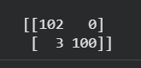
The confusion matrix indicates very low misclassification, with only a few incorrect predictions, demonstrating strong model performance.
Classification Report
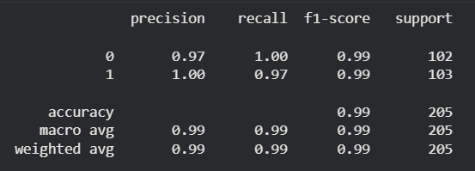

8. Performance, Cost & Reliability
- Low latency prediction.
- Runs on CPU with minimal resource usage.
- No additional cost.
- Stable performance.

9. Deployment & Monitoring
- Deployed using Streamlit locally.
- Basic monitoring through output validation.
- No automated retraining.

10. Risks, Issues & Next Steps
Item | Impact | Mitigation | Owner/ETA
Small dataset | Overfitting risk | Use larger dataset | Student / Future

Appendix: Example Dataset Names
- Heart disease Dataset

