**Steps to install & config Sophos VPN client :**

Download the setup and configuration files from the OneDrive VPN folder that I have shared with you.

1.Run the installer on your computer.

2. Launch the Sophos Connect VPN client.

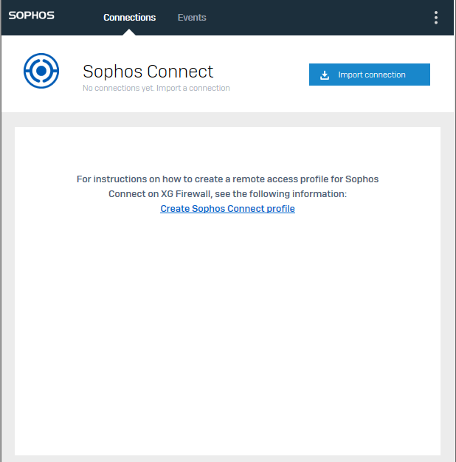

3.Click on "Import Connection" and select the configuration file that I have sent.

4.Right-click on the settings icon next to 122.165.126.205 and rename it as "Rieker Sensing".

5.Then, use the credentials that I have shared with you.

*Note: Login credentials have been sent in a separate email.