Mechatronics and Industrial Internet of Things

IIoT-Based A SMART INVENTORY MANAGEMENT SYSTEM FOR CONSTRUCTION SITES

PROJECT REPORT

BHAVESH PRAKASH G - 24MER005
VASANTHAN B – 24MER060
PRABHUKUMAR N – 24MER40
AJAY PRABHAV A – 24MER003
SANTHAKUMAR M – 24MEL065
DEEPAK C – 24MEL069

- Project Overview:
The Smart Inventory Management System for Construction Sites is designed to efficiently monitor, track, and manage construction materials and inventory movement. Construction sites handle large quantities of materials such as cement, steel, bricks, pipes, tools, and other equipment. Manual inventory management can lead to material shortages, excess stock, loss, wastage, and inaccurate records.
The proposed system uses sensors, RFID, barcode/QR code technology, or a microcontroller-based system to identify and track materials. Whenever materials are received, stored, issued, or moved from one location to another, the inventory information is updated. The system keeps track of the available quantity and provides the current stock status.
The system can also provide alerts when the quantity of a material falls below the required level. This helps site managers arrange materials on time and avoid delays in construction activities. By reducing manual work and improving inventory visibility, the system helps achieve better resource utilization, reduces material wastage, and improves overall construction site management efficiency.

- Project Statement:
Construction sites require large quantities of materials such as cement, steel, bricks, pipes, tools, and other resources. Managing these materials manually can result in inaccurate records, material loss, unnecessary wastage, overstocking, and unexpected shortages. Tracking the movement of materials between storage areas and work locations is also difficult using traditional methods. These problems can increase project costs and cause delays in construction activities.
Therefore, there is a need for a smart and efficient inventory management system that can continuously track material availability and movement at construction sites. The proposed system is designed to:
- Monitor inventory levels in real time.
- Track the movement of construction materials.
- Record material usage and stock updates.
- Identify low-stock conditions automatically.
- Generate alerts when materials need replenishment.
- Reduce manual record keeping and human errors.
- Minimize material wastage and loss.
- Improve resource utilization and inventory visibility.
- Support efficient construction site management.
By providing accurate inventory information and timely notifications, the system helps site managers make better decisions regarding material procurement and utilization. This reduces delays in construction activities, improves inventory control, and enhances overall project efficiency.

- Proposed Solution:
The proposed solution is to develop a Smart Inventory Management System for Construction Sites that provides accurate and real-time monitoring of construction materials. The system is designed to overcome the limitations of traditional manual inventory management, such as incorrect stock records, material loss, excessive usage, wastage, and unexpected material shortages.
The system uses identification and tracking technologies such as RFID tags, barcode/QR codes, sensors, and a microcontroller to identify and monitor construction materials. Each material is assigned a unique identification code so that its quantity and movement can be accurately recorded. When materials enter the construction site, the system registers the received quantity and updates the inventory database automatically.
The proposed system performs the following functions:
- Identifies construction materials using RFID, barcode, or QR code technology.
- Records material entry, issue, transfer, and return operations.
- Continuously updates inventory information.
- Calculates the available stock in real time.
- Monitors inventory levels against predefined stock limits.
- Generates alerts when material quantity falls below the minimum stock level.
- Displays inventory status through an LCD, computer, or mobile application.
- Supports IoT-based cloud storage and remote monitoring.
- Provides information on material consumption and inventory movement.
Whenever a material is issued for construction work, transferred between storage locations, or returned to the storage area, the inventory information is updated automatically. The system continuously calculates the available stock based on material entries and usage records. This provides site managers with accurate information about current inventory levels and helps ensure that materials are available when required.

- System Architecture:

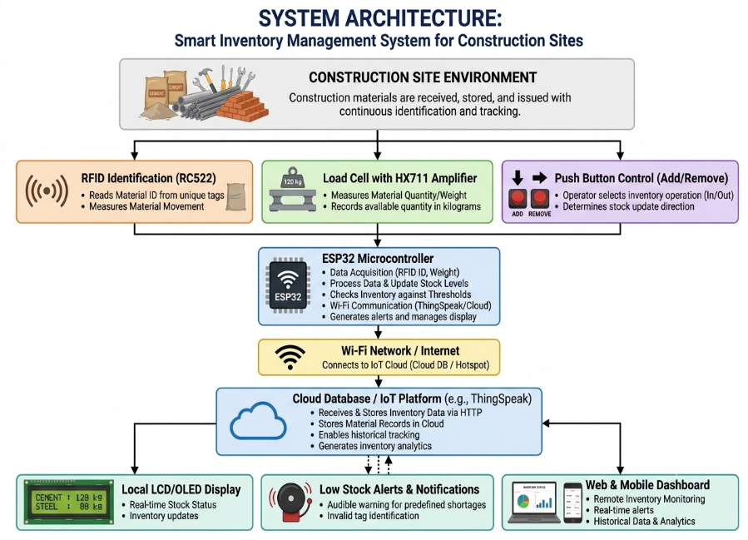

- Circuit Table:

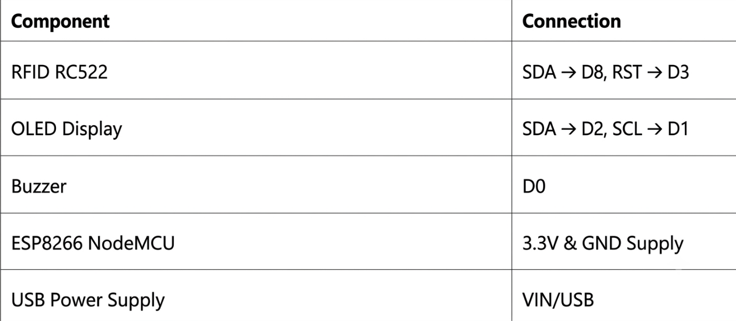

- Circuit Design:

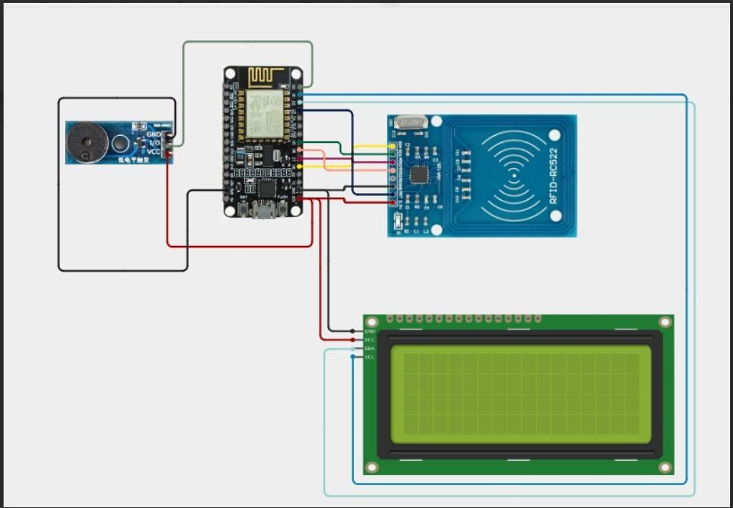

- Algorithm:
Step 1: Start the system.
Step 2: Initialize the ESP8266 NodeMCU, RFID reader, OLED display, and buzzer.
Step 3: Connect the ESP8266 to the Wi-Fi network.
Step 4: Scan the RFID tag attached to the material.
Step 5: Read the material identification information.
Step 6: Update the inventory database based on material entry, issue, or return.
Step 7: Calculate the available stock quantity.
Step 8: Compare the stock level with the predefined minimum limit.
Step 9: Generate a low-stock alert if the quantity falls below the limit.
Step 10: Display the inventory status on the OLED display.
Step 11: Upload inventory information to the cloud platform.
Step 12: Repeat the process continuously for real-time inventory monitoring.
- Coding:

#include <SPI.h> #include <MFRC522.h> #include <Wire.h>
#include <LiquidCrystal_I2C.h> #include <ESP8266WiFi.h> #include <ThingSpeak.h>
// =================================================
// WIFI SETTINGS
// =================================================
const char* ssid = "Xiaomi 11i"; const char* password = "12345678"; WiFiClient client;
// =================================================

// THINGSPEAK SETTINGS
// =================================================
unsigned long channelID = 3458770;
const char* writeAPIKey = "PH9Z3KRMKRAGSKBZ";
// =================================================

// RC522 RFID - ESP8266 GPIO PINS
// =================================================
#define SS_PIN 15 // D8 #define RST_PIN 0 // D3
MFRC522 mfrc522(SS_PIN, RST_PIN)
// =================================================

LiquidCrystal_I2C lcd(0x27, 16, 2);
// =================================================

// BUZZER - LOW ACTIVE
// =================================================
#define BUZZER_PIN 16 // D0
// LOW = Buzzer ON
// HIGH = Buzzer OFF
// =================================================

// SETUP
// =================================================
void setup() {
//

// SERIAL MONITOR
// Serial.begin(9600); delay(1000); Serial.println();
Serial.println("==============================");
Serial.println(" RFID SYSTEM"); Serial.println("==============================");
// =================================================

// BUZZER SETUP
// ================================================= pinMode(BUZZER_PIN, OUTPUT);

// LOW ACTIVE BUZZER
// HIGH = OFF
digitalWrite(BUZZER_PIN, HIGH);

// =================================================
Wire.begin(SDA_PIN, SCL_PIN); lcd.init();
lcd.backlight(); lcd.clear(); lcd.setCursor(0, 0);
lcd.print("RFID SYSTEM"); lcd.setCursor(0, 1); lcd.print("Starting...");
// =================================================

// CONNECT TO WIFI
// =================================================
Serial.println(); Serial.println("Connecting to WiFi..."); lcd.clear();
lcd.setCursor(0, 0); lcd.print("Connecting WiFi"); WiFi.begin(ssid, password);
while (WiFi.status() != WL_CONNECTED) { delay(500);
Serial.print(".");
}
Serial.println(); Serial.println("WiFi Connected"); Serial.print("IP Address: "); Serial.println(WiFi.localIP()); lcd.clear();
lcd.setCursor(0, 0); lcd.print("WiFi Connected");

delay(1000);
// =================================================

// START THINGSPEAK
// =================================================
ThingSpeak.begin(client); Serial.println("ThingSpeak Ready");
// =================================================
// START RFID
// =================================================
SPI.begin(); mfrc522.PCD_Init(); delay(1000);
// =================================================

// READY
// =================================================
lcd.clear(); lcd.setCursor(0, 0);
lcd.print("RFID SYSTEM"); lcd.setCursor(0, 1); lcd.print("Scan Your Card"); Serial.println("LCD Ready"); Serial.println("RC522 Ready");
Serial.println("ThingSpeak Ready"); Serial.println("Buzzer Ready"); Serial.println("Scan Your Card");
Serial.println("==============================");
}
// =================================================

// =================================================
void loop() {
//

// CHECK FOR NEW RFID CARD
//

if (!mfrc522.PICC_IsNewCardPresent()) { return;
}
//
// READ RFID CARD
//

if (!mfrc522.PICC_ReadCardSerial()) { return;
}
//
// CREATE UID STRING
//

String uid = ""; Serial.print("UID: ");
for (byte i = 0; i < mfrc522.uid.size; i++) { if (mfrc522.uid.uidByte[i] < 0x10) { Serial.print("0");
uid += "0";
}
Serial.print( mfrc522.uid.uidByte[i], HEX
);
uid += String(

mfrc522.uid.uidByte[i], HEX
);
}
uid.toUpperCase(); Serial.println();
// =================================================
// DOOR
// ================================================= if (uid == "BA8A8132") {
showKnownTag( "Door",
uid, 1
);
}
// =================================================

// LAB
// =================================================
else if (uid == "7BABD13E") { showKnownTag(
"Lab", uid,
2
);
}
// =================================================

// SATHEESH
// =================================================

else if (uid == "D61A9269") {

showKnownTag( "Satheesh",
uid, 3
);
}
// =================================================

// SABEER
// =================================================
else if (uid == "6F22CB48") { showKnownTag(
"Sabeer", uid,
4
);
}
// =================================================

// PRASANA
// =================================================
else if (uid == "1F22EB48") { showKnownTag(
"Prasana", uid,
5
);
}
// =================================================

// UNKNOWN CARD
// =================================================
else { showUnknownTag(uid);
}
//
// STOP RFID COMMUNICATION
// mfrc522.PICC_HaltA();
mfrc522.PCD_StopCrypto1();
//

// READY FOR NEXT CARD
// delay(1000); lcd.clear();
lcd.setCursor(0, 0); lcd.print("RFID SYSTEM"); lcd.setCursor(0, 1); lcd.print("Scan Your Card");
}
// =================================================

// FUNCTION: KNOWN RFID TAG
// =================================================
void showKnownTag( String name,
String uid, int personID
) {

// BUZZER OFF
// LOW ACTIVE BUZZER
// HIGH = OFF
// digitalWrite( BUZZER_PIN, HIGH
);
//
// SERIAL OUTPUT
// Serial.println();
Serial.print("Known RFID Tag: "); Serial.println(name); Serial.print("UID: "); Serial.println(uid); Serial.println("Access Granted");
Serial.println(" ");
//

// LCD OUTPUT
// lcd.clear();
lcd.setCursor(0, 0); lcd.print("Access Granted"); lcd.setCursor(0, 1); lcd.print(name);
//

// SEND DATA TO THINGSPEAK

sendToThingSpeak( uid,
personID, 1
);
//
// KEEP RESULT ON LCD
// delay(3000);
//

// MAKE SURE BUZZER IS OFF
// digitalWrite( BUZZER_PIN, HIGH
);
}
// =================================================

// FUNCTION: UNKNOWN RFID TAG
// =================================================
void showUnknownTag( String uid
) {
//
// SERIAL OUTPUT
// Serial.println();
Serial.print("Unknown RFID Tag:

Serial.println("Access Denied"); Serial.println(" ");
//

// LCD OUTPUT
// lcd.clear();
lcd.setCursor(0, 0); lcd.print("Unknown Tag"); lcd.setCursor(0, 1); lcd.print("Access Denied");
//

// SEND DATA TO THINGSPEAK
// sendToThingSpeak( uid,
0,
0
);
//
// BUZZER - LOW ACTIVE
// 3 BEEPS
//
for (int i = 0; i < 3; i++) {

// BUZZER ON
digitalWrite( BUZZER_PIN, LOW
);

// BUZZER OFF
digitalWrite( BUZZER_PIN, HIGH
);
delay(300);
}
//
// MAKE SURE BUZZER IS OFF
// digitalWrite( BUZZER_PIN, HIGH
);
//
// KEEP RESULT ON LCD
// delay(2000);
}
// =================================================

// FUNCTION: SEND DATA TO THINGSPEAK
// =================================================
void sendToThingSpeak( String uid,
int personID, int accessStatus
) {

//
if (WiFi.status() != WL_CONNECTED) { Serial.println(
"WiFi Disconnected"
);
return;
}
//
// FIELD 1 = RFID UID
// ThingSpeak.setField( 1,
uid
);
//
// FIELD 2 = PERSON ID
// ThingSpeak.setField( 2,
personID
);
//
// FIELD 3 = ACCESS STATUS
// ThingSpeak.setField( 3,
accessStatus
);
//

// WRITE DATA TO THINGSPEAK

//

int response = ThingSpeak.writeFields( channelID,
writeAPIKey
);
//
// CHECK RESPONSE
//

if (response == 200) {
Serial.println(
"ThingSpeak Update Successful"
);
}
else
{
Se ria l.p rin t(
"ThingSpeak Error: "
);
Serial.println(response);
}

- System Working:

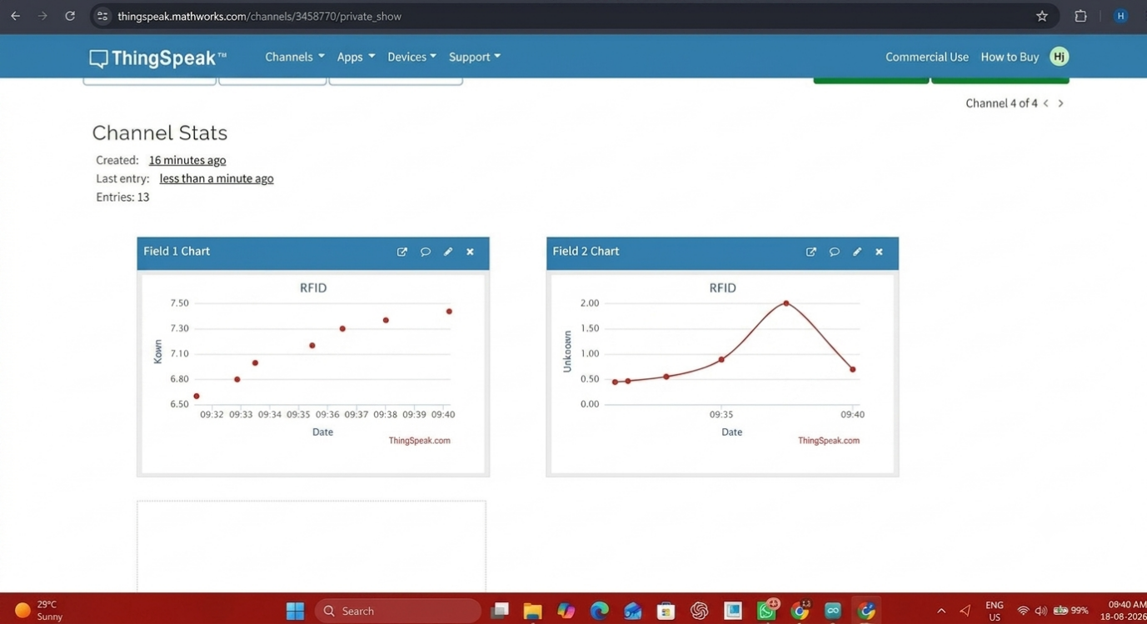

- Working sequence:
Start → Initialize ESP8266, RFID Reader, OLED Display & Buzzer → Connect to Wi-Fi → Scan RFID Tag → Identify Material → Update Inventory Record → Calculate Available Stock → Check Minimum Stock Level → Generate Alert (if required) → Display Inventory Status → Upload Data to Cloud → Repeat Process

- Bill of Materials:
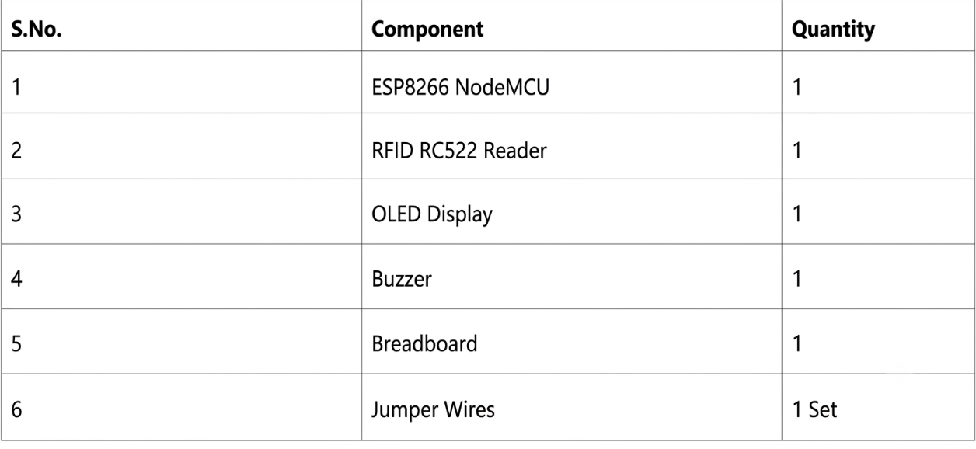
- Prototype Implementation:

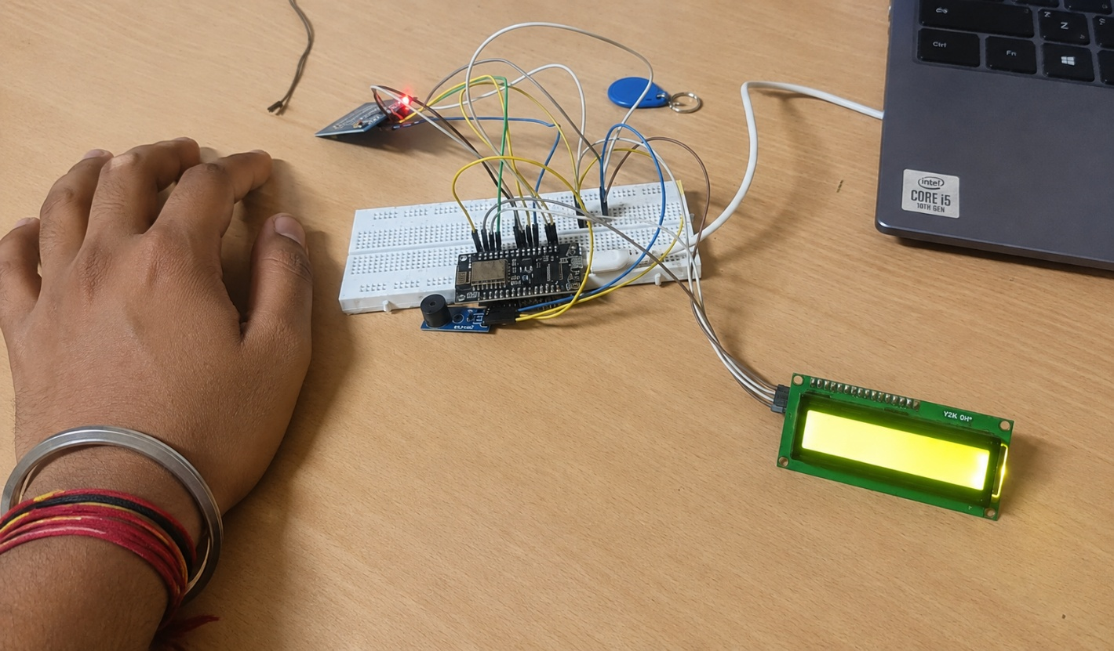
- Results and Performance Analysis:
Performance:
The system provides:
- Real-time data acquisition from environmental and temperature sensors.
- Lightweight and efficient packet transmission using the MQTT protocol.
- Immediate local threshold comparisons and buzzer/LCD updates via ESP32 edge processing.
- Continuous historical data logging and graph rendering on the ThingSpeak platform.
Advantages:
- 24/7 remote monitoring via web and mobile dashboards.
- Proactive identification of abnormal temperature, humidity, air quality, or equipment status.
- Reduction of energy consumption and operational costs.
- Cost-effective alternative built using off-the-shelf components.
- Simplified maintenance scheduling through automated cloud-based records.
Limitations:
- Heavy reliance on stable local Wi-Fi and internet connectivity for remote tracking.
- Susceptibility to sensor drift over time, requiring periodic calibration.
- Automated corrective actions limited by integrated relay channel configurations.
- Message rate frequencies and data channel storage limits imposed by free-tier cloud platforms.

