Mechatronics and Industrial Internet of Things

IIoT-Based Smart Refrigerator Monitoring System

PROJECT REPORT

BHAVESH PRAKASH G - 24MER005
VASANTHAN B – 24MER060
PRABHUKUMAR N – 24MER40
AJAY PRABHAV A – 24MER003
SANTHAKUMAR M – 24MEL065
DEEPAK C – 24MEL069

- Project Overview:
The Smart Refrigerator Monitoring System is an IoT-based solution developed to continuously monitor the internal temperature and humidity conditions of a refrigerator. Maintaining proper environmental conditions inside a refrigerator is essential for preserving food quality, preventing spoilage, and ensuring efficient operation of the cooling system. Traditional methods of manually checking refrigerator conditions do not provide continuous monitoring and may fail to detect sudden changes that can affect stored food items.
The system continuously measures temperature and humidity using a sensor and transmits the collected data to a cloud platform through Wi-Fi. This enables users to remotely monitor refrigerator conditions in real time and analyze historical data to identify abnormal environmental changes. By providing continuous monitoring and remote access to sensor information, the system helps improve food safety, supports preventive maintenance, and demonstrates the application of IoT technology in smart home and food-storage environments.

- Project Statement:
Food stored in refrigerators requires suitable temperature and humidity conditions for proper preservation. Manual checking of refrigerator conditions does not provide continuous monitoring and may fail to detect sudden changes. Such variations can affect food quality, increase the risk of spoilage, and reduce the overall efficiency of the refrigeration system.
Therefore, an IoT-based Smart Refrigerator Monitoring System is proposed to continuously monitor the internal environmental conditions of a refrigerator and provide remote access to the collected data through a cloud platform. The system is designed to:
- Continuously measure refrigerator temperature.
- Continuously measure refrigerator humidity.
- Monitor environmental conditions in real time.
- Detect abnormal temperature and humidity variations.
- Transmit sensor data through Wi-Fi.
- Store sensor readings on a cloud platform.
- Enable remote monitoring through a dashboard.
- Support historical data analysis for performance evaluation.
The proposed system helps users monitor refrigerator conditions remotely, identify potential refrigeration problems at an early stage, and maintain suitable storage conditions for food preservation.

- Proposed Solution:
The proposed Smart Refrigerator Monitoring System uses a DHT11 temperature and humidity sensor and an ESP8266 NodeMCU to continuously monitor the environmental conditions inside a refrigerator. The DHT11 sensor measures the internal temperature and humidity, while the ESP8266 reads and processes the sensor data. The collected information is then transmitted to a cloud platform using Wi-Fi, allowing users to monitor refrigerator conditions remotely.
The system can identify abnormal conditions such as excessively high temperature or unusual humidity levels, which may indicate problems with the refrigeration system. The stored cloud data can be viewed through a dashboard and analyzed to observe environmental changes over time. This enables continuous monitoring and helps users maintain suitable conditions for food preservation.
The system operates as follows:
- Temperature Monitoring: Continuously measures the internal refrigerator temperature using the DHT11 sensor. The ESP8266 reads the temperature value at regular intervals.
- Humidity Monitoring: Measures the relative humidity inside the refrigerator and monitors changes in environmental conditions.
- Data Processing: The ESP8266 receives and processes the sensor readings and determines the current refrigerator condition.
- Wireless Communication: The ESP8266 uses Wi-Fi to transmit the collected data to the cloud platform.
- Cloud Data Storage: Temperature and humidity readings are stored on the cloud platform for remote monitoring and future analysis

- System Architecture:

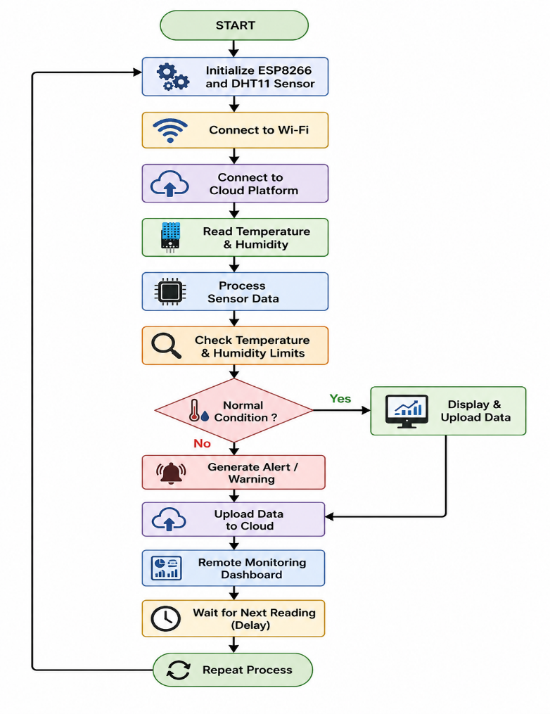

- Circuit Table:

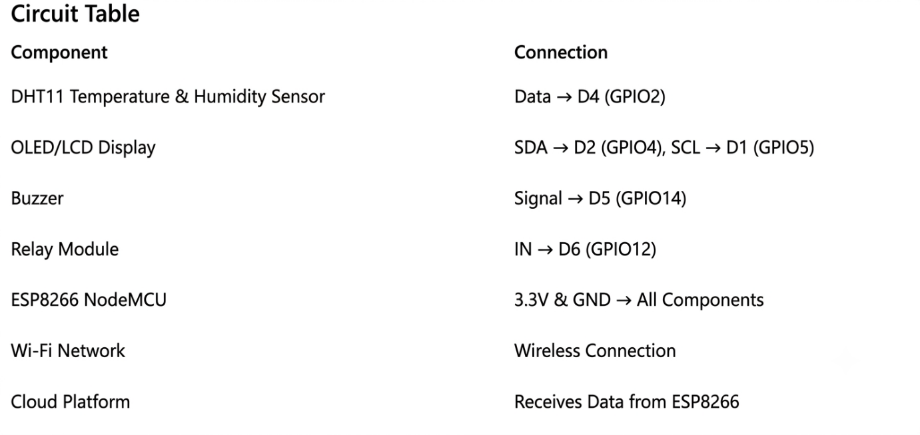

- Circuit Design:

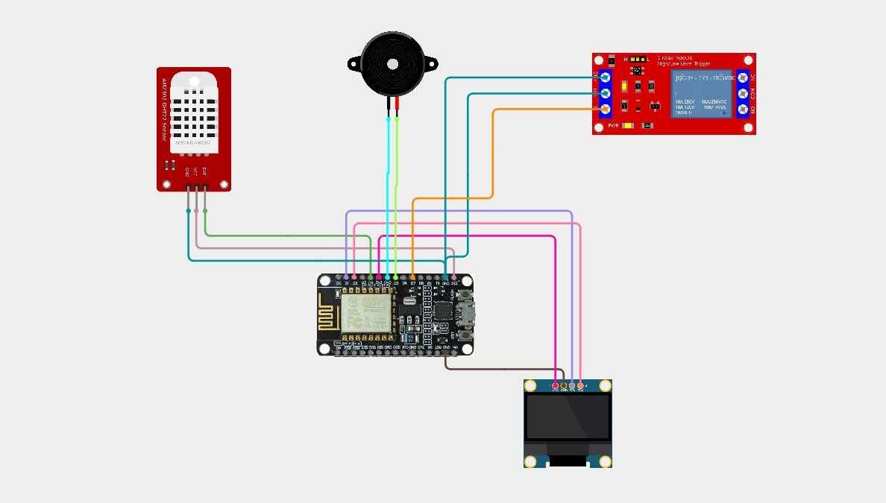

- Algorithm:
Step 1: Start the system.
Step 2: Initialize the ESP8266 NodeMCU, DHT11 sensor, OLED/LCD display, buzzer, and relay module.
Step 3: Connect the ESP8266 to the configured Wi-Fi network.
Step 4: Establish communication with the cloud platform.
Step 5: Read temperature from the DHT11 sensor.
Step 6: Read humidity from the DHT11 sensor.
Step 7: Display the measured values on the OLED/LCD display.
Step 8: Compare the readings with predefined threshold values.
Step 9: If abnormal conditions are detected, activate the buzzer and relay.
Step 10: Upload temperature and humidity data to the cloud platform.
Step 11: Enable remote monitoring through the dashboard.
Step 12: Repeat the process at regular intervals.

- Coding:
#include <WiFi.h> #include <Wire.h>
#include <Adafruit_MQTT.h> #include <Adafruit_MQTT_Client.h> #include <DHT.h>
#include <hd44780.h>
#include <hd44780ioClass/hd44780_I2Cexp.h>
// =====================================================
// WIFI DETAILS
// =====================================================
#define WIFI_SSID "OnePlus Nord CE5 7C5C" #define WIFI_PASSWORD "qkts5737"
// =====================================================
// ADAFRUIT IO DETAILS
// =====================================================
#define AIO_SERVER "io.adafruit.com" #define AIO_SERVERPORT 1883
#define AIO_USERNAME "Sivasaravanan"
#define AIO_KEY "aio_ADVS50c7oG5Sx1R3FskFAq0ȠUrB"
// =====================================================
// DHT11
// =====================================================
#define DHTPIN 15 #define DHTTYPE DHT11
DHT dht(DHTPIN, DHTTYPE);
// =====================================================
// I2C LCD
// =====================================================

hd44780_I2Cexp lcd; #define SDA_PIN 21
#define SCL_PIN 22
// =====================================================
// RELAY
// =====================================================
#define RELAY_PIN 26
// Most common relay modules are ACTIVE LOW #define RELAY_ON LOW
#define RELAY_OFF HIGH
// =====================================================
// BUZZER
// =====================================================
#define BUZZER_PIN 25
// =====================================================
// MQTT
// =====================================================
WiFiClient client;
Adafruit_MQTT_Client mqtt( &client,
AIO_SERVER, AIO_SERVERPORT, AIO_USERNAME, AIO_KEY
);
// =====================================================
// ADAFRUIT IO FEEDS
// =====================================================
// Temperature feed

Adafruit_MQTT_Publish temperatureFeed = Adafruit_MQTT_Publish(
&mqtt,
AIO_USERNAME "/feeds/hvac-temperature"
);
// Humidity feed
Adafruit_MQTT_Publish humidityFeed = Adafruit_MQTT_Publish(
&mqtt,
AIO_USERNAME "/feeds/hvac-humidity"
);
// Status feed
Adafruit_MQTT_Publish statusFeed = Adafruit_MQTT_Publish(
&mqtt,
AIO_USERNAME "/feeds/hvac-status"
);
// Buzzer feed
Adafruit_MQTT_Publish buzzerFeed = Adafruit_MQTT_Publish(
&mqtt,
AIO_USERNAME "/feeds/hvac-buzzer"
);
// =====================================================
// CONNECT TO WIFI
// =====================================================
void connectWiFi()
{
Serial.println();

Serial.println("Connecting to WiFi...");

WiFi.begin(WIFI_SSID, WIFI_PASSWORD);

while (WiFi.status() != WL_CONNECTED)
{
delay(500);
Serial.print(".");
}
Serial.println();
Serial.println("WiFi Connected!"); Serial.print("IP Address: ");
Serial.println(WiFi.localIP());
}
// =====================================================
// CONNECT TO ADAFRUIT IO
// =====================================================
bool connectMQTT()
{
if (mqtt.connected())
{
return true;
}
Serial.println();
Serial.println("Connecting to Adafruit IO..."); int8_t ret = mqtt.connect();
if (ret != 0)
{
Serial.print("MQTT Connection Failed: ");

Serial.println(mqtt.connectErrorString(ret)); mqtt.disconnect();
return false;
}
Serial.println("Adafruit IO Connected!"); return true;
}
// =====================================================
// SETUP
// =====================================================
void setup()
{
Serial.begin(115200);
//
// DHT11
// dht.begin();
//
// I2C LCD
//
Wire.begin(SDA_PIN, SCL_PIN); int lcdStatus = lcd.begin(16, 2); lcd.backlight();
lcd.clear();
lcd.setCursor(0, 0);
lcd.print("HVAC MONITOR"); lcd.setCursor(0, 1);
lcd.print("Starting...");
//

// RELAY
//
pinMode(RELAY_PIN, OUTPUT);
digitalWrite(RELAY_PIN, RELAY_OFF);
//
// BUZZER
//
pinMode(BUZZER_PIN, OUTPUT);
digitalWrite(BUZZER_PIN, LOW); delay(2000);
//
// WIFI
//
lcd.clear();
lcd.setCursor(0, 0);
lcd.print("WiFi Connecting"); connectWiFi();
//
// MQTT
//
lcd.clear();
lcd.setCursor(0, 0);
lcd.print("Adafruit IO"); lcd.setCursor(0, 1);
lcd.print("Connecting..."); connectMQTT();
delay(2000); lcd.clear();
}

// =====================================================
// LOOP
// =====================================================
void loop()
{
// ===================================================
// CHECK WIFI
// ===================================================
if (WiFi.status() != WL_CONNECTED)
{
Serial.println("WiFi disconnected!"); connectWiFi();
}
// ===================================================
// CHECK MQTT
// ===================================================
if (!connectMQTT())
{
Serial.println("MQTT not connected."); delay(5000);
return;
}
// ===================================================
// READ DHT11
// ===================================================
float temperature = dht.readTemperature(); float humidity = dht.readHumidity();
// ===================================================
// SENSOR ERROR

// ===================================================
if (isnan(temperature) || isnan(humidity))
{
Serial.println("DHT11 ERROR!"); lcd.clear();
lcd.setCursor(0, 0);
lcd.print("DHT11 ERROR"); lcd.setCursor(0, 1);
lcd.print("Check Wiring");
digitalWrite(RELAY_PIN, RELAY_OFF); digitalWrite(BUZZER_PIN, LOW); delay(2000);
return;
}
// ===================================================
// HVAC STATUS
// ===================================================
String hvacStatus;
String buzzerStatus;
if (temperature > 30.0)
{
// High temperature
digitalWrite(RELAY_PIN, RELAY_ON); digitalWrite(BUZZER_PIN, HIGH); hvacStatus = "HIGH TEMPERATURE"; buzzerStatus = "ON";
}
else
{

// Normal temperature
digitalWrite(RELAY_PIN, RELAY_OFF); digitalWrite(BUZZER_PIN, LOW);
hvacStatus = "NORMAL"; buzzerStatus = "OFF";
}
// ===================================================
// LCD DISPLAY
// ===================================================
lcd.clear();
lcd.setCursor(0, 0); lcd.print("Temp:");
lcd.print(temperature, 1); lcd.write(223);
lcd.print("C");
lcd.setCursor(0, 1); lcd.print("Hum:");
lcd.print(humidity, 1); lcd.print("%");
// ===================================================
// SERIAL MONITOR
// ===================================================
Serial.println();
Serial.println("==============================");
Serial.print("Temperature : "); Serial.print(temperature, 1); Serial.println(" C");
Serial.print("Humidity : "); Serial.print(humidity, 1);

Serial.println(" %");
Serial.print("HVAC Status : "); Serial.println(hvacStatus);
Serial.print("Relay : "); if (temperature > 30.0)
Serial.println("ON"); else
Serial.println("OFF");
Serial.print("Buzzer : "); Serial.println(buzzerStatus);
// ===================================================
// SEND TEMPERATURE
// ===================================================
if (temperatureFeed.publish(temperature))
{
Serial.println("Temperature -> Adafruit IO : OK");
}
else
{
Serial.println("Temperature -> Adafruit IO : FAILED");
}
// ===================================================
// SEND HUMIDITY
// ===================================================
if (humidityFeed.publish(humidity))
{
Serial.println("Humidity -> Adafruit IO : OK");
}
else

{
Serial.println("Humidity -> Adafruit IO : FAILED");
}
// ===================================================
// SEND HVAC STATUS
// ===================================================
if (statusFeed.publish(hvacStatus.c_str()))
{
Serial.println("Status -> Adafruit IO : OK");
}
else
{
Serial.println("Status -> Adafruit IO : FAILED");
}
// ===================================================
// SEND BUZZER STATUS
// ===================================================
if (buzzerFeed.publish(buzzerStatus.c_str()))
{
Serial.println("Buzzer -> Adafruit IO : OK");
}
else
{
Serial.println("Buzzer -> Adafruit IO : FAILED");
}
Serial.println("==============================");
// ===================================================
// WAIT 5 SECONDS
// ===================================================

delay(5000);
}

- System Working:

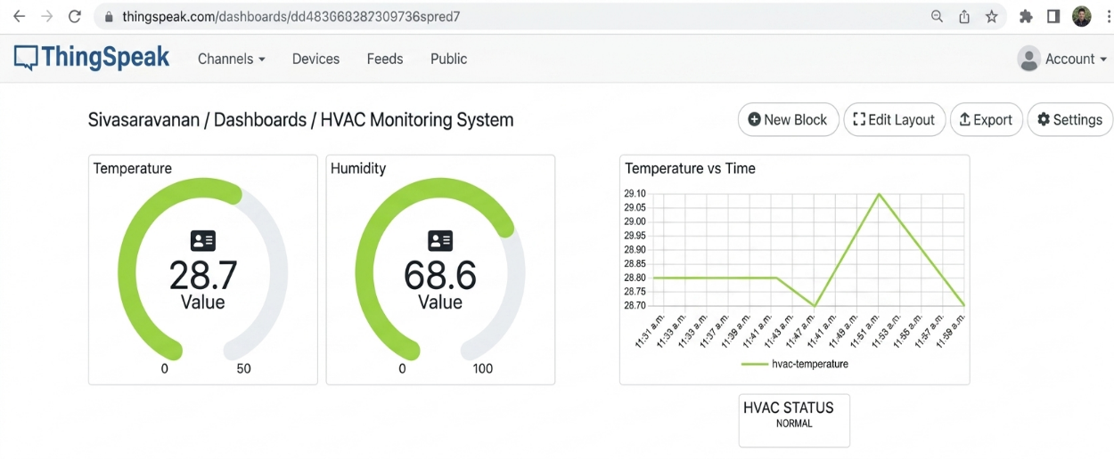

- Working sequence:
Start → Initialize ESP8266 & DHT11 Sensor → Connect to Wi-Fi → Connect to Cloud Platform → Read Temperature & Humidity → Process Sensor Data → Check Threshold Limits → Display Values → Generate Alert (if required) → Upload Data to Cloud → Remote Monitoring Dashboard → Repeat Process

- Bill of Materials:

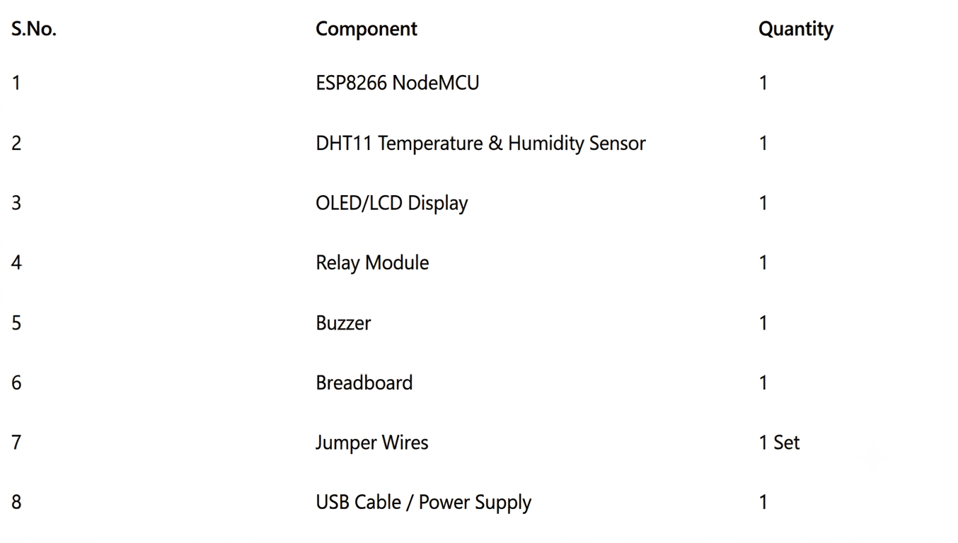

- Prototype Implementation:

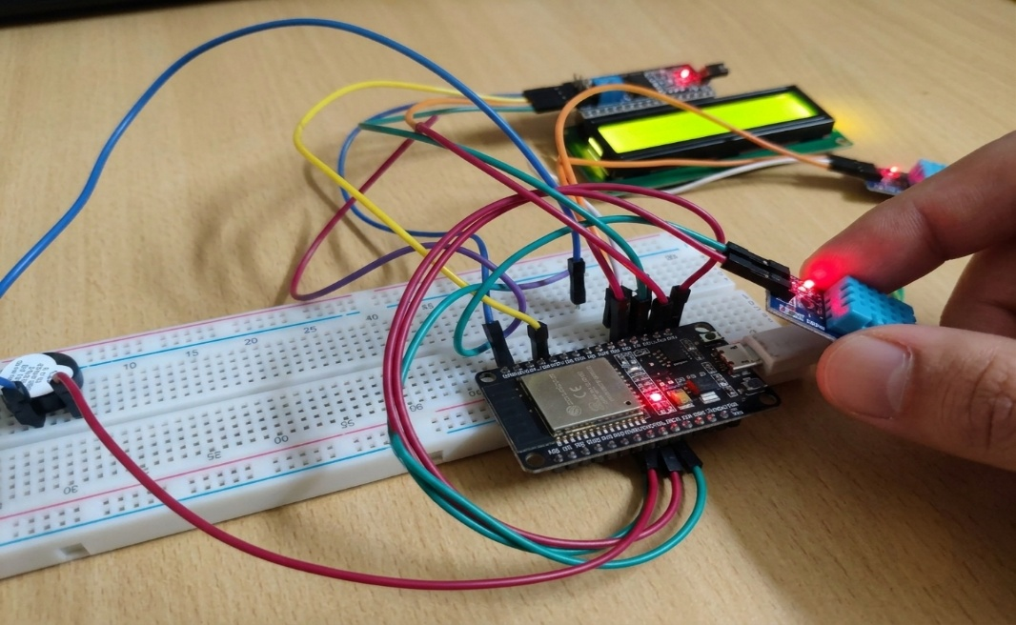
- Results and Performance Analysis:
Performance:
The system provides:
- Continuous temperature monitoring inside the refrigerator.
- Continuous humidity monitoring.
- Real-time sensor data acquisition.
- Wi-Fi based wireless communication.
- Cloud-based data storage.
- Remote monitoring through a dashboard.
- Historical data visualization and analysis.
- Detection of abnormal temperature and humidity conditions.
Advantages:
- Continuous monitoring of refrigerator conditions.
- Remote access through a cloud dashboard.
- Early detection of refrigeration problems.
- Cloud-based storage of sensor data.
- Historical trend analysis of temperature and humidity.
- Wireless communication using Wi-Fi.
- Low-cost and easy-to-implement IoT solution.
Limitations:
- The system depends on Wi-Fi and Internet availability.
- DHT11 provides limited accuracy compared to industrial-grade sensors.
- Sensor performance may be affected by environmental conditions.
- Cloud monitoring is unavailable during network failures.
- The prototype mainly monitors conditions and does not directly control refrigerator cooling.
- Power interruptions can temporarily stop data collection and transmission.

