Mechatronics and Industrial Internet of Things

IIoT-Based Smart Irrigation and Water Management System

PROJECT REPORT

BHAVESH PRAKASH G - 24MER005
VASANTHAN B – 24MER060
PRABHUKUMAR N – 24MER40
AJAY PRABHAV A – 24MER003
SANTHAKUMAR M – 24MEL065
DEEPAK C – 24MEL069
- Project Overview:
The Smart Irrigation and Water Management System is an IoT-based system designed to automate irrigation by continuously monitoring soil and environmental conditions. The system uses a soil moisture sensor to determine the moisture level of the soil and can also monitor parameters such as temperature and humidity using an environmental sensor.
A microcontroller processes the sensor readings and determines whether irrigation is required. Based on predefined moisture thresholds, the system automatically switches the water pump ON or OFF, supplying water only when the soil moisture level falls below the required limit.
The system can be extended with Wi-Fi connectivity to monitor soil conditions and irrigation status remotely through an IoT/cloud platform. The proposed system provides a low-cost, automated and efficient solution for optimizing water usage and improving irrigation management in agricultural applications

- Project Statement:
Agricultural irrigation often depends on manual watering or fixed irrigation schedules, which can result in over-irrigation or under-irrigation. Excessive watering leads to water wastage, soil nutrient loss and increased energy consumption, while insufficient watering can negatively affect plant growth and crop productivity.
The lack of real-time monitoring of soil moisture and environmental conditions makes it difficult to determine the exact amount and timing of irrigation required. Therefore, there is a need for a smart and automated irrigation system that can continuously monitor soil conditions, control water supply according to the actual requirement and reduce unnecessary water consumption.
- Water & Resource Wastage: Inefficient irrigation methods lead to high water loss, soil nutrient depletion, and unnecessary energy consumption.
- Impact on Crop Yield: Lack of precise watering schedules causes over-irrigation or under-irrigation, hindering optimal plant growth and productivity.
- Lack of Real-Time Insights: Manual tracking fails to provide continuous monitoring of changing soil moisture and environmental conditions.
- Need for Automation: An automated solution is essential to optimize water usage, reduce manual intervention, and deliver water based on actual soil needs.
- Proposed Solution:
The proposed system uses a soil moisture sensor and ESP32 microcontroller to continuously monitor the moisture content of agricultural soil. The sensor provides information about the current soil moisture condition, which is processed by the ESP32 to determine whether irrigation is required.
Based on predefined moisture threshold values, the system classifies the soil condition as Dry, Moist or Wet. When the soil moisture level falls below the required threshold, the ESP32 activates a water pump through a relay module to supply water to the plants. Once the required moisture level is reached, the pump is automatically switched OFF.
Additional sensors such as a DHT11/DHT22 can be used to monitor temperature and humidity. The ESP32's Wi-Fi connectivity can also be used to transmit sensor data and irrigation status to an IoT/cloud platform for remote monitoring and analysis.
The system provides a low-cost, real-time and automated irrigation solution that reduces water wastage, minimizes manual intervention and improves water utilization for agricultural applications.
- Automated Irrigation Control: Continuously reads soil moisture and operates the water pump via a relay module based on set thresholds.
- Soil Condition Classification: Categorizes moisture states into Dry, Moist, or Wet to maintain optimal soil conditions.
- Environmental Monitoring: Integrates DHT11/DHT22 sensors to track ambient temperature and humidity levels.
- IoT & Cloud Connectivity: Uses built-in Wi-Fi to send live sensor metrics and system status to an IoT platform for remote monitoring.
- Resource Efficiency: Minimizes manual labor and prevents water wastage by irrigating only when necessary.

- System Architecture:

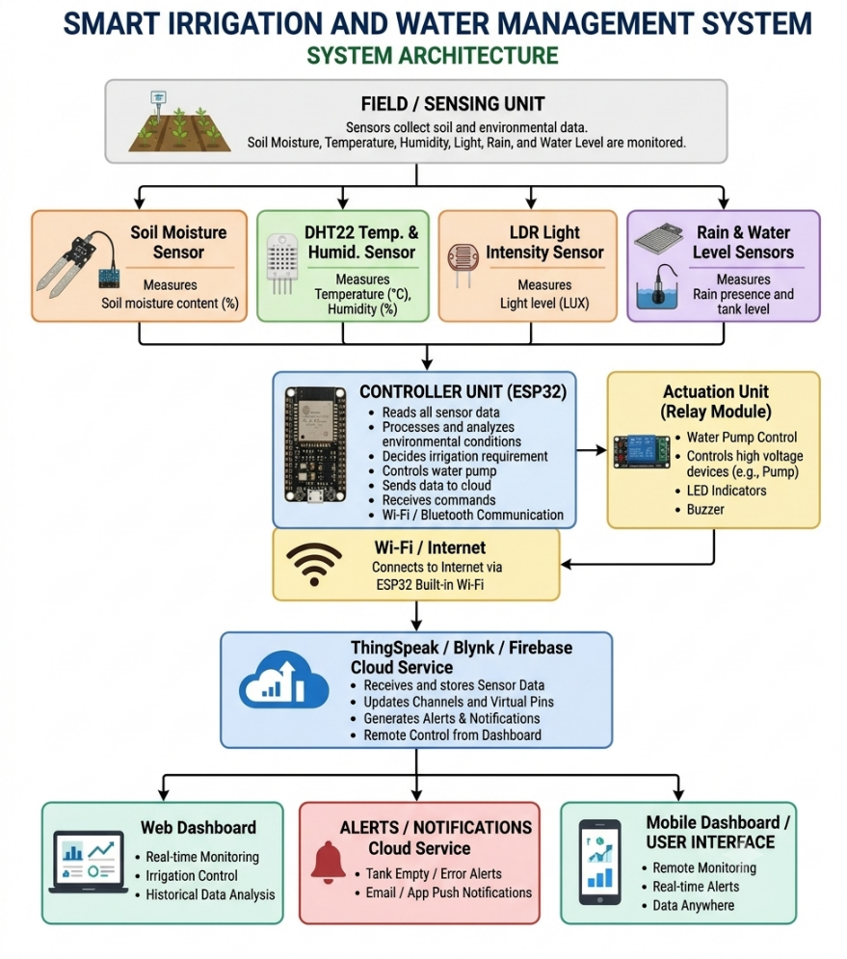

- Circuit Table:

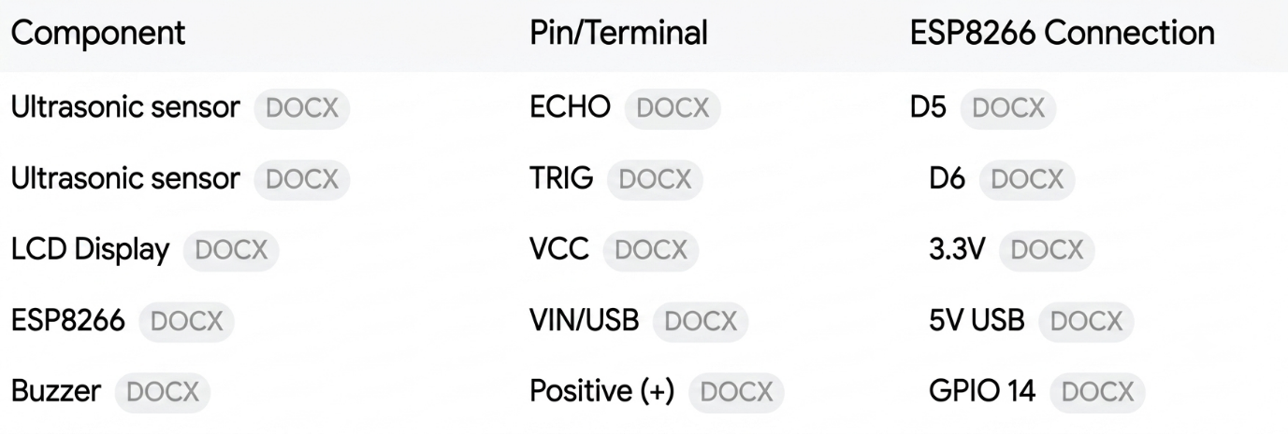

- Circuit Design:

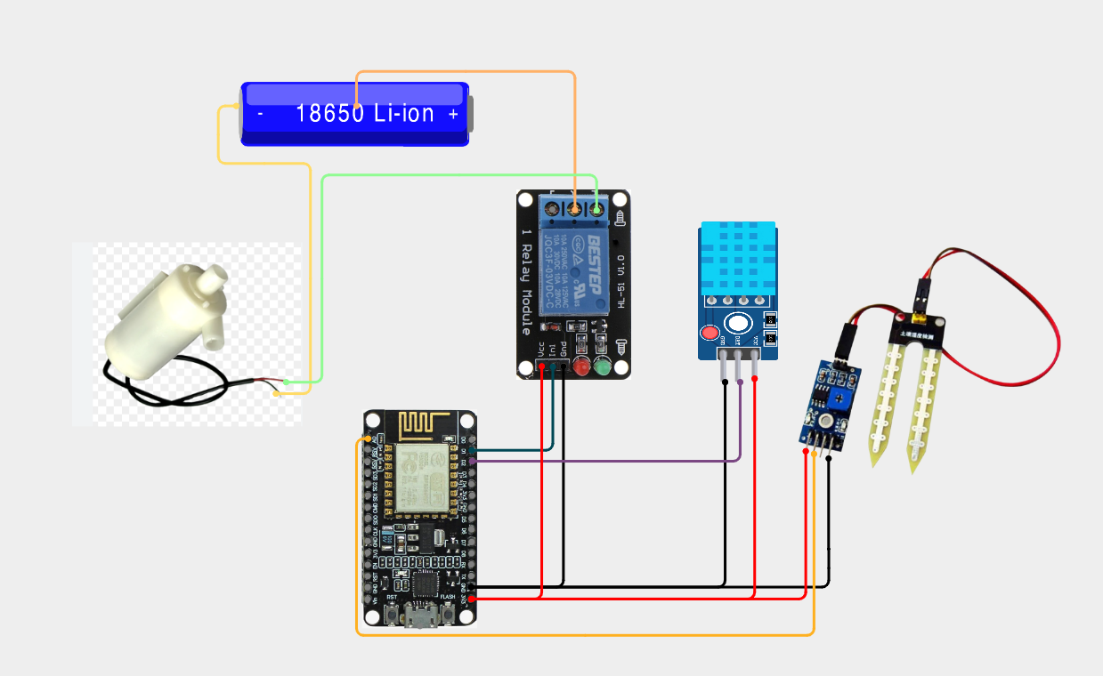

- Algorithm:
Step 1: Initialize the system and components.
Step 2: Define soil moisture thresholds (Moisture_low and Moisture_high).
Step 3: Collect real-time sensor data (soil moisture, temperature, humidity, rain, and water level).
Step 4: Display local readings and upload data to the cloud.
Step 5: If soil moisture < Moisture_low, turn ON the water pump.
Step 6: If soil moisture $≥$ Moisture_high, turn OFF the water pump; otherwise, maintain the current state.
Step 7: Monitor for critical exceptions like heavy rain, tank emptiness, or sensor errors.
Step 8: Trigger the buzzer and red LED if any critical condition occurs.
Step 9: Wait for the designated interval and repeat the loop.

- Coding:

#include <ESP8266WiFi.h> #include <ThingSpeak.h> #include <DHT.h>
// ========================================
// WIFI SETTINGS
// ========================================
const char* ssid = "Xiaomi 11i"; const char* password = "12345678";
// ========================================
// THINGSPEAK SETTINGS
// ======================================
unsigned long channelID = 3454107;
const char* writeAPIKey = "QJL2ZTM3AYFT6N71"; WiFiClient client;
// ========================================
// PIN DEFINITIONS
// ========================================
#define SOIL_PIN A0 #define DHT_PIN 02
#define RELAY_PIN 05 #define DHT_TYPE DHT11
// ========================================
// DHT SETUP
// ======================================== DHT dht(DHT_PIN, DHT_TYPE);
// ========================================
// SOIL MOISTURE CALIBRATION
// ========================================

#define DRY_VALUE 1023
#define WET_VALUE 300
#define MOISTURE_THRESHOLD 30
// ========================================
// SETUP
// ========================================
void setup()
{
Serial.begin(115200); dht.begin();
pinMode(RELAY_PIN, OUTPUT);
// LOW-active relay
// Pump initially OFF digitalWrite(RELAY_PIN, HIGH);
// ======================================
// CONNECT TO WIFI
// ======================================
Serial.println(); Serial.println("Connecting to WiFi..."); WiFi.begin(ssid, password);
while (WiFi.status() != WL_CONNECTED)
{
delay(500); Serial.print(".");
}
Serial.println(); Serial.println("WiFi Connected!"); Serial.print("IP Address: "); Serial.println(WiFi.localIP());
// ======================================

// START THINGSPEAK
// ======================================
ThingSpeak.begin(client); Serial.println("ThingSpeak Started!");
}
// ========================================
// LOOP
// ========================================
void loop()
{
// ======================================
// READ SOIL MOISTURE
// ======================================
int soilRaw = analogRead(SOIL_PIN); int soilMoisture = map(
soilRaw, DRY_VALUE, WET_VALUE, 0,
100
);
soilMoisture = constrain(soilMoisture, 0, 100);
// ======================================
// READ DHT11
// =====================================
float temperature = dht.readTemperature(); float humidity = dht.readHumidity();
// ======================================
// CHECK DHT11
// ======================================

if (isnan(temperature) || isnan(humidity))
{
Serial.println("DHT11 reading failed!"); delay(2000);
return;
}
// ======================================
// IRRIGATION CONTROL
// ======================================
int pumpStatus;
if (soilMoisture < MOISTURE_THRESHOLD)
{
// Soil is dry digitalWrite(RELAY_PIN, LOW); pumpStatus = 1; Serial.println("Soil Status : DRY"); Serial.println("Pump Status : ON");
}
else
{
// Soil is sufficiently wet digitalWrite(RELAY_PIN, HIGH); pumpStatus = 0;
Serial.println("Soil Status : MOIST"); Serial.println("Pump Status : OFF");
}
// ======================================
// SERIAL MONITOR
// ======================================

Serial.println(" ");
Serial.print("Soil Raw Value : "); Serial.println(soilRaw); Serial.print("Soil Moisture : "); Serial.print(soilMoisture); Serial.println(" %"); Serial.print("Temperature : "); Serial.print(temperature); Serial.println(" °C"); Serial.print("Humidity : "); Serial.print(humidity); Serial.println(" %"); Serial.print("Pump Status : "); Serial.println(pumpStatus);
// ======================================
// SEND DATA TO THINGSPEAK
// =====================================
ThingSpeak.setField(1, soilMoisture); ThingSpeak.setField(2, temperature); ThingSpeak.setField(3, humidity); ThingSpeak.setField(4, pumpStatus);
// Optional status message if (pumpStatus == 1)
{
ThingSpeak.setStatus("Automatic irrigation - Pump ON");
}
else
{
ThingSpeak.setStatus("Automatic irrigation - Pump OFF");
}

// Send all fields
int response = ThingSpeak.writeFields( channelID,
writeAPIKey
);
if (response == 200)
{
Serial.println("ThingSpeak update successful!");
}
else
{
Serial.print("ThingSpeak update failed. HTTP error: "); Serial.println(response);
}
Serial.println(" ");
// ThingSpeak update interval
// Keep at least 15 seconds between updates delay(20000);
}

- System Working:

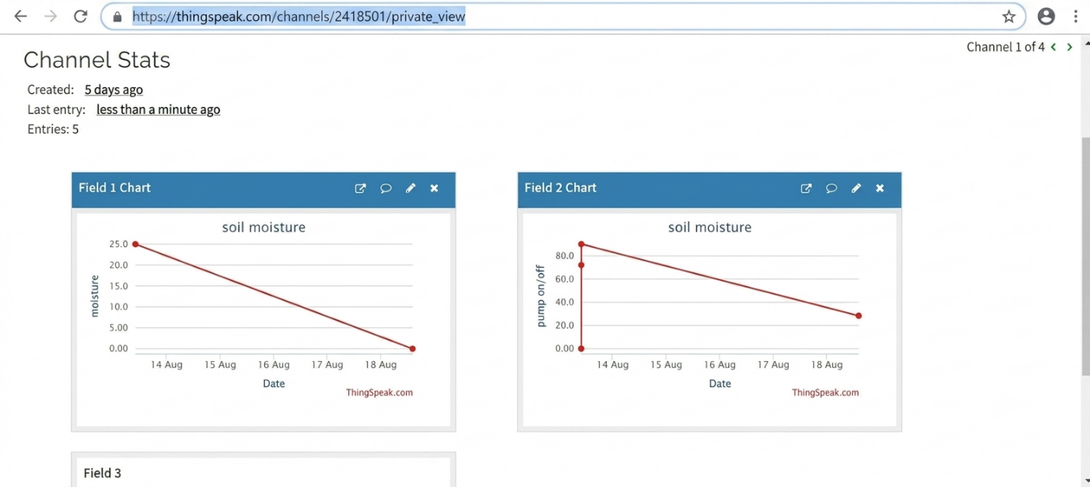

- Working sequence:
Sensing → Processing → Local Display → MQTT Transmission → Cloud Storage → Data Analysis

- Bill of Materials:

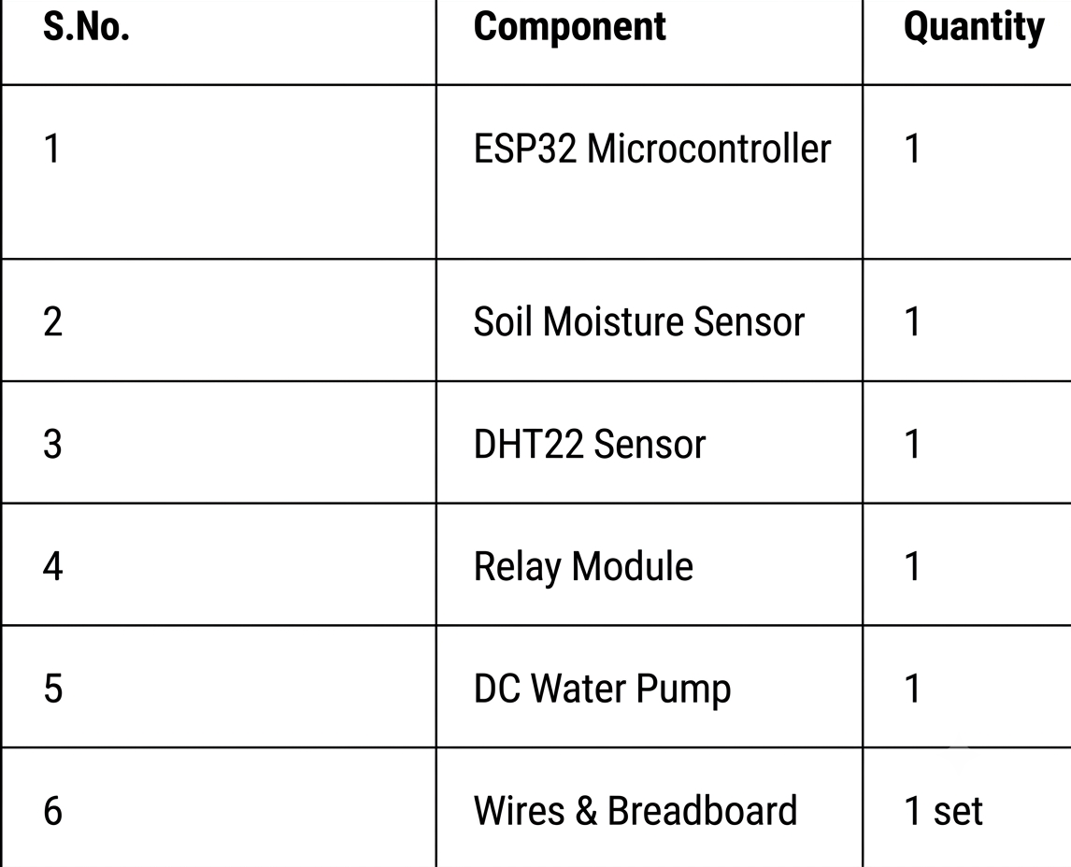

- Prototype Implementation:

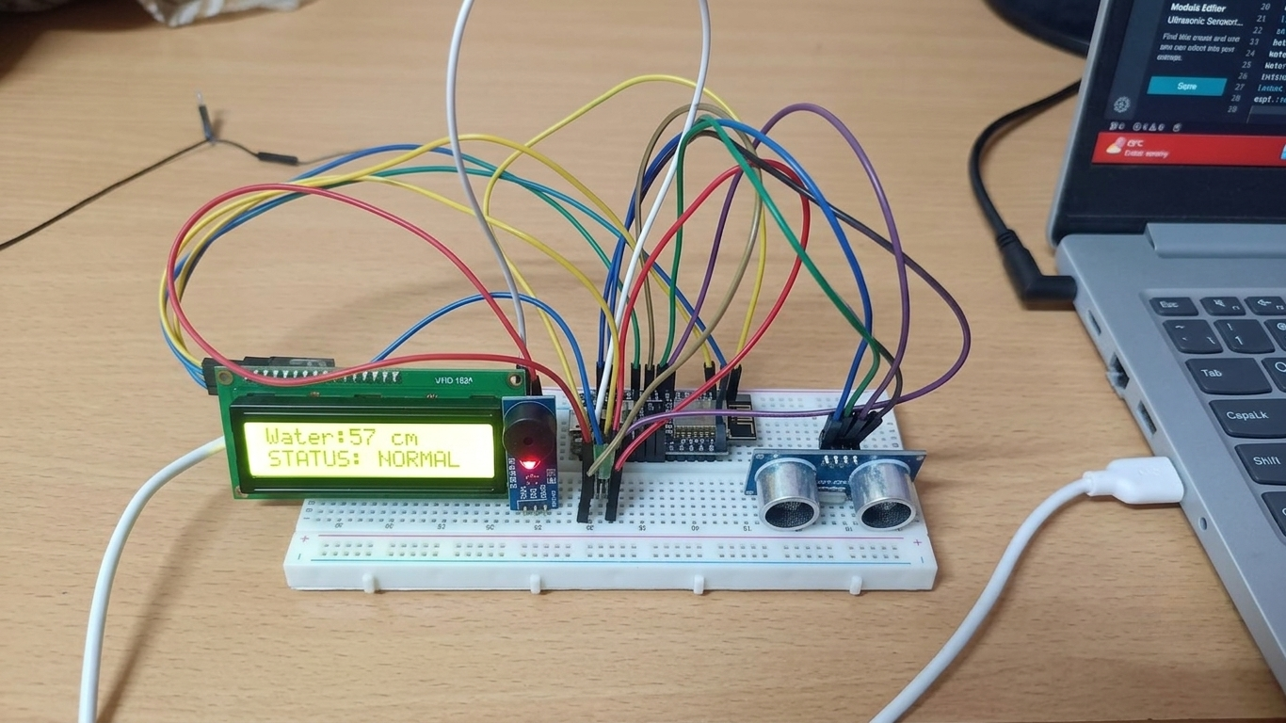
- Results and Performance Analysis:
Performance:
The system provides:
Performance:
- Real-time soil moisture and environmental monitoring
- Automatic pump control based on preset thresholds
- Seamless cloud integration via Wi-Fi for remote tracking
Advantages:
- Optimizes water usage and prevents over-irrigation or under-irrigation
- Minimizes manual intervention through complete automation
- Low-cost and efficient solution tailored for agricultural applications
Limitations:
- Depending on a stable Wi-Fi network connection for continuous cloud updates
- Vulnerable to sensor wear or corrosion over prolonged exposure in soil
- Limited to basic threshold-based actions without advanced predictive weather integration

