Authentication get token

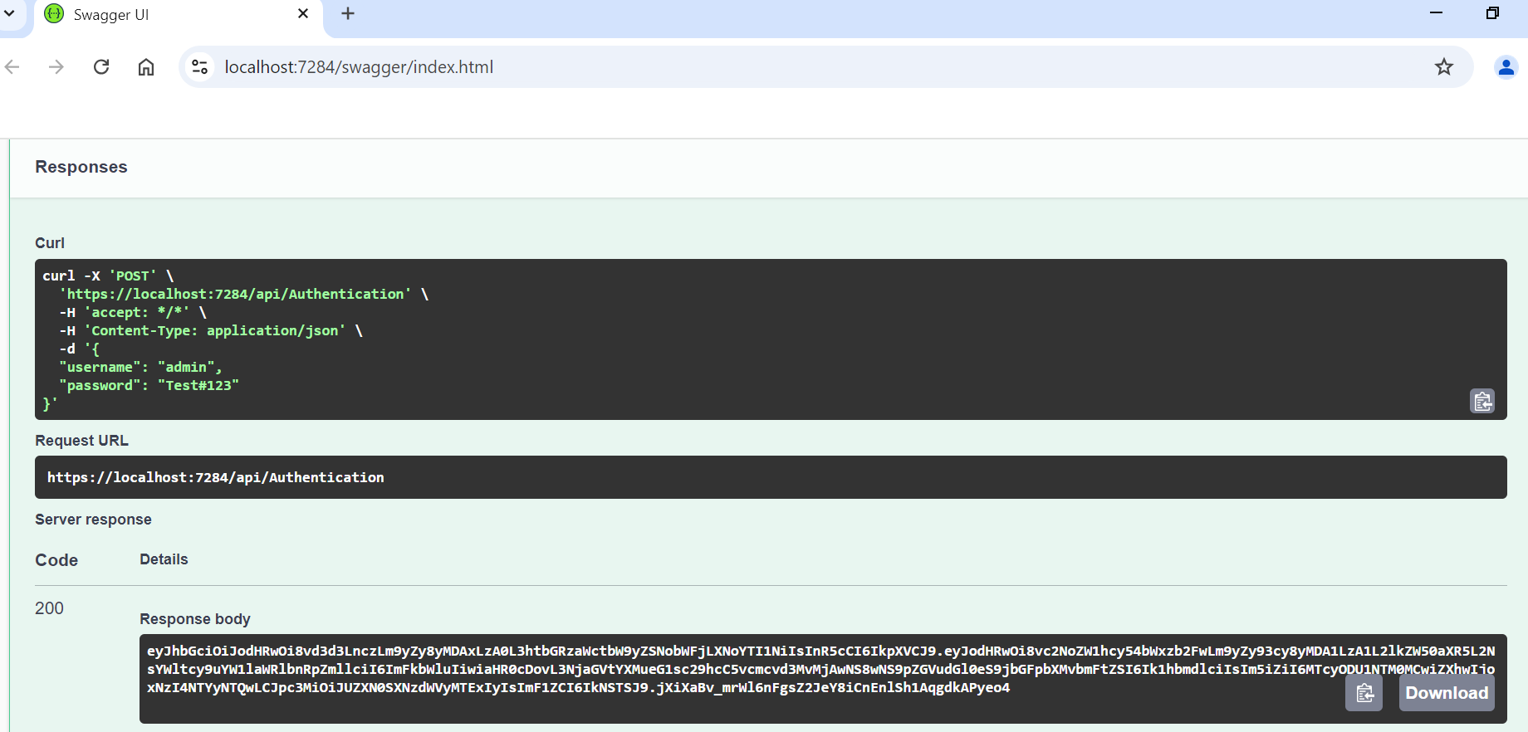

Angular login page

Customers list

Add new customer model



