**Problem statement / Sales Analysis:**

Design KPI and Charts

**KPI’s**

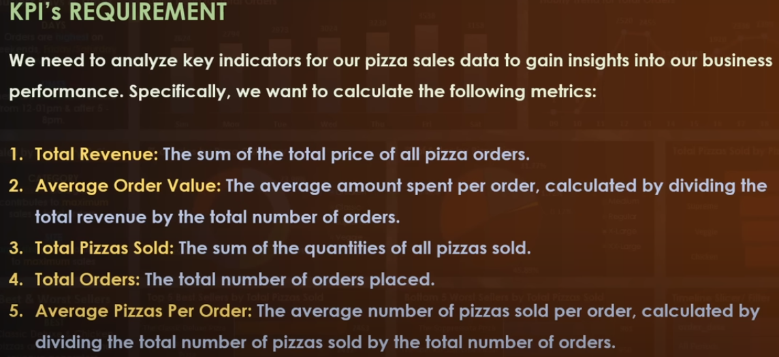

**Charts**

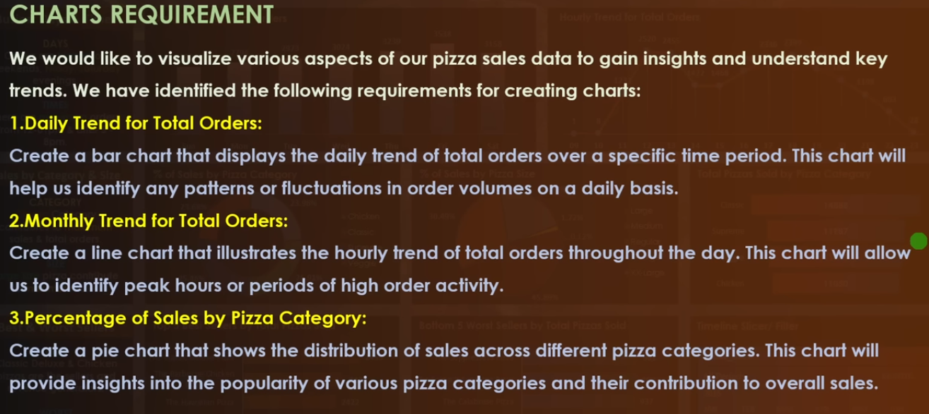

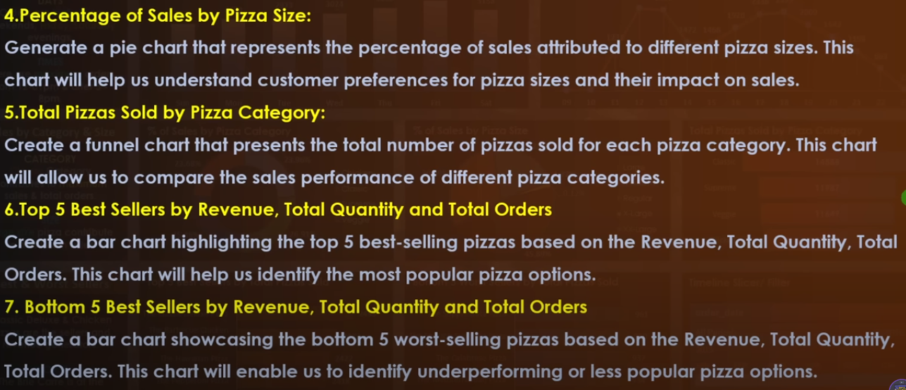

**Tools Used**

- Microsoft Excel

- Microsoft Power BI

- Microsoft SQL

**Project Title**: Sales Performance Analysis Dashboard

**Objective**: To analyze and visualize sales data for a foodservice company to identify trends and make data-driven decisions.

**Data Source**: Excel dataset from Kaggle

**Project Overview**:

**Data Import and Transformation**:

- Imported the dataset from Excel to SQL to extract the numbers.

- Imported the dataset from SQL into Power BI.

- Cleaned and transformed the data to handle missing values and format columns appropriately.

**Data Modeling**:

- I have created a Fact table with foreign key and a Dimension table with primary key.

**Visualizations**:

Designed a dashboard with the following visualizations:

Daily Trend for Total Orders: A column chart showing the daily trend for total orders.

Monthly Trend for Total Orders: A area chart displaying monthly trend for total orders.

Percentage Of Sales by Pizza Category: A donut chart showing percentage of sales by pizza category.

Percentage Of Sale by Pizza Size: A pie chart visualizing percentage of sale by pizza size.

Total Pizza Sold by Pizza Category: A funnel chart showing total pizza sold by pizza category.

Top-Down Analysis and Bottom-Up Analysis showing the best and worst selling pizza by revenue, total order, and quantity

A card showing Total Revenue, Average Order Value, Total Pizza Sold, Total Orders, and Average Pizza Per Order

**Interactivity**:

Implemented slicers and filters to allow users to filter data by date and product category for deeper insights.

**Measures**:

Created measures to calculate metrics like Total Revenue, Average Order Value, Total Pizza Sold, Total Orders, and Average Pizza Per Order.

**Insights and Commentary**:

Provided commentary on key findings and trends observed in the data, such as identifying when the maximum orders are placed, category and the size of pizzas which are sold maximum, and best and worst selling pizza.

**Results and Achievements**:

The Sales Performance Analysis Dashboard enabled the company to:

- Identify that the Classic Category and Large Size Pizzas contribute maximum to the Sales Revenue and Orders Placed.

- Orders are placed maximum during the Weekends and during the month of July and August

- The Thai Chicken Pizza is the best seller by Revenue and The Classic Deluxe Pizza is the best seller by Quantity and Orders

- The Brie Carre Pizza is the worst seller by Revenue, Quantity and Orders