Epic 6: Fitting the Model
In this phase, the Random Forest Regression algorithm learns patterns from the training dataset and builds a predictive model.

Objective
Train the machine learning model using the training dataset.

Training Code
from sklearn.ensemble import RandomForestRegressor
model = RandomForestRegressor(random_state=42)
model.fit(X_train, y_train)
predictions = model.predict(X_test)

Model Training Flow Diagram
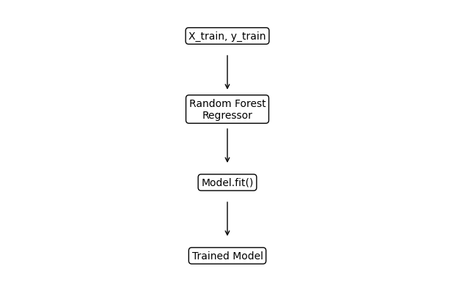

Model Evaluation
Metric | Purpose
R² Score | Measures prediction accuracy
Mean Absolute Error (MAE) | Measures average prediction error

Expected Outcome
- The Random Forest model is trained successfully.
- The trained model can predict Well-Being scores.
- The model is ready to be evaluated and saved.

