Epic 7: Saving the Model
After training, the machine learning model is saved to disk so it can be reused by the Flask web application without retraining.

Objective
Persist the trained Random Forest model using Joblib.

Python Code
import joblib
joblib.dump(model, "wellbeing_model.pkl")
loaded_model = joblib.load("wellbeing_model.pkl")

Model Saving Workflow
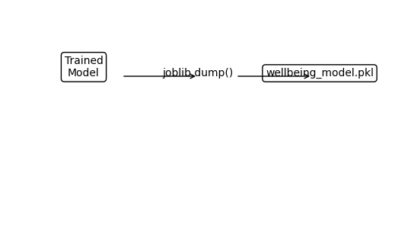

Benefits
- Avoids retraining every time the application starts.
- Enables fast predictions in the Flask application.
- Makes the trained model portable and reusable.

