Epic 8: Building the Flask Web Application
This epic integrates the trained machine learning model with a Flask web application, allowing users to enter lifestyle information and receive a predicted Well-Being Score through a web interface.

Objective
Develop and run a Flask application that loads the saved model and serves predictions.

Project Structure
WellBeing_Project/
├── app.py
├── wellbeing_model.pkl
├── templates/
│ └── index.html
├── static/
│ ├── style.css
│ └── script.js

Application Workflow
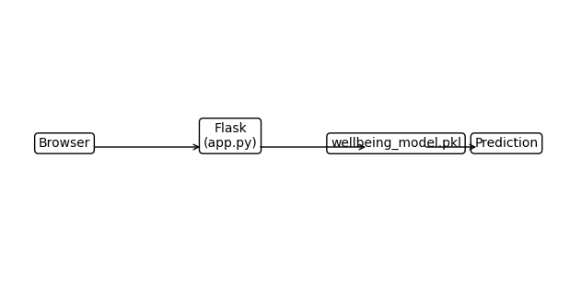

Implementation Steps
- Create app.py and load the saved model.
- Design index.html for user input.
- Style the interface using style.css.
- Accept form data and predict the Well-Being Score.
- Display the prediction to the user.

Run the Application
python app.py
Open http://127.0.0.1:5000 in a web browser.

