
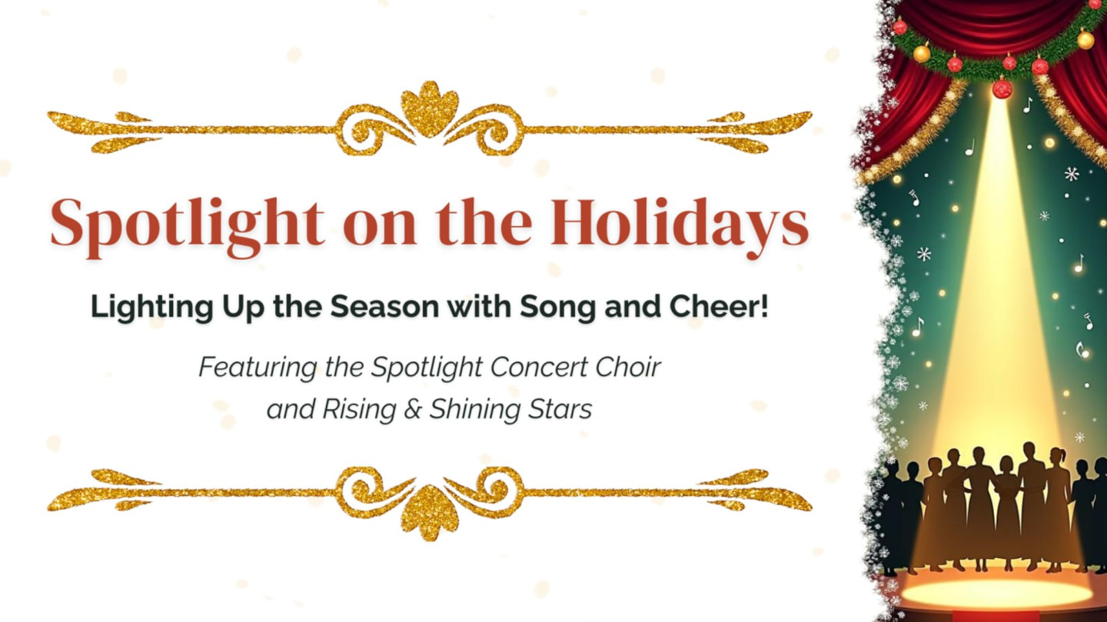
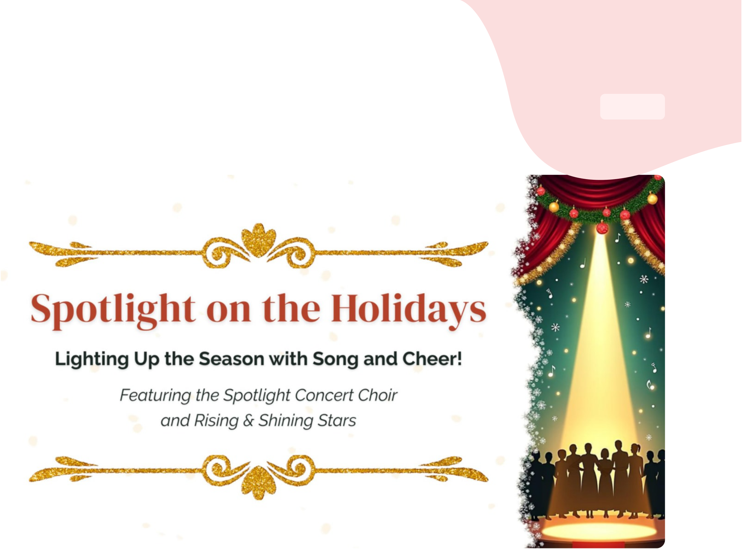





Tickets: Spotlight on the Holidays | N°74  1/2
TICKETDETAILS
GeneralAdmission
BUYER
PrasannaPrabhu
prabhupr70@yahoo.com
EVENTDETAILS


USA











Tickets: Spotlight on the Holidays | N°75  2/2
TICKETDETAILS
GeneralAdmission
BUYER
PrasannaPrabhu
prabhupr70@yahoo.com
EVENTDETAILS


USA

