Task-01

1) Difference between HTTP1.1 vs HTTP2

The Hypertext Transfer Protocol, or HTTP, is an application protocol that has been the de facto standard for communication on the World Wide Web since its invention in 1989. From the release of HTTP/1.1 in 1997 until recently, there have been few revisions to the protocol. But in 2015, a reimagined version called HTTP/2 came into use, which offered several methods to decrease latency, especially when dealing with mobile platforms and server-intensive graphics and videos. HTTP/2 has since become increasingly popular, with some estimates suggesting that around a third of all websites in the world support it. In this changing landscape, web developers can benefit from understanding the technical differences between HTTP/1.1 and HTTP/2, allowing them to make informed and efficient decisions about evolving best practices.

HTTP/1.1

Developed by Timothy Berners-Lee in 1989 as a communication standard for the World Wide Web, HTTP is a top-level application protocol that exchanges information between a client computer and a local or remote web server. In this process, a client sends a text-based request to a server by calling a *method* like GET or POST. In response, the server sends a resource like an HTML page back to the client.

For example, let’s say you are visiting a website at the domain www.example.com. When you navigate to this URL, the web browser on your computer sends an HTTP request in the form of a text-based message, similar to the one shown here:

GET /index.html HTTP/1.1

Host: www.example.com

This request uses the GET method, which asks for data from the host server listed after Host:. In response to this request, the example.com web server returns an HTML page to the requesting client, in addition to any images, stylesheets, or other resources called for in the HTML. Note that not all of the resources are returned to the client in the first call for data.

### HTTP/2

HTTP/2 began as the SPDY protocol, developed primarily at Google with the intention of reducing web page load latency by using techniques such as compression, multiplexing, and prioritization. This protocol served as a template for HTTP/2 when the Hypertext Transfer Protocol working group httpbis of the [IETF (Internet Engineering Task Force)](https://www.ietf.org/) put the standard together, culminating in the publication of HTTP/2 in May 2015. From the beginning, many browsers supported this standardization effort, including Chrome, Opera, Internet Explorer, and Safari. Due in part to this browser support, there has been a significant adoption rate of the protocol since 2015, with especially high rates among new sites.

From a technical point of view, one of the most significant features that distinguishes HTTP/1.1 and HTTP/2 is the binary framing layer, which can be thought of as a part of the application layer in the internet protocol stack. As opposed to HTTP/1.1, which keeps all requests and responses in plain text format, HTTP/2 uses the binary framing layer to encapsulate all messages in binary format, while still maintaining HTTP semantics, such as verbs, methods, and headers. An application level API would still create messages in the conventional HTTP formats, but the underlying layer would then convert these messages into binary. This ensures that web applications created before HTTP/2 can continue functioning as normal when interacting with the new protocol.

Picture spekes:-

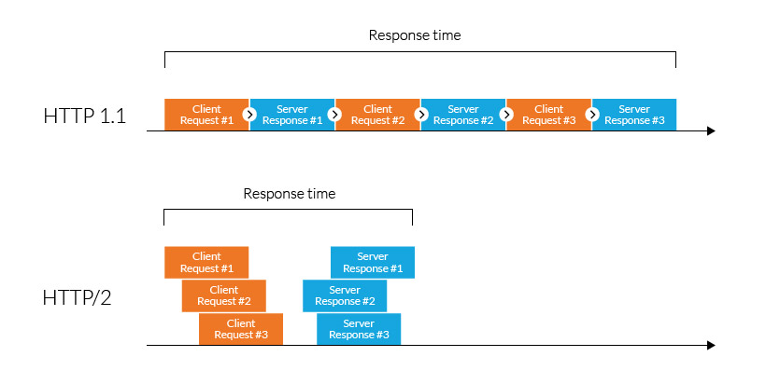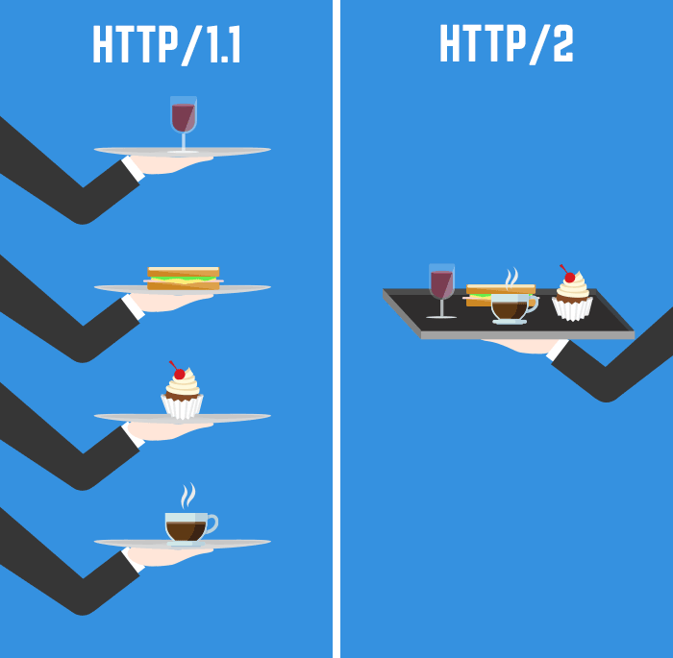

**2) http version history**

The **HTTP**/1.1 standard as defined in RFC 2068 was officially released in January 1997. Improvements and updates to the **HTTP**/1.1 standard were released under RFC 2616 in June 1999.  
...  
**History**.

|  |  |
| --- | --- |
| **Year** | **HTTP Version** |
| 1996 | 1.0 |
| 1997 | 1.1 |
| 2015 | 2.0 |
| Draft (2020) | 3.0 |

**3) List 5 difference between Browser JS(console) vs Nodejs**

|  |  |  |
| --- | --- | --- |
| S.No | Javascript | NodeJS |
| **1** | Javascript is a programming language that is used for writing scripts on the website | NodeJS is a Javascript runtime environment. |
| **2** | Javascript can only be run in the browsers. | NodeJS code can be run outside the browser |
| **3** | It is basically used on the client-side | It is mostly used on the server-side. |
| **4** | Javascript is capable enough to add HTML and play with the DOM. | Nodejs does not have capability to add HTML tags. |
| **5** | Javascript can run in any browser engine as like JS core in safari and Spidermonkey in Firefox. | Nodejs can only run in V8 engine of google chrome. |

**4)** **what happens when you type a URL in the address bar in the browser?**

This is how I would explain it:

1. You enter a URL into a web browser
2. The browser looks up the IP address for the domain name via DNS
3. The browser sends a HTTP *request* to the server
4. The server sends back a HTTP *response*
5. The browser begins rendering the HTML
6. The browser sends requests for additional objects embedded in HTML (images, css, JavaScript) and repeats steps 3-5.
7. Once the page is loaded, the browser sends further async requests as needed