WORLDJAM
Real Objects. Real Sounds. AI-Arranged Music in AR.
High-Level Design (HLD) | iQOO Phone-First Hackathon 2026
Turn the physical world into a playable musical instrument.
Capture the actual sound of objects, place them in AR, let the user sing, and let local AI arrange the session into music.
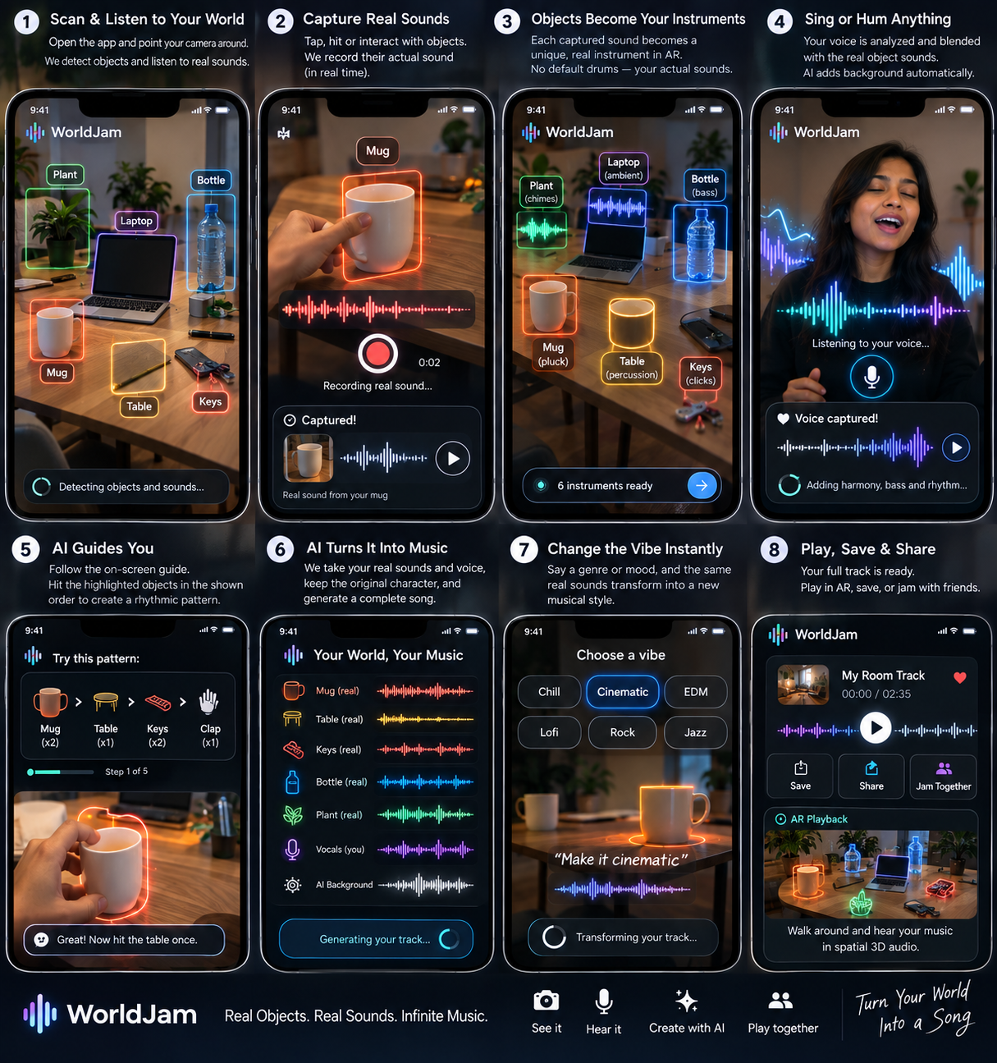
Prepared as a technical concept document for team planning

1. Product Definition
What WorldJam is and what makes it different

One-line product definition
WorldJam is a phone-first AR music experience that captures the real sounds of everyday objects and the user voice, turns those captured sounds into interactive AR sound objects, and uses local AI to arrange when and how they should be played so the result becomes rhythmic and musical.

Core product promise
The key rule is simple: the object sound stays real. A cup does not automatically become a generic drum sample. WorldJam records the cup sound, stores it as the cup's sound identity, and replays that same captured sound when the user interacts with the virtual cup.

What is novel in the experience
- Physical environment becomes the instrument: the user does not need a keyboard, guitar, drum kit, or sample library.
- The app combines camera + microphone + AR + local AI in one continuous loop.
- AI acts as a musical director: it understands the captured session and produces a structured music plan rather than trying to synthesize an entire song from scratch.
- The user voice remains the human lead layer; local AI can align it with the object-sound rhythm and add accompaniment.

Branding note
WorldJam is the working hackathon name because it communicates the product immediately. A quick web scan also found existing uses of the WorldJam name, including a music/setlist site and a WorldJam MusicGroup entity. Treat WorldJam as a hackathon/project codename unless a formal name check is done before public commercialization.

2. User Experience Flow
From scanning a room to a finished AR track

01 | Scan & Listen | Open camera. WorldJam observes the scene and listens to ambient sound.
02 | Capture Real Sounds | The user taps, hits, shakes, clicks, or otherwise interacts with selected objects; the microphone records the actual sound.
03 | Create AR Sound Objects | The physical objects receive AR anchors and become interactive sound objects linked to their captured recordings.
04 | Sing or Hum | The user records any vocal phrase. Pitch/timing features are extracted locally while the original voice is preserved.
05 | AI Rhythm Guide | Local AI generates a beat/pattern and tells the user which object to trigger and when.
06 | AI Arrangement | The session is converted into a structured arrangement: BPM, bars, object events, vocal role, harmony and accompaniment instructions.
07 | Play in Spatial AR | The sounds are spatially positioned around the room and can be heard as the user moves the phone.
08 | Save / Share | The session is rendered as an audio track and can be saved or shared. Multiplayer can be a future extension.

3. High-Level Architecture
React Native for product experience + native Android for performance-critical paths

WORLDJAM
|
+-------------+-------------+
| |
React Native App Native Android Core
UI / UX / AR Shell Audio / ML / NPU bridge
| |
+-------------+-------------+
|
Camera + Microphone + Touch
|
+-------------+-------------+
| | |
Object/AR Audio DSP Voice Analysis
Analysis FFT/Onset Pitch/Timing
| | |
+-------------+-------------+
|
Gemma 4
Local AI Brain
|
+-------------+-------------+
| |
Session understanding Music plan generation
/ interpretation BPM / pattern / harmony
| |
+-------------+-------------+
|
Native Audio Engine
|
+----------------+----------------+
| | |
Real object Real voice AI layers
recordings bass/chords/etc.
| | |
+----------------+----------------+
|
MUSIC
|
AR Playback

Layer responsibilities
Layer | Responsibility | Why
React Native | App screens, camera shell, AR UI, object cards, recorder UI, timeline, controls | Fast product iteration and shared UI architecture
Native Android | Low-latency audio, microphone capture, FFT/onset/pitch helpers, model runtime bridge, spatial playback hooks | Avoid heavy real-time work in the JS thread
Gemma 4 | Understand session metadata, choose musical roles, create rhythm/arrangement instructions, interpret voice commands | Local reasoning and orchestration
Audio Engine | Play captured recordings, schedule events, mix voice, render effects and accompaniment | Deterministic, low-latency execution
AR Layer | Anchor sound objects in the camera view and map touch/interaction to audio triggers | Makes the physical world playable

4. AI and Audio Design
Use the right tool for the right job

The central principle
AI plans. DSP analyzes. The audio engine performs. This keeps WorldJam fast and explainable while still giving local AI a meaningful role.

Recommended local stack
Capability | Candidate / approach | Role in WorldJam | Path
Reasoning / music director | Gemma 4 | Interpret session state and output JSON music plans | On-device local LLM
Sound event understanding | YAMNet or a similarly small audio classifier | Identify broad sound/event categories as hints | Local inference; test exact iQOO handset performance
Pitch / melody | Basic Pitch or lightweight pitch extraction | Extract vocal melody as note events / MIDI-like representation | Prefer local/mobile implementation
Voice commands | Whisper.cpp tiny/base where needed | Convert commands such as “make it jazz” to text | Local Android
Beat / onset / energy | FFT + onset/tempo DSP | Detect attacks and timing in recordings | Native Android DSP
Playback | Oboe / AAudio | Low-latency trigger and mix playback | Native Android
Music layers | Procedural or pre-rendered instrument layers | Bass/chords/texture without huge raw-audio generation | Phone-friendly execution

Why not make a large music generator the core
Large text-to-audio music generators can be powerful, but they are not the right foundation for a 30-hour phone-first demo where the core experience must work locally. WorldJam gets its identity from captured sound plus AI arrangement. The AI can produce structured events while the audio engine produces the actual playable result.

Suggested Gemma contract
INPUT
objects + captured-sound features | vocal pitch/timing | mood | tempo
OUTPUT JSON
{ "bpm":92, "bars":4,
"objectPattern":[{"object":"cup","beats":[1,3]},
{"object":"table","beats":[2,4]}],
"voiceRole":"lead", "accompaniment":["bass","guitar"],
"style":"jazz" }

5. Core WorldJam Modules
The components the team will implement

Module | Responsibility
Camera & Scene Capture | Camera preview, AR tracking, object anchors, scene state
Object Registry | Stores object label, anchor, captured audio path, audio features, role and pattern
Real Sound Recorder | Records short clean samples, trims silence, normalizes level, stores locally
Audio Analyzer | FFT, RMS energy, spectral features, onset detection, tempo hints, optional classifier
Voice Analyzer | Voice capture, pitch/timing extraction, optional speech-to-text commands
Gemma Orchestrator | Turns session state into a structured music plan and interprets natural-language control
Rhythm Guide | Converts music plan into visual AR prompts such as “Cup x2 -> Table x1 -> Keys x2”
Audio Scheduler / Mixer | Schedules sound events to beat grid, handles looping, voice, accompaniment, gain and effects
Spatial AR Audio | Maps each sound object to a spatial position and updates playback as the camera/phone moves
Session Renderer | Exports a final track or demo recording and keeps all project assets local

WorldJam object model
WorldJamObject → id, label, arAnchor, capturedAudioPath, audioFeatures, detectedEvent, musicalRole, beatPattern, volume, visualStyle.
WorldJamSession → bpm, timeSignature, key, objects[], vocalTake, arrangementPlan, style, createdAt.
6. End-to-End Runtime Sequence
What happens when a user makes a track

Step | Action | System behavior
A | Camera starts | Create AR session and begin scene tracking.
B | Objects selected | User selects a cup, table, bottle, keys, etc.
C | Capture | Record short real sounds from interactions.
D | Analyze | Compute lightweight audio features; optionally classify the sound event.
E | Register | Create AR sound objects and attach each real audio sample.
F | Voice | User sings/hums; preserve raw voice and calculate timing/pitch features.
G | Gemma | Send compact session JSON to the local Gemma 4 model.
H | Guide | Receive a structured beat pattern and display AR prompts.
I | Perform | User taps/hits AR objects following the guide; scheduler triggers the exact captured recordings.
J | Arrange | Add deterministic/procedural bass, chords, texture or other accompaniment based on Gemma's plan.
K | Spatialize | Place sounds at their AR positions and mix them.
L | Render | Save the finished track or a demo clip locally.

7. Phone-First / iQOO Hackathon Strategy
Design the demo around the provided handset

What the official hackathon materials support
- React Native is explicitly allowed for the application layer.
- Local/open-source AI is encouraged; Snapdragon NPU use is an on-device target.
- Red Light is phone-first; Office Kit is available during Green Light, so the core demo should remain local.
- Previous city recaps identify the iQOO 15; confirm the exact Hyderabad loaner image at check-in.

Recommended deployment boundary
PHONE CORE (OFFLINE)
React Native UI + AR
Native audio + scheduler
Gemma 4 local
Local audio analysis
Local storage + playback/mix
GREEN LIGHT OPTIONAL
Office Kit / laptop for development + presentation

What should be local vs optional
Function | Core demo | Optional enhancement
Object / AR interaction | Local | Richer 3D visuals
Real sound recording | Local | Advanced cleanup
Audio analysis | Local | More classifiers
Gemma orchestration | Local | Bigger offline model if device permits
Beat guide | Local | Adaptive difficulty
Accompaniment | Local procedural / pre-rendered | Heavier generation during non-critical phase
Final rendering | Local | Laptop export during Green Light

8. Demo Story
A judge should understand the magic within 60-90 seconds

Recommended live demonstration
- 1. Point the iQOO 15 camera at a table setup.
- 2. Select three or four objects: cup, table, bottle and keys.
- 3. Record each real sound by tapping/hitting the object.
- 4. The objects appear as AR sound objects, each labeled as “REAL”.
- 5. Sing a short melody into the phone.
- 6. Show Gemma 4 running locally and producing the beat/arrangement JSON.
- 7. The app says: “Follow this pattern: Table -> Cup -> Cup -> Bottle.”
- 8. User follows the AR prompts; each trigger plays the captured real sound.
- 9. Bass/chords/guitar-style accompaniment joins the real sounds and voice.
- 10. Say “Make it jazz” and show the same captured sound session being rearranged into a different pattern/style.
- 11. Move the phone around the AR scene and demonstrate spatial positioning.
- 12. End with the line: “We did not bring instruments into the room. We turned the room into the instrument.”

Why the demo is strong
- The judge can hear the real captured object sound and immediately understand that it was not a generic sample.
- The AR layer is visibly tied to the physical environment.
- The local AI has a concrete, testable responsibility: it creates the musical plan and guides interaction.
- The phone itself is essential: camera, microphone, on-device AI, touch and spatial audio all participate in the experience.

9. Risks and Design Decisions
Keep the product ambitious but controlled

Risk | Decision
Trying to classify every possible object perfectly | Use broad object categories and allow manual confirmation. The product value comes from the captured sound + arrangement loop, not perfect universal recognition.
Large raw-audio generation is too heavy | Use Gemma for planning and procedural / local playback for the actual track.
JavaScript audio scheduling becomes unreliable | Move critical playback and timing into native Android / Oboe path.
AR depth is not available or behaves differently on the loaner | Build capability detection and fall back to stable surface/anchor placement.
Voice and object sounds overlap | Use short capture windows, simple denoising / gating and clear capture UX.
Gemma output is unpredictable | Force a strict JSON schema, validate it, and apply deterministic music constraints before execution.
Live generation takes too long | Separate instant playback from “arrange” operations. The interaction loop must stay immediate.

Non-goals for the hackathon MVP
- Full DAW replacement.
- Unlimited high-quality text-to-song generation on the phone.
- Perfect recognition of every real-world object or sound.
- Complex multiplayer spatial synchronization as a core dependency.

10. Future Extensions
How WorldJam can grow beyond the hackathon

- Multiplayer Jam: two phones contribute different object-sound layers to one synchronized session.
- Creator mode: publish “sound worlds” or challenge sequences tied to a physical location.
- Adaptive coach: Gemma learns the user rhythm skill and changes challenge difficulty.
- Sound transformation: pitch, time-stretch, reverb and texture while preserving the captured object identity.
- Live performance mode: AR instruments become a stage for a phone-based performer.
- Spatial composition: walk through the room and discover musical layers placed at different locations.

Sources & Verification Notes
Current web research used for architecture and hackathon context

Source | URL | Use in this document
iQOO / Reskilll Hackathon 2026 Guide | https://iqoo.reskilll.com/guide | Official rules and stack guidance; includes React Native and phone-first/on-device AI requirements.
iQOO India - iQOO 15 | https://www.iqoo.com/in/products/iqoo15 | Official iQOO 15 product information and hardware positioning.
Qualcomm AI Hub - YAMNet | https://aihub.qualcomm.com/compute/models/yamnet | Mobile deployment reference for YAMNet; exact iQOO 15 compatibility should be tested on the event handset.
Google AI Edge - LiteRT samples | https://github.com/google-ai-edge/litert-samples | Reference for Android/local model deployment and optimized inference examples.
Basic Pitch mobile implementation | https://github.com/w-ensink/basic_pitch | Mobile-oriented implementation/reference for audio-to-MIDI style pitch extraction.
Whisper.cpp Android | https://github.com/ggml-org/whisper.cpp | Android local speech recognition reference.
Android Oboe | https://developer.android.com/games/sdk/oboe/low-latency-audio | Official Android low-latency audio guidance for Oboe/AAudio.
WorldJam name check - WorldJam Setlists | https://worldjam.vip/ | Existing 2026 web use of the WorldJam name.
WorldJam name check - WorldJam MusicGroup | https://search.sunbiz.org/Inquiry/CorporationSearch/SearchResultDetail?aggregateId=flal-l19000268732-e733a890-9c74-4c35-ae16-2c96d2551aac | Existing corporate use of WorldJam MusicGroup in Florida; this is a naming caution, not a trademark/legal clearance.
Verification note: this document distinguishes the product architecture proposed by the team from capabilities that are explicitly documented by external sources. Exact AI model acceleration, AR depth behavior, and the final Hyderabad loaner software image should be validated on the provided iQOO 15 at the event or during any official technical briefing.

