**IMPROVEMENT IN ROAD SIGNAGES ON NATIONAL HIGHWAY IN INDIA USING ARTIFICIAL INTELLIGENCE (AI) BASED SURVEYS**

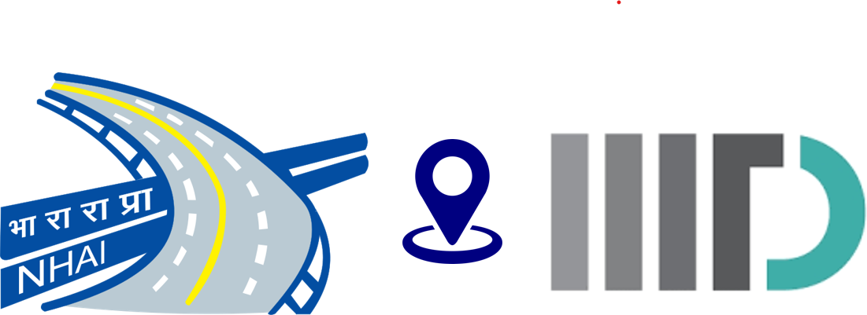

**Name of the stretch -  
  
Six lane road from mohali to patiala via isbt - 43 singhu border**

**Unique Project Code (UPC) -N/09001/01002/PB   
State -Punjab  
Regional Office (RO) -Punjab  
Project Implementation Unit (PIU) -Amritsar**

**Table of Contents**

{ TOC \o "1-3" \h \z \u }

# Chapter 1: Introduction

This is the introduction section.

## 1.1 Background

Some details about the background.

## 1.2 Objectives

Some details about the objectives.

# Chapter 2: Literature Review

This section covers related work.

## 2.1 Previous Studies

A summary of previous studies.

# Executive Summary

National Highways Authority of India (NHAI), under Ministry of Road Transport and Highways (MoRTH), Government of India has signed a Memorandum of Understanding (MoU) with Indraprastha Institute of Information Technology, Delhi (IIITD) to utilize AI based solutions for carrying out Gap Study w.r.t availability and broad condition of road sign on around 25,000 km of National Highways by assessing the difference between the survey findings and the requirement as per the respective CA & latest Codal provisions relevant to high-speed corridors.  
  
The MoU was signed on 30-10-2025 and project completion period was kept as twelve (12) months. The date of commencement of this project was 30-10-2026.  
  
This report summarizes the findings of a gap study conducted on National Highway project **Six Laning of Jalandhar - Amritsar Section of NH-1 from Km 387.100 to Km 407.100 (Bidhipur Dhilwan).**The length of project stretch is **20 km**with “Six Lane with divided carriageway with Service Road” configuration and the type of pavement is Flexible/Rigid. The construction work of the project was completed on/ date of COD was value . The project is currently under DLP/O&M stage.The survey on this project stretch was carried out on 3/10/2025 by the team of IIIT Delhi. As per survey findings which is based on Artificial Intelligence (AI), there are 303 nos. of roads signs including Chevron, Hazard, Cautionary Warning, Prohibitory Mandatory & Informatory Signs, on this stretch. However, as per NHAI record/ approved Road Signage Plan of Contract Agreement, the number of road signages on this project are 242 nos. (data as provided by NHAI). Therefore, a gap of -61 nos. sign boards have been observed. Accordingly, there is an additional requirement of -61 nos. of signages as per the existing contract agreement/ NHAI record.   
  
Secondly, this project has also carried out gap study based on the recommendation of certified road safety auditor (RSA). As per RSA recommendation, the number of road signs required on this project are {road_signs_required} nos. Accordingly, there is an additional requirement of {road_signs_rsa} nos. of signages based on the recommendation of Road Safety Auditor (RSA).   
  
The following table presents the summary of Gap study report :

# 1. Introduction

## 1.1.Brief description about the MoU

National Highways Authority of India (NHAI), under Ministry of Road Transport and Highways (MoRTH), Government of India has signed a Memorandum of Understanding (MoU) with Indraprastha Institute of Information Technology, Delhi (IIITD) to utilize AI based solutions for carrying out Gap Study w.r.t availability and broad condition of road sign on around 25,000 km of National Highways by assessing the difference between the survey findings and the requirement as per the respective CA & latest Codal provisions relevant to high-speed corridors.

The project duration as per the MoU is twelve (12) months and the date of commencement of work is 27.09.2024. The tentative length of road to be covered under the aforementioned study shall be 25,000 km. The list of stretches included in the project are from different states which is divided into 05 zones (Zone A to E).

|  |  |  |  |  |
| --- | --- | --- | --- | --- |
| 1 | 2 | 3 | 4 | 5 |
| saukdghfjs | saukdghfjs | saukdghfjs | saukdghfjs | saukdghfjs |
| sakdugdb | sakdugdb | sakdugdb | sakdugdb | sakdugdb |
| sakdhjcdsgcv | sakdhjcdsgcv | sakdhjcdsgcv | sakdhjcdsgcv | sakdhjcdsgcv |

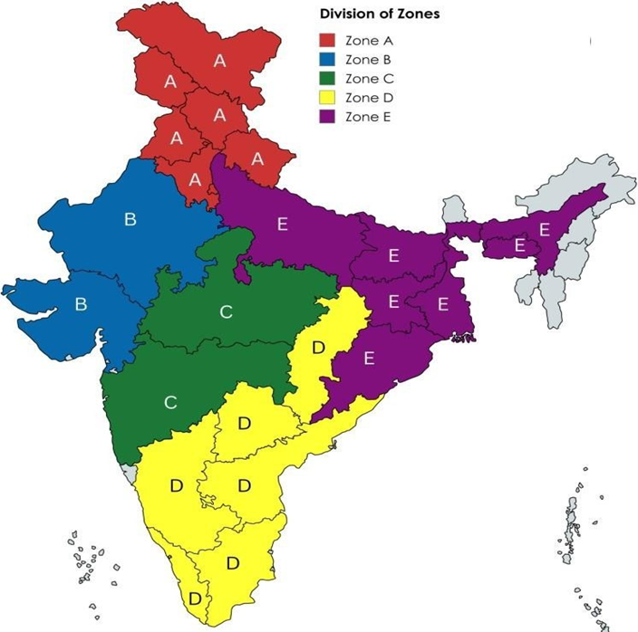

## 1.2 Objectives of Gap Study

Adequate availability of the road signs on the roads plays a significant role in the road safety. NHAI intends to enhance the road safety for all road users by embracing innovation and adopting advanced technologies.   
  
Artificial Intelligence (Al) has emerged as a powerful tool for automating tasks and improving data analysis capabilities. By harnessing the potential of Al and Geographic Information Systems (GIS), NHAI can revolutionize its approach w.r.t road signs inspection.   
  
Therefore, NHAI in collaboration with IIIT Delhi intends to utilize Al based solutions for Improvement in the availability of road signs on National Highways in India.

WRITE OBJECTIVES SIGNED FROM MOU

## 1.3 Scope of services

The scope of work is to carry out Gap studies w.r.t the availability and broad condition of road signs on around 25,000 km of National Highways in India. The services includes following:   
  
i. The gap study shall be carried out by assessing the difference between the survey findings and the requirements of road signs as per signage plan of the respective Contract Agreement.   
  
ii. Gap study based on updated / latest Codal provisions relevant to high-speed corridors to cater for enhanced safety requirements. For this purpose, IIITD shall engage a certified Road Safety Auditor (RSA) for assisting in the gap study and preparation of report.   
  
iii. IIITD shall carry out the surveys for collecting imagery and other ancillary data related to availability and condition of road signages on selected National Highways stretches in India as provided by NHAI.   
  
iv. The data collected through surveys shall be processed through deployment of adequately capable Artificial Intelligence (AI) for accurate identification and classification of road sign types.

## 1.4 Salient features of the instant National Highway Project

The salient features of the instant National Highway Project are mentioned as under:

**Index map:**Start Chainage :3  
End Chainage :400  
  
**Total Service Roads Surveyed -**56  
  
**Total Intersections Surveyed -**10

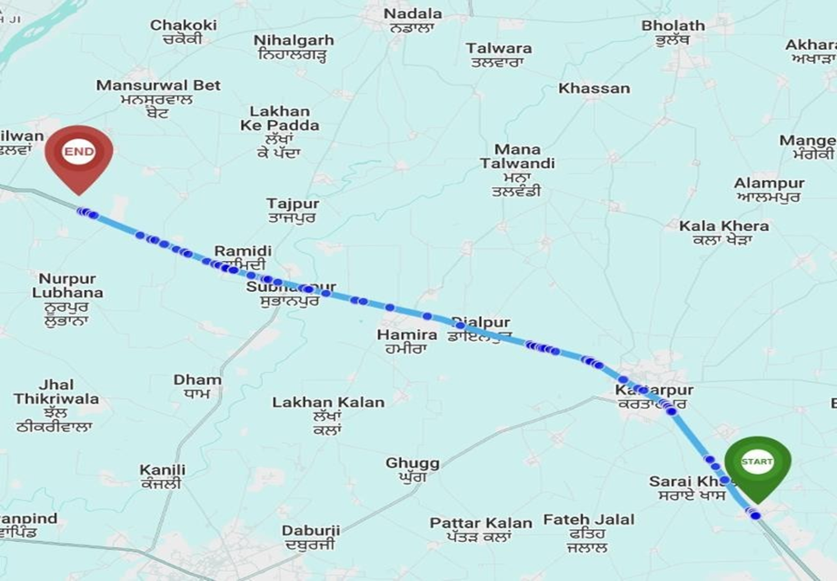

# 2. Methodology

## 2.1. Data Collection

The research methodology used is a combination of data collection and processing the same through Artificial Intelligence (AI) based solutions. The data collection involves the use of technology like integrated device which is mounted on the vehicle and the survey is done with expert and driver in the vehicle. The start point is marked and the Main Carriageway (MCW) is covered on both LHS & RHS. The survey further includes covering all the service roads and intersections of the same stretch on vehicles to collect data remotely. The data which is collected is uploaded for the further processing through AI models.

## 2.2. Broad Methodology- Artificial Intelligence based solution

AI models are employed to process the collected data, identify patterns, and generate insights into road signages as seen in the video captured. The chainage, name of the road, latitude & longitude are marked simultaneously.

# 3. Inventory of Road Signs

## 3.1.Road Signage Inventory (provided by NHAI)

## 3.2.Road Signage Inventory based on Survey Data (conducted by IIIT)

## 3.3.Road signage Requirement as per Road Safety Audit

# 4. Results of Gap study

## 4.1.Gap study based on NHAI data

## 4.2.Gap study based on Rad safety audit