Design Specification On

**KING**

**Online Car Rental System**

Prabin Malla

00163020

Computing Project

Level 5 Diploma in Computing

Softwarica College of IT & E-Commerce

Kathmandu, Nepal

May 24, 2017

Contents

INTRODUCTION: 3

SECTION 2: Structural Model 4

Class Diagram 4

ER Diagram 5

DATA DICTIONARY: 5

SECTION 3: BEHAVIOURIAL MODEL 7

Activity Diagram 8

SEQUENCE DIAGRAMS: 10

SECTION 4: CONCLUSION 12

REFERENCES: 13

# INTRODUCTION:

All the information were gathered, hold together and analysed. After the information were analyse then the designing was done to further the project King Online Car Rental System. The designing phase includes of the structural diagram and the behaviour diagram for the system that is going to build up. In structural diagram, the overall class diagram of the system is created and in behaviour model, the activity diagram and the sequence diagram is build which defines different roles and behaviours of the classes and the actors involved in the system.

Designing is considered to be the important part in the system development. Designing is performed when building the system due to the following main reasons:

* Designing is the benchmark language between the programmer and the designer as designinng is the blueprint of the system which helps to trace whether the system is moving to the genuiine plans as considered from designing team.
* Designing is also considered to be the framework to the programmers. It proves the adequate level of the information and it leds them to understand about the system they want to create and they can make it in certain fix time.

Unified Modelling Language also known as UML is the standard diagrammatical modelling language which is useful to the anayst, programmers. UML is used for the Analysis, Design and the execution of the system that is to be build. UML can also be used for different modelling business and other methods too. In buiding this system, we have used UML for designing the system due to the following reasons as:

* UML provides the directions for the team to perform certain events.
* It gives different condition to monitor and determine the systems product and action too.
* This is known as the best preparation to build successful system.
* UML helps to trace the singe developers role along with the team roles.

When the system is going to be designed then, we have to keep in mind that different UML diagrams should be created which are: Class Diagram, Activity Diagram and Sequence Diagram. Different tools are used to create the mentioned diagram. The different tools are described as:

* Visual Paradigm:  
  Visual Paradigm is the open source tool which is use to create the UML diagrams. This tool is more effective than the Star UML as it is used for developing the UML diagrams along the E-R diagrams and many more diagrams.
* Star UML:  
  Star UML is also widely used open source tool which was developed by MK lab. Star UML is used for creating fast, extensible, flexible and freely available UML diagrams.

The Designing Specification documentaion consists of many sections which are going to be demonstrated in coming pages. At first the Structural Model is described of the system in the upcoming topic i.e. Section 2 and the Section 3 covers the Behaviou Model of the system which consists of the activity and the sequential diagram. Lastly the conclusion is provided in Section 4 to fianlise the Design specification topic of the system going to be build.

# SECTION 2: Structural Model

Structual Model diagam is used to illlustrate the static nature of the system to be build and its different parts on different possible stage and how all the classes are interlinked with each other. Shortly the Structural Model can be represented as the overall class diagram of the system which includes of the: Classes in system, Relationship of the classses in system, different methods, different attributes along the different classes, the detailed class defination and lastly the suitabe decription of the class diagam and the reationship build between the classes in the system.

## Class Diagram

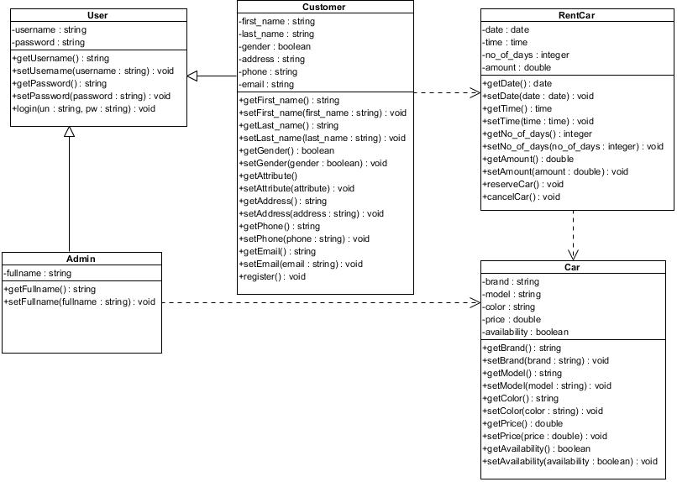

Fig 1: Class Diagram of the system.

The system that is going to be created from the proposal, I have came to include the five classes which are classifed accoding to their functionality process. All the classes that are createad in the class diagram were identified using the Natural Language Analysis (NLA). The created class diagram provides all the detailed information related to each classes, their relationship, attributes along their methods.

## ER Diagram

ER diagram is also known as the Entity Relationship Diagram, which is like class diagram as compared, as it helps to model whole system. The E-R diagram display the entities also known as classes in class diagram. In E-R diagram the attributes of each entities is displayed and also the relationship between the entities. This E-R diagram is build from the class diagram directly. Once the database design is intiated then the diagram changes to the form than is presented in the relational database. The E-R diagram of the King Online Car Rental System is shown in Fig 2 below:

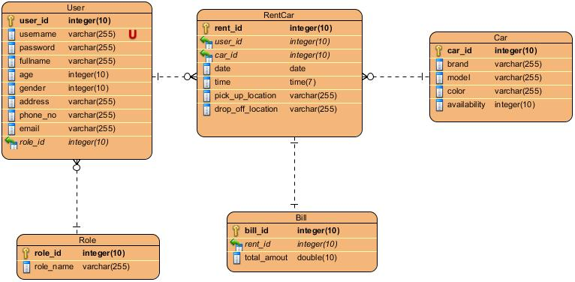

Fig 2: E-R diagram of system.

## DATA DICTIONARY:

After the E-R diagram is build then the data dictionay is also build for the five tables that are presented in the E-R diagrams. The five data dictionaries are as below:

User:

|  |  |  |  |  |
| --- | --- | --- | --- | --- |
| Field name | Data type | Length | Null able | Key |
| user_id | Int | 10 | Not Null | Primary |
| username | Varchar | 255 |  | - |
| password | Varchar | 255 |  | - |
| fullname | Varchar | 255 |  | - |
| age | Int | 255 |  | - |
| gender | Int | 255 |  | - |
| address | Varchar | 255 |  | - |
| phone_no | Varchar | 255 |  | - |
| email | Varchar | 255 |  | - |
| role_id | Int | 10 |  | Foreign |

RentCar:

|  |  |  |  |  |
| --- | --- | --- | --- | --- |
| Field name | Data type | Length | Null able | Key |
| rent_id | Int | 10 | Not Null | Primary |
| user_id | Int | 10 | Not Null | Foreign |
| car_id | Int | 10 | Not Null | Foreign |
| date | Date | - |  | - |
| time | Time | 7 |  | - |
| pick_up_location | Varchar | 255 |  | - |
| pick_off_location | Varchar | 255 |  | - |

Car:

|  |  |  |  |  |
| --- | --- | --- | --- | --- |
| Field name | Data type | Length | Null able | Key |
| car_id | Int | 10 | Not Null | Primary |
| brand | Varchar | 255 |  | - |
| model | Varchar | 255 |  | - |
| color | Varchar | 255 |  | - |
| availability | Int | 10 |  | - |

Role:

|  |  |  |  |  |
| --- | --- | --- | --- | --- |
| Field name | Data type | Length | Null able | Key |
| role_id | Int | 10 | Not Null | Primary |
| role_name | Varchar | 255 |  | - |

Bill:

|  |  |  |  |  |
| --- | --- | --- | --- | --- |
| Field name | Data type | Length | Null able | Key |
| bill_id | Int | 10 | Not Null | Primary |
| rent_id | Int | 10 | Not Null | Foreign |
| total_amount | Double | 10 |  | - |

# SECTION 3: BEHAVIOURIAL MODEL

Behavioural model is used to describe the different behaviours of actors along the interaction of the different classes formed in the system. The behaviou model can also be descrribed as the interaction among the structural diagrams. It is used to show the dynamically structure of the developed system. This leds to the defination of the variations to the system in certain period of the time. Behaviou model is the must have design when building the projects due to the follwing reasons which are described as:

* It is able to show how the system is processing when the users’ inputs and they change their input in certain time period.
* It is used to define the dynamic act of the objects.

Behaviour model are the most essential diagram as they show the algorithm of how the system works and is build up. There are many certain way of building the behavior model types which are descibed as in following ways:

* Activity Diagram:  
  Activity Diagram is the most common behavioural UML diagram. Activity diagram describes the definite flow of the control of the destined system. In a particular way, Discovering the challenging businesses rules and their procedures. Activity diagram are also used to describe the logic of different process which are represented in the class diagam in strutural model.
* Sequence Diagram:  
  Sequence diagrams ae used for representing the high level of the interactions between the objects that are in sequential order that interacts and arises. This diagram defines the flow of the messaage, different events and the action performed in between different objects of the system.
* Communication Diagram:  
  Communication diagams also known as the collaborative and the interactive diagrams are used to show the interaction involved between different objects and parts by the sequenced interaction in a arrrangement which is free form.

For building this system, the behaviour model I choosed was the activity diagram and the sequence diagram due to the following prioities:

* Activity diagram is also known as the prototype for the implement of the codes to build in system.
* The activity diagram is understood by both the customers and the stakeholders which leds to user friendly diagam.
* The scope and the lifeline of the objects presents in the system is shown by the sequence diagram.
* Lastly, the sequential diagram processes at a high level of concept as compared to other activity diagram.

## Activity Diagram

As mentioned above the activity diagram gives the overall idea of how the system works involving all the possible steps after one passes by. It shows the process by process movements of the actors as they changes their input in the system, through different activities such as the action on the objects from actor and the actors involving in the system. Figure 3 shows the complete activity diagram involved in the system where the black circle represents the start and the black bulls eye represents the stop states.

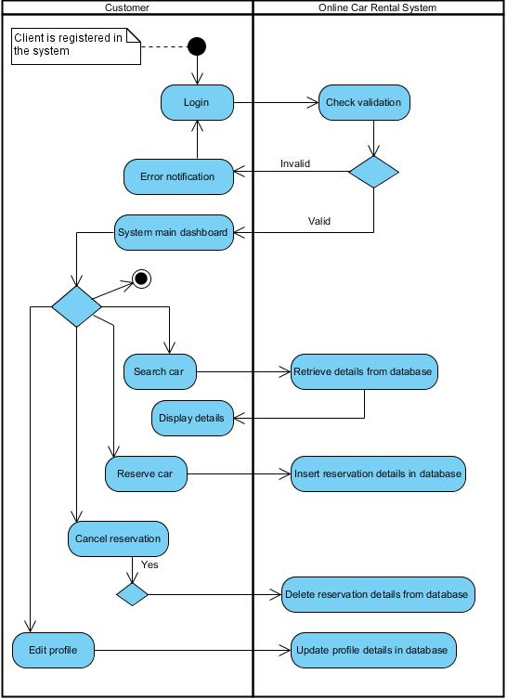

Fig 3.1: Activity Diagram of the Customer and the System.

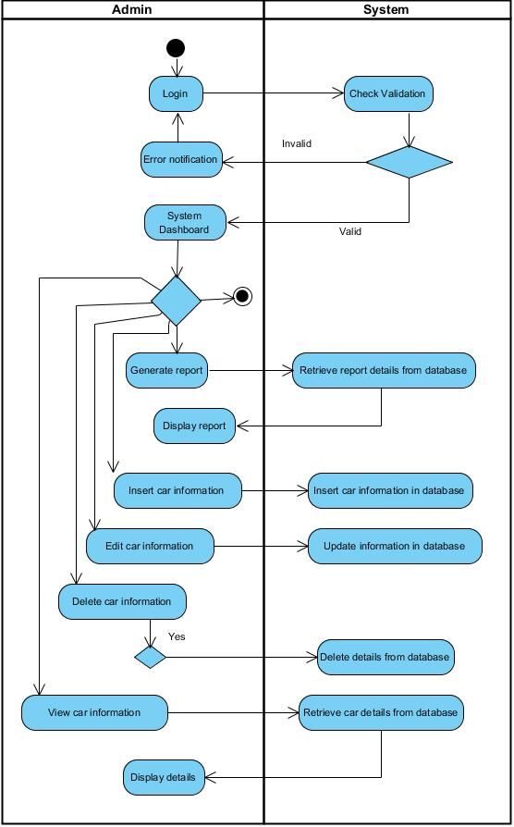

Fig 3.2: Activity Diagram for the Admin and the System.

## SEQUENCE DIAGRAMS:

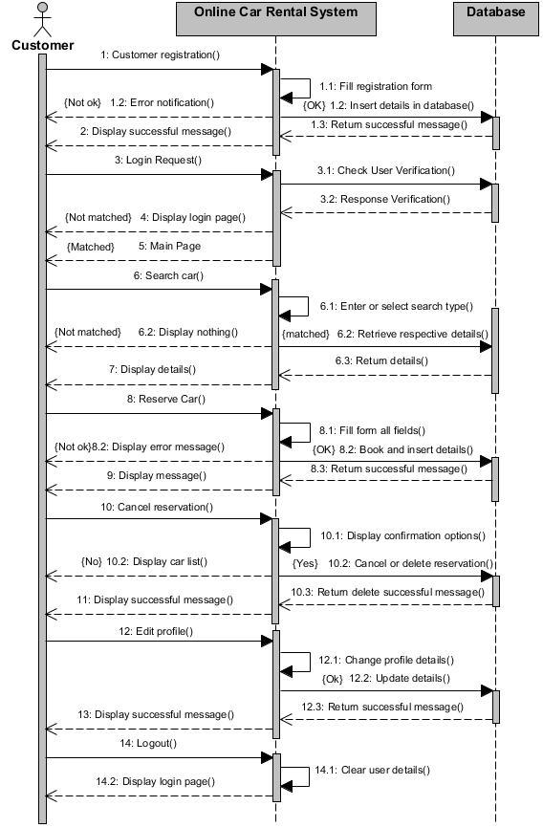

Fig 4: Sequence Diagram for customer and the system.

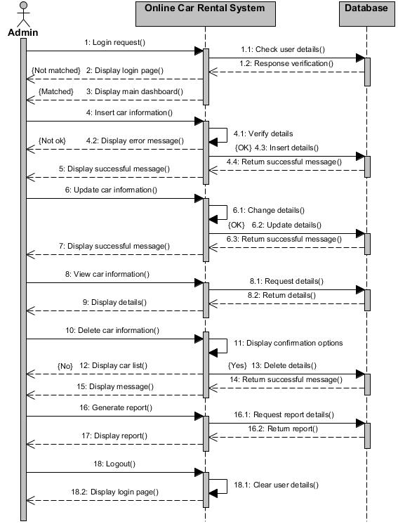

Fig 4.1: Sequence Diagram for Admin and the system.

# SECTION 4: CONCLUSION

In this topic, we have designed the design specifiation for our proposed system of the King Online Car Rental System. In this topic we are able to know the different designing tools along with different designing diagrams from the research and the type of designs too. The topic leds us to know the importance of designing in the computer pojects when something is going to be build. So we can say that the designing make the interation between the customers, system and admin easy to understand as they have different roles to perfom.

Lastly, in my project I have used the Structural modelling where the class diagram is designed along the Entity Relationship(E-R) diagram too and its data dictionary. And the Behaviuoral Modelling Languagae is used to create the activity diagram and the sequential diagarm that is involved in my project to build the system.

# REFERENCES:

Infolab.stanford.edu. (2017). The Design Phase. [online] Available at: [http://infolab.stanford.edu/~burback/watersluice/node11.html](http://infolab.stanford.edu/~burback/watersluice/node11.html%20)   
[Accessed on May 20, 2017]

Inghelbrecht, Y. (2017). UML Sequence Diagrams : A Quick Introduction. [online] Tracemodeler.com. Available at: [http://www.tracemodeler.com/articles/a_quick_introduction_to_uml_sequence_diagrams/](http://www.tracemodeler.com/articles/a_quick_introduction_to_uml_sequence_diagrams/%20) [Accessed on May 20, 2017]