Project Proposal On

**KING**

**Online Car Rental System**

Prabin Malla

00163020

Computing Project

Level 5 Diploma in Computing

Softwarica College of IT & E-Commerce

Kathmandu, Nepal

April 9, 2017

Table of Contents

1 Introduction 3

Scope: 3

1.1 Aim: 3

1.2 Objectives: 3

1.3 Main Features: 4

1.4 Development Methodology: 4

2 Project Plan: 5

2.1 Work Breakdown Structure (WBS) 5

2.2 Time Estimation 6

2.3 Milestones: 6

2.4 Schedule 7

3 Risk Management: 8

4 Configuration management 9

5 Conclusion: 10

References: 10

# 1 Introduction

This project “KING Online Car Rental System” is designed to be utilized by the King Car Rental Organisation who provides car rental services to the customer. It is an online system that allows the customer to observe the available cars, register their information, view their profile and transaction history and book car according to their requirement.

With the advancement of the Information and Communication technology, more and more company are moving towards using an automated system. Firstly, having an automated system helps the organisation to enhance their business by providing services to the customer on the global scale rather than limiting themselves on the local market through the use of internet technology. Secondly, the customer can have a quality of services since they can reserve the vehicles online prior to their required pickup time or date. Finally, the company can observe the transaction of the customer by analysing their profile and make effort to offer better services. So, having an online car rental system has a lot of advantages to the car rental industry and the customer

## Scope:

The project revolves around identifying the business concept of the car rental process and how to integrate it into our system. So, a lot of research is required to understand the core concept to achieve the aim and objectives of this project.

## 1.1 Aim:

The aim is the identification of the needs that is to be achieved with our project. Aims are associated with the things that we are designing, developing, investiging and evaluating. The aims of my project are as:

* To develop a web-based systemwhich allows to ease the process of car rental system to the customer and the business organisation.
* To ease the process of car rental system.
* To interact between the customer and business to make ebusiness.
* To evaluate the problem and give the better soution for certain problem.
* To research the tools and technologies for solving the problems.

## 1.2 Objectives:

The objectives are the goals or aims that are to be achieved while building the project. Objectives helps to identify the specific and measureable achieveements that are neeeded to be completed to achieve the aim of the project as required. The objectives of the projects are listed below:

* To research on how car rental industry work.
* To research on PHP Technology used for the development of this project.
* To research on project development methodology.
* To document the development of this project.
* To analyze the problem along with its flaws.
* To track the system development phases with the milestone, such as analysis, design, development, testeing for the future references.

## 1.3 Main Features:

The main features of this project are

* Customer’s registration.
* Customer profile edit.
* Online reservation of cars.
* User Authentication.
* Manage car (Adding, Viewing and Listing car details) for customers.
* Manage booking (Listing and View car bookings) by administration.

## 1.4 Development Methodology:

Waterfall Methodology will be utilized for the development of this project. It is a linear sequential method. So it is easy to understand and use for our project. It involves performing various phases namely Analysis, Design, Development, Test & Maintenance and each phases must be completed before moving onto next one. So the phases do not overlap with each other.

The reasons for using this methodology for my online car rental system are as follows:

* All the requirement of this project are fairly clear and fixed. So there is little or no chance of changing requirement as the project start to develop.
* This is an academic project. So it is small and all the resources required for the project are available to us.
* Since the project has fixed requirement, it is easy to perform each phases of this methodology and minimize the risk and uncertainty involved during the development of the project.

The phases that are involved in the waterfall development methods is shown in the figure 1 as follow:

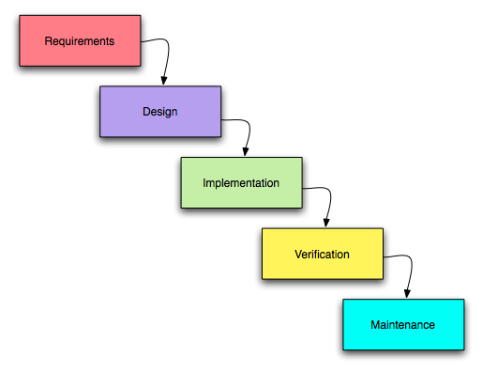

Fig 1: Waterfall methodology

# 2 Project Plan:

## 2.1 Work Breakdown Structure (WBS)

The Work Breakdown Structure is used to breakdown the project into manageable chunks so that all members of project team can understand, as each level of WBS delivers additional definition and details.

Benefits of using a WBS for this project.

* Allows us to define and organize the scope of the project.
* Allows us to break down the structure of the project into small measurable units.
* Allows us to manage, control and allocate the resources for the project in a better way. So, there will be better estimation of time, risk and cost for the project

Fig 2: Work BreakDown Structure

## 2.2 Time Estimation

The Work Breakdown Structure for this project is illustrated in the table below:

|  |  |  |
| --- | --- | --- |
| WBS # | Task name | Days |
| 0. | **Online Car Rental System** | **100** |
| 1  1.1  1.2 | **Project Planning**  Scoping  Planning | **10**  5  5 |
| 2  2.1  2.2  2.3 | **Analysis**  Requirements  Use Cases  Architecture | **13**  2  5  6 |
| 3  3.1  3.2  3.3 | **Design**  Structural model  Behaviour model  UI Design | **30**  8  8  14 |
| 4  4.1  4.2 | **Implementation**  Build Database  Full Application Coding | **30**  5  25 |
| 5  5.1  5.2 | **Testing**  Unit Testing  Integration Testing | **6**  3  3 |
| 6  6.1  6.2 | **Reporting**  User manual  Final report | **11**  2  9 |

Table 1: Work Breakdown Structure

## 2.3 Milestones:

The table for the milestone is below:

|  |  |
| --- | --- |
| **Milestones** | **Date** |
| Project proposal | 9 April, 2017 |
| Analysis speciﬁcation | 23 April, 2017 |
| Design speciﬁcation | 24 May, 2017 |
| Implementation (Midway Presentation) | 14 June, 2017 |
| Final report | 11 July, 2017 |

Table 2: Milestone of the project

## 2.4 Schedule

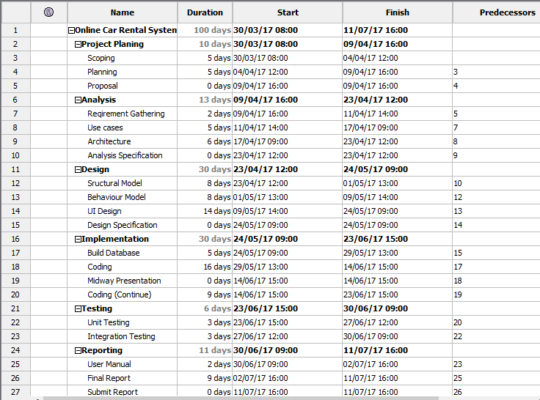

Fig 3:Schedule for grant chart.

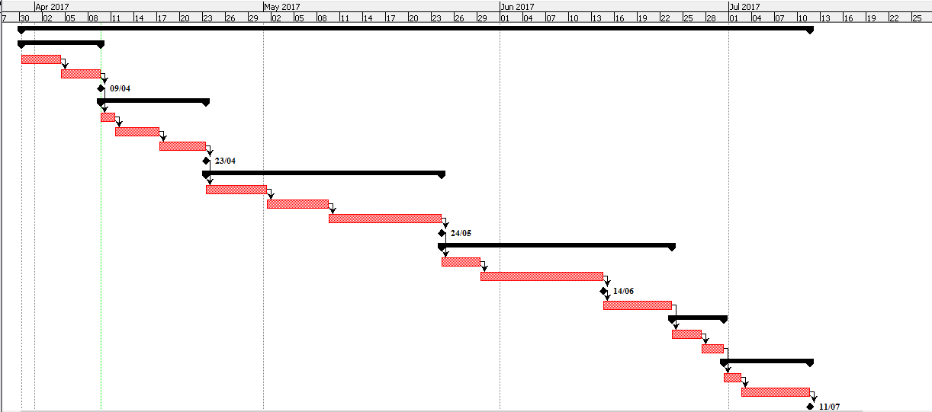

Fig 4: Gantt chart of the project

# 3 Risk Management:

Risk Management is the procedure of recognizing, measuring and managing the risks to minimize its consequences or outcomes on the project.

To evaluate the effect of each identified risk, following relation is used:

Impact = Likelihood x Consequence

In this relation, the likelihood and consequence values are allocated based on the scale illustrated in Table 3 and Table 4.

|  |  |
| --- | --- |
| Likelihood | Value |
| Low | 1 |
| Medium | 2 |
| High | 3 |

Table 3: Risk Likelihood Value

|  |  |
| --- | --- |
| Consequence | Value |
| Very Low | 1 |
| Low | 2 |
| Medium | 3 |
| High | 4 |
| Very High | 5 |

Table 4: Risk Consequence Value

Risk Management for this project:

|  |  |  |  |  |
| --- | --- | --- | --- | --- |
| Risk | Likelihood | Consequence | Impact | Action |
| Changing requirement | 1 | 4 | 4 | Detailed analysis of the requirement is done so that it remains constant throughout the project. |
| Hardware failure | 2 | 4 | 8 | Back up the data on regular basis so that is can be recovered in case of hardware failure. |
| Under estimation of the project completion time | 2 | 5 | 10 | Proper planning and estimation of time. Modify schedule to complete the project on time. |
| Lack of project resource | 1 | 4 | 4 | Research and collect all the resource required for the project. |
| System Crash | 2 | 4 | 8 | Proper backup plan should be maintained. The data of the project are regularly backed up in the cloud i.e. google drive. Another source was using the flash drive. |
| Natural Disaster | 2 | 3 | 6 | The bacup are used in the cloud for the future reference. The server backup is created. |
| Vehicle Roberry | 2 | 4 | 8 | The Gprs tracking system can be used to track the vehicle routes. |

Table 5: Risk Management

# 4 Configuration management

Configuration Management is the procedure which helps to monitor the different versions of the system while they are being developed. In short it is the directory of the project where all the build up data and information are saved. It is done in order to maintain the effieciency, reliabaility and the performance of the system. All the files that are related in developing the project are kept in one drive particularly google drive and the flash drive. All the useful information to track down the project development like **proposal, analysis, design, testing and final report** are stored in the folder name **Computing Project** under **Car Rental** as shown in the **figure4:configuration management.** This is the configuration management for the **Online Car Rental System.** The datas are regularly backed up for the future reference so when the project are needed to change then the figure shows the changes that needs to be change as in the diretory. All the files are backed upp in the google drive along with the date regularly backed up. For the changes in the system the same is done as gone through the proposal, analysis, design, testind and preparing the final report.

* **Computing Project**

Proposal

16C_PRABIN_MALLA_PROPOSAL.docx

Gantt Chart

ganttChart.pod

Analysis

Design

Testing

Final Report

Figure 4: Configuration Management.

# 5 Conclusion:

To sum up, the project “Online Car Rental System” is proposed to automate the car rental system. By developing the system, the customer will be able to book to car online and the company will manage the bookings. Risk management has been done to identify the potential risk and how to manage them to minimize their impact. Gant chart has been used to schedule the task that are carried throughout the project.

Finally this is the project created for the King Online Car Rental System where the customers can view the website for the booking of cars for rental for some ceratin fix time. The customers can book the car by viewing the website which helps the customers to manage their time, they can view the website and have a look at the car as their desire. The Administrator can also add the new cars and give the list of available cars. This project gives the overall view how the online car rental system works.

# References:

* Dawson, C.W. (2005). *Projects in Computing and Information Systems: A Student’s Guide*. Addison-Wesley. ISBN: 9780321263551.
* IT Knowledge Portal. (2017). *Software Development Methodologies.* Available on: <http://www.itinfo.am/eng/software-development-methodologies/>  
  [Accessed on Apr 6, 2017].
* Marquette University. (2017). *WHAT IS RISK MANAGEMENT?* Available on: <http://www.marquette.edu/riskunit/riskmanagement/whatis.shtml>  
  [Accessed on Apr 6, 2017].
* Margaret Rouse. (2017). *project management definition.* Available: <http://searchcio.techtarget.com/definition/project-management>  
  [Accessed on Apr 6, 2017].