**Loading Data into HBase using Pig Scripts**

1. We will be using student Dataset for loading data into HBase using Pig, Below are columns in the Dataset :

StudentName, sector, DOB, qualification, score, state, randomName.

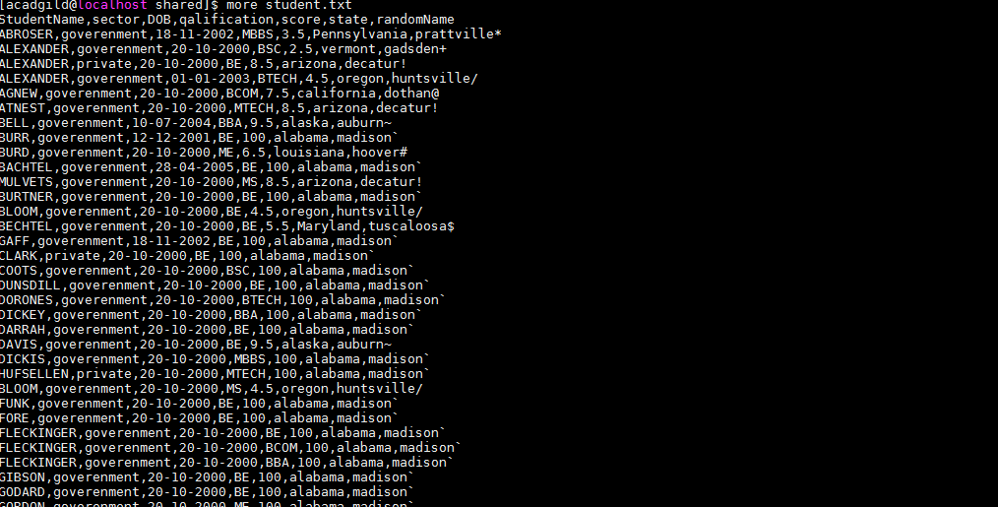

1. Copy the Dataset into HDFS which will be further loaded into HBase.

**hadoop fs -put student.txt /HBase_Data**

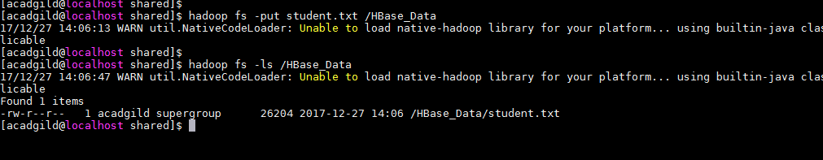

1. Include few jar files of HBase to Pig Classpath

**PIG_CLASSPATH=/usr/local/hbase/lib:/usr/local/hbase/lib/hbase-*.jar**



1. Start HBase shell and create a table student

**create 'student','student_data'**



1. After creating table exit from hbase shell and switch to pig grunt shell. Now load the data from HDFS to pig Alias relation.

**rawdata = load '/HBase_Data/student.txt' using PigStorage(',') as (StudentName:chararray, sector:chararray, DOB:chararray, qualification:chararray, score:int, state:chararray, randomName:chararray)**

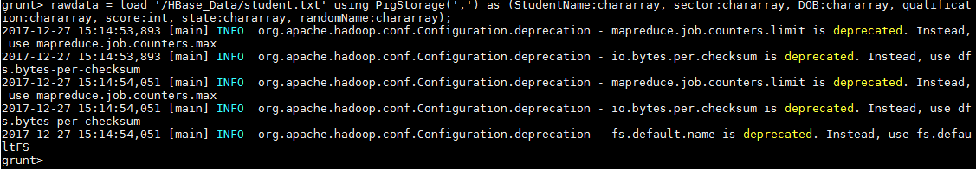

1. Now using the STORE command load the data inside the HBase table

**STORE rawdata INTO 'hbase://student' USING org.apache.pig.backend.hadoop.hbase.HBaseStorage('student_data:StudentName,student_data:sector,student_data:DOB,student_data:qualification,student_data:score,student_data:state,student_data:randomName')**

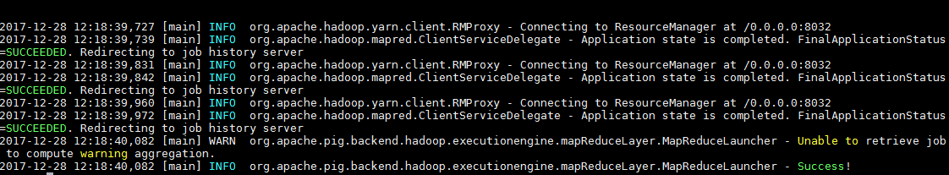

1. Now check the data in HBase table

**scan 'student'**

